Computer Science NEA

By

Contents:

Section 1: Analysis

* Identification of the problem
* Computational solution
* Stakeholders
* Interviewing
* Research
* Requirements & Limitations

Section 2: Design

* Decomposing the Problem
* Description of the solution
* Test plan
* Main menu & Login screen
* Quiz design
* Rocket game design
* Database design

Section 3: Development

* **Phase 1:** Setting up the quiz
* **Phase 2:** Setting up button classes and implementing buttons in the quiz
* **Phase 3:** Setting up question file
* **Phase 4:** Creating 2D environment with moving features and interactive elements
* **Phase 5**: Creating minigame which uses score from quiz
* **Phase 6:** Creating a login system with appropriate validation
* **Phase 7:** Creating database which stores user information and scores
* **Phase 8:** Creating main menu with topic selection which feeds into quiz
* **Phase 9:** Using database to create leader boards
* **Phase 10:** Testing
* *QUIZ TESTING*
* *MINIGAME TESTING*
* *LOGIN SCREEN TESTING*
* *MAIN MENU TESTING*
* *DATABASE TESTING*

Section 4: Evaluation

* Satisfaction of success criteria.
* Limitations of the program
* Future improvements
* Video demo
* Stakeholder reviews and final comment from developer

Section 5: Code

Section 6: Bibliography

Analysis:

Identifying the problem:

* + Currently in the UK it is a requirement that all students take the sciences at GCSE level. Through conversation with peers and via online debates it became apparent that the science that students most struggled with is physics. This is a subject that I am passionate about and so I thought it would be a good idea to create a programme that helped students to prepare for their physics examinations. I realised that often the problem isn’t with the understanding of theory but more the use of equations and how to apply them in certain situations. Unfortunately at GCSE level it is required that the students also memorise the equations which may be what puts many people off. Having had a quick google search it is apparent that there is not much on the market it terms of computer programmes/games for helping students to learn in a more interactive way. Interactive tasks often work well for many people as they can apply theory to a real life situation or in this case a situation in a game. This helps to solidify the knowledge and can jog their memory in a crucial situation such as their exam.

My Idea for the Game:

* + The program I intend to create will be one which has 2 main features, a quiz and a minigame. The function of the quiz is for the actual revision part of the program, where students can look at questions, are presented with answers and have to choose one to progress onto the next level. The results of this quiz will be stored for future use and can also be used as part of the reward in the minigame. The minigame will take the form of an old video game, similar to asteroids, whereby the user must control a rocket and land it on the surface of the moon. They will have to dodge obstacles and they will also have a fuel metre which will affect how much they can ‘boost’. My idea is to use the score from the quiz as a reward system which converts the score into an amount of fuel which is then available to the rocket and the user.
  + In order to make the program more user friendly I will also need to include a menu system which will be interactive and use a WIMP style Graphical User Interface. This will also apply to the account and login system which will be needed if each user is to be able to store their results. On the main menu I will include the leader board system which is another incentive for the students to do well in the quiz. The teacher who manages the program could set out a reward system whereby the top 3 scorers each month get a prize of some description.
  + In order to store the scores and to create a leader board I will need a database which is accessed by different parts of the program and can perform multiple functions. Using SQL I can change the database when needed and access specific parts of the data from it when needed as well. For this I will use the SQLite module in python.
  + The questions in the quiz will be loaded from a text file, this Is because it can easily be formatted so that the teacher who is using the program can change the questions. They may want to use it as a monthly competition whereby the questions change each month and the students have as many chances as they want to improve the score to place on the leader board or to get higher on it. This encourages repetitive use of the program and therefore more revision as they repeat the questions and learn key information.
  + In order to improve the idea I will be researching quiz games for revision that already exist and analysing their effectiveness, while also getting a stakeholders opinion on them. I will also have a look at the game asteroids and see the style of the game and what things I want to be similar and what I could do differently.

Stakeholders:

* + Science Teachers
  + Students
  + Parents of students
  + Due to the nature of the program and the complexity of the content the main stakeholders/target market will be secondary school science teachers and students. As it is a requirement in the UK for almost all students to do triple science at GCSE it makes the program suitable for all students who are hoping to succeed. It would hopefully be a useful revision tool for them to use in the crucial last few months running up to their exams. Also for students who struggle to simply learn from a textbook this would provide an educational and interactive learning experience. It is a well-known fact that many students learn more effectively visually. By involving teachers I can find out what students most struggle with on average and also how I can improve the program to make it more educational and challenging. There is a possibility for further development so that A level students are able to use the program for more advanced topics at A level. However as A level students are not a primary stakeholder the focus will not be on them for this project. But I will also be taking the opinion of students who have taken the Physics GCSE into account as they’ve experienced the exams most recently. There is also a possibility of having a homework feature where a teacher could set work on a specific topic.

With the thread of COVID-19 causing the closing of schools and offices across the world, working from home has become a norm for many people in the past few months. Technology is now playing a vital role in a changing world, schooling and education is one of the most important things that a child has growing up. With a program such as this it would make work easily accessible from home. Allowing students, teachers and parents to coordinate a child’s education and prevent them losing out.

**Students**: In summary the program benefits the students that us it the most, therefore they are the primary stakeholders. They will be able to use it as a learning tool which should be a valuable resource considering the ever-growing use of technology in education. It also provides a platform on which students can revise both at school and at home. The program should also be able to track and monitor progress and adapt to the students’ needs also making it a very useful program as it is dynamic and should not be repetitive. It will also be interactive to keep the levels of interest high and keep the learning engaging.

**Teachers:** Teachers would also benefit from the program as they can monitor the students use of the program and also see what the student may be struggling with. This means that in class the teacher can recap topics that students are struggling with or arrange 1 to 1 sessions to help them. This improves the efficiency of work and speeds up the recognition of students error.

**Parents**: Parents would be a stakeholder as they want the best for their children in their education. They would also be able to access the data and see the results of their child’s work and monitor their progress. It would help to indicate whether the student needed to spend more time on the subject, this would help them guide the student in their revision and improve their overall grade. It may also be something they can use to encourage their child to engage with their learning especially with home learning becoming more and more commonplace.

Interview:

My questions:

1. Would you be interested in a computer program that would enhance your learning in physics, and what kind of format would you like it to be in?
2. Would you prefer an extensive game or a simple interactive program?
3. Do you think visual representation/examples such as pictures and animations help to enhance a learning experience?
4. Did you use computers much to revise throughout your GCSEs, if not why not?
5. In your honest opinion, do you think that people would be interested in a program such as the one that has been described?

**Interview With Student 1 (Jake)**:

1. Yes I’d be interested in that, in an interactive format as it allows focus to be maintained for longer periods of study.
2. An interactive, engaging program.
3. Yes they help to enhance the experience, especially for visual learners.
4. I did not use a computer that much to revise for my GCSE exams, there were not many online resources readily available.
5. Yes as it provides an interactive home learning experience that helps to make what is widely considered to be a ‘boring’ subject more engaging and enjoyable. Educational games is an unsaturated market with a lot of potential.

**Interview With Student 2 (Fred)**:

1. Yes that would be appealing, in a new and engaging way.
2. Simple interactive program
3. Yes, they make it easier to remember based off of the animation
4. Yes I did, it makes it fast and easy to get information and allows you to access a wide variety of information quickly
5. Yes as it allows the user to take in information with a simple animation to help gain the main ideas of the topic, allowing it to be a more enjoyable experience rather than just reading out of a textbook.

**Interview With Teacher**:

1. Personally I would be interested in using it as a teaching resource. It could benefit students greatly especially with the recent emphasis on home learning.
2. It would have to be something which engaged with the students making them more inclined to using the program but without distracting animation or pictures that could put them off track.
3. Some students do seem to find that visual representations help with their understandings of many topics.
4. I certainly didn’t as the resource was not available at the time however I think in a changing world it is vital that students make full use out of the resources available to them. Technology can be a huge help for all students and is now a massive part of education as a whole.
5. I think the idea would work as long as it could be made into something whereby the students could have a more enjoyable working experience but also where a teacher could monitor their progress.

Research:

To the best of my knowledge and prior research I do not believe that there is a physics specific website or program that caters to a student’s needs. Often they are allowed to see the answer and then can repeat the same question again and get it right as they’ve seen the answer moments before. This is not effective as it means students can get the answer wrong but then get it right on their next attempt by just simply copying. I will be looking at the Physics GCSE, two quiz/revision websites and the game ‘Asteroids’ to help my research.

* **The Physics GCSE Itself**: As I am making the program for GCSE students it Is essential that I do some research into the physics GCSE and see what each exam board requires. The program will not be exam board specific but will be a general physics GCSE program so that all physics students can utilise it.

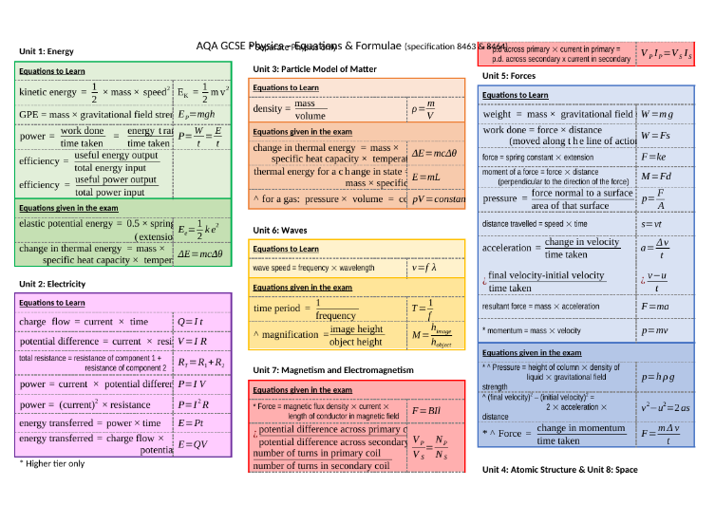This diagram on the left shows all the equations used in the AQA specification in GCSE. As my school uses AQA this is the exam board then this is the main basis I will be using for the program. These equations and the concepts related to them are what the GCSE students will need to revise. They can then track and monitor progress in each topic using the database and graphing system. This allows them to improve in specific areas of their GCSE training and fine tune their revision techniques. This also allows teachers to fine tune both class and 1 to 1 tuition.

I have completed the GCSE myself and have the textbooks so I know what kind of questions I will need to write and how difficult I need to make the questions. I can also ensure that the content I am including is up to date and relevant to what students will be learning now by using sites such as BBC Bitesize to cross reference the information in the questions.

* **Seneca**: one of the most famous online learning websites. It is used in many schools across the world to enhance students revision and to help them learn the key parts of the subjects that they’re taking. I have some first-hand experience with the software (which caters for all kinds of students) and I personally think its ample if you want a 5 minute refresher, however the questions aren’t often challenging and are repeated. It is also multiple choice most of the time and will simply let you guess until the answer is correct with no kind of penalty to a ‘score’ you are given. This can mislead students into thinking they’re doing well when actually they were 75% likely to get the answer wrong in an actual exam. However it is very easily accessible and teachers can set tasks on it for students to complete as homework.

Unfortunately in order to unlock most of the progress tracking features you need to pay for a ‘premium’ version of Seneca which is expensive and could mean that some students loose out if they cant get it themselves.

This is a typical topic summary screen on Seneca showing the best score and ‘memory strength’ for that topic. This is a good feature as it allows a student to see how well they are doing on that topic.

There is a summary of different topics and sub topics which all have a completion metre which is also a solid feature of the website.

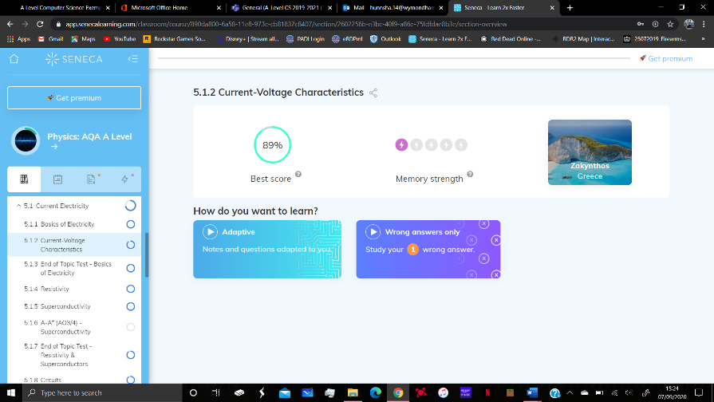

Stakeholder Response to Seneca (Student 1):

Seneca is an engaging piece of software that is interactive, colourful and encouraging. The software is good to refresh memory and also teach the basics of a topic. Overall it is a good learning experience which is definitely useful. There are disadvantages however, one of these being that a premium version of Seneca must be paid for allowing the user enhanced tracking of progress at an expensive price. Another issue is that the questions used are the same regardless of how many times you attempt a topic; this can result in the user simply learning the correct response to a given question as opposed to developing a good core understanding of the subject in general.

Stakeholder Response to Seneca (Student 2):

Seneca is an easy to use website, which allows information to be given then tested repeatedly allowing it to be embedded into the users mind. The information is given in short segments with memorable examples allowing it to be easier for the student to recall the information when it counts by remembering the short pieces of information.

Points to take from Seneca:

**Advantages of using Seneca**: It is very quick to access and offers a quick refresher for a topic. It shows your progress for specific topics and sub topics. It allows you to review questions you got wrong. It is also an interactive experience with interactive panels and colourful animations.

**Disadvantages of using Seneca**: The review of the questions you got wrong are not then followed by a similar but different question, you simply move onto the next topic giving you the false impression that you have completed that topic in depth when actually some further revision may be needed.

* **MyMaths**: Unfortunately my maths is maths focused and doesn’t offer a physics section. It is a very good website used for maths students from year 7 to 13. It allows students to choose topics to revise but also for teachers to set work. When teachers set work the student has to complete this by a certain date. You also only get one chance at the questions. If you get them wrong then you can close the tab and start again but the questions are completely different. This is effective as it means that the student can’t keep guessing the answer and are eventually going to have to admit failure if they can’t complete the questions. This means their score is less than 100% and teachers can use this to monitor progress and offer the student help if they are struggling.

This is the score for the section the student is completing. They then have to click mark and the score is then registered. If the student quits or refreshes the page the questions change completely. The score is only registered to a database once the student checks out.

The website uses pictures to try and make it seem more inviting and eye catching. However they are often unrelated to the topic and make no sense therefore are of little benefit.

The questions show roughly what kind of marks the question would be worth if it was an actual exam which is useful for students to see the difficulty of the question compared with the marks that it is worth.

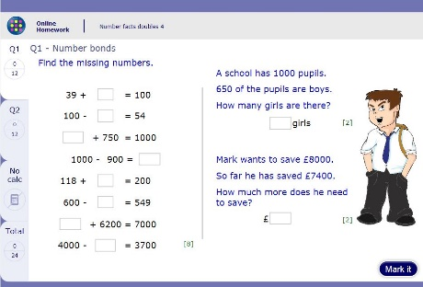

Stakeholder response to MyMaths(Student 1):

MyMaths is far from the optimal educational resource. The user interface is lacklustre; it is clearly aimed at a much younger audience and as a result fails to engage the user. The questions are often different so do allow the user to develop a good understanding of the topic but due to the UI design the user does not remain engaged and often discouraged. The questions do suggest the marks they would be worth in a test which is helpful . Once again, however, the graphics leave much to be desired specifically as they are very often not related.

Stakeholder response to MyMaths (Student 2):

MyMaths is partially useful. Although it has completely irrelevant pictures, MyMaths helps gain the basic idea of what the topic is, which can be used to answer some of the longer and more complicated questions. On the other hand, the questions used are quite often very different to what actual questions are in exams, making it often difficult to see when to use the skills acquired and resulting in it being harder to use.

Points to take from MyMaths:

**Advantages of using MyMaths**: MyMaths is an effective learning resource, teachers can set homework and tasks for students to complete and monitor their progress. I am hoping this will be an aspect of the game I create. It doesn’t allow a trial and error method for students to complete questions and so it stops them from cheating and learning nothing.

**Disadvantages of using MyMaths**: Can seem boring or tedious as the website is quite dull and simply lists questions meaning it is not an interactive experience. Also often has completely unrelated pictures which can be distracting.

**Asteroids:** Asteroids is an arcade classic which tasks the user to survive as long as possible by destroying asteroids on the screen. In the game the user plays as a triangle which represents a rocket. This rocket is able to move around the screen by thrusting and it also has the ability to shoot the asteroids that are in ‘space’.

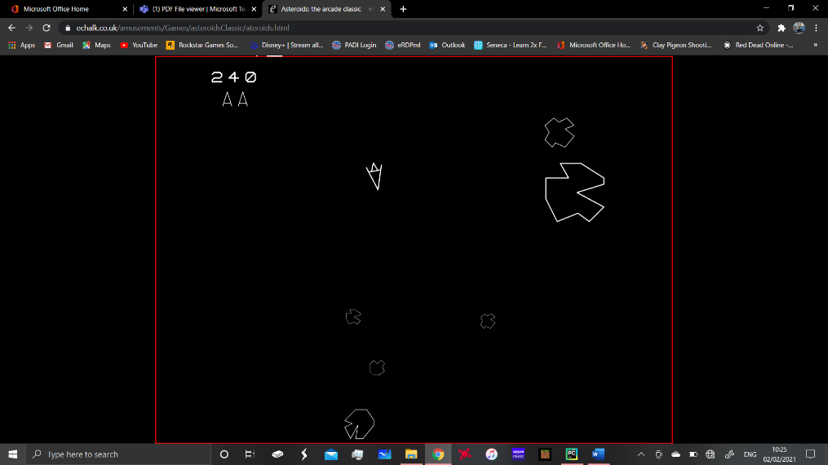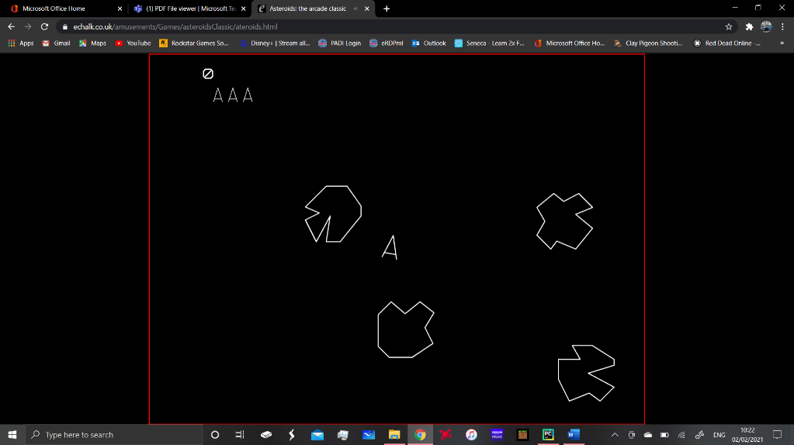Here is the rocket in its normal state (not thrusting) and some asteroids around it. I really like how the asteroids move around the screen randomly and respawn if they exit the screen I think this is an excellent feature for this survival game. I also like the score counter in the top left that tells the user how well they are doing. The mechanics of the game are also very good, when you boost you move in the correct direction at a decent speed. If you turn through an angle the speed is then a component of the two speeds and you move appropriately, this approach makes the game more realistic. However the objective of my game is slightly different and mimics more of a real life situation. As my rocket will be landing on a ‘moon’ I will be including a gravity element in the game which this does not have. The rocket is also able to slow down to a stop if it runs out of momentum which is a bit unrealistic and I would like to do this differently in my minigame as well. The mechanics of my game will mimic that of orbiting the moon or being close to the moon’s surface with little gravity which the rocket is easily able to overcome.

The second photo shows the rocket in ‘thrust’ mode, the smaller triangle represents flames which I really like, it gives the user a clear indication of what they’re doing and the direction they’re about to go in. It also shows that their button clicks are having an effect.

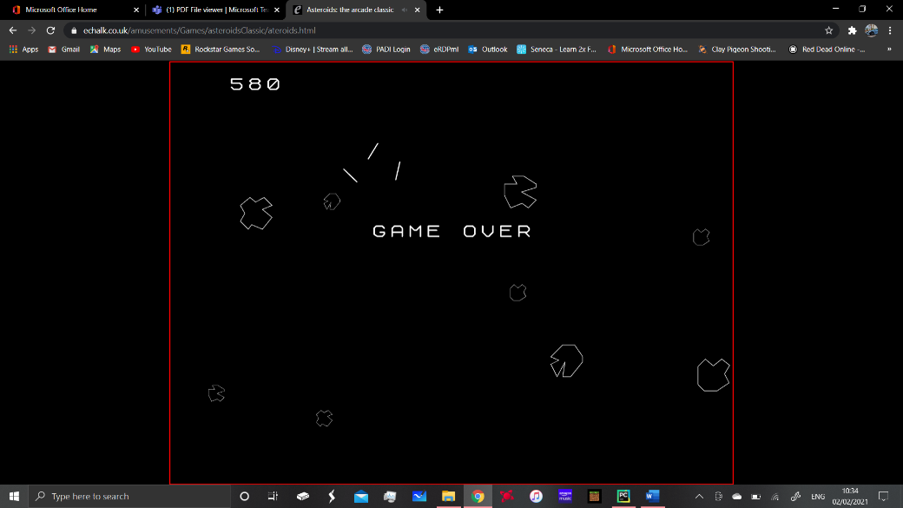As you can see once you’ve crashed 3 times the game tells you it’s over and the rocket breaks into pieces. I like this feature and I think it could be used in my own game, however I would like my game to be a bit more graphically advanced but I do think that the asteroid game is an excellent base and starting point which has some excellent features. After this it also gives the option to start a new game and I think my program would have this option but to go back to the main menu instead. This way the student can see where they now place on the leader board and choose to have another go if they aren’t happy with the result.



**Features the Program Should Include:**

Using my research and the initial project idea it is clear that a number of features are essential for the program to be useful and for it to be a success. The increased use of home learning also impacts the importance of some of the features and how they are implemented. The key features are:

* + - The program must be engaging and help the students to consolidate their knowledge. This can be done using careful selection of questions. The questions will be multiple choice but it won’t be immediately obvious which is the correct answer. The minigame and leader board reward systems will also ensure that the student can properly engage with the program in order to improve their learning and compete against their peers.
    - It must be challenging so that the game cannot be easily completed. This can be achieved by using questions that the student is not allowed to become familiar with. It can also use challenging questions and the questions can be changed monthly by the teacher to promote competition and to keep questions up to date with topics the students have covered. It can also be changed if the students are finding the program too difficult.
    - Questions need to be randomised to prevent a trial and error approach to questions. This prevents the same question coming up twice meaning that answers can’t be memorised or guessed until the correct answer is found. Only a correct answer will increase their fuel and score levels.
    - Demonstrate progress to the student and their teachers. Through the use of a leader board the top 3 students can be shown. The teacher will also have access to the database which will show the data of all the students, this can then be used as part of a wider database which tracks their progress over a year if the questions changed monthly for example.

**Limitations of the Proposed Solution:**

I believe that the main limitation of this solution is that the questions are multiple choice, this means that there can be an element of luck in the program. It would also be difficult to measure how good the user actually is at the subject as they could get a question correct by chance. There is also one form of the minigame, while it would be nice to include different levels and sprites there isn’t enough time in order to do this. There might also be an issue comparing students from different ability groups as the questions all come from the same file, unless they could use separate files for separate classes this could be a potential limitation.

**Requirements of the Solution:**

* + - Software:

The IDE I have chosen for developing the program is PyCharm, it is an extremely versatile IDE which uses colour coding for things such as variables, functions, classes and statements. It is widely used In the industry as it contains many features which make it easier for the user to interact with the IDE. It is optimised for use with the python programming language which is what I am using to create my project. I am familiar with the programming language and it is easy to learn, there is also a lot of information available on the internet in case I get particularly stuck with any part of the program. I have also elected to use the PyGame module for all my game development as it contains all of the methods and functionality I need in order to create the game, the menus and graphical user interfaces. For sprite creation I have used a website called Piskel which is free to use and allows you to export your designs as PNG images. This allowed me to create basic sprites which weren’t copyrighted and could be adapted for my needs. In order to create databases in the game I needed to use the SQLite module, this is an extension to Python which allows you to create, edit and maintain databases. In order to view the databases I used software called DB Browser which is available free online. This allowed me to see what the tables I created look like in a more user friendly format which allows me to ensure that they are correct.

* + - Hardware:

The program will not require a high spec PC as this would mean that it would be inaccessible in most school environments. It will not require much main memory to run, therefore the CPU and RAM requirements won’t be too high. The only other requirements will be a monitor, mouse/touchpad and a keyboard to input account information and to interact with pygame. These hardware requirements are very basic making the program hopefully as accessible as possible.

Computational Methods:

* + - **Thinking abstractly**, on a user level they are not going to see how the game works or any of the code needed to make it work. The minigame for example is completely visual meaning the user is presented with something they control and an environment for it to interact with. This requires the use of sprites for the characters and environment which are clearly different from each other, it also means the code to control these sprites should be so that the user is able to easily control them and the game is not too easy/difficult. Any menus in the program should have a GUI which the students can interact with, using visual pointers and aids which enable them to use it easily.
    - **Thinking ahead,** In order for the user to know what’s going on in the program I will need to include things such as messages in the game. This could be in the form of score counters, error messages as a result of validations and game over messages. This will ensure that the user is able to continue using the program and don’t get stuck. Before the game they also might need a screen to show the controls and how to actually play the game. These will most likely use the arrow keys as they are very self-explanatory and people who are not into PC games may find it easier.
    - **Thinking procedurally and logically**, In order for the program to be successful the quiz must work as intended with the user clicking their answer and the next question being displayed, the score counter should also be incremented as needed. The minigame should contain the functionality for moving the player around on the screen, interacting with the environment and also an ending.
    - **Thinking Concurrently,** In order for the program to be efficient some processes will need to happen concurrently, this includes the movement of the player on the screen and the depreciation of the fuel levels. This allows the fuel level to go down when the player presses the thrust button and these processes happen at the same time. The fuel level indicator also goes down as the fuel level decreases. Another concurrent process is the detection of inputs in the menus and quiz whereby the program checks each frame if it receives an input from a mouse click for example.

Success Criteria:

1. The program will require the user to first create an account or log in if they already have one. After this the program will register any required data to the username of that account. This allows them to log their data to their own accounts. This is necessary as the learning process should be ongoing and should show continuous improvement. The student should be able to see what they have achieved and then work to improve their score.
2. The main menu will allow the student to select what subject they would like to revise. By including multiple topics in the program it is not limited to just one topic in a subject or even just one subject. The program can be easily adapted and used for any topic or subject.
3. The user can begin the game with the topic they have chosen selected, the game will be clear and provide instruction as to what the student needs to do. When it comes to answering questions the options will be clearly shown. The student should be able to easily interpret what is going on in the program and what is required of them. The topic selection should also be clear enough so they know what they have selected.
4. The questions in the quiz will randomise each time so that that out of the topics selected no two questions are the same, questions will also be removed from the list in order to prevent repeats. This prevents a trial and error approach to the questions, it also means that per quiz each question can only be attempted once.
5. An indication of the correct or wrong answer will be shown when the student chooses an answer. A correct answer will increment score counter in real time. The student should be able to see how they’re doing in real time meaning their score updates each question, this Is necessary to show the student how well they are doing at any point.
6. The score from the quiz should feed into an interesting real time minigame which provides motivation to do well. Younger students often are motivated by reward, by initiating a minigame after they’ve completed the quiz they will have a type of reward for their efforts.
7. The data is fed into a database which is used to display a leader board for high scores for that month, this allows students to compete in order to improve their knowledge and get better scores than their friends. This builds on the reward system whereby the students can be rewarded for their efforts. This could encourage them to always improve and practise to get better.

Design:

Decomposing the problem:

In order to have a chance at making the project manageable I will have to break the proposed solution into separate modules. There will be 3 main modules comprising the quiz, the minigame and the main menu. There will also be a database module which provides the other modules with the ability to load and save data.

Description of the Solution:

The design of the various parts is pivotal in this part of the project, this section breaks down these individual parts that make up the whole solution. There will be abstract ways of showing algorithms and basic functions where appropriate in order to convey the solutions more easily. I will be using the pygame module on python in order to create the game and the quiz. This is because pygame is a widely used module which makes it straightforward to add graphical elements to a program as well as providing keyboard and mouse control inputs. In order to make the program maintainable and to reduce the amount of code in each file I will be using a modular programming technique. This involves decomposing the main problem into several sub problems which exist as different modules. These interact with one another to create the overall program.

Main program

Main menu Login System

Minigame

Quiz

Database

Creating a GUI

Creating 2D environment

Displaying answers as multiple chocie

Loading from a CSV

Using SQL for database manipulation

Using Validation and saving to the database

Functions for fetching data, updating data and adding data to/from the database.

Allowing a user to select an answer and checking if it is correct.

Creation of players and obstacles, clear objective.

Using button class for GUI

Use quiz input to alter the difficulty of the game.

Linking the quiz to the minigame

Using database functions to fetch data from the database for the leaderboards.

Movement of objects on the screen.

Using a button class to create button objects.

Collision detection

Player Class

Design of Modules:

**Introduction:** When designing any features for this project it is imperative that the stakeholders and target market are considered. This means making all features accessible and easy to use for them. This will affect how every part of the program looks and functions, if it is hard to use people are likely to lose interest quite quickly. This would defeat the object of the program as it is designed to engage students in their learning and increase interest in the subject.

**Main Menu & Login Screen Design:**

Below is an example of what the main menu and login screens could look like, the login screen is the first module that the user will see, they will first have to login to access any other parts of the program. This is because if I am registering their data to a database it would be difficult to store values for people with no username to store the values against. The data would be random in the table and not related to a username which is an issue when it comes to collating the data and presenting it. The example below is a straightforward GUI which could be easily interpreted by people who are using the program. It is much more self-explanatory than a text based interface would be which is why this kind of interface is so useful and user friendly.

Revise - Login

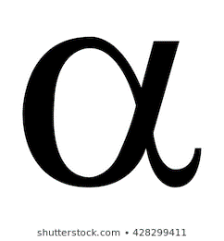

**Username**

**Password**

Image

Image

**Login**

**Create Account**



Topic

Topic

Topic

Revise – Main Menu

Start Game

Picture

Leader board

* Features of the login screen:
  + Interface for users to type into
  + Create account function
  + Login with existing account function
  + Validation of account information
* Features of the Main Menu:
  + Topic selection function
  + Start game option
  + Leader board linked to database
  + GUI which is user-friendly
* The pygame module provides some useful tools for creating a GUI such as this, for example using rectangles which users can interact with using mouse and keyboard inputs. There can also be indicators to show which options you have selected. There would also be a login screen linked to this which would use type face boxes so that users can create accounts and also login to existing accounts, this allows people to have data saved to an account and will help later with the leader board feature. Using a GUI is much better than a text based interface, especially in a WIMP format which people would be far more familiar with, this makes the program more accessible and easier to use. This links back to the stakeholders as they are GCSE students and are more used to having an interface such as this.
* Use of object orientated algorithms allow you to create button classes which can then create objects with their own attributes which can be specified when they are created. This allows for easy editing if I wanted to change a colour or the size of a button for example. This makes the buttons flexible in their design while having some pre-defined properties that they must have.
* The login screen includes buttons which have labels which clearly show their function, it will also need validation features which send requests to the database. This is because you don’t want duplicate usernames and invalid data inputs being allowed into the database. It uses an algorithm that compares the data entry to the data in the database and also checks that the data entry is valid, this means that the user cannot create redundant data such as a blank account. The validation also needs to reflect that which you would see in industry. It needs to tell the user why their entry is invalid and make it clear how to make their entry valid, in order to do this usernames and passwords must be of a certain length which is predetermined.

**Login System Flow Chart:**

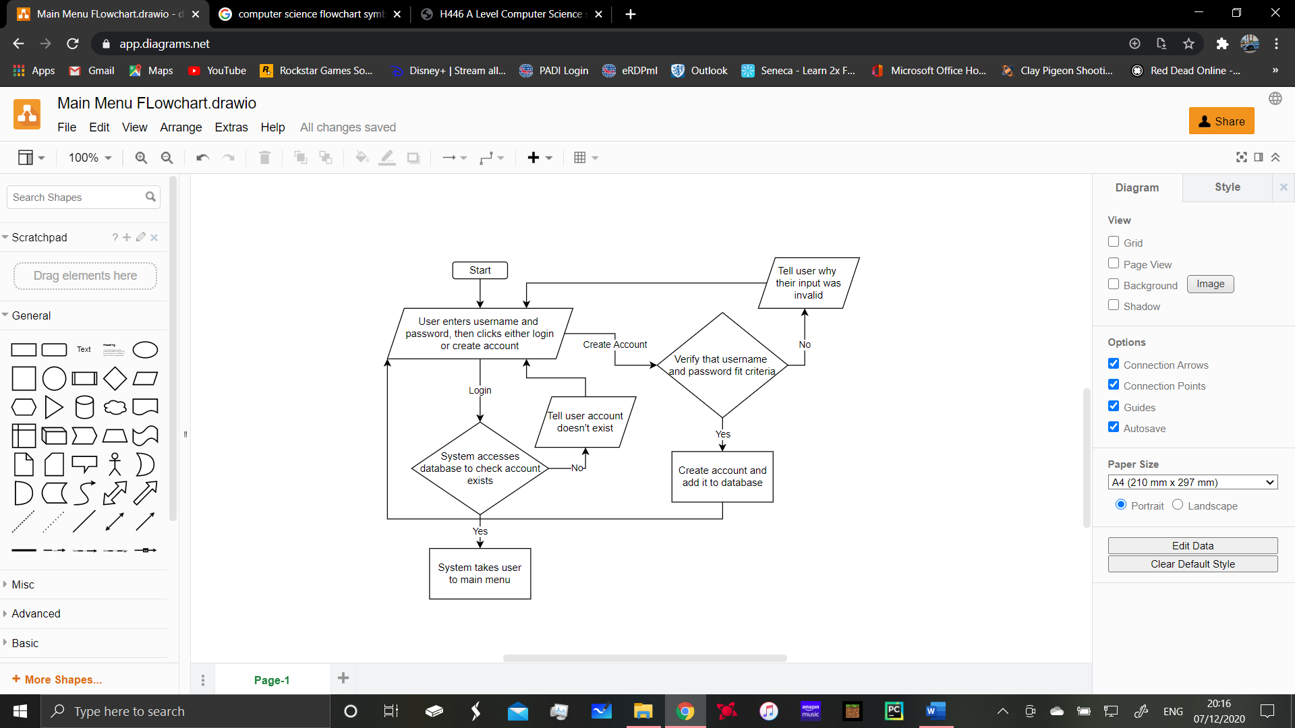

**Main Menu Flowchart:**

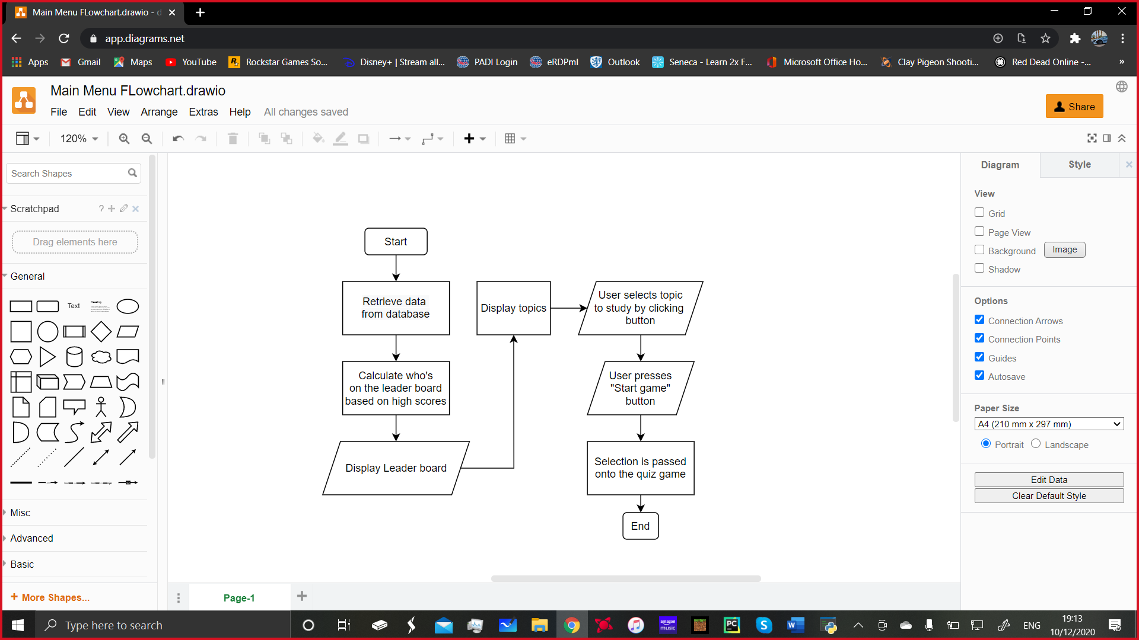

**Validation and Saving to the Database when the user creates an account Pseudocode:**

FUNCTION register(username, password)

IF length of username < 3 or length of username > 10:

display text “Username must be between 3 and 10 characters”

IF length(password) < 5:

display text “Password too short, must be >= 5 characters”

connect to database

values = (username)

checkusernameexists = (SELECT * FROM users table WHERE username = values)

IF checkusernameexists != None:

display text “Username already exists.”

close database connection

values = (username, password)

adddatatotable = (INSERT INTO users table VALUES (?,?), values)

commit changes

close connection

display text “account successfully created

The purpose of this pseudocode is first to check that the username that has been entered into the text box doesn’t already

exist in the table, this is an extremely important piece of validation as databases cannot have repeating data. The username is also used as the primary key in the table which means that it cannot be repeated or the program will not be able to access data based on the username. This is what will need to be done for the leader board system. If it is found to be okay then the data is put into the table, then the changes are saved to the database to ensure it’s integrity. If there is a problem with the data entered into the text box then an appropriate error message is sent to the user on screen so they can see what is wrong. If they create an account and the changes are saved to the database the user is also informed of this success.

**Button Class:**

|  |
| --- |
| Class: Button |
| Attributes: Rectangle = Integer, Text = String, focus = Boolean, |
| Methods: Draw(self), |

This is the class diagram for the Button class, it contains some attributes that the button will have. As the program develops it may evolve and need more attributes and methods to increase its functionality. This means that it can be adapted to the situation it is needed for, this is done by adding more attributes and methods so that it can do more things in the program.

This function is used in the main menu to utilise the fetch function shown above:

FUNCTION getleaderboard

button height = 100

button width = 200

leaderboard_buttons = []

FOR topic IN TOPICS (TOPICS is a list):

leaderboard = fetchfromleaderboard(topic)

IF len results > 0:

CREATE leader board topic button

Leaderboard_buttons.append(topic button)

ENDIF

FOR i IN range 3 – len(leaderboard):

entry = leaderboard[i]

button = Button(STRING(i+1) + entry[0] + STRING(entry[1]) + Button attributes)

leaderboard_buttons.append(button)

ENDFUCNTION

The result of this function is that for each topic buttons are created, the first being a label for the topic, the next buttons that are created contain the username and score for the user for that topic. This means that each button will display the username of the top 3 scorers, their score and their position on the leader board. The function will only create the buttons if there are entries in the database which correspond with the information it is trying to fetch. If there are less than three entries it still creates the buttons for the entries that are there, it just will not create an empty leader board.

**Links to success criteria:**

The main menu and login screen have been designed to satisfy success criteria 1, 2 and 7. Success criteria 1 is focused on the login system which I have shown, it uses the buttons for data entry and for the login and register buttons. These buttons are all linked with the database and can be used to update and register accounts, as well as validation and fetching of data for logging in. The topic selection has been designed as part of the GUI and features interactive buttons which can be clicked on to toggle which topic the user wants to study. The leader board system has also been designed, showing the function which fetches the data from the tables and the way in which this function is used. These may be altered when it comes to developing the program but the initial designs are now in place as a guideline for this.

**Quiz Design:**

The quiz is another important feature of the program as it forms most of the program’s main function which is to educate and help people revise. To that effect it needs to be both challenging but also enjoyable, the system I think would work best for this is if a teacher was able to set questions for the quiz as they would be familiar with the class’ ability and the kinds of questions they’d be used to. Through the use of a tab separated value file the teacher would be able to set the questions easily, it makes the implementation of file loading code very simple. It also simplifies the writing of the questions for the teacher as it is simple system to use, they would most likely have a small set of instructions in order to understand how to write the questions so they could write a file that the program could interpret.

**Question File Example:**

Here the question file is shown in a table format similar to what would be seen in Microsoft excel, it can then be exported as a tab delimited text file where each column is separated by a tab character. The final column represents the index of the correct answer, eg. 0 represents the first answer. Each question becomes a question object which becomes part of a list of questions.

|  |  |  |  |  |
| --- | --- | --- | --- | --- |
| What is the capital of Brazil? | Rio | London | Brasilia | 2 |
| What is the capital of England? | Edinburgh | London | Dundee | 1 |
| What is the capital of Spain? | Madrid | Barcelona | Sydney | 0 |

**Question Screen Class:**

|  |
| --- |
| **Class**: Question Screen |
| **Attributes:** Question, buttons |
| **Methods:** mouse_click, draw |

The mouse click method in the question screen class is used to detect a mouse click and check whether it was within one of the buttons which is drawn also as part of the question screen. The draw method is used to draw all on screen elements so they are displayed to the user. The question screen class is used to create the object of the question screen which is displayed as a window in the game. It contains all of the questions and the answers for each question. It displays the 3 answers as buttons and the question as a text surface.

Pseudo Code for quiz game:

FUNCTION quiz_game(topic : STRING)

score : INTEGER = 0

Qsanswered : INTEGER = 0

maxQs : INTEGER = 15

questions : QUEUE of Questions = load_questions(topic)

WHILE Qsanswered < maxQs

Remove next question from queue and display on screen with answer buttons

Wait for user to click a button

IF button clicked = correct answer

score = score + 1

END IF

Qsanswered = Qsanswered + 1

display score

END WHILE

END FUNCTION

* The quiz game is relatively simple, it is a multiple choice design which I think is an optimal design for a revision game. It is not too intense and doesn’t take a long time to complete. This fits in with the original idea to be used as a revision tool as it can be used as a quick memory refresher. This can be used throughout the year as it will still be relevant whether the student decides to compete with other students or not. Multiple choice questions can range in difficulty however this will be up to the teacher writing the questions. Using the queue data structure and randomising the questions means that the student cannot get the same 2 questions in one go on the quiz. The result of the quiz is also stored which provides something to use to link it to the minigame which will be implemented later on.
* Pygame allows me to draw buttons that the player clicks on in order to choose the answer from 3 different options, this is perfect for the multiple choice format. The program will check for mouse clicks and if the click is within one of the buttons, this means that it can register that the button has been clicked on and then distinguish based on the correct answer index if it was the correct button.
* Using a queue data structure is optimal for this application, the questions enter the queue in a random order but are removed from the queue when the question is answered. This means that the questions don’t repeat during the same game. This is optimal as if a question is repeated it would not only be pointless but could give some students an unfair advantage on the leader board.
* The score counter that I have included allows the user to see how many questions they have answered correctly. I could include another screen where this shows the user how much fuel this equates to in the game. This would show the user that the quiz isn’t just for nothing and that they are actually gaining an advantage in the game because of their work.

Links to success criteria:

Part 3 of my success criteria relates to the quiz part of the game and highlights how the quiz should be easy to understand and interpret, I believe that by using a simple system such as this the user will be easily see what they are supposed to do and it is easy for the teacher to implement the questions. The options for the answers are displayed as 3 separate, distinct buttons which are spaced out and the user can click on. Part 4 talks about randomising questions and removing the ability for questions to be repeated. This is achieved using the queue data structure which provides a useful way of preventing repeating questions, I have also included an algorithm which chooses the questions completely randomly from the list of questions that is created. Part 5 of the success criteria is satisfied as the score will be displayed to the user based on the number of correct answers which is giving the student an indication of how well they are doing in real time. This can be done as after each question the score button is redrawn. Therefore the score can be updated by checking whether the student got the question right before it is updated to the next question.

**Minigame Design:**

The minigame provides an extra incentive to do well in the quiz as the player will benefit from getting a higher quiz score. My initial idea for the game is that a player will have to land a rocket on the surface of the moon with a limited amount of fuel. This is how the quiz links to the game as gaining a higher score in the quiz would provide more fuel within the game. The rocket will start at the top of the screen and will be pulled towards the surface via a gravity effect. In order to land safely the rocket must be controlled so that it is upright and not moving too quickly. I will be considering additional elements that can be added in order to make the minigame more challenging.

* This game will involve real time moving elements as opposed to static on screen elements similar to what is used in the quiz. For example, the rocket will move a small amount each frame based on its velocity, which is affected by gravity and by the player’s control inputs from the keyboard. There will be a main game loop which continually updates the positions of objects in the game and then draws them on the screen.
* The game I have in mind has the classic 8 bit graphic style, this makes it easier for me to design things for the game and it is easier to make the game look good rather than including lots of detail. Here are some objects I designed for the game which display the style of the game.

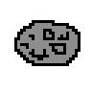

* In order to ensure that the controls are easy to understand I will be using the arrow keys as these are commonly used for simple games like this. It means that any student can use it and it doesn’t take long to get used to the controls. I think the arrows are better than WASD for this game as it is self-explanatory and reduces accidental key presses on other keys.
* The theme of the game relates to the topics that are in the quiz and there are things such as gravity in the game which affect the user in a similar way to how it would in real life although this is an abstracted 2D view.

**Player Class:**

|  |
| --- |
| **Class**: Player |
| **Attributes**: Position = INTEGERS, velocity = FLOAT, Direction = FLOAT, Fuel = FLOAT, Sprite = IMAGE FILE, Mask = SELF |
| **Methods**: Update(self), Draw(self) |

**Update Method:**

FUNCTION update(self):

IF player has crashed or landed:

Return

Key = get key input

IF key is right:

Rotate right

IF key is left:

Rotate left

IF key is UP

Activate thrust, decrease fuel

Velocity on Y axis = downwards (gravity)

Self.rotated_image = rotate the image by the same angle calculated after the button press.

angle ok = check if angle is in allowed range

speed ok = check if speed is within an allowed range

IF angle ok AND speed ok:

Landed = True

Velocity set to 0 so rocket cannot move

ELSE:

Crashed = True

Velocity set to 0 so rocket cannot move

ENDFUNCTION

This update function will have to be applied regularly in order to update what is going on on-screen, in the success criteria I have stated that the minigame will be real time so I will be implementing a system in order to use frames and calculating frame rates in order to make the game work in real time. This means the update function will be run each frame in order to display the correct things on screen, this means when the user starts to rotate the rocket it is instantly rotated on the screen, there will be a negligible amount of time between the button being pressed and the actual action happening on screen. The same goes for thrust where the user will be able to instantly react, this is important as I intend to add in obstacles in the form of asteroids and these will be moving across the screen. The user will need to be able to react to these obstacles in order to land and win the game. This kind of game is also more appropriate for the target audience which is teenage students. It will be engaging and interesting and doesn’t require much reading or time to become familiar with the game.

Pseudocode for Minigame Example:

FUNCTION rocket_game (quiz_score : INTEGER)

max_fuel : INTEGER = 100

fuel : INTEGER = 25 + score * 20

IF fuel > max_fuel THEN

fuel = max_fuel

END IF

Set player position to top of screen

Set player velocity to 0

Set player rotation to be upwards

quit : BOOLEAN = False

WHILE NOT quit

IF left or right arrow keys are currently down THEN

rotate player in the corresponding direction

END IF

IF up arrow key is currently down THEN

Apply a small change to the player’s velocity based on the direction they are facing

Decrease fuel level by a small amount

END IF

Apply gravity to player velocity

Apply player velocity to position

IF player goes off the side of the screen THEN

Place them back onto the screen

END IF

IF player Y position is within landing zone THEN

If speed and angle are ok for landing THEN

Player has landed

ELSE

Player has crashed

END IF

END IF

IF player has crashed THEN

Display button “Crashed - game over”

ELSE IF player has landed THEN

Display button “Landed – game over”

END IF

IF player clicks game over button THEN

Quit = True

END IF

Display fuel gauge

Display player

END WHILE

END FUNCTION

Asteroid Class:

|  |
| --- |
| **Class**: Asteroid |
| **Attributes**: Position = INTEGERS, Direction = FLOAT, Velocity = FLOAT, Sprite = IMAGE FILE |
| **Methods**: Update(self), Draw(self) |

Pseudocode for Asteroid Update:

FUNCTION update(self)

Velocity = x

Position = position + velocity

Image_pos = check that image in the correct position

Collision_surface = create surface for collision detection

IF collision_surface touches rocket collision surface

Player has been hit by asteroid, crashed = True

IF the asteroid exits the screen:

Respawn asteroid in an appropriate place

END FUNCTION

The use of this table and pseudocode will allow me to correctly set up my asteroid class, ensuring it has the necessary methods built into it so that it can perform the functions I intend it to. This includes being able to interact with the player and altering the course of the game. I could also make a variable difficulty setting using asteroids whereby the number on the screen and the velocity they have can be changed by setting the game to a different difficulty setting. The actual asteroids will be in a similar style to the game and will be realistic in their design both in terms of their motion and how they look.

Links to Success Criteria:

The minigame that I have designed here takes the score from the quiz and equates that to an amount of fuel in the game therefore giving the student who is playing the game a sense of reward. This links back to success criteria 6 which is used to describe how the game should be influenced by how well the student does in the quiz. The aim of the game is to get as much fuel as possible so the rocket can move around more and increase the likelihood of the player surviving. This should motivate the students to do well because they will want to show their friends that they can land the rocket, I could also implement another leader board feature which solely focuses on the minigame and who is best at completing it, it could take the number of landings and the number of crashes and display this as a leader board on the login screen or main menu. Using an object orientated approach is perfect for this kind of game as I can create objects easily using the classes as a blueprint and manipulate these easily. Each thing on the screen can exist as it’s own object which makes the program maintainable as long as sensible class and attribute names are used.

**Database Design:**

The purpose of the database is to store the users data, for example their usernames and passwords and scores for each topic. This means that it can be loaded into the game when needed for the leader board function for example. In order to create the database I will be using SQLite in python, this allows you to create and manipulate databases in python. The database will be its own module in python which can be imported by the other modules when needed, this means that code is not repeated every time you want to access the database or edit it. The values that will need to go into the database are shown below. However this is in the 0 NF meaning that there is repeating data. The following tables show the normalisation.

|  |  |  |  |  |  |
| --- | --- | --- | --- | --- | --- |
| **Username** | **Password** | **Crahses** | **Landings** | **Topics** | **Scores** |
| Bob | 1234 | 1 | 4 | Maths  Physics  Computing | 6  8  6 |
| Sam | letmein | 6 | 3 | Maths  Physics  Computing | 5  6  4 |

Users Table:

|  |  |
| --- | --- |
| **Username** | **Password** |
| Bob | 1234 |
| Sam | letmein |

|  |  |  |
| --- | --- | --- |
| **Username** | **Topic** | **Score** |
| Bob | Maths | 6 |
| Bob | Physics | 8 |
| Bob | Computing | 6 |
| Sam | Maths | 5 |
| Sam | Physics | 6 |
| Sam | Computing | 4 |

User Scores Table:

The table is split into two with the first being the table that stores the users credentials, username is the primary key for this example and will be for the actual program. In order to avoid having 2 usernames that are the same the teacher would have to ensure that the students each had a unique username, possibly made up from characters from their first

and last name and their birthday. It is highly unlikely that 2 students would have the same first and last name and the same birthday. Password is not dependant on username so this table is normalised. The second table is not normalised as we have some repeating data where one username can take multiple subjects however for this project where the numbers of people accessing the database will be quite small this is appropriate as it won’t massively decrease the performance/transaction times of the database. The user scores table uses a compound primary key consisting of username and topic, this is because it then makes each attribute unique, it means that the data is in fact not repeated as it is combined with the topic attribute. This system should work for a database of this size however I recognise that it is not an ideal format for the database to be in, it will however be appropriate to use. I will be using the sqlite module in python to implement the database as it is easy to use, however it would not be appropriate for a larger scale program such as an online version that millions of people could access.

**Microsoft Access Representation:**

Users table:

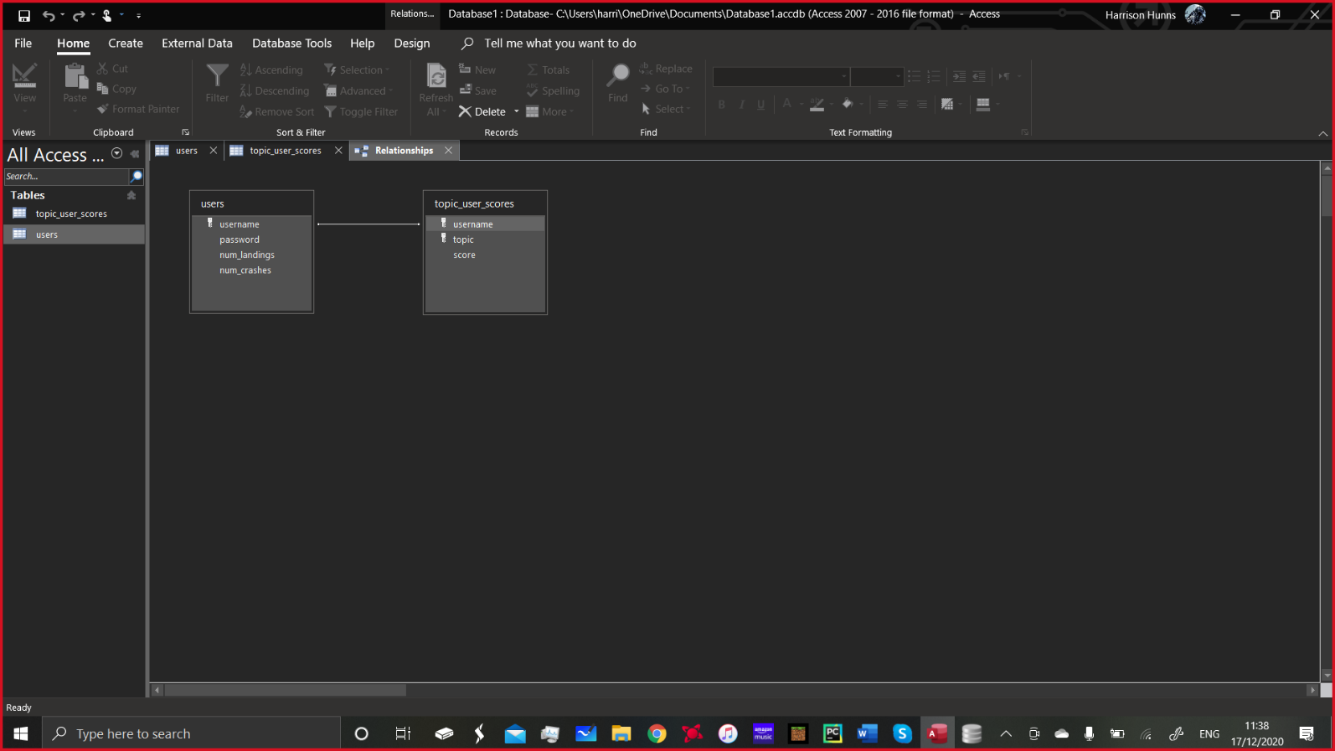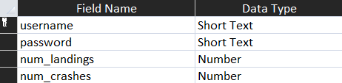 Entity relationship diagram showing primary keys:

User scores table:

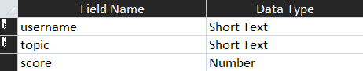

**Database Setup Function:**

FUNCTION setup database():

CREATE TABLE USERS (username PRIMARY KEY NOT NULL ensure length of username is 3-10 characters, password NOT NULL check length of password is more than 5 characters, num_landings, num_crashes)

CREATE TABLE user scores (username TEXT NOT NULL, topic TEXT NOT NULL, score INTEGER NOT NULL, PRIMARY KEY (username, topic)

Save changes

END FUNCTION

This function is used to set up the tables, there are two tables as shown in the visual database representation, this code can also be replicated in python using SQLite meaning I now have a basis to work on for setting up and creating databases in python. There will be several functions using SQL commands which will be used in the program. For example in order to create a leader board on the main menu I will need a function in order to select the data I need and to order it in descending order.

**Using the Database to Create a Leader Board:**

This function would be used in the database and combined with the code shown earlier in the main menu:

FUNCTION fetchfromleaderboard(topic)

connect to database

value = topic

execute (SELECT FROM topic scores table WHERE topic = ? ORDER BY score DESC, values)

fetch results

close database connection

return result

END FUNCTION

Links to Success Criteria:

The database is a useful tool which can have many applications and functions. For example my plan is not only to allow users to create accounts and save data into the database but also to enhance their learning. This is done through the leader board system and through data collection as the teacher would be able to check the class database and see how well the student is doing in the quiz and how many times they have attempted it. This can highlight any uses that the student may have in order for extra tuition to take place for that topic if some students are struggling. The database is also where all the user accounts are stored along with their scores for each subject. This means that they can be stored in a singular file with multiple tables rather than having separate files for account info, scores etc. In order to view the database in the development I will be using the program DB Browser which is freely available on the net. This program allows you to open databases and see an abstracted version of the tables. This means as a developer it is much easier to see what data is being put into the tables which I have created. If the program was to be used for class work and the teacher needed to check the class database a similar program would have to be used for them to understand the data, similar to the spreadsheet system commonly used in schools at the moment.

Identifying Test Data

In order to test the program I need to set out the development phases and what each phase intends to achieve. Currently there are 4 modules or main parts of the program which are broken down into smaller sub sections, these will constitute to phases in the development of the solution which can be completed chronologically and be combined to give a final solution. I will begin by developing the main two parts of the program which are the quiz and the minigame. The quiz can be broken down into stages, firstly the quiz will need to be set up using pygame which will allow me to create interactive screens which can display text and colours and create a GUI. The quiz will be the first development milestone, the second will be the completion of the rocket game. The next big task will be creating menus, implementing a GUI which is easy to interpret and creating a login system. The login system will use validation which will need to be tested thoroughly to ensure that invalid data cannot be saved in the database. In doing this I can also test the database using the DB browser application to check that data is being saved correctly and then that the program can access the correct data from the database when required. The functionality of the buttons can be tested when buttons are created on the screen using the different attributes, the buttons should behave as the user expects them to and draw correctly and in the correct position on the screen.

Quiz Test Data:

|  |  |  |
| --- | --- | --- |
| Test Number | Test Aim | Expected Result |
|  | When game begins the quiz shows questions from the selected subject. | Appropriate questions are displayed. |
|  | Confirm that quiz proceeds with the next question when an answer is pressed. | The next question is displayed regardless of correct/incorrect answer. |
|  | Scoring is counted correctly. | Score counter incremented when correct answer is clicked. |
|  | Questions are not repeated. | Question doesn’t appear more than once within the same quiz. |
|  | Questions are shown in a random order. | The questions appear in a different order each time the game is played. |
|  | Ensure that all items are displayed correctly on screen. | Text shouldn’t exceed the width of the pygame window or buttons that they are inside. |

Minigame Test Data:

|  |  |  |
| --- | --- | --- |
| Test number | Test Aims | Expected Result |
|  | Check that when left and right controls cause the rocket to rotate. | Rocket rotates by expected amount. |
|  | Thrust control affects rocket’s velocity. | Holding thrust causes rocket to begin to move in the direction it is pointing. |
|  | Determine that correct rocket sprite is shown when thrusting. | Thrust animation is shown when thrust control is pressed. |
|  | Collisions with the ground at high speed. | Hitting the ground above acceptable speed causes crash. |
|  | Collisions with the ground at an angle. | If the angle is past a certain point it causes a crash. |
|  | Collisions with Asteroids | Ensure that when an asteroid hits the rocket it causes a crash. |
|  | Crash effect is shown when rocket is in crashed state. | The crashed sprite is displayed. |
|  | Fuel gauge decreases when thrust is pressed. | The fuel gauge goes down at the correct rate. |
|  | Rocket cannot thrust when fuel is 0. | Check that rocket isn’t affected by thrust if the fuel level is 0. |
|  | Rocket fuel amount is correct based on quiz score. | Ensure that a 100% score is a full fuel bar and that 0% score is the default fuel amount. |
|  | Asteroid trajectories are randomised. | Check asteroids don’t all follow the same path. |

Login Screen Test Data:

|  |  |  |
| --- | --- | --- |
| Test Number | Test Aim | Expected Result |
|  | Ensure username is present when creating an account. | It doesn’t allow an account to be created if no username has been entered. |
|  | Ensure password is present when an account is created. | It doesn’t allow an account to be created if no password is entered. |
|  | Ensure username is of a suitable length. | Doesn’t allow a username to be created with a username of <3 or >10 characters. |
|  | Ensure password is of a suitable length. | Doesn’t allow a password of <5 characters to be created. |
|  | Account can be created if password and username are valid. | Account is created and user is notified. |
|  | Account details can be used to log in to the system. | The user is logged in and taken to the next screen. |
|  | Entering incorrect username or password doesn’t allow the user to log in. | Error message displayed telling user that the username or password is incorrect. |
|  | Focus of the buttons can be changed using tab key and mouse click. | Pressing Tab changes the focus of the button to the next button down or puts is back to the top if it is the last button. If the mouse click is in the username or password then the focus should be put on that button. |
|  | Account can be created or user can log in by pressing enter key. | Pressing enter while either of the text boxes or login is highlighted will attempt to log the user in. Pressing enter on ‘create account’ attempts to create an account. |
|  | Check users can’t make two accounts with he same username. | The program will now allow two accounts with the same username to exist. |

Main Menu Test Data:

|  |  |  |
| --- | --- | --- |
| Test Number | Test Aims | Expected Result |
|  | The start game button performs the correct function. | When start game is pressed the quiz begins. |
|  | Topic selection allows for correct topic to be loaded into the quiz. | When quiz begins selected topic is the one which was focused in the main menu. |
|  | Leader board is not displayed if the game hasn’t yet been played. | The leader boards should not appear if the game has not yet been played as the data doesn’t exist. |
|  | Leader board displays correctly after the first game has been played. | The leader board displays the first user and their score. |
|  | After several games the leader board displays correctly. | The leader board displays each user in the correct place with their score and no more than three users. However there can be less than three entries on the leader board. |

Using this test data it is possible to test each module which the user can interact with. This will enable me to ensure that the user cannot break the program and get away with entering data which is invalid. This ensures that the program continues to run as expected and doesn’t have issues with the user interacting with it. It allows me to test the core functions of the program and also extended features such as the GUI extensively meaning I can fine tune them to get the best results. These tables give me a plan to follow in order to do this and also enforce the modular development style of the program. I can break down each module test table and use screenshots and explanations to show the program working and any problems I encountered.

Database Test Data:

|  |  |  |
| --- | --- | --- |
| Test Number | Test Aims | Expected Result |
|  | Ensure that when create account is clicked an account is created in the database. | When create account is clicked an account with the correct username and password appears in the database. |
|  | Ensure that when log in is pressed the user is logged in with the correct account. | When the user logs in the main menu will display something to tell the user what account they are logged in with. |
|  | When a user has logged in with an account any data is saved to that account. | Any subsequent data such as high scores will be saved to that account and can be seen in the database. |
|  | Check that data in the leader board matches the data in the database. | When compared the results in the leader board should be the same as those in the database. |
|  | Check that when a crash happens the number of crashed should be updated in the database. | When a crash happens the number of crashes should be incremented by 1. |
|  | Check that when the rocket lands the number of landings is updated in the database. | When a landing occurs the number of landings should be incremented by 1. |

Using these test tables allow me to carry out structured formal testing at the end of the development of the program. I can prove that certain elements of the program work. I will use screenshots and written explanation in order to prove that elements of the program work as expected and provide the desired result. Testing is an important part of the development as you need to prove that the program works and satisfies the success criteria. I will do a short evaluation of each stage after the development and then the main testing will take place at the end of the development where I confirm that every feature has been properly implemented an works as expected. After this I can do a full run-through of the program in order to show that all the features combine correctly in order to create the finished product and ensure that the features combine correctly and perform as expected when combined with the rest of the program.

Development of a Technical Solution:

Development Plan:

My program was developed using an extreme programming approach, I developed different phases independently but some parts were developed concurrently. I was able to respond to changes in the requirements of the program and communicate with stakeholders to ensure that the program was still going to be useful and engaging. I used an incremental development approach as it meant that I had the flexibility of changing aspects of the program and making them build upon the last section. Some things were able to be tested independently such as the rocket game however to test the program in its later stages the whole program needed to be run. By doing this however over time I was able to ensure that the program ran efficiently and met the success criteria that I set out, in turn this allowed for improvement in the code efficiency and execution times. Unfortunately due to the current circumstances communication with stakeholders has been difficult however I have included their comments on the system where possible.

Development Phases:

**Phase 1:** Setting up the quiz

**Phase 2:** Setting up button classes and implementing buttons in the quiz

**Phase 3:** Setting up question file

**Phase 4:** Creating 2D environment with moving features and interactive elements

**Phase 5**: Creating minigame which uses score from quiz

**Phase 6:** Creating a login system with appropriate validation

**Phase 7:** Creating database which stores user information and scores

**Phase 8:** Creating main menu with topic selection which feeds into quiz

**Phase 9:** Using database to create leader boards

**Phase 10:** Final Testing

*QUIZ TEST*

*GAME TEST*

*LOGIN SCREEN TEST*

*MAIN MENU TEST*

*DATABASE TEST*

Using these separate phases I will be able to ensure that all success criteria are met and that the program evolves in complexity as it develops into its final form. This means that It meets all functional requirements and maintains a professional standard and finish. As each stage is linked to the next it is difficult to analyse each stage but I will make comments on how I have improved features as I annotate the code. The code was developed concurrently and this enabled me to change things easily as it meant that not all code was permanent such as if I used the waterfall model. Final evaluation will look at the overall success of the program, stakeholders response and the limitations and problems found through testing.

**The Solution:**

I have used Python and the Pygame module to develop my program, this is because there are some extremely useful methods in pygame for creating on screen elements and separate windows. It is also used professionally in the computer science and game creation community. Therefore it seemed to be suitable choice for creating my game, as well as myself having experience with python.

I have used a modular solution with the code split into a number of files, each of which has it’s own function. In total there are 10 files including the text files used for the questions and answers. This fits with my development approach as I can easily edit each file and I know exactly where the code for each section is. Using commenting has also helped me improve the maintainability of the program.

1. main.py – the main file of the program, has minimal code and is used to initiate the rest of the program.
2. menus.py – contains the code for the login screen and main menu code.
3. rocket.py – contains the rocket game code
4. quiz.py – contains quiz code
5. shared.py – a feature I added later in the development to remove some code which was being repeated in all files
6. button.py – my program uses a button class which has functions built into it for representing buttons that the user clicks, text boxes and boxes which can be typed into.
7. Database.py – contains all of the database functions used in the program and the code for creating the database.
8. The .txt files – the 3 files which contain the questions are called topic.txt where topic is the name of the topic.

**Phase 1: Quiz Game:**

Using a top down approach the quiz seemed like the most logical part to begin with. It is the main part of the program and making it multiple choice meant that it was a manageable base point to start with. It also uses parts of the code which I have outlined earlier on in the design section. The main function of the program was the quiz section and so it was beneficial to get one of the main parts conquered before moving onto more complex features. It has been developed to do exactly what the success criteria outlined. It includes some graphical on screen elements as well as loading from exterior files.

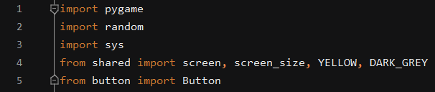This is the first instance where Pygame is imported, this is because I used Pygame’s Rect method to create on screen text boxes which contained the answers to the questions. I start off by importing pygame so that its modules can be used in the quiz, it is initialised in the shared file which is what allows us to actually implement these methods in every file. This prevents the initialise code from being constantly repeated in every file unnecessarily. I have imported random as In my success criteria it says the questions should be randomised, this means that random needed to be imported so that it can be used. Sys is a python module which allows us to interact with the system, it is used for user functionality as I thought it would be a good idea to allow for the game to close if the red cross is pressed. Normally pygame would not allow you to do this and it causes the game to freeze so I added it to make it easier for the users to understand as it is what they’re most likely used to. The screen is defined in the shared file so that is also imported along with the colours needed for the colour scheme of the quiz. The Button is then imported from button as this is the multifunctional text display.

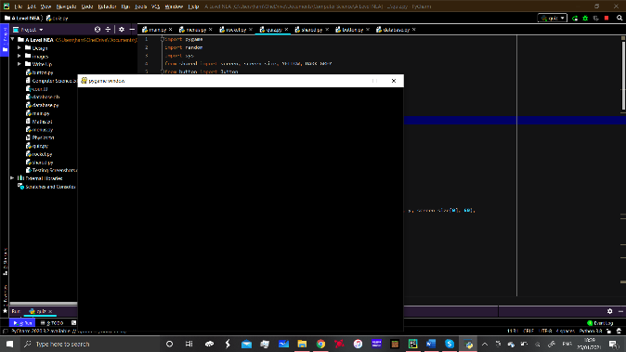This code is taken from the shared.py file and it specifies the screen size and the screen display which is what opens a separate window f or the user to interact with.

Shown here is an example of a pygame window with just a black fill, however you can see that it creates the window which is what all of the on screen elements can now be displayed on. This allows us the opportunity to use this throughout the program now that it works.

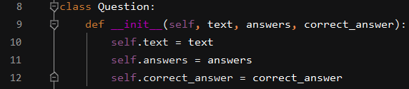 I began by setting up a class for the questions, this would allow them to exist as objects which can easily be manipulated in the game. The properties of the class are easy to understand and show explicitly the function they perform.

**Phase 2: The buttons:**

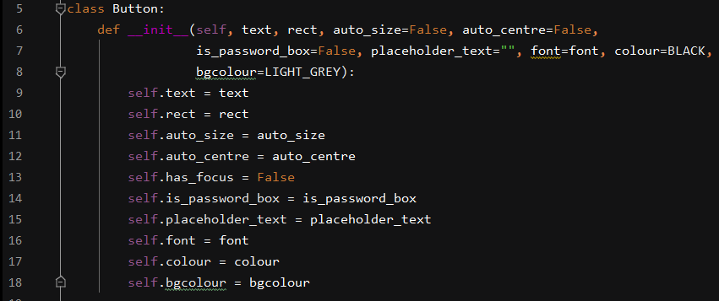

The button class was one of the first things I developed in the program, this is it’s final from showing all the properties it was able to have. The class acts as a blueprint for all the button objects in the game that they are created using. As the game evolved and became more complex the functionality of the button became more. It became a multi-functional device which meant that it was sensible for it to have its own file. By having its own class I could give it more functionality without having to edit every button class in different files. The first property of the button is the text function which allows it to display text, the colour function is the default colour for text in the buttons. The rect property links to Pygames Rect method which is used for drawing rectangles on the screen and the bgcolour property is used to change the colour of the button rectangle. The auto size and auto centre properties are defined using Boolean and link to the function which auto sizes and centres the buttons on screen so that they are an appropriate size. Has_focus is a property I added in when creating my menus as part of the GUI and is linked to functions which place a border around the button if they have focus, focus can be changed by clicking with the mouse or pressing tab, similar to what is seen commonly on web pages. Placeholder_text and is_password_text are used in the login screen for both security and to enhance the GUI by making the function of each box more obvious. The font is also a property of the button as the font can be different sizes when it is used for different applications such as a difference in size of the text for text boxes and titles. Each feature of the button will be more thoroughly explained when I reach the stage of development that it is involved in.

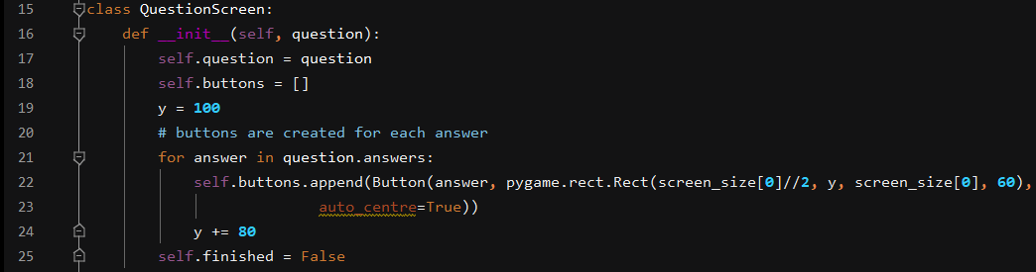The question screen class is capable of using the question object in order to create buttons with the answers on them. It puts the buttons into a list and the y value is how it spaces the buttons out, every button has a space of 80 pixels between them which was decided by eye and looked correct. I also created an auto centre feature which allows the buttons to centre themselves on the screen. This is decided by the Boolean operation auto_centre = True when creating the object. Self.finished is the Boolean variable which checks whether the quiz element of the game is complete. As you can see when the button objects are created the size of the rectangle and the auto centre are both defined as properties of the object.

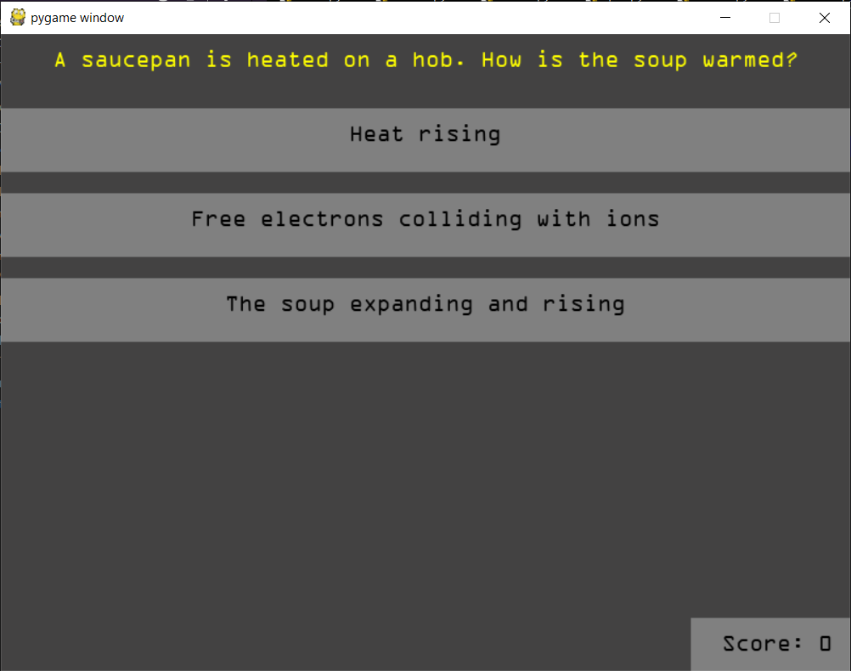This is a screenshot of the question screen which shows an example of one of the questions and the 3 answers provided. The answers are suitably spaced out due to the class above. The question and answers are fetched from code which is later on in the program as these are the classes not the actual objects.

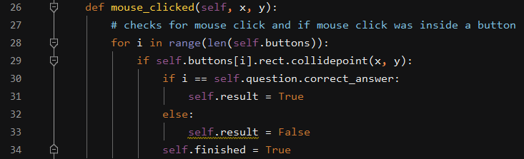

This is the mouse clicked function which is the first function I coded which handles user interaction with the quiz. This function Is for checking the x and y coordinates when a user clicks the screen and is called later on in the program in something called the event loop. However this function is only concerned with checking the x and y coordinates of a mouse click and comparing them with the position of the buttons on the screen. If the click is found to be within one of the buttons the result Boolean is set to true or false depending if the button was the correct answer. Line 30 shows where this comparison is made using an IF statement, the self.finished variable is then set to True so that the next question can commence. It uses the loop in line 28 to check through each button and this function is executed for every mouse click.

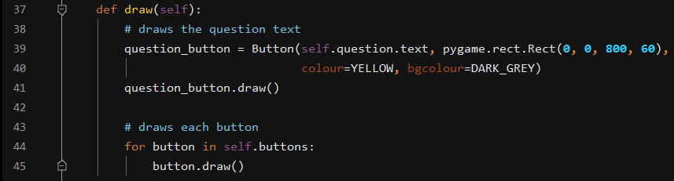

In order to display things in pygame you either have to blit them to the screen or draw them. Things which exist as objects are drawn on the screen. Here I have drawn the question text as a button which is in the top left, it uses the button class where the first 2 properties are the object’s top left coordinates (0,0) means the top left of the screen, the next two properites (800, 60) define the size of the rectangle that the question goes inside of. The colour of the text is then set to yellow as this is different from the default text colour for the buttons. The background colour is then set to the same colour as the background colour of the quiz game so that there is a clear distinction between the question and answers.



This difference is demonstrated here, the answers are in the light grey buttons and as long as the user clicks anywhere within this area that is the answer they select. The question text is also very clear and bold and is a different colour to the background so it can be seen.

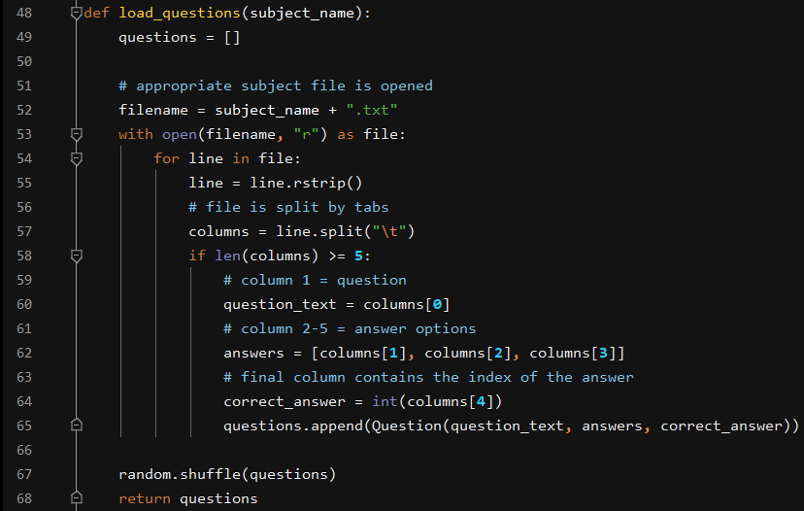**Phase 3: Setting up the Question file to feed into the quiz**

This function is based upon the pseudo code written in the design section for loading questions from a csv file. However I have split my file by tabs because it was easy to implement. As you can see it takes the subject_name parameter which is chosen in the main menu part of the program, it then opens a text file in read mode. The name of the text file has the same name as the subject name which is selected in another part of the program. I then used the r strip method to remove trailing white space characters such as spaces, tabs and new lines. The columns are then split by tabs and the name of each column is specified. Column 1 contains the question and it sets the question to the question_text variable which is used in the draw function, this means the question for that column can now be drawn on screen. The next 3 columns contain 3 different answers which are appended to a list, this list is then used to draw the appropriate answer buttons. I used a system whereby there is a 5th column which contains the index of the correct answer. So this index is then compared with the list to decide which answer is correct. The random.shuffle uses the random module to put the questions in a random order, this satisfies one of the success criteria which says that the questions should be randomised to prevent pattern recognition by the students using the program.



Here is an example of a question file which I’ve used, as you can see the first ‘column’ in the file is the question which will be asked. The answers (4,2,8) are then put into a list in that order. There are 8 bits in a byte so the answer is 8 which in this case is the second item in the list as lists are 0 indexed meaning they count from 0. Therefore the 2 in the final ‘column’ in the text file represents this. This format is used for all 3 topics and for all questions in the program. Line 65 in the quiz program is what assigns the value to the questions which are part of the quiz game function (shown next).

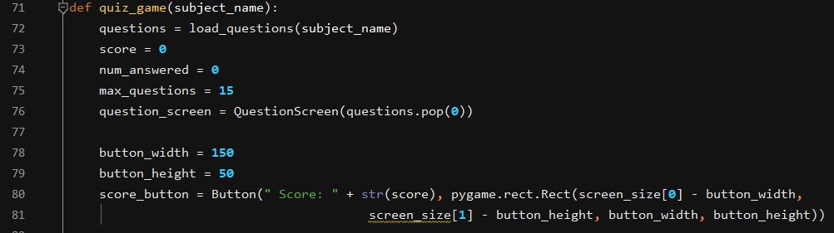

This is the start of the quiz function, it takes the parameter subject name which is decided in the main menu, however when I first coded the game it didn’t have this feature as there was only one set of questions. The questions are then loaded using the load questions function above. Score is set to 0 as they haven’t got a score initially, the same with number of questions answered as they haven’t answered any questions initially. The maximum amount of questions is then set as this corresponds with the rocket game and the fuel level within that. The questions.pop(0) is used to remove questions from the list of questions once the finished Boolean variable is set to True. I decided to add a score display so that the user could see how well they are doing. This involved the use of the Button class with some text in it, it also converts the score to a string which is what displays how many questions the user has got right. The button height and width are predefined and is big enough to fit all the text on it. The button is updated at the same time as the question changes so it runs in real time. It is displayed in the bottom right of the screen.

Here is a demonstration of the score button in action, I clicked the correct answer to the problem and it increments the score by 1. This feature shows the student how well they are doing in real time:

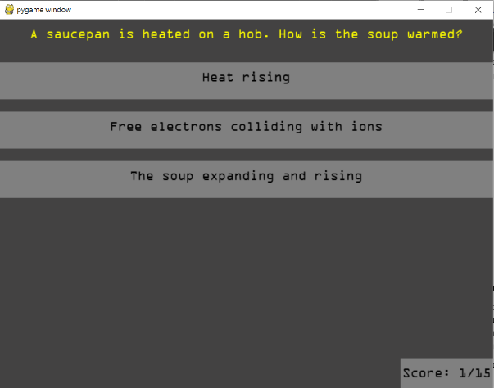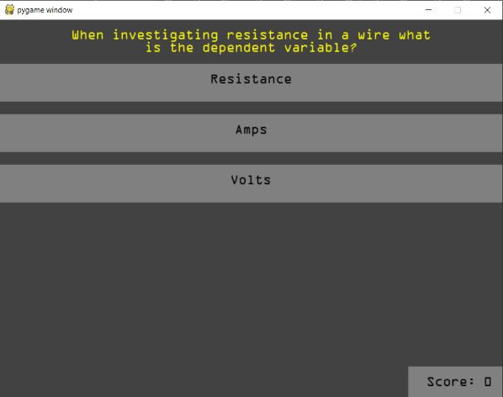

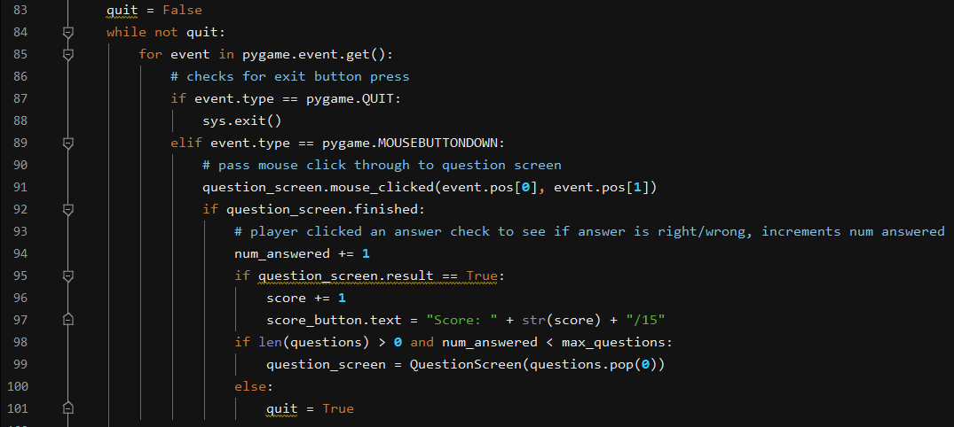

Game Loop:

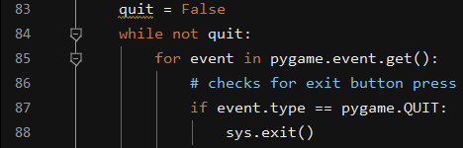

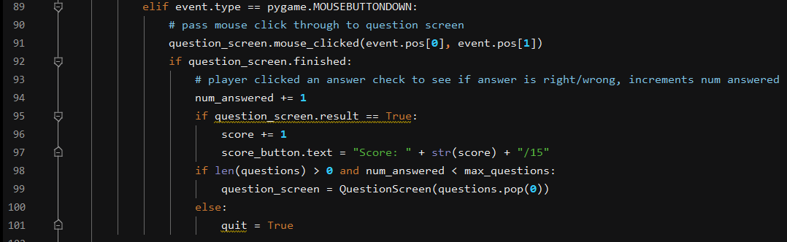This is where the sys module is used that I imported earlier. It is also the first event loop that I dealt with. The event loop is a method in pygame which allows you to check for inputs such as mouse clicks and button presses. Here I’ve used it to say that If the exit button is pressed then the system can end the game. I encountered a problem with this before I implemented it whereby if you pressed the exit button the game just ceased to work and was in an error state not responding. This is a problem because the only way to close the window was to close it in task manager or press stop in the IDE. This is not user friendly and would cause issues. This is where the event loop begins checking for mouse clicks as these are the only inputs for this part of the program. The mouse clicks are first passed into question screen which uses the mouse_clicked function to check where on the screen the click was and whether it was inside an answer button. This event loop also increments the number answered by 1 as whether it is right or wrong there has still been an answer submitted so it makes sense to have this here. The score is then incremented if the answer is correct which changes the text on the score button. This is important as it satisfies success criteria 5: “An indication of the correct or wrong answer will be shown when the student chooses an answer. A correct answer will increment the score counter.” The program checks to see if there are actually questions in the file and whether the number answered is less than the max questions. It then pops the current question from the list so that the next one can appear. If there are no questions remaining in the list then the quiz game quits and the next part of the program begins.

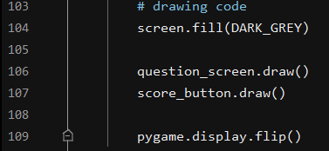This code is at the end of the quiz and is used to draw onscreen elements. Screen.fill sets the background colour of the window to grey. The question screen and score button are then drawn so that the user can see them on screen. Pygame.display.flip is an important function built into pygame which allows you to update the whole screen at once. Without it nothing would appear on the screen.

Possibly one of the most important lines in the quiz game is this one which returns the score at the end of the program. This is important as it means that success criteria 6 can be satisfied later on and the score from the quiz can be passed into the minigame.

Evaluation of Phases 1, 2 and 3:

Having completed the quiz game phases 1,2 and 3 are now complete and function as expected. Having developed this part of the program I have created a basis for the rest of the program to link to. I have also completed two of the success criteria in creating the quiz. They are:

Success criteria 4: The questions will randomise each time so that that out of the topics selected no two questions are the same, questions will also be removed from the list in order to prevent repeats.

This was completed through the use of the random.shuffle when loading in the questions. This means the questions appear in a random order. There are 15 questions in each question file so there is no possible way of a question being repeated unless it repeats in the question file.

Success criteria 5: An indication of the correct or wrong answer will be shown when the student chooses an answer. A correct answer will increment score counter in real time.

Satisfied using the score button which works as it should and updates in real time.

The quiz game is then also able to feed into the rocket game through the use of the line “return score”. This leads to the next success criteria being met which is that the quiz should lead into an interesting and engaging minigame. As the quiz could be seen as the boring part this means that it has the ability to lead into a reward in the form of the minigame. Overall making the quiz a success as it performs well and is efficient. It is also self-contained in its own module which is what I outlined in the design section. This means the quiz is maintainable along with the use of detailed comments and the well named variables, classes and functions. In this case Phase 1 has encompassed both phases 2 and 3 within it.

**Phase 4: Setting up a 2D environment with interactive elements]**

The next stage in the development was one which required me to learn some concepts which were completely alien to me. I decided to create the game the use of Pygame was going to be sufficient as it is used in industry and had most of the features I needed built in as methods. The game took the style of an 80’s style arcade game with 2D basic graphics but still with an element of fun and challenge. I used [www.piskelapp.com](http://www.piskelapp.com) in order to create some of my sprites and on screen details such as the sprites and background. Sprites are the on screen elements which move around and can sometimes be controlled. They are an important part in game creation as they allow you to create things which can be seen on screen and controllable characters. The rocket game was created using an iterative approach and agile development method where new features were added along the way to increase the difficulty and complexity of the program.

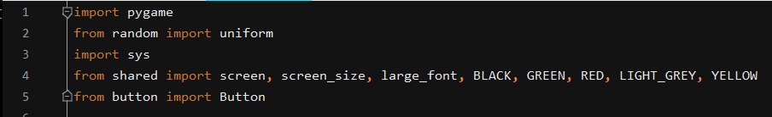

I started the rocket.py file by importing any modules and files that I would need. The pygame and system modules appear on most of the files and their functions were explained in phase 1. Line 2 is used to import the random module, although I needed to use uniform which is a specific function of random. Uniform allows the user to specify that a random value should be chosen from a range of values. It then imports the screen, screen size, font size and colours from the shared file and Button from the button file as the button is used at the end of the minigame. These are all of the tools and modules needed to create the 2D environment, Pygame being the main one.

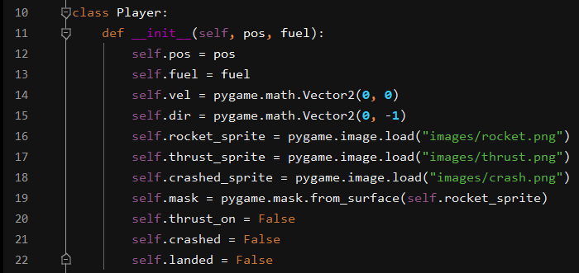

In order to create a player in a game we need to use an object orientated approach whereby a class defines the properties that a player can have, the player can then be created using this class as a blueprint. Similar to building a building from the blueprints or plans. As I have created a moving player the main properties are the position, direction and velocity as well as the sprite which is what the user actually sees. The other properties were added later as part of the actual minigame. Phase 1 however is only concerned with setting up the 2D environment.



The next important feature needed to create moving on screen elements is an update function which allows us to update what’s going on. Without this the user would just be looking at a still image with nothing happening. The update function contains everything that needs to be checked in real time. This means that it can change the properties of the player object as and when it needs to be changed. This can contain many different things which will be seen in the rocket game.

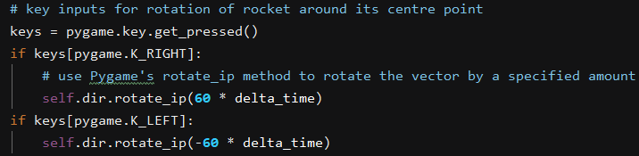

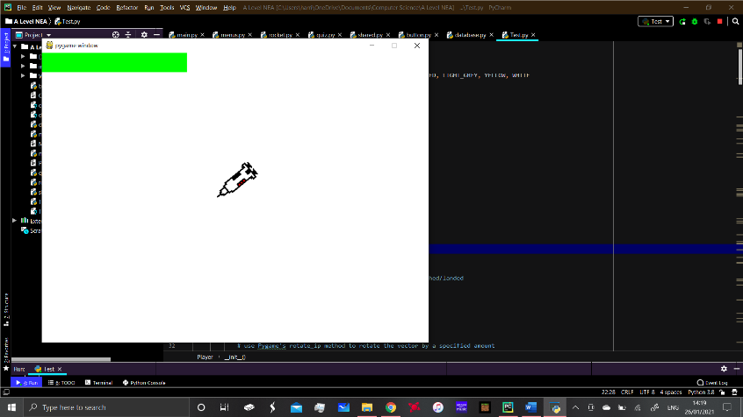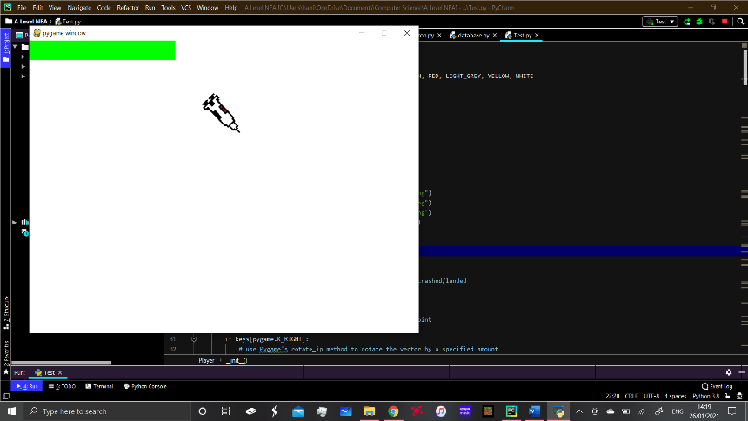Something I did include in the update statement is this code which checks for a key press on the left or right arrow. Following this it uses Pygame’s rotate_ip method in order to update the players direction by specified amount each frame. As you can see it uses something called delta time, this was an improvement which I added later on to the minigame. This is because I initially had the game at a fixed frame rate of 60 frames per second which is alright as long as the machine it is running on has the power to run the game at 60 fps. In the modern age this shouldn’t be much of a problem however I decided to use delta time to allow the game to have a variable frame rate.  This is the code for delta time which is in the main loop for the rocket game. It allows me to set the frame rate to a maximum of 100 fps and do my calculations in milliseconds rather than seconds. This allows for more accurate animations. It also means if the machine isn’t capable of running the game at 100 fps there wont be a noticeable change in performance. The game will adapt and the on screen objects will move smoothly rather than being laggy like they would be at a fixed frame rate. This allows the flexibility and means the game could be run on several machines or even on a mobile device which may not have the processing power that a computer would have.

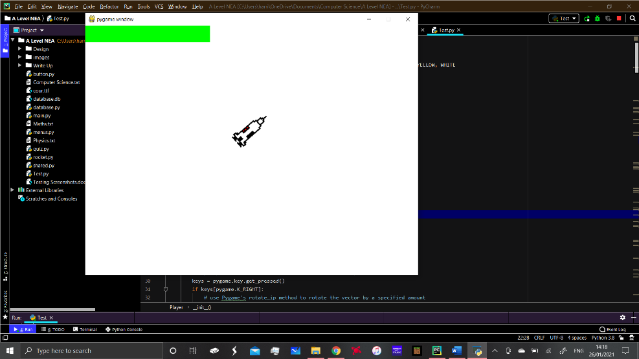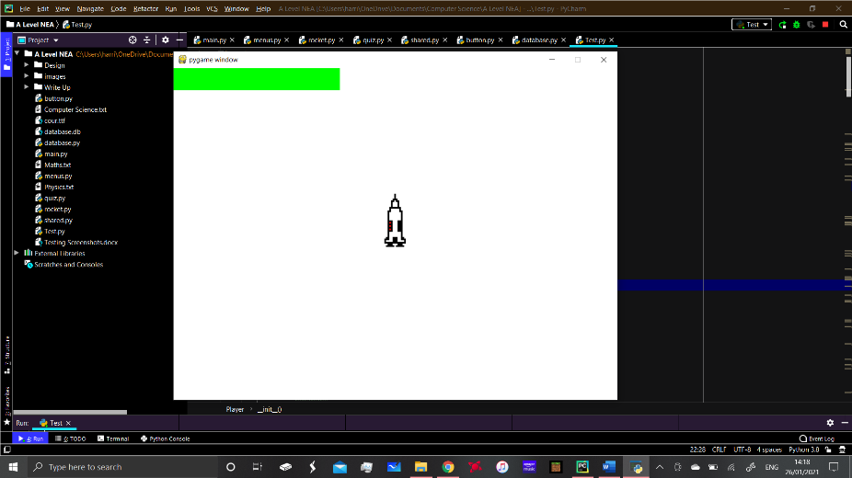

As seen here the code allows me to rotate the sprite on the screen. The axis of rotation is decided later on however but it is around the centre point of the rocket. 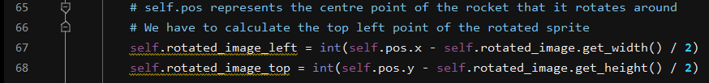

Self.pos represents the centre of the rocket and normally the sprites are manipulated around their top left point, as I found out in testing. So lines 67 and 68 are used to find the centre point of the rocket as it rotates as the size of the sprite essentially changes, As it is actually rectangular in shape as it goes at an angle it actually takes up more space than it did before which can cause problems when it comes to collision detection. So this code essentially deals with the axis of rotation and ensuring that the rocket always rotates around its centre point.

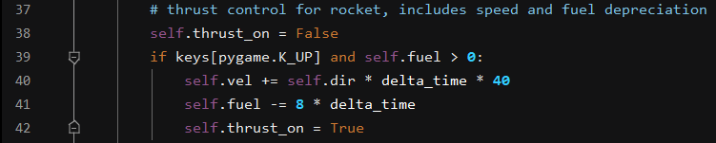

The objects in the game act as vectors which are things which have both size and direction. By doing the code shown before we have determined the direction of the vector but now we need to determine the size. This is done by increasing the velocity by a certain amount when the key is pressed down. It determines its component in each direction (using self.dir) and calculates the resultant size and direction of the velocity to give the vector and allow it to move on screen. The fuel was added as a feature later on however the code shows that it is depreciated when the thrust is activated.

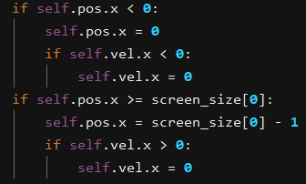I had an issue whereby when you got the rocket moving it was able to go off the screen, this meant that the player could completely lose control and it was impossible to get the rocket back. This was problematic as it made the game impossible to complete and it was inevitable that the user would fail. To give them a chance at redemption this code makes the edges of the screen into a boundary that the rocket cannot cross. This means it cannot leave the screen. However I then noticed that the rocket still had a velocity so it could be hard to escape the wall as the rocket now constantly pushed against it. This was remedied by the second part which sets the velocity to 0 if the rocket touches the wall so that it can accelerate away from it.

One issue with using sprites is that the image is separate from the actual player object. If the image is not update then the game will display it being in the same position but the player may actually be somewhere completely different in a vector that the user cannot actually see. This code is used to rotate the rocket image so that it faces the correct direction and the user can actually visualise which way it is going on screen and where it will go when they press thrust.

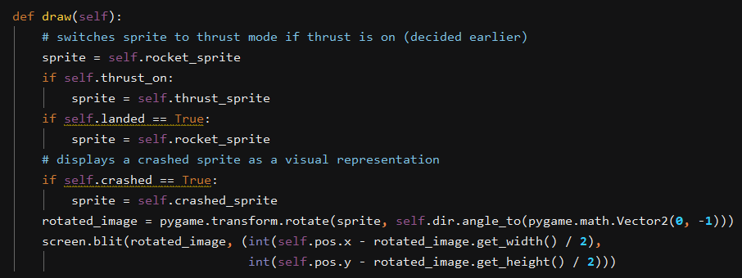

The final part of setting up the 2D environment is drawing the objects on the screen so that the user can see them. This involves the use of a draw function which can be called in the main program and is executed whenever a variable changes. It also draws the rotated images which were calculated earlier again ensuring that they’re shown to be rotating around their centre point. This time it’s the actual sprite image rotating not the player object. However since the code is the same they rotate at the same rate.

Summary for Phase 4:

Having experimented with pygame and creating objects using object orientated programming I felt confident enough to start developing the game. At first the task seemed huge as I had never used pygame or created any games within python. I had now learnt how to create the objects in the game, assign images and manipulate the images at the same time as the objects. This means that I could create characters which moved around the screen using user inputs. This was the main basis of the game which allowed me to progress onto making it more complex. Because I had used a rocket sprite in experimentation I had figured out how to make the rocket move and behave like I wanted it to.

**Phase 5: Creating the minigame**

Some of the code shown above is from my minigame however it was developed over time and became more complex after some practise with the use of 2D objects and manipulating them on screen. The game starts the user in the same position each time and their objective is to dodge incoming asteroids which are randomly spawned on the left of the screen and respawn if they exit the screen at any point. They must land the rocket on the surface of the “moon” which is part of the background image. The player must also take into account how much fuel they have and ensure that they don’t run out or else they are almost certainly going to crash. I will outline each of the features and how I have displayed them on the screen. It involves the use of object orientated programming to create different on screen objects which have their own properties and are able to interact with each other.

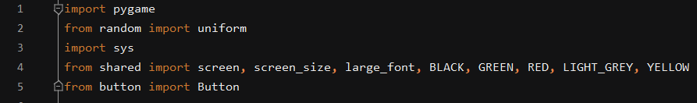

The modules needed for the game are shown here. The shared and button modules are other files in the program. They outline the parts which are required form the other files such as colours and buttons. The system module is used for interacting with windows and closing the program using the red x in the top right of the window as explained before. Random and uniform are used for selecting a random value from within a range of values.

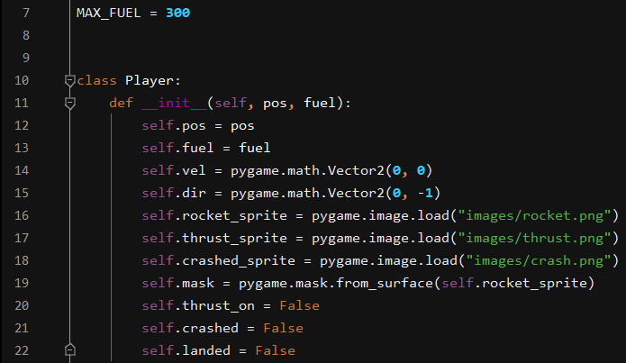

Max fuel is a global constant and so it is defined at the beginning of the program, this is because it is used in 2 completely separate applications and both require access to it so it would make sense to put it here and make it a global constant.

The next thing to set up was the player class which is far more advanced than the ones I used for practising creating 2D environments. The player still requires it’s position, direction and velocity to be defined but there are obviously some more properties which were added for the functionality of the game. For example there are 3 different possible sprites whereas for experimentation I only used 1. I also have some Boolean properties which are changed within the game. The Boolean operations are crucial for deciding the state which the player is currently in and updating things appropriately.

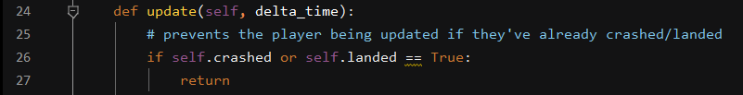

While in development I noticed an issue where the rocket could land and be in the landed state but it would continue to update if the player was pressing the controls. This meant the rocket could rotate and even take off in the background. This looks pretty stupid as the game was clearly over and the message is displayed at the end to show this. This code is there to stop this happening as it means if the object is in a crashed or landed state then it can no longer take any inputs.

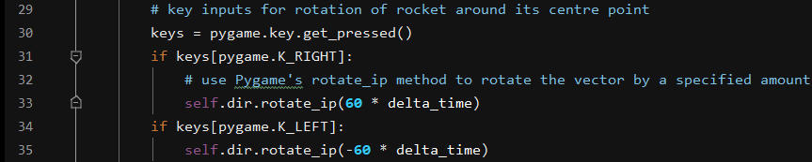

This code was explained before, it is used for calculating the centre point of the object and ensuring that the axis of rotation is around that centre point. It takes a key press form the left and right arrows which are the controls for the game and updates the players direction appropriately. The speed of rotation can be altered by changing 60 to a different multiplier which can make the rocker turn more quickly/slowly.

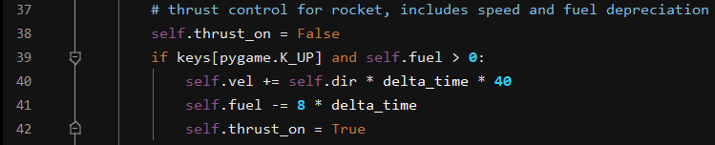

The thrust update for the rocket Is shown here, it sets the thrust Boolean property of the object to True which allows the fuel to go down and sprite to change. Line 39 sets the precondition that the up arrow must be pressed and the fuel must be above 0 for anything to happen. The velocity is then changed by multiplying the direction by the number of frames the rocket should move by. The fuel is then depreciated by a set amount each frame for every millisecond that the button is held down. This allowed me to make the fuel decrease at an acceptable rate which meant the game was playable and the fuel didn’t run out too quickly/slowly. This was tested several times and fine tuned to see how long on average it took to land and to decide on how difficult it was. The difficulty can be altered by increasing/decreasing the multiplier to change how fast the fuel level decreases when the button is held down.

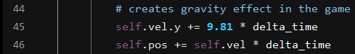

As the objective of the game is to land on the moon then it seems appropriate to have a gravity effect in the game to mimic the effect of real gravity. This works by always giving the rocket a velocity in the y direction if the rocket is thrusting this thrust is enough to overcome this gravity however and it would be able to escape the planet. If no thrust is used the rocket will gain momentum and crash into the planet as it is accelerated by the gradual increase in velocity in the y direction. This can be both a help and a danger in the game and was an interesting feature to add and play with. Again the gravity can be altered by changing the multiplied however I have found this to be the optimum gravity strength for the game. This is also where the velocity of the player is applied to the position which enables it to move in the correct direction with the correct speed.

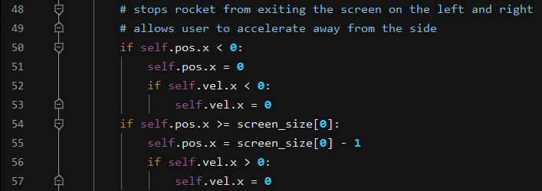

I have already mentioned the issue where the rocket would leave the sides of the screen if it happened to fly in that direction. In order to combat this I set the walls to be boundaries which the rocket couldn’t go past. It works by setting the position back to the position next to the wall if the centre part attempts to leave the screen. Initially I had an issue where the rocket still had a component of velocity against the wall and would continue to try and leave the screen and continually touch the side of the wall and the player couldn’t do anything. I fixed this issue by changing the x velocity to 0 which means that its horizontal velocity was instantly made 0 when it touched the wall. This means the player was essentially stationary (in the horizontal plane) and were able to get away from the wall. They would still be losing altitude however as it doesn’t do anything to the y direction and the gravity is still active. This achieved the desired boundary effect meaning players wouldn’t disappear off the screen with no way to return.



The actual image of the rocket (the sprite) is actually separate from the object, it requires its own code to manipulate its direction. It takes the angle of the player object and applies it to the image as well. The variable rotated_image is then used to display the sprite later on.

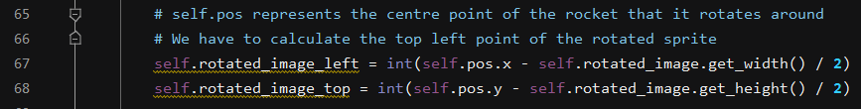

This code calculates the centre point of the rocket by taking the coordinates of its top left corner, it then calculates where the centre point of the rocket is when the image is rotated and ensures that it always rotates around its centre point. This is imperative as before I had these I had some weird things happening to the rocket where it appeared to rotate around a point in space when the image was rotated.



These lines were used for testing purposes, In the game to get a successful landing 2 success criteria must be met. First of all the rocket must be travelling at an appropriate speed for landing and it also must be upright. A range of values is accepted for this and to decide what this range would be I carried out a series of tests where I would land the rocket and these 2 lines of code above would tell me at what angle it was facing and the speed it was travelling at. This allowed me to determine by trial and error what looked acceptable for landing.

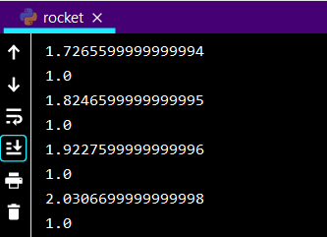This is what the output looks like in the debugger window when the comments are uncommented. The top number is the velocity and the bottom number is the angle of the rocket. It doesn’t work with conventional angles like you would usually think so in this case 1.0 means that the rocket is in its upright position. I did several tests to see what visually looked acceptable and realistic. It constantly reads out as it is part of the update function which is run every frame.

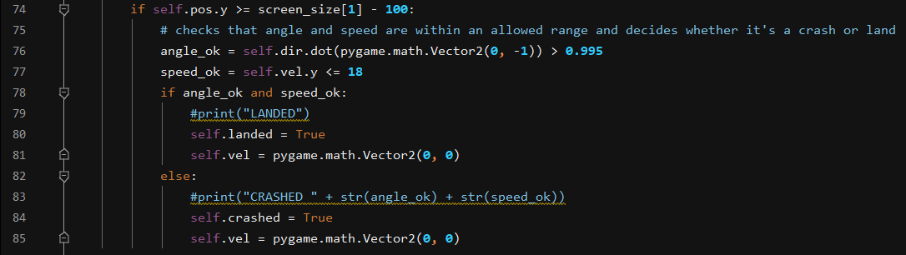

This code is used for checking whether the rocket has crashed or landed when it reaches the moon’s surface. It does this by saying that if the rocket is below a certain point on the screen which corresponds with the moon on the background image then the following code is run. The angle and speed of the rocket are checked against the values which I found to be appropriate using the commented code explained above. If they’re both confirmed to be okay then the game recognises that the rocket has landed successfully and ends the game. It also sets the vector to 0 meaning the rocket cannot move again after this point. If it is found that the rocket has crashed it is put into the crashed state using the Boolean property self.crashed. line 83 was used for testing where I would be checking to see what went wrong and why I didn’t land if I thought I should have. This allowed me to further fine tune the landing and the acceptable range of values for speed and angle at landing.

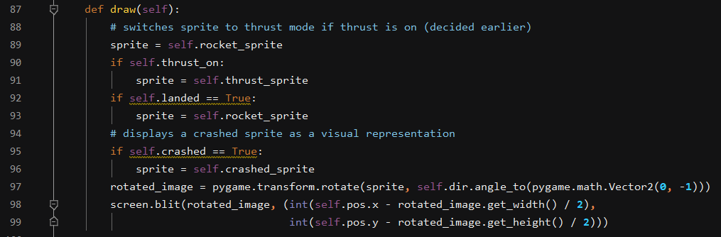

Like all other on screen objects the objects in the game need drawing on the screen for the user to be able to see them. This means the use of a draw function which is constantly run as it is part of the update function. This is the last part of the update function however as the last thing you want to do each frame is draw the object to the screen. This means that every frame the image being drawn to the screen is accurate and is displaying exactly what should be on the screen at that point in time. The draw allows you to switch between images for the sprite. For example I wanted to make flames come out of the rocket’s exhausts when the user pressed thrust so they could see as week as the rocket moving that the button was having an effect. I did this by creating a sprite of the rocket with flames coming out the exhausts and applying this sprite for the duration that the button is pressed. I also introduced a crashed sprite in case the rocket crashed and the user could see that the game was over. Although the button also appeared simultaneously to tell them this. The screen.blit rotated image means that whatever image the sprite is switched to that same calculation is applied so that it is rotated around its centre point. It also takes the variable rotated_image which was defined earlier to ensure that it will appear at the same angle as the sprite which it replaced. This means that if the rocket is moving at an angle and the user presses thrust the rocket doesn’t suddenly change to an upright position. It is hard to capture this in action without the use of a video however it works as it should for all of the sprites.

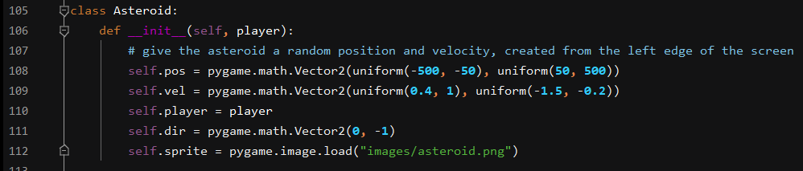

Before I started the main game loop I decided that to increase the difficulty of the game I would add some asteroids which the user would have to avoid in order to land the rocket successful. A collision with an asteroid would cause the rocket to crash and the game to end in a landing. This meant using object orientated programming again in order to create a class that contained the properties of the asteroid. For it to move it would need a vector, using Pygame’s Vector2 method I was able to give it both random speed and position. I used the uniform part of the random module. This was because after testing the game and having completely random number I found it was extremely difficult as asteroids would often come straight at the rocket from an unexpected angle. So I decided to put an upper and lower limit on the speed that the asteroids can travel at. They all start with the same direction however because it means they always move across the screen in the same direction.

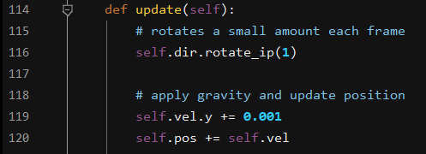

Like the player class the asteroid class also needs an update function so that it is kept up to date every frame and updates in real time. The first thing in the update function uses rotate_ip which is a method built into pygame which allows the asteroids to rotate as they fly though space. This was a feature I added as it looked good and added to the game visually. I then applied the gravity to the asteroids and ensured that their position was updated appropriately. I had a go at changing the number on line 119 to alter how strong the gravity is for the asteroids. I found this to be the optimal result and the fairest one, otherwise the asteroids can be pulled down very quickly sometimes even into the rocket. This is also where the velocity of the asteroids is applied to their position which means that the asteroids move in the correct direction with the specified velocity.



Like the rocket the image of the sprite doesn’t automatically rotate along with the object so the image also needs rotating, it uses the self.dir.angle to translate the angle calculated by the self.dir.rotate onto the image and ensure it is also rotating. It also sets the sprite to the sprite which is defined in the class. The sprite is given the same velocity and direction as the player which means the image moves as the player moves.

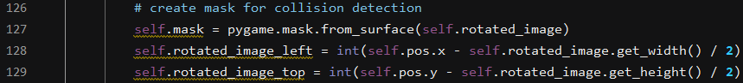

The next challenge to overcome was how to do collision detection. The collision detection for landing is done in a simple whereby the program checks to see if the rocket is below a certain point on the screen which corresponds to the background. Because this collision involves two moving objects colliding it had to be done in a different way, this is achieved by using pygames mask method. The way this works is that it creates a surface over the object which is the same size as it and rotates with it. (as you can see it takes self.rotated_image as the parameter) It then calculates the middle point of the rotated image.

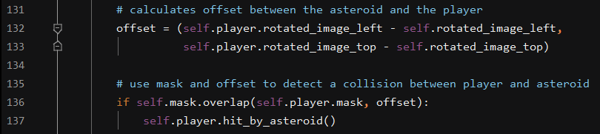

The offset is then calculated between the asteroids and the rocket. This can be thought of as the space between the two objects and is used to decide if the objects are overlapping at all. Obviously if the rocket touches the asteroid we want the game over button to be displayed and the rocket to be in a crashed state. This is done using line 136 which says that if the rocket mask and asteroid mask overlap at all then the player has been hit by an asteroid.

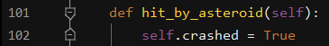

If the masks are found to be overlapping then this function in the player update function is responsible for setting the rocket to the crashed state. This means that the sprite will be updated and the game will be over. This is the most efficient way of doing this and means that the collision detection is kept quite simple. It means that every asteroid on the screen knows where the sprite is in comparison to itself. Asteroids are not affected by other asteroids and only by the player.

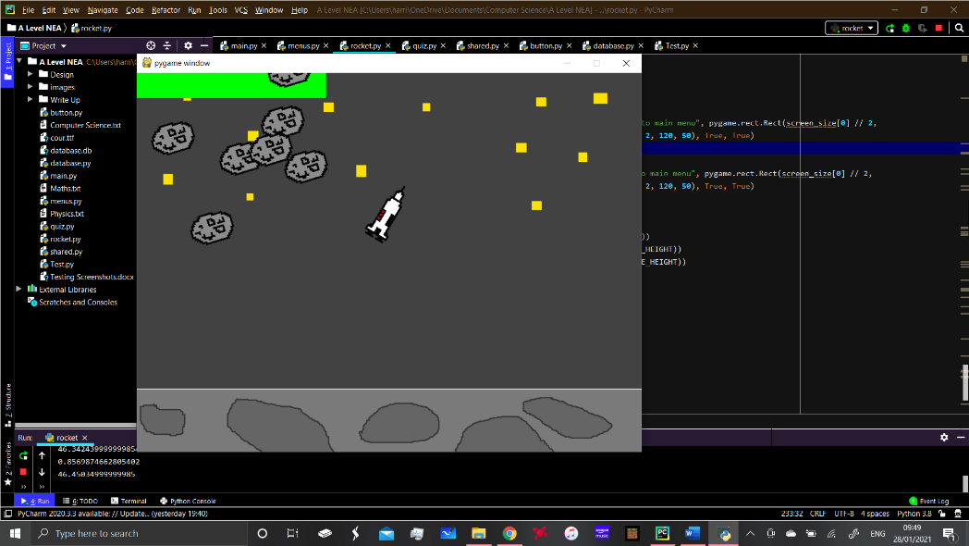

As you can see here the asteroids are randomly distributed, they all turn at the same rate hence why they look the same however their speeds and directions are still random (between a range of values due to the use of uniform). One thing I could look at in future is starting them all from a different rotated position so that they don’t all turn in unison.

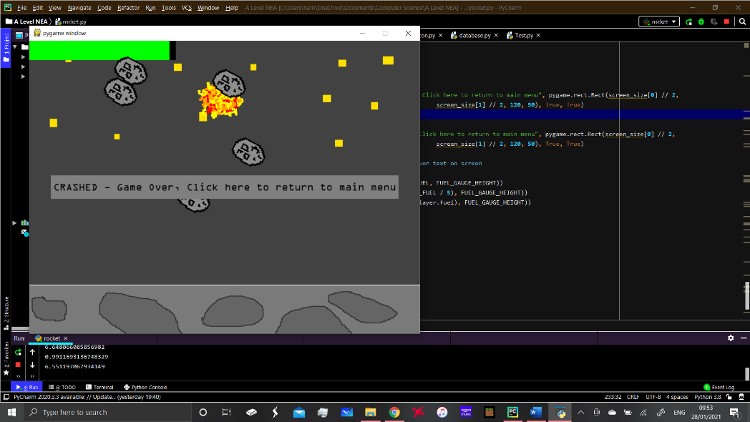

This is an example where you can see the rocket has just been hit by an asteroid. This is the best way of showing that the collision detection works as I cannot put video on here. However there is no issues whereby the rocket or asteroid is colliding with an “invisible” part of the sprite which is a problem often seen in collision detections in video games.

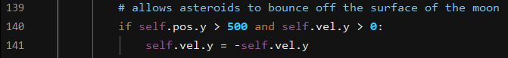

One Problem I had when adding the asteroids is that they didn’t have the boundaries that I set out for the rocket. This meant they just disappeared off the screen and the game suddenly became very easy as long as you had the right amount of fuel. One thing that happened as a result of this was that the asteroids could essentially go through the “moon”. This looked strange as it was supposed to appear as a solid surface which the rocket could land on. My solution was this, it meant that if the asteroids touched the moon’s surface (which I made sure was at the same level as the surface the rocket touched) then their Y velocity was reversed. This means that it created the illusion that they bounced off the surface. As the X velocity remains the same it looks natural and carries on in the correct direction.

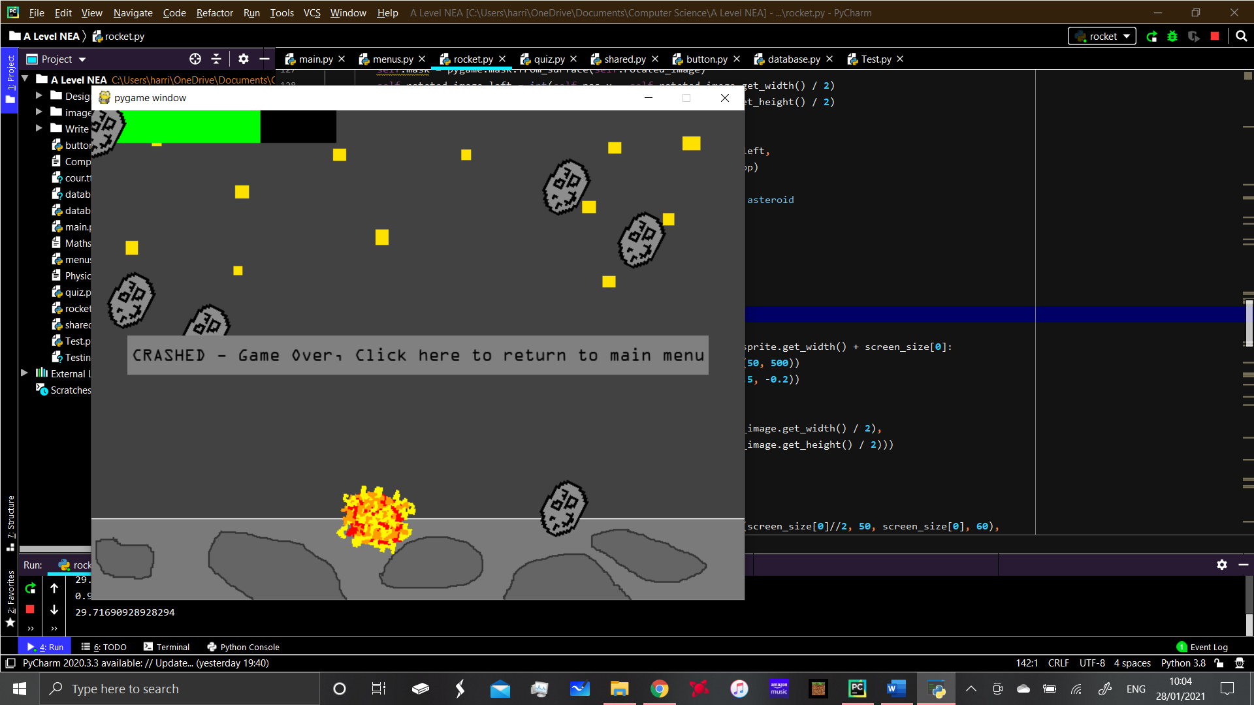This is an example where the asteroid has just bounced off the moon. IT creates some interesting results and can increase the difficulty of the game. Due to the nature of the game with the asteroids constantly moving it is almost impossible to capture this without video unfortunately.



As mentioned there was an issue whereby the asteroids would exit the screen and it would then be clear. This posed a problem for the game as it suddenly became extremely easy and there was no more challenge. I did start by creating boundaries and making the asteroids bounce off the boundaries, this made the game extremely difficult as the asteroids would fly around in random directions and were very hard to survive. I also looked unrealistic as the asteroids were bouncing off deep space where there is no boundaries. My solution was to create a system whereby the asteroids would be able to leave the screen, however once they exited the screen they ‘respawned’ meaning they were deleted and recreated. This code checks for the asteroids leaving the screen and then resets them back to a random position again. As before they begin on the left hand side of the screen and have a random position and velocity. This means that they are constantly coming back if they exit the screen and the game doesn’t become easier just because the asteroids have left the screen. As this is part of the update it is constantly checked and applied where needed.



Like the player class the asteroid class also requires a draw function in its update function in order to draw the objects on the screen. This means that the visual picture is always kept up to date each frame. This means every frame the asteroid is rotated and moved by the amounts specified earlier.

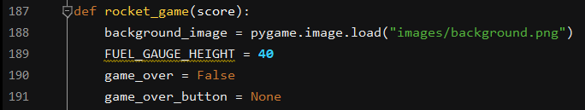

This is the main rocket game function which begins the game when called, as you can see it takes the parameter score which is the part that comes from the quiz. This is where the quiz links in with the minigame as the score is translated into the fuel that the rocket has. This makes the game easier for the player as long as they’ve got the questions right. However I have made it so that even if the player gets all the questions wrong they still have some fuel so there is a slight chance they could land however it is very difficult. The background image is set here which is what displays the moon and the background in general. I have also created a fuel gauge and the height of that is defined here. The variable game over is also defined here as well as game over button.

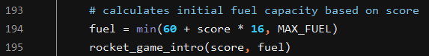

This is where the fuel for the game is calculated, this links to success criteria 6 which talks about motivating the students in the quiz by rewarding them with the fuel in the minigame. Here the minimum amount of starting fuel is set and any extra fuel is calculated based om score and added. The fuel can go up to the max_fuel value, although it won’t be able to go above that value. The amount of fuel they gain per question and the minimum fuel can be altered here to make the game more or less difficult. This is a useful feature as if the stakeholders feedback that the game is too difficult then I can alter the game to be less difficult.



This is where the player object is created and the position of the player is allocated. The starting position I chose is 400, 100 meaning the player begins near the top of the window in the centre of it. This is because the window size is 800x600 so 400 pixels would mean that the centre of the ship is in the centre of the window.

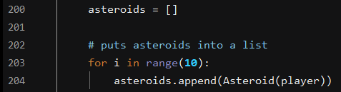

This is my system for creating the asteroid objects, they are added to a list called asteroids and can be appended and removed from the list. They are added the list using a for loop which means that you can alter the amount of asteroids that appear in the game, this is easily done by changing the number on line 203. Using the for loop also prevents the repetition of the code on line 204 which I originally had as several lines of code to create the asteroids.

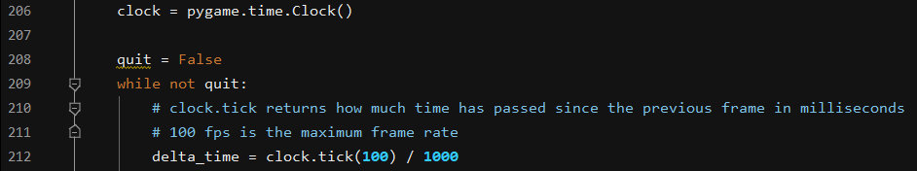

This is where the frame rate of the game is decided, the code means that until the quit button is pressed or the game ends then the game has a frame rate decided by this code. I have used delta time and clock.tick in order to manipulate this and work out timings for things such as rotations, fuel depreciation and other important features. Delta time is used in pygame to check how much time has passed between each frame. Delta time is how much time has passed since the previous frame in milliseconds, this is because of line 212 which sets the clock tick to 100 fps, this means that there are 100 frames per second or 1 frame every 10 milliseconds. This allows me to set all the timings for the game to this standard. Using delta time also means that if the computer is running slow that the time between the last frame will still be calculated and the game will account for this. This means that it can still run smoothly even if the computer is running slow. If I was to use a fixed frame rate then it wouldn’t be able to account for the change in performance, this may mean that there are changes in frame rate for the user. If it was to run slow then one second the user may be on one part of the screen moving but then all of a sudden the game updates and they’re in a completely different position on the screen. This renders the game unplayable as it can’t keep up and the player may not know where they are for seconds at a time.

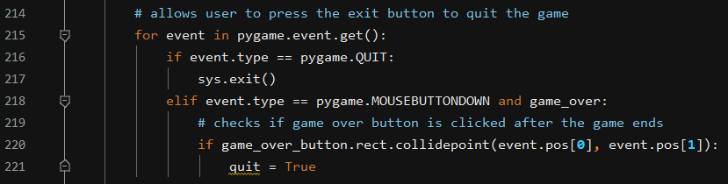

Like all windows that this program opens I have included the ability for the user to press the cross button to close the program. By pressing it, it sets the quit Boolean variable to true and closes the window which terminates the program. This event loop also encompasses the mouse clicks, it finds the coordinates of the mouse click and checks whether the click is inside one of the game over buttons, it then terminates the game if the button is clicked.

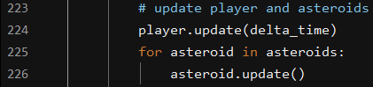

This is where the update functions for both the player and asteroids are called. The player update function takes delta time as a parameter in order to keep it up to date each frame as explained before. It also updates all the asteroids in the list so that they are up to date each frame. This means that the player always receives an up to date image on screen, this feature of the game is imperative to its complexity as it was designed to run in real time meaning it’s always up to date and the player can see exactly what’s happening at all times.

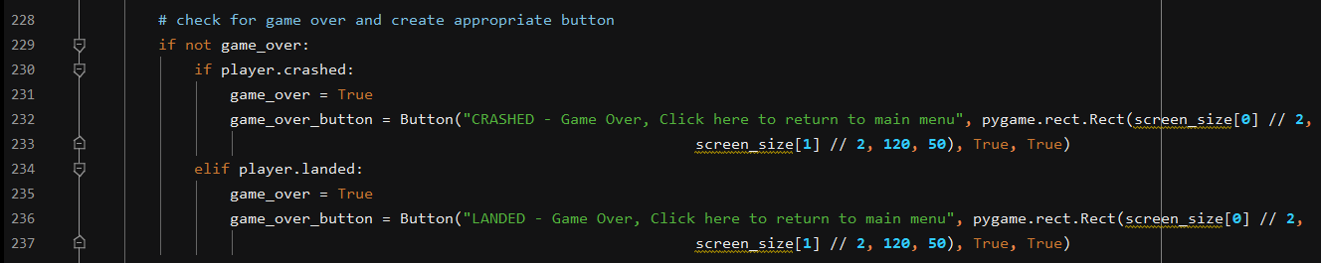

This is where the game decides if it is over. If the player crashes and the Boolean variable becomes true then the game is put into a game over state. A button is created which tells the user they have crashed and the game is over and what to do next. The same goes if the player has landed except the button has text on telling them they’ve landed and what to do next. The code above which checks for mouse clicks then closes the rocket game if the user clicks on the button as instructed.

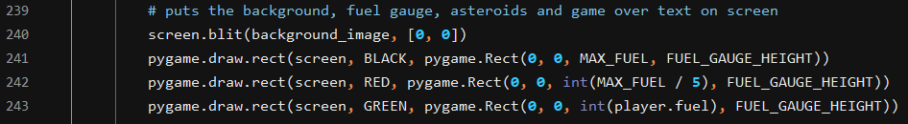

As with the quiz all the objects on the screen must be drawn on the window for the user to be able to see them, here the background image is dawn on the screen first, it is the same size as the window so it is drawn from the top left coordinate (0,0). Lines 241-243 are used to draw a fuel gauge on the top left of the screen. The first rectangle is black in colour and represents the size of the max fuel value. There is then a red rectangle which represents a “danger zone” at 25% fuel or less. The green rectangle uses player.fuel to represent a green rectangle which decreases in width as the fuel goes down. This happens in real time as the value of player.fuel is constantly decreased as part of the player update function. Therefore it creates a dynamic on screen representation of the fuel decreasing. This way the player sees how much fuel they have and the rate at which it decreases, that way they can work out how to survive and land the rocket on the moon.

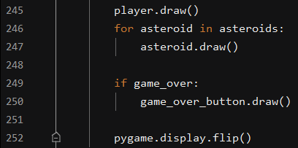

This is the final part of the drawing code which is used to draw the asteroids from the list of asteroids, this way every asteroid is drawn and as they are constantly updated they are always drawn in the correct way, ie correct rotation and position on the screen. The buttons are then drawn if the game over state is satisfied, that way once the game is finished the correct game over button is displayed. The pygame display is then flipped (updated) in order to display everything correctly in real time.

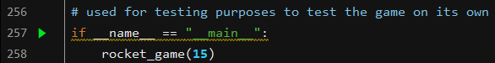

I needed a way to test the rocket game independently from the rest of the program as I was developing the rest of the program at the same time. The way I did this was by running these 2 lines of code which allowed me to pass in a score for the rocket game to test it when starting with different scores. This allowed me to test the game with several levels of fuel and adjust things like rate of fuel depreciation, asteroid speed and other factors which affect the difficulty of the game.

Using a Base Class

After reviewing the rocket game code I noticed that there was repetition of some code in both the player and asteroid classes. For example both the player and asteroid have a position, direction and velocity. In reality this would not be an effective way of coding as if the game was on a large scale there may be hundreds of different objects on the screen at any time. If there were 20 classes all with lines that repeated in each class then this would increase the space which the game took up. This is a disadvantage as it increases the system requirements and the game takes up a lot more space. I decided to create another class which would contain all the properties for objects which could move, I named this class MovingGameObjects.

|  |
| --- |
| Class Name: MovingGameObjects |
| Attributes: position, velocity, direction, collision sprite, gravity, keep on screen |
| Methods: Update, Draw |



I have used an abstract base class for creating this class, this means that the class itself cannot be instantiated, it is intended for use as a base class only. This is because the objects being created aren’t going to be MovingGameObjects, they will have their own classes but if they share properties these properties can be put into the MovingGameObjects class so that the code is not having to be repeated. When the objects are created they can then inherit from this abstract class and use it’s methods. In order to create abstract base classes in python you need to import the module which will allow you to identify a class as an ABC. This means that from then on you can designate any class to be an abstract base class.





Previously this is what the Player and Asteroid classes looked like, as you can see there are multiple repetitions of code in both, both the asteroid and the player are using pos, vel, dir, a sprite of some description and , masks. This means that all of these properties can be put into the abstract base class which will allow them to inherit the properties from the class rather than having the properties in both classes which takes up much more space.

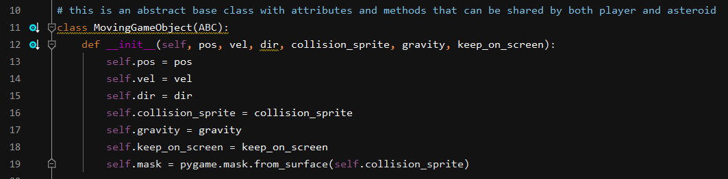

This is the MovingGameObject class, as you can see it as all of the attributes mentioned above and it serves as the abstract base class which the other classes in the rocket game can then inherit from. I also looked at the code and noticed that the code for the gravity effect was repeated in both the Player and Asteroid class. The keep_on_screen attribute is a Boolean attribute which allows you to specify whether an object should be kept on the screen or not, this is not a massive detail for this program however I may want to expand it in future, if I wanted to add another object which couldn’t leave the screen I would be able to do this by setting the Boolean to True. I have also included the code for creating the masks in the abstract methods as this is used on both the player and asteroids therefore there is no need for them to be repeated. Shown below are some examples of code which was originally in both the Player and the Asteroid class:



Shown above are the two instances where the gravity application was originally applied, as you can also see I made a mistake originally where the gravity on the asteroids was not applied in the same way as the gravity to the rocket. This meant they were frame dependent and their performance could drop while the rest of the program would compensate for a drop in performance through the use of delta time which uses millisecond timings to alter things which move on screen.





The top image shown above is in the draw function for the Player class, the bottom function is the draw function for the Asteroid class. As you can see the code is exactly the same and takes up a total of 4 lines of code. This is unnecessary and is a flaw in the efficiency of the code. This means it can be assimilated into the abstract base class. This means the code only appears once but can be inherited for both classes. The same goes for the code which ensures that the sprites are rotating around their centre point. The code for this is also repeated in the code meaning that it can also be added to the abstract base class. This way when it comes to implementing this in the actual object the code can be inherited from the base class rather than it’s own class. Using the base class also means that everything in the base class can be applied to all the objects in the game, this is advantageous as it means that when things are added to the program in later updates the base class is already there to provide some of the attributes the new objects may need.

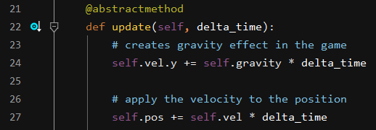

In order to use methods in an abstract base class you have to use what’s known as an abstract method which is defined using the syntax above. Things that were included in the update function in both the player and asteroid classes are now part of the ABC update function. This part of the code is showing how the gravity is applied to the velocity of the objects. The Velocity is then applied to the position as it was originally, the code works in the exact same way as before however now it is in a more general form which can be applied to either object and can be altered when the object is created.

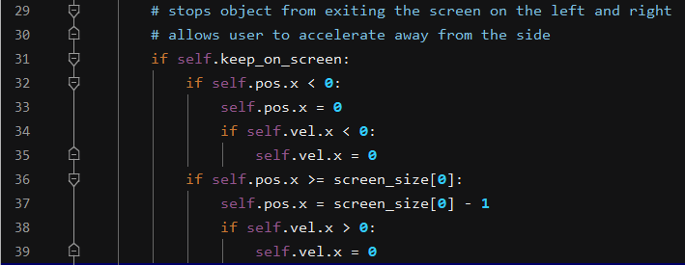

The code for keeping objects on the screen is also part of the update function, it performs in the same way as It did previously however now it is either applied or not applied to an object using the Boolean True or False. This means you can choose whether a particular object can or can’t go off the screen and apply the code if needed.

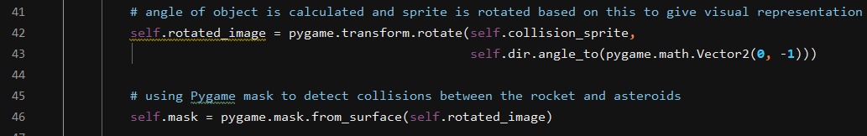

This is where the object angle is used to position the sprite image on the screen, it also ensures that the correct sprite is displayed if a collision is detected. The code for masking the objects for collision detection has also been integrated into the abstract base class. This means for any object whereby collision detection is going to be used it can be inherited from the base class and the code doesn’t need to be in the code for that class.

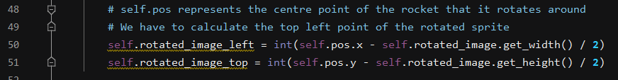

This is the final part of the update function for the base class, this is the code that deals with rotation and ensuring that the sprite is rotating around it’s centre point. This means that all sprites are able to rotate around their centre point. When the object is created these different parts of the function are specified so each object can be customised and can inherit from this class.



This is the draw function for the abstract base class, this code was repeated in both the asteroid and the player class as shown above. The code was repeated but performed the same function, therefore it made sense to remove it and put it into the ABC so that it could be inherited. The modification of the code is shown below and the actual creation of objects using the inheritance.



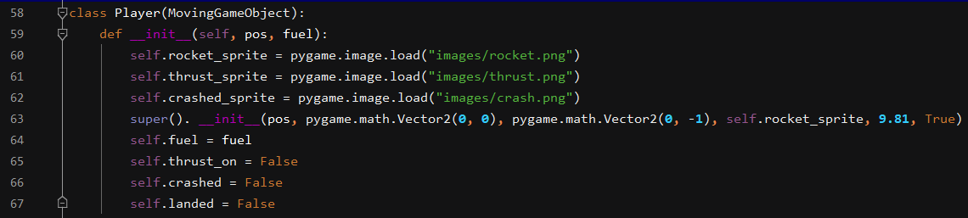

This is the player class before and after the use of the abstract base class, as you can see the actual class code takes up much less space, the only attributes local to the Player class are those that are used by it for a specific and bespoke purpose that would not be used anywhere else. Line 63 is where the inheritance from the base class takes place, here the position, velocity, direction, sprite, gravity and the stay on screen attributes are specified for the rocket. The velocity and direction are both Vector2 quantities and so have been defined in this way, pos is constantly updated based on the on screen coordinates. The sprites are defined above so that the update function In the ABC knows which image to use for the sprite at any point. I have set the gravity value to 9.81 which Is multiplied by delta time in the update function in order to create a gravity effect. The stay_on_screen attribute is then set to True so that the code to stop the rocket going off either side of the screen is executed.



This line of code is used in the player update function to call the inherited update function which updates the screen each frame with the new data which is calculated as part of the update. This way the rotation of the rocket and asteroids and their position on the screen can always be kept up to date each frame. This replaces multiple lines of code which were previously used to update rotation, apply gravity etc. This method is far more efficient as it requires less lines of code in the actual player update due to the use of inheritance. It also means code is not repeated in the asteroid class unnecessarily.



Several lines of code have also been replaced in the Player draw function using just this line of code which takes the rotated image parameter and passes it into the abstract base class draw function which calculates how much the sprite image should be rotated by.



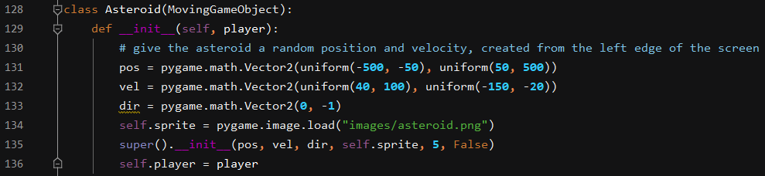

Shown above is the asteroid class before and then after the use of the abstract base class, as you can see the position, velocity and direction are no longer an attribute of the asteroid class, they are variables which are defined using the Vector2 method and the uniform module which I imported as part of random. This is because I still wanted the asteroids to function in the same way however I have now dealt with them being frame dependent. I now use delta time on all update functions so I had to alter the figures by multiplying them by 100, the figures were in pixels per frame, whereas now they are in pixels per second because I multiply the velocity by delta_time (time passed since last frame, in seconds) before applying it to position. The class then inherits position, velocity and direction from the base class as well as its sprite and gravity value. The Asteroids have kept their respawn function therefore I have set the keep_on_screen attribute to False so that they are able to leave the screen and respawn if they do leave it.

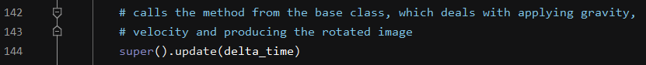

This is the part of the update function for the asteroids. It inherits all update functions it needs from the base class. Again around 10 lines of code have been cut out through the use of this as they were repeated in the Player update as well. This is much easier to maintain for future updates or if any bugs are found in the program.

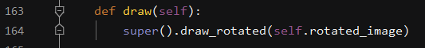

As the asteroid is an object which just moves across the screen and only has a single sprite it’s whole draw function is replaced by this one line of code which inherits the rotated image calculation from the parent class and ensures that the image is in the correct position, is rotated by the correct amount and around its centre.

Game Intro Screen

During the development and through playing the game myself I realised that when the game began it wasn’t immediately clear how the quiz related to the game. In order to make it clearer I decided to create a screen called the game intro screen. By using this I could make it clear to the player what they have achieved and how this helps the minigame. I also needed to show the user what the controls for the game are. I did this by creating a function which comes before the rocket game function and takes the score parameter from the quiz.

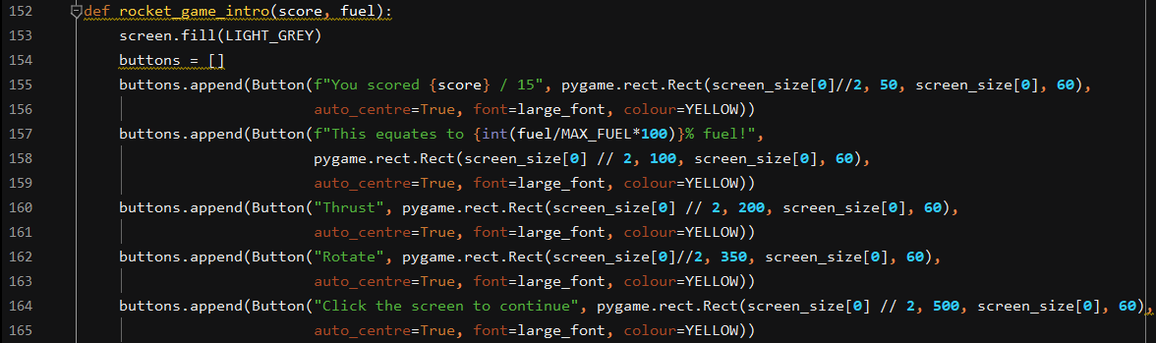

The function also takes the parameter fuel which is calculated in the rocket game function. Firstly the screen is set to grey which is the chosen background colour for the intro screen. I then created a series of buttons on which I put the text for the intro screen. This is one example of where the buttons are multifunctional as I have used them as text displays rather than as a button. Although in a program In the industry this is probably not the most efficient way of doing this it was appropriate for this project as it made the buttons more easy to use and manipulate. In the industry it is more likely that text displays, buttons and text entry boxes would have their own classes in separate files rather than all being integrated into one button class which is multifunctional and could be more difficult to maintain. The first button is used for displaying the users score from the quiz. The next button displays this number as a percentage of the max fuel variable. The next 2 buttons are used to explain the controls.

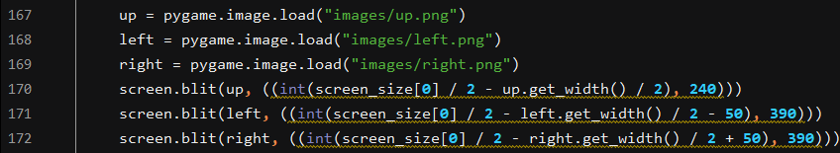

The controls exist as images in a png format and so they are loaded in and positioned using Pygame’s screen.blit method and using the size of the window to decide where to position the pictures on the screen. I got them to appear under the text that represents them to make it immediately obvious what it does. This screen is part of the GUI which helps the user to use the program and make it more accessible.

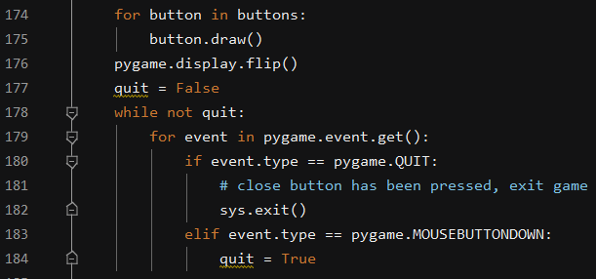

This code is for the drawing and display of the buttons on the screen. The pygame.flip is required anywhere where buttons are drawn to ensure they’re up to date. This code also deals with the next stage which is closing the intro screen and beginning the game. The intro screen only appears at the beginning of the program and the player is given as much time as they need to read and understand it. Using this code means that when they click with the mouse on the screen the intro screen closes and the game begins.

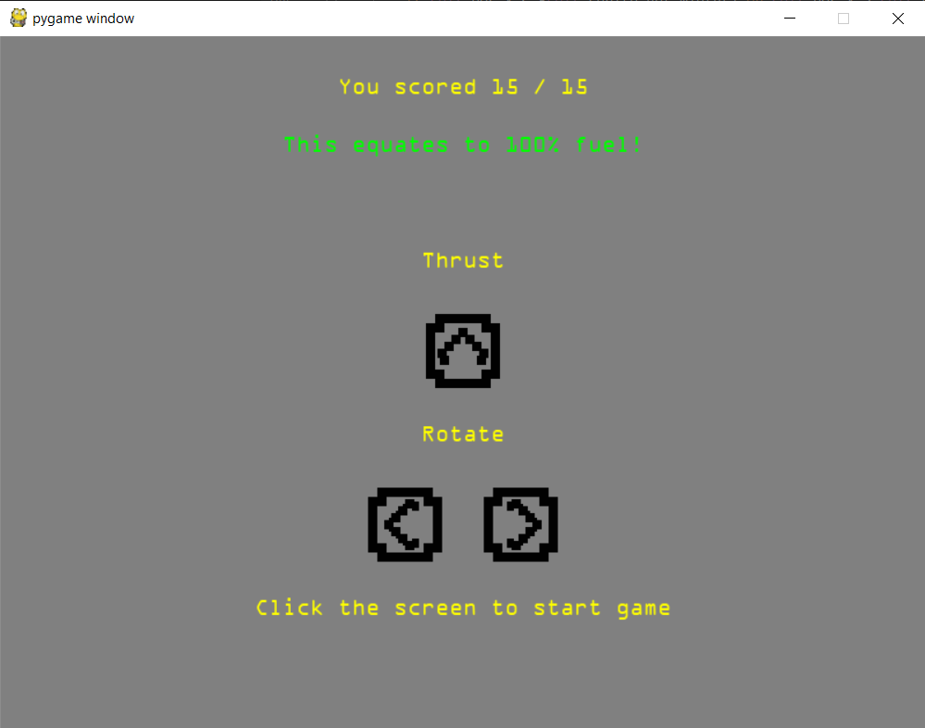

This Is the final result for the game intro screen. It shows clearly the controls and how the users score relates to the fuel level in the game. This would hopefully give the student a sense of achievement even before the game has begun and they’ve landed. When doing this screen I also calculated that 100% fuel was equal to 15 questions. This involved altering max fuel variable to ensure that 15 questions was equal to a full bar of fuel. I didn’t have to edit the fuel gauge as these are based on these variables. I also altered how the fuel depreciated and I only had to change 3 numbers. This means that if the number of questions needed to be increased/decreased this could easily be done without altering large amounts of code. It only requires a few numbers to be changed.

Phase 5 Evaluation:

With Phase 5 now completed the main 2 parts of the program are now complete, probably the most difficult part also now tackled. In doing this I have also completed 2 of the success criteria for the program:

Success Criteria 3: The user can begin the game with the topic they have chosen selected, the game will be clear and provide instruction as to what the student needs to do.

Success criteria 3 is complete through the creation of the game intro screen which provides the instructions on how to control he rocket, it also tells them how much fuel they have got which helps them to decipher how easy its going to be to land the rocket. The dodging asteroids part of the program is shown in the menus which were developed later.

Success Criteria 6: This score should feed into an interesting real time minigame which provides motivation to do well in the quiz.

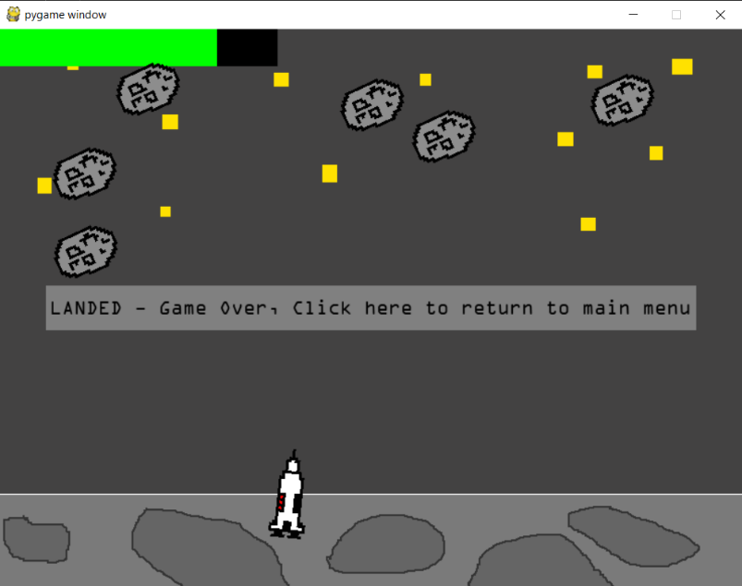The minigame is now complete and can exist on its own as well as being part of the main program through the use of the test code that I created. I believe it is both interesting, challenging and relevant to the STEM subjects which the program is used to revise for. There are some screenshots from the game below showing the intro screen and some in game footage, as well as all 3 possible endings to the game. You can also see the fuel level indicator in the top left and the different amounts.

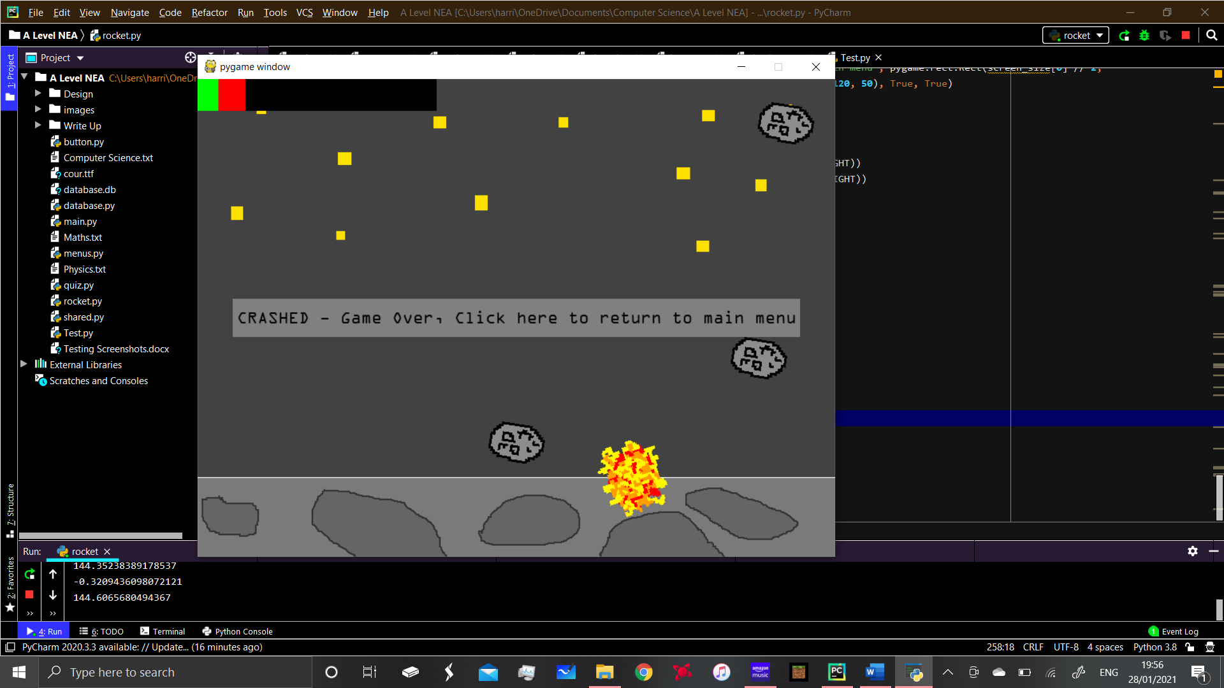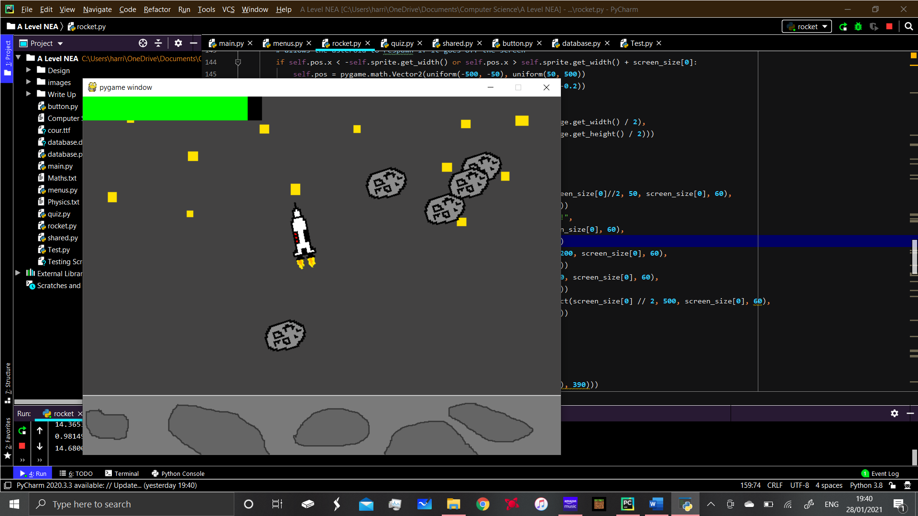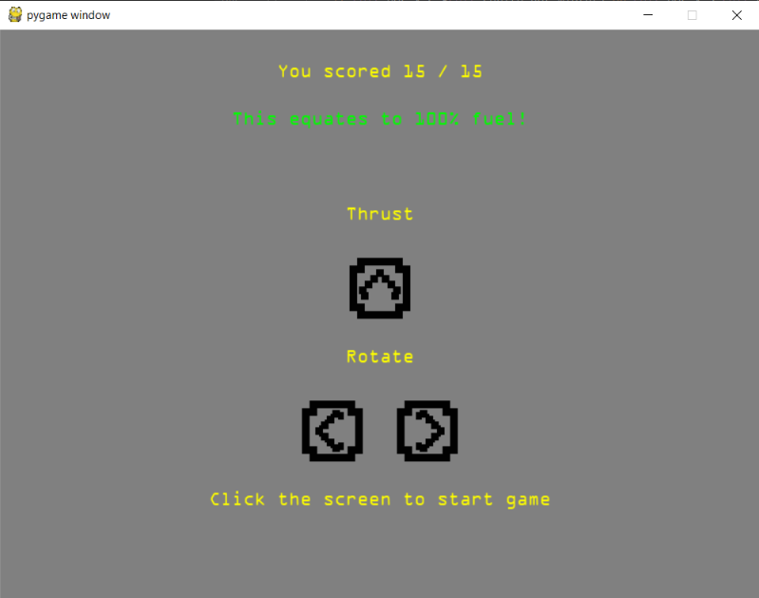

**Phase 6: Creating Login System with validation**

I wanted the program to have an account system so that students could store their results and compare with their friends or show their teacher the scores they were achieving. This involved creating a login system and login screen as well as beginning the development of a database which would store the users credentials. In doing this I created a menu with a GUI and also began creating a database using SQLite. This was also challenging as never before had I created a database which worked with python. It uses the structured query language to manipulate the database and this will be shown as well as the validation code that ensures that the data being sent to the database is valid and not redundant data. For the login system I created a file called menus.py which would be the file which stored both the login systema and main menu. Ideally I would have these in separate files for easy maintenance but I have stored them in the same file as it isn’t necessarily a huge bit of code.

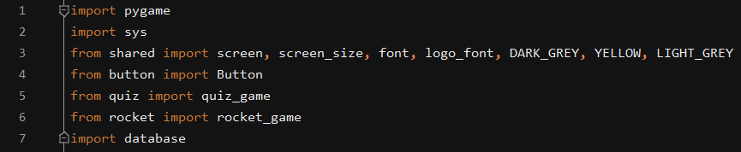

I started by importing all of the modules and data that would be needed for the main menu. Some of it is from other files in the program such as shared and button. The multifunctionality of the button class became more complex when I began creating the login screen. This was because I needed text boxes which could be typed into and be clicked on.

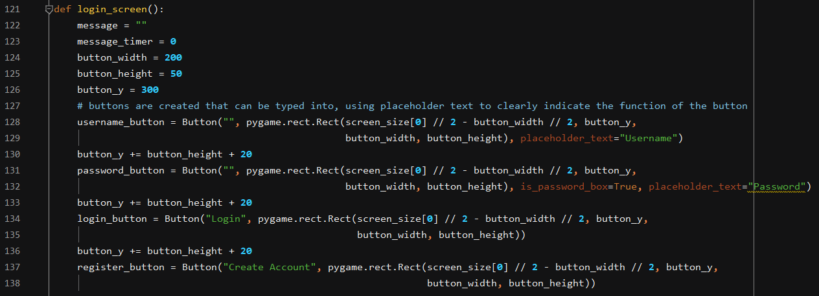

This is the beginning of the login screen function in the menus file. It shows the variables and constants at the top. The buttons are then created. I had to adapt the buttons for this part of the program and add some extra functionality to the in their file. The top button is used for the username. I added a function called placeholder text because initially when I set this up you couldn’t tell what the box actually was it was just an empty box that you could type into. Most username buttons on the net have some placeholder text so you can tell what they are and I decided to mimic this. All of the buttons on this page are centred to the middle of the window. Button height + 20 creates a space between each button so they aren’t touching each other. The second button is used for the password although I added a functionality called “is_password_box” which is set to True, the reason for this is explained below. The next 2 buttons are for logging in or creating an account.

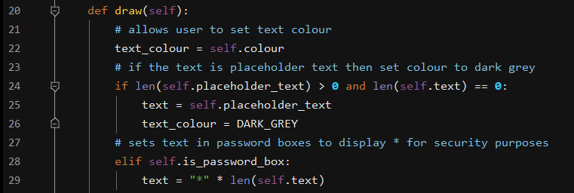

This is the draw function from the button class (in button.py), as you can see the placeholder text property is here and changes the button if it is set to be a button which contains placeholder text. The placeholder text works by putting text (which the user decides on) in the box before anything is typed there. Once the user begins typing the placeholder text is removed, the text that is typed in will either be the default colour or the user can change the text colour when the button object is created. The if password box property converts all text which is typed into the box into an Asterix symbol, this mimics the effect that websites and companies often use when you type your password in.

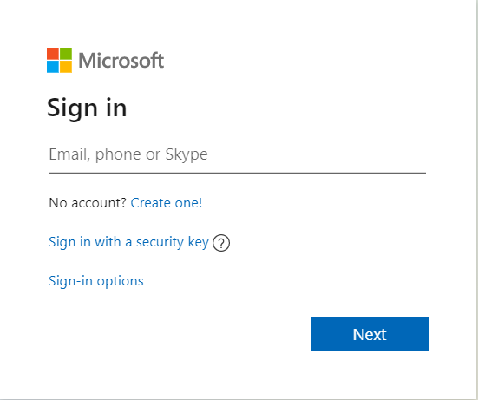

Placeholder text showing the user what to type into the text box. Used in both Microsoft’s login system and the login system in my program. (password box also has placeholder) I have also shown how the text in the password box is converted to * signs for security.

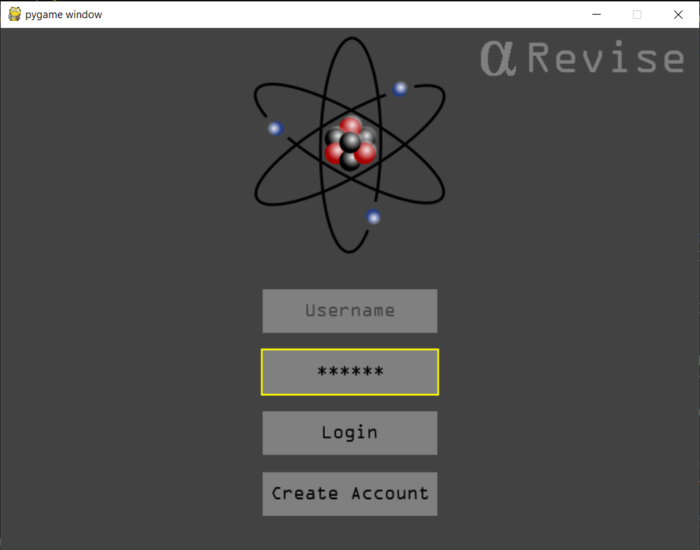

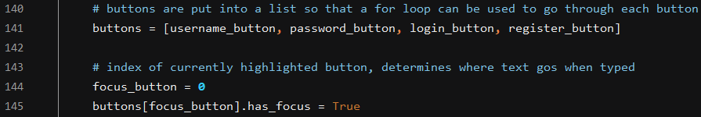

Going back to the login screen code, this is where the buttons are appended to a list, I did this because I introduced another feature called button focus or focus_button as I’ve called it. Initially the username button has the focus as it is most likely the first button that will be needed, it is the first item in the list and this is shown by the 0 index. Then the Boolean variable is set to True which means the code from the button class can be executed.

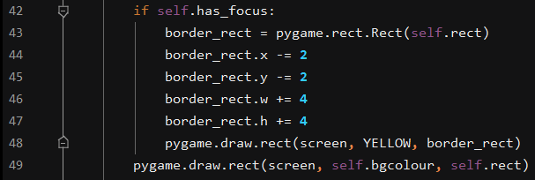

This is the code from the button class that highlights the currently focused button. The reason for using focusing is that the user knows which button they are interacting with at any point in time. The way my focus system works is that another rectangle of the same colour is drawn behind the button giving the illusion of a border around the button they have selected. This ensures that the user can clearly see what button it is that they have selected. It draws the second rectangle behind the button and it is slightly wider in both the height and width so the border shows.

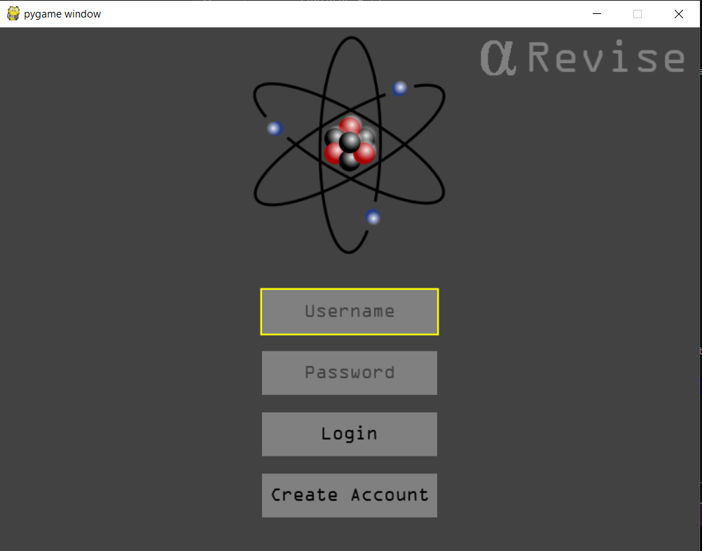

This is an example of the focus button function of the button class. As you can see the username button has the yellow border around it. Because I have put the buttons into a list I can then use the variable focus_button on line 144 of the menus.py file to increase the index of the currently focused button. This will redraw the rectangle on the next button. This system mimics the system used in the industry and makes the GUI even easier to understand.

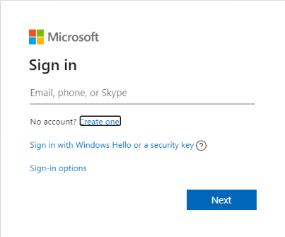Using Microsoft’s login system as an example again, when tab is pressed a border appears around the button which is selected. This allows you to navigate their login system without using the mouse pad or an external mouse. This is a useful GUI and accessibility feature and it also makes the program look more professional and well finished.

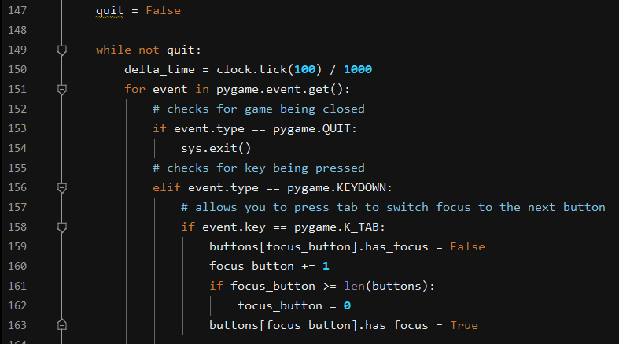

This code deals with the events that can happen in the menus, the first event is the system event whereby the user can press the red cross to close the program and stop the code running. This was an important feature to include as people may have become confused or frustrated if they pressed it and the program just stopped responding and didn’t close. Also there was no other way to close it other than in task manager or in the IDE. It means the user can quit the program at any time they need to. The next event checks for keys being pressed, it says that if the tab button is pressed then increase the index of the currently focused button by one, this is what allows the user to use tab to navigate between the buttons. It also has the feature built in whereby it returns to 0 if they keep pressing tab, before I added this you could keep increasing the index and it would essentially be trying to focus a button which didn’t exist in the list. Line 159 Is used to un focus the previously focused button.

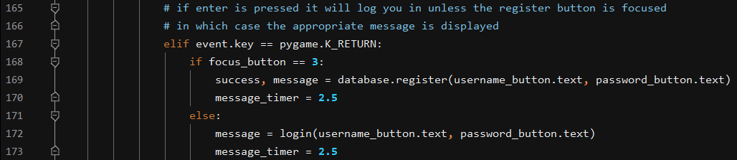

This is the next part of the event loop and it checks for the user pressing enter, it then checks which button was focused when they pressed enter. If it was button 3 (the register button) then it executes the code which adds the entry to the database. This completes the process of creating an account. If it was any of the other buttons focused when enter is pressed it attempts to login and if the credentials are valid they will go to the next screen. The message timer is used for displaying error messages to tell the user where they’re going wrong and why it isn’t registering/logging in.

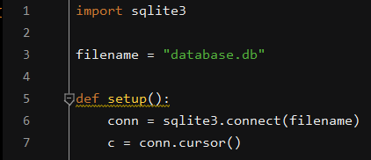

This is the first part of the code in the database, it imports the SQLite module which I used to make the database and specifies the filename. As there is only a single database for this program I called it database. The database Is then setup using the filename and a connection is made.



This is the code which sets up the users table, this table is where the account details are saved. As you can see the primary key is username, the teacher would have to ensure that each class member had a unique username made up of their first name last name and date of birth in order for this primary key to be appropriate. This means that it is highly unlikely that 2 people would have the same username. It also ensures that the username isn’t less than 3 characters long and that it isn’t more than 10 characters. This is done using SQL commands such as CHECK LENGTH, it also ensures that the password is more than 5 characters long. I have included a number of landings and crashes attribute to the table however the program doesn’t use it, it was an idea which could be further developed in future, the rocket game is what adds to these values when the player is put into a landed or crashed state.

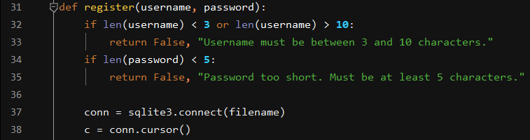

This is the register function in the database, it registers the user if the data they have entered is acceptable (username between 3 and 10 characters and password more than 5 characters). If it is not successful it returns false and the error messages are displayed telling the user which part of the register they haven’t satisfied and the reason for this. These are the messages which are displayed using message timer.

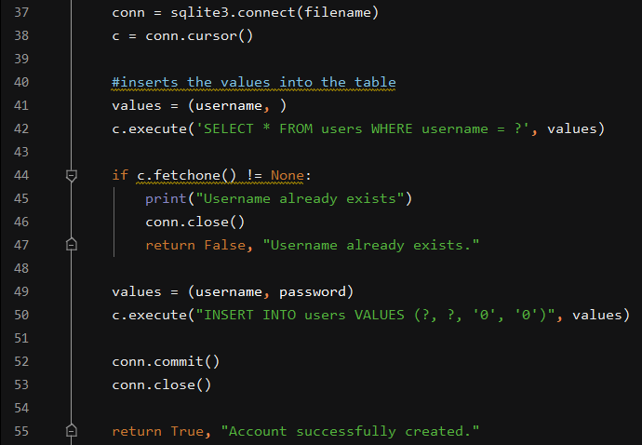

This is the code which creates the account in the database if the entries in the text boxes are valid. It firstly makes a connection to the database on line 37 and specifies which database it is connecting to. The cursor object then has to be created in order to execute commands and make changes. Line 41 takes the text from the username box and checks to see if the username already exists, if it does then the error message is displayed to the student saying they cant use that username as it already exists. If it doesn’t already exists and everything checks out after validation the values are passed into the database using the INSERT INTO command. Conn.commit() then saves the changes to the database and then the database is closed. The function then returns True and an appropriate message to tell the user their account is now registered. Using this extensive validation system I can ensure that the database isn’t filled with redundant data such as blank entries and single character usernames etc. IT also helps the user through the use of error messages meaning they can see where they’re going wrong if they’re having issues logging in.

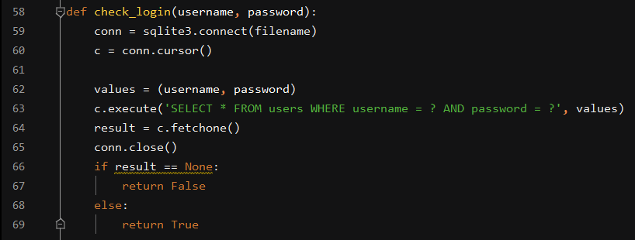

This is the check login function which is what validates the text entry if the user is making an attempt to login. It connects to the database and uses the SELECT command to check if there are a set of credentials which match the ones which have been entered into the text boxes on the login screen. The function then returns either False or True, if it returns True the login screen is closed, although the code for this is in the menus.py file. This is the best way of creating accounts as SQL commands can easily be understood and maintained by other people and the comments on the code explain what each part does. I have also tried to keep the variable names, table names and function names as clear as possible so there is no ambiguity when it comes to understand what a variable or function is used for.

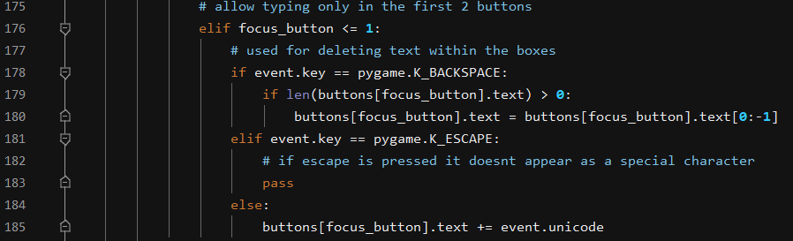

This code is from the event loop in the login screen function, it deals with the actual typing into the username and password boxes. It says if the button is less then or equal to number 1 in the list then it can be typed into (the username box is the first item, index 0, the password box is the second item, index 1). It first checks for the backspace key being pressed and it removes the last character of the text which is in the currently focused button. I realised when typing into the button that some keys appeared as special characters when pressed, one example of this was the esc key which appeared as a box (it doesn’t actually have a Unicode symbol so pygame just displays it as a rectangular box). This is accounted for on line 181 where it passes over the escape key if it is pressed at any point. If none of the other keys it is checking for are pressed then the focus button takes the Unicode character for the key currently being pressed. This allows people to type into the boxes using their keyboard and as I have used Unicode it would support many different languages.

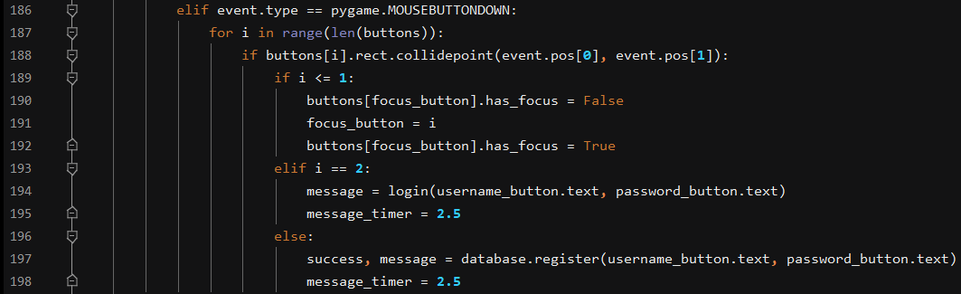

The final event type after KEYDOWN is mouse button down, this is the code I have used throughout the program for checking for mosue clicks. Again it works by getting the coordinates of the mouse click and comparing the coordinates to the buttons on the screen. The IF statement on line 189 checks to see if the click is in the first 2 buttons in the list (the username and password button) and if it is it changes the focus to that button, when the buttons have the focus they can then be typed into. Line 193 deals with the login button, it links to the database and either logs the user in or displays the appropriate error message. The same happens for the register button, the account is either registered or the correct error message is displayed as to why it hasn’t. This means the interface can also be navigated using the mouse as well as pressing tab, this is a useful feature as people are now more used to using a mouse to navigated pages and GUIs such as this which use a WIMP system.

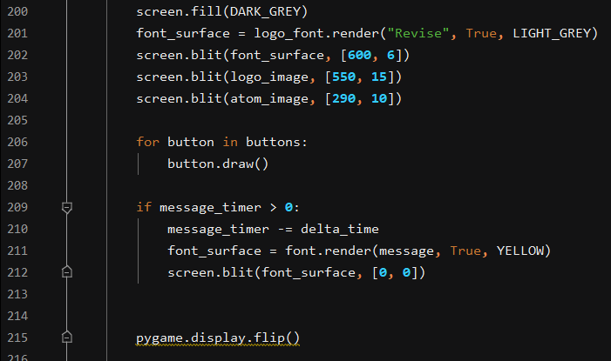

This is the drawing code for the login screen, the background is dark grey in colour and has the logo and images drawn over it. The buttons are then drawn using a for loop as they are part of a list. The spacings between the buttons and their position on the screen are specified when the button objects are created. The message timer is also used here in order to blit the messages onto the screen as a font surface for a given amount of time. This is the reason that delta time is imported at the beginning of the menus file as it allows you to set how long the error message appears for. It disappears once the timer is up. The display is then flipped so that the text and images are updated.

Phase 6 Evaluation:

With Phase 6 now complete I have successfully created the database and login system with the appropriate validation to ensure that the accounts system is simple and easy to use. I have used my SQL skills in order to alter the database and used Object orientated programming for the buttons. I have also created a validation system that displays the correct messages and timed these messages so that they aren’t permanently on the screen. This was done through my skills using Pygame which have now improved considerably.

Success Criteria 1: The program will require the user to first create an account or log in if they already have one. After this the program will register any required data to the username of that account. This allows them to log their data to their own accounts.

This success criteria is now satisfied as the user has the facility to created an account and register it to a database. Their results for the test can then be saved to these accounts so that they can track progress and show their teacher and their friends their results. Using unique usernames can ensure that the students are doing their own work and using the program. This could lead to further developments with the database which increase its functionality. Here are some error/success message examples:

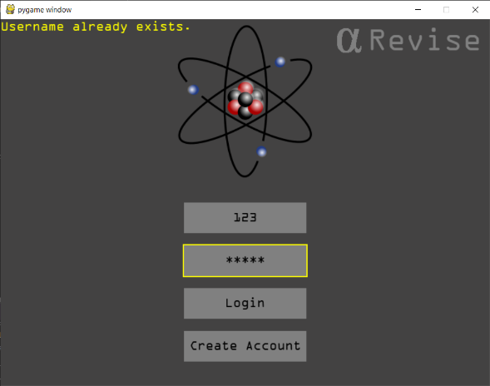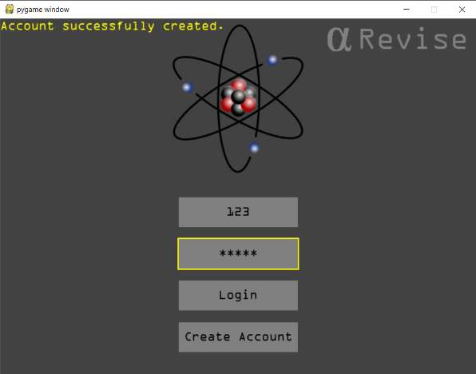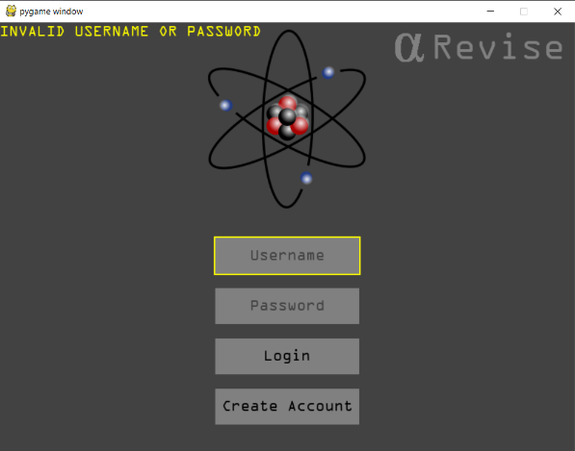

**Phase 7:** Creating database which stores user information and scores

Although the database has already begun development while developing the main menu I thought about how I was going to display leader boards. In my original idea there was only one topic and the score for this topic was stored in the database along with the username and password. I wanted to increases the complexity of the program so I went back to my design and had a look at how I could create the database design that I thought of there. Using this design I would have 3 separate topics and each user would be able to have a score for each topic. This creates a one to many relationship where 1 student can take many subjects, the subject is selected at the main menu stage however I will refer to this variable as I explain how the database works.

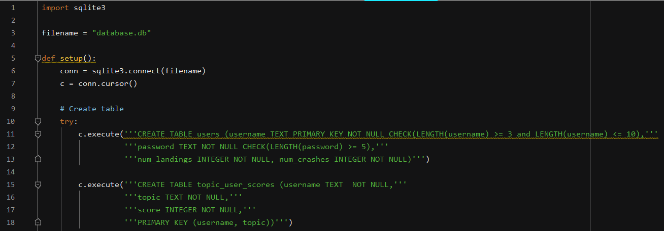

As it is the same database as the login system the setup etc is exactly the same. The only difference is that we now have another table called topic_user_scores. This table has a compound primary key consisting of username and topic. This is because each username can have a unique score for each topic and creating this as a compound primary key makes it easier to relate the two attributes and search the database. The last attribute in the table is score which scores the score for each topic. This program below is called DB browser and it allowed me to view the databases in a format which is easier for people to understand.

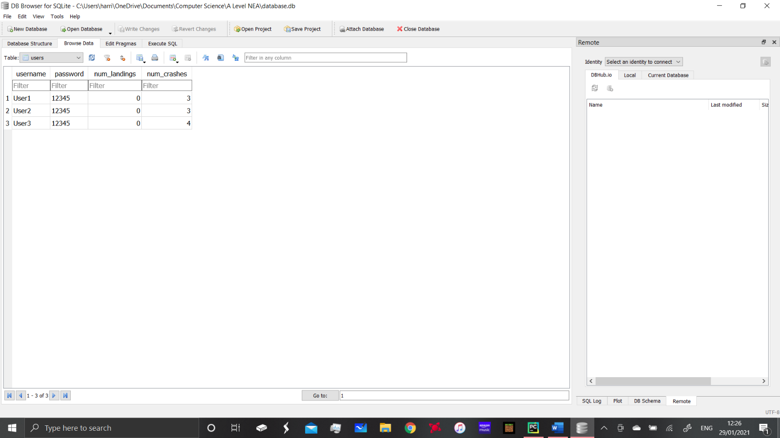

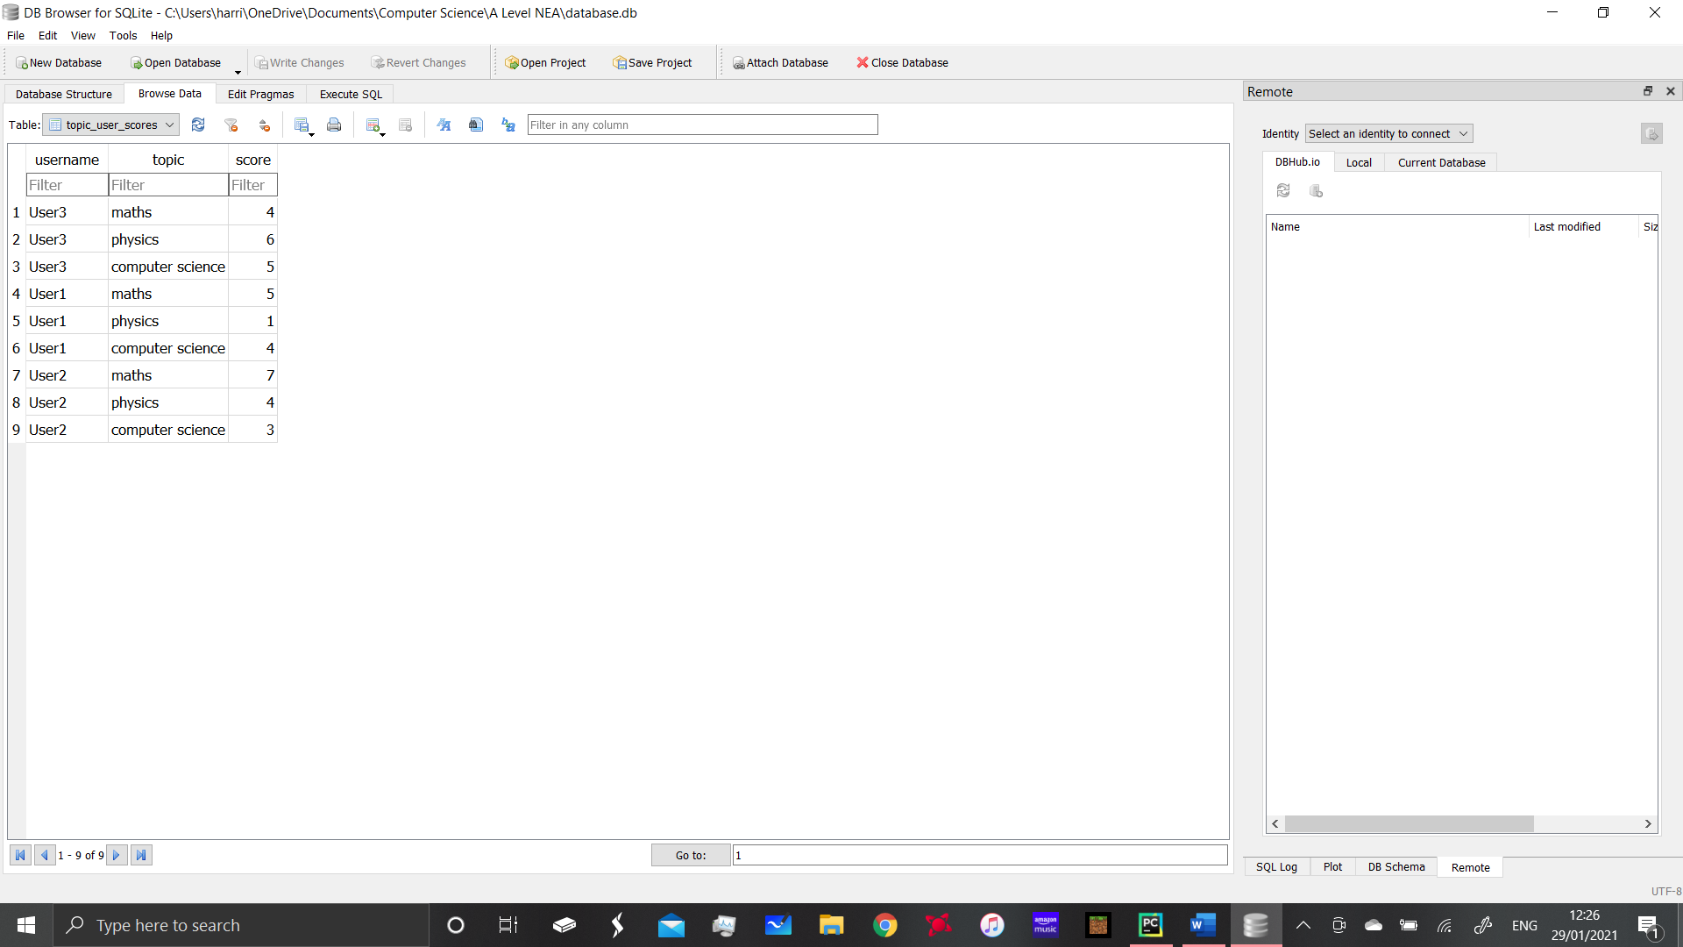This top table is the users table and as you can see the usernames and passwords are stored here. In reality the passwords wouldn’t be stored in plain text like this however that could be a future point for development. The number of landings and crashes are stored as well however as I said this isn’t part of the program yet despite the code being there.

The second table is the topic_user_scores table, as you can see there is a slight problem with data in the table being repeated due to the one to many relationship. Where each user has completed a topic it creates a new entry with their username, topic and score for that topic. This is due to the use of the compound primary key. This kind of database would only be appropriate for a small scale project like this and wouldn’t work for a large online database storing thousands of peoples data.

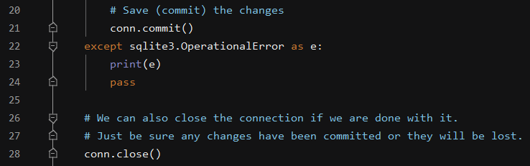

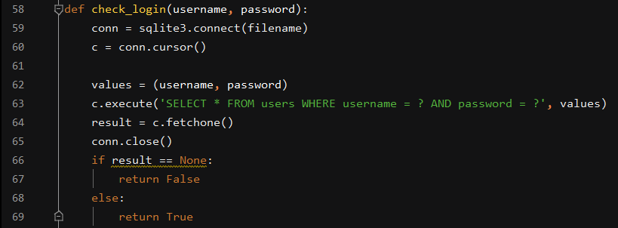This is the code which saves the databases after they have been created. When creating the databases I kept getting an error which wasn’t actually relevant and wasn’t creating any problems for the program. I decided to therefore bypass the error as it wasn’t causing any problems using lines 22-24. They highlight a particular error and if that error comes up it simply passes over it. The database is then closed as it is doesn’t need to be open the whole time the program is running.

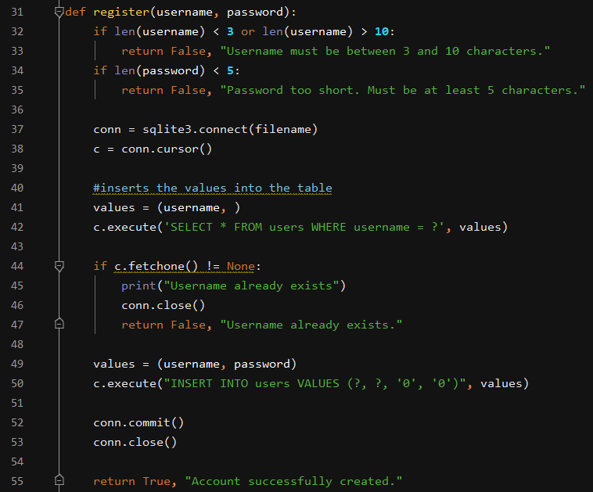

These 2 functions were explained during the development of the login system and are associated with the registering and logging in of accounts. They are called in the login screen function which is inside the menus.py file and perform their functions as expected and explained before. They are still part of the overall database file however so I decided to include the screenshots here.

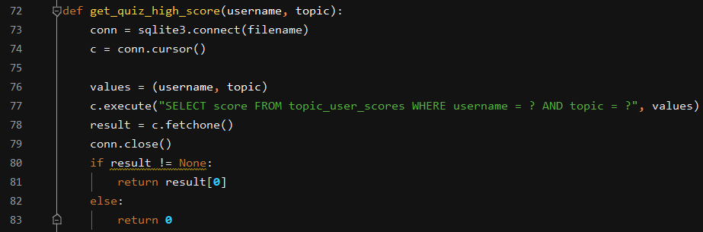

In order to use the quiz high scores for anything we need to get them from the database, the scores for each user and topic are put into the database after the quiz but the function is called in the main menu, this will be explained later as the menus and the database were developed concurrently. Once the connection has been made and the cursor is established the SELECT statement is used to select the score from whichever topic and user is needed. If the score is 0 then the function returns 0. As you can see the function takes the parameters username and topic as these are combined to create the primary key and to select the score for each topic.

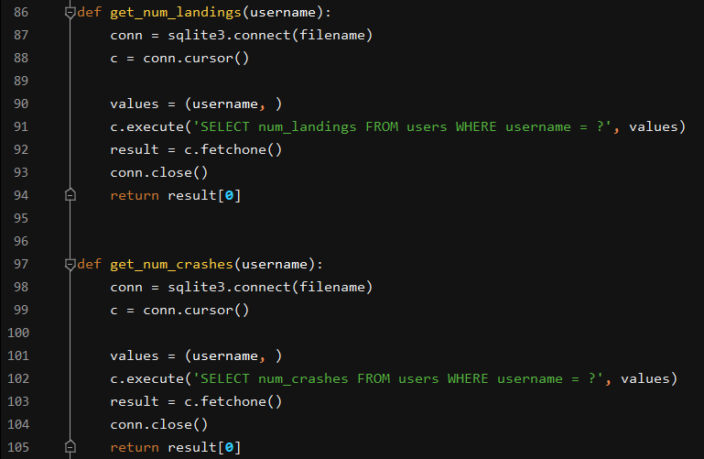

When I had the idea to register how many landings and crashes each user was getting I created a getter method for doing this which is shown above. This would allow me to get the results of the number of landings or crashes if I wanted to work out who was the top pilot for example. This would add an interesting feature to the game however I decided not to use it in the initial version as I believe it wouldn’t be that useful and is more based on the minigame. This may take away from the programs original and main purpose. On the other hand it may make the students want to do better in the rocket game which would inspire them to do better in the quiz. This may be a feature that would be added later on as part of a beta test to see if people think It makes a difference. Also by counting up the number of landings and crashes and adding them together you can tell how many times the student has done the quiz so this could also be a tool to see how frequently the students are using the program.

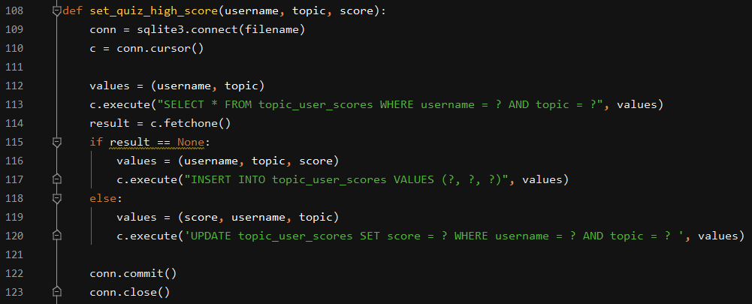

The high scores also need a setter method, the purpose of this is to update the database when a new high score is achieved. The getter method is used for retrieving or ‘getting’ the data for it to be used. The setter is used when new data needs to be added or the object needs changing in some way. Firstly the database is opened and the connection is made and the cursor is established. The username and topic are then used to determine which record is being edited. If there is no result in the score attribute for the username and topic being referred to the INSERT INTO statement is used to add new data into the score. If the user already has a score for the topic specified then score is passed into the UPDATE statement as part of values. The changes are then saved and the connection to the database is closed ensuring that all data is saved and up to date.

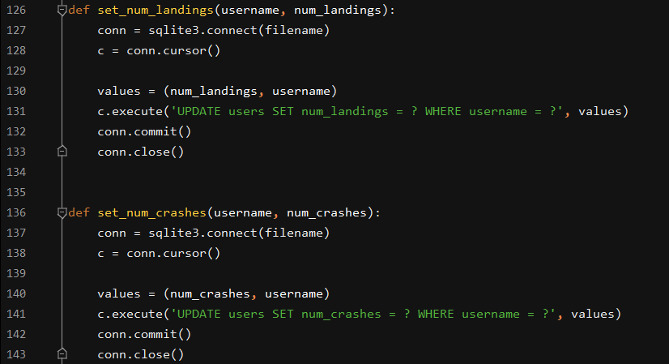

There is also a setter method for the number of landings and crashes. It works in the same way for both by creating a connection and cursor to the database and then uses an UPDATE statement to update the number of landings and crashes for each user. The changes are then saved and the database is closed.

Phase 7 Evaluation:

Although not all usages of the database have been explained yet there is evidence that it works and this is through the use of DB browser. The database can store the user credentials which are gained from the login screen function. The database.register function on line 169 of the menus.py file in order to add the user credentials to the database. Line 115 in the menus.py file shows the use of the check_login function which uses the SELECT statement to extract the data from the database and compare it to what the user has entered. The correct action is then carried out.

Success criteria 7: The score should be fed into a database which stores the scores for each user and topic

This is satisfied by the inclusion of the code mentioned above, as the users can create accounts, login and then any data they get from the game is saved to the database. This includes their score on the quiz and the number of landings and crashes. This data helps the program to fulfil it’s function by allowing the teacher to see the results from quizzes and the number of times they students have attempted the quizzes.

**Phase 8:** Creating main menu with topic selection which feeds into quiz

Originally when I created the program the quiz part was very basic and used a CSV file to load 3 questions, this was simply for testing purposes and I always had plans to increase the complexity of the program. I also wanted the game to be similar to one which would be seen in the professional industry, I decided to implement a main menu and on this menu I wanted to have a way of selecting from 3 topics which the user could revise. These ended up being Maths, Computer science and Physics although In reality the teacher could set questions from and subject/topic and the program would be able to adapt. This makes the program very flexible and versatile and it could potentially be used for an infinite amount of subjects where multiple choice answers can be used. I wanted the main menu to lead on from the login screen after the user had logged in so it is part of menus.py which contains both the login screen and the main menu.

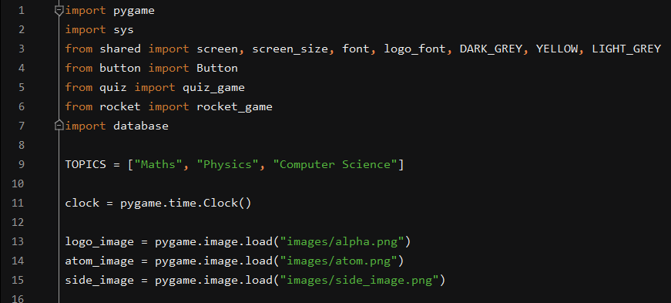

This is where the modules needed for the main menu and login screen are imported. The topics global variable is also defined here and can be edited here if the program was to be used for another subject. I have also included the pygame.time method as the messages on the login screen have a timer on them. The images are also defined here for use later on.

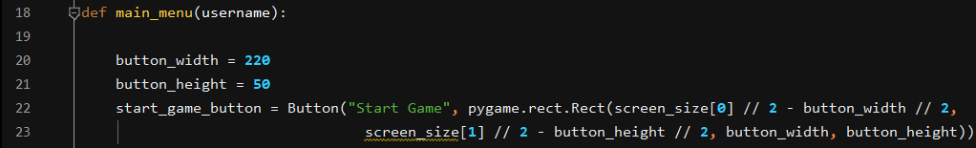

This is the beginning of the main menu function, I have defined a button width and height which I have used for the start game button and the topic buttons. The start game button is then created using the button class and it functions as a button with text on it which can be clicked on to begin the game.

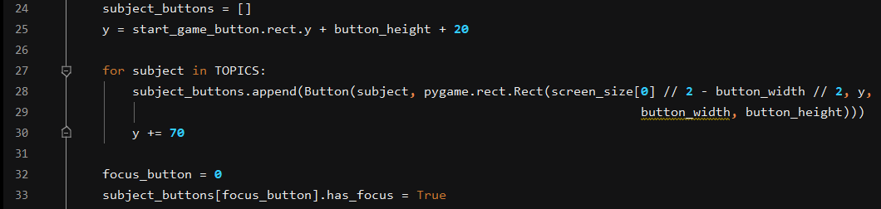

A list called subject buttons is then created and a button is created for each of the topics in the topic list at the start of the function. The variable y Is used to determine the spacing between the buttons so that they don’t look like one big button. The buttons are all drawn to be the same size with same size between them which makes them look professional and uniform. The focus button is then set to 0 and line 33 sets the has_focus to True for whichever topic button has the index equal to the focus button variable. This means that as the number changes the button which has the focus also changes.

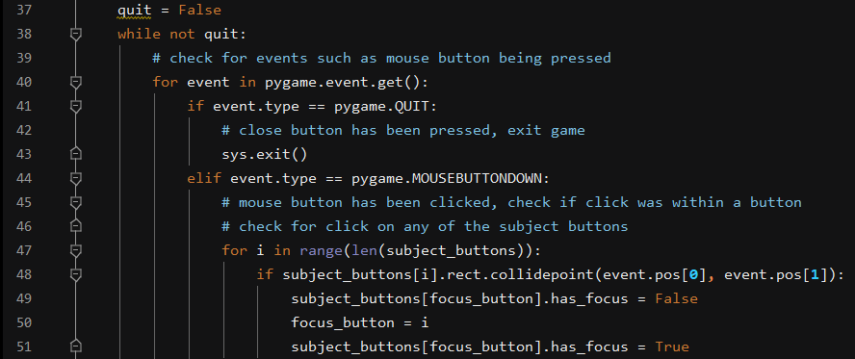

The beginning of the event loop is shown above with the first event being the pygame.quit which allows the user to close the main menu using windows red cross in the top right, this is used universally throughout the program where needed. The next event it the MOUSEBUTTONDOWN event which checks for the mouse being clicked. Again it checks for the coordinates of the mouse click using line 48. The purpose of the IF statement is to set the focus to the button which was clicked if the click was inside the button. It does his by using a for loop with i and setting the focus_button variable to i and saying that the button which has the index i is the button with the focus. The has_focus Boolean is then set to True for that variable which applies the yellow border from the button class and also means that button is selected for any further operations.

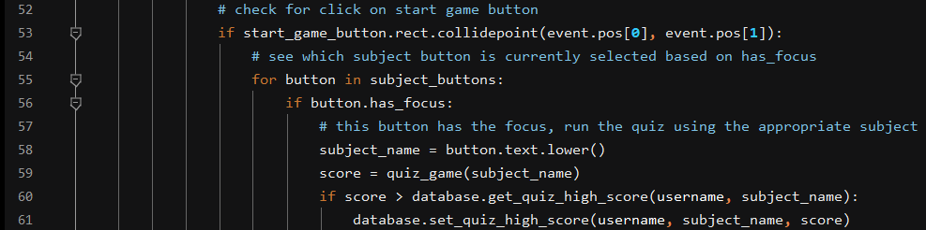

The next mouse click event is checking for a click inside the start game button. It is then deciphered which of the subject buttons was selected (the top one is always selected by default) it then passes this subject name into the quiz as the parameter subject_name. The subject_name parameter is not only used to open the correct questions in the quiz but it is also used to return the score back to the menu so that it can update the database if necessary. This is where the get_quiz_highscore function from the database file is first used. It is used to get the score for that subject currently and compare it to the new score which has been returned from the quiz. The IF statement then decides that if that new score is higher than the current score then it will use the set_high_score function to update the score in the database. This is here the quiz game function is called from using the subject name which the student has highlighted using the focus. This subject name is then passed in as the parameter.

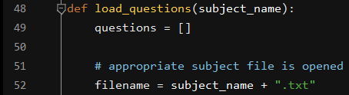

This is the code form the quiz which opens the text file, as you can see this is where the subject_name variable is used. It means that when the user focuses the button of the subject they want to study the correct subject is then opened in the quiz game.

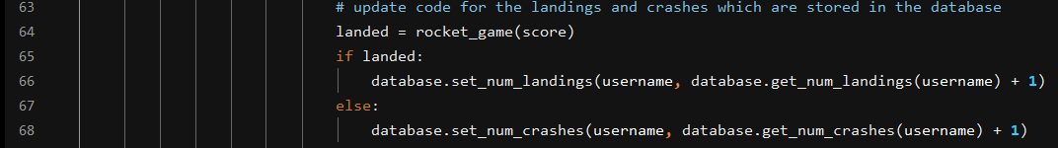

The crashes and landings are also updated here using the database set_num_crashes/landings functions. It takes the score from the rocket game and increments the counter by one depending whether the user crashed or landed.

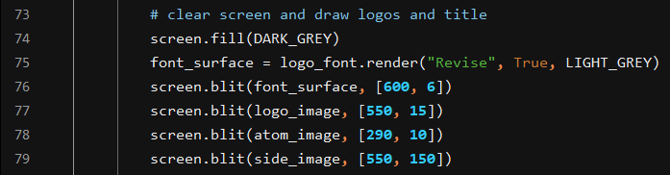

The background of the menu is set to dark grey to fit in with the rest of the program’s colour scheme. The logo and images are then also added in and some images which explain how to play the game. The numbers on the right are the ‘coordinates’ of the top left corner of each image.

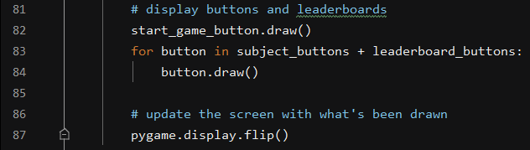

The buttons are then drawn in and pygame.flip is executed in order to update the screen. Using the for loop to draw the buttons is much more efficient than repeating drawing code.

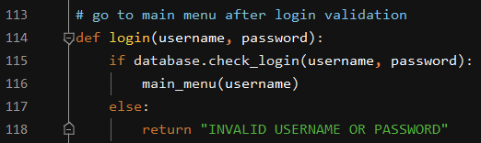

This is where the main menu function is called, this ensures that it appears after the login screen and that the user is logged in while using the main menu and onwards. The login function is called after the login screen. This way in the main file the only function that has to be called is the login screen function. After this all of the other functions call each other when needed. This allowed me to make the main.py file very simple.

Phase 8 Evaluation:

Shown on the left is the login screen with all of the buttons displayed. You can clearly see the placeholder text and the focus function and how that works. Shown on the right Is the main menu when it is first opened, the start game button is just a button so it cant be focused itself. However all the subject buttons can be focused by clicking them with the mouse. You can see the yellow border effect which shows which option is currently toggled and which will be loaded when start game is pressed. The images on the right relate to the game and the image in the bottom right is part of the instructions which tell the user what theyre meant to do in the game.

Success criteria 2: The main menu will allow the student to select what subject they would like to revise.

This is now satisfied as the user can select from 3 different topics and begin the game when they want to. This is achieved using the focus and start game buttons which allow one of 3 options to be selected before the game is begun.

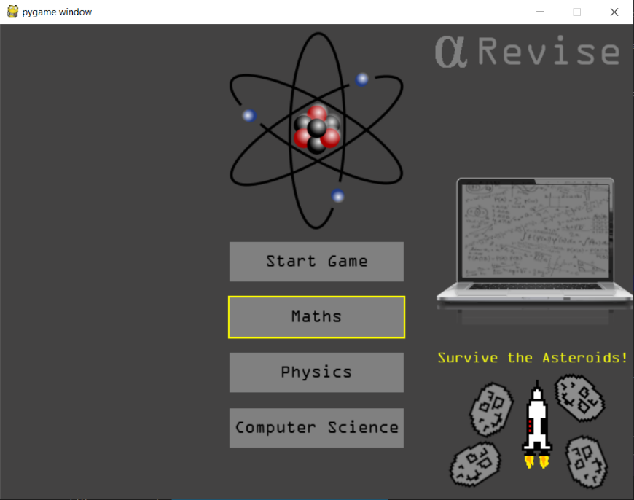Having completed this I now have a functioning program which has a login system, main menu, quiz and a minigame. The programme is almost completed and my skills have improved greatly through learning new techniques and practising ones I’d already learnt. The final part of the solution is all that’s left, this is the task of creating the leader boards on the main menu which complete the final success criteria. I think that I have successfully created a program which suits all of its needs and looks attractive and professional. It also runs smoothly and efficiently and isn’t hugely demanding.

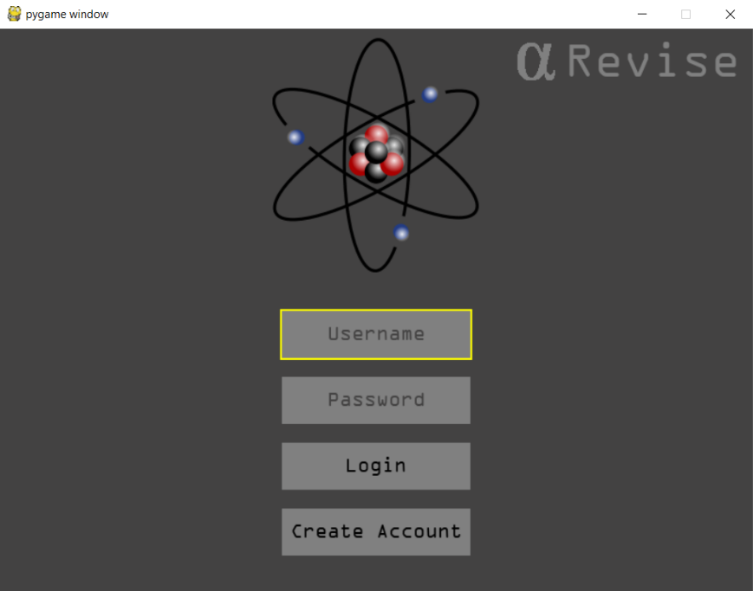

**Phase 9:** Using database to create leader boards

The final stage of the program that I wanted to add was the leader board system on the main menu. This is a feature of the program which makes it unique as it makes it competitive. As the program is intended for learning and revision there needs to be something which makes the students want to use it. Despite having the minigame the leader board feature adds a competitive element to the game. Some students will benefit from this as they enjoy competition, this will mean the program is used more as they want to improve their score to gain a top spot on the leader board. This could also be accompanied by a reward system set out by their teacher as well which would provide another incentive to use the program, do well in the quizzes and ultimately improve their learning. Initially when I only had one topic I had a simple leader board which just showed the top 3 scorers for that month. Now it is far more complex, there are three separate leader boards with the top 3 scorers for each topic on them. The leader board is displayed on the main menu and therefore some functionality needed to be added to the main menu and database in order to display this.

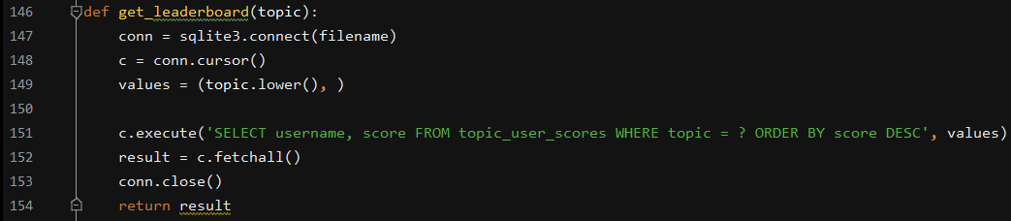

Firstly in order to get information from the database a getter method is needed. This comes in the form of this function which connects to the database to allow the information to be fetched. The values variable takes the topic name and converts it into lowercase. The information from the database is then fetched using the SELECT statement, the statement selects from the user scores table where the topic is equal to the topic name set in the variable. It then uses ORDER BY to order the results into descending order. The results are then fetched from the database and the connection is closed and the results are returned to the program.

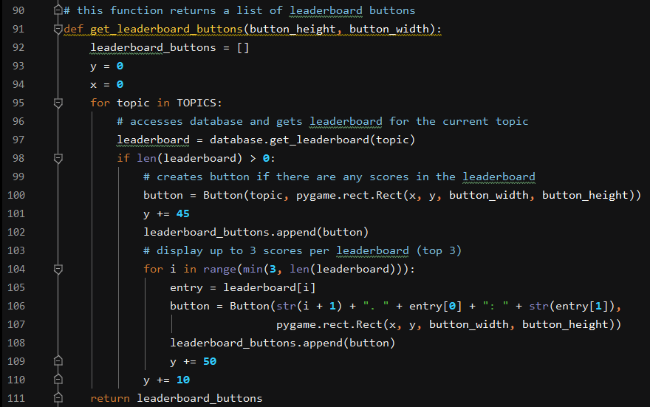

This is the get_leaderboard_buttons function, it is part of the main menu function and is used to fetch the data and create the buttons using it. It uses the same sized buttons as the topic buttons and start game button as it takes the button height and width as parameters and these are constants defined earlier in the program. It then creates an empty list of buttons which will contain the leader board buttons. The x and y variables are then set to 0 and these can be used to set the spacing and positioning of the buttons when the objects are created. It then uses a FOR loop to apply all the following code to all the topics from the TOPICS list.

The variable leader board then calls the get_leaderboard function from the database to select the information needed to put into the leader board from each topic. It determines whether there is anything in the database before creating any buttons. If information is found then it creates a button with the topic name on it. This is because each leader board is displayed with a topic name at the top so you know which leader board is for which topic. It then creates a spacing of 45 pixels before the next button is created and adds the topic button to the list of leader board buttons. The for loop on line 104 is used for fetching the top 3 results from the leader board, it specifies that there should only be 3 entries in the leader board. The entry variable is then set to leaderboard[i] meaning it will go through each entry in the database and create an array form them. 0 is the first index of the array and is equal to the username which is the first attribute in the table. The second index in the entry list is number 1 which equates to the second attribute in the database, this is the topic which the user in the first index has studied. The final thing in the entries list is the score for that topic which is index 2. The buttons are created and the properties are changed using the creation code. Firstly a string is created which takes the number of the item in the array and adds one, this means that the first item is displayed as number 1 the next thing in the leader board will be displayed as number 2. The next thing In the object creation code is for the username to be displayed as a string, then the score is displayed next to it. The buttons are then appended to the list. The y variable is then increased by 50 pixels which means it is below the previously created button. The leader boards are then spaced out by a 10 pixel gap so you can distinguish where one of the leader boards ends and the next begins.



This is where the leader board buttons are created and the function is called. It comes as part of the main menu function which means they are displayed on the main menu. They appear in the top left corner as the x and y positions are initially set to 0 in order to put them there. This is because the button coordinates are always equal to the top left corner of the button.



This code is run every time the main menu function I executed which is both after the login screen and the minigame when the game over button is pressed. This means that the leader board is always displayed in its most up to date form.

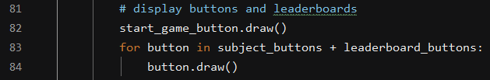

This is the code which draws the buttons on the main menu. As you can see I have added the leaderboard_buttons array to the subject buttons array, this means that they will be drawn at the same time.

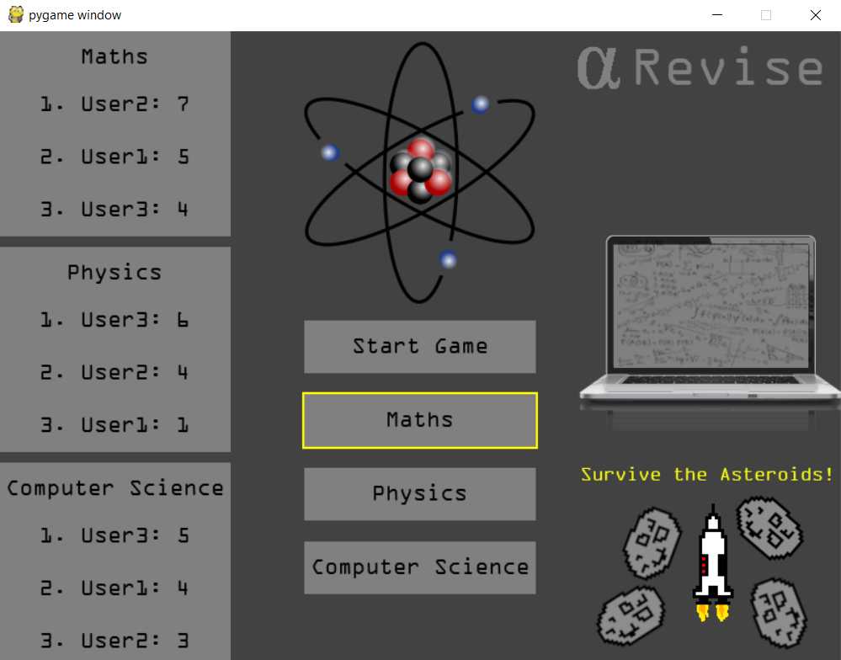

This is the final result and how the leader board looks when displayed in the main menu. As you can see there are 3 distinct leader boards which all have 3 users results on them and have ranked them in order of best to worst. If for example only one user had completed the computer science topic quiz then the leader board would only display them on the leader board and none of the other users. This is because they are still at the top even if they’ve had no competition, if only 2 users have played then the 2 users will still be displayed in first and second based on their score. It only creates buttons for data which is there which means that if nobody has done the quiz then no leader board is created. This means that you don’t have empty leader boards on the screen, only ones which have one or more entries but no more than 3 so that they can all fit on the window as shown above.

Phase 9 Evaluation:

With phase 9 now complete the program is complete and ready for testing. The database is now complete and works as expected. It would also continue to work if the subjects were changed and if the maximum score of the quiz was changed. It successfully puts all of the users in descending order based on their score. It creates three separate database tables. It also updates if the user completes the quiz and then returns to the menu. For example if they were third on the leader board and they complete the quiz with a higher score when they return to the menu after the minigame their score will be up to date. This is because the buttons are redrawn every time the main menu function is called. This means the user only ever sees an up to date version of the leader board which will always be true and correct as the code for the database ensures that the changes to it are saved.

Success Criteria 7: The data is fed into a database which is used to display a leader board for high scores for that month, this allows students to compete in order to improve their knowledge and get better scores than their friends.

This success criteria is now satisfied as a leader board has been implemented into the menu which can be viewed both before and after a quiz is complete. This allows students to compared results and teacher to award students if they have managed to place higher than the rest of their class.

**Final implementation details:**

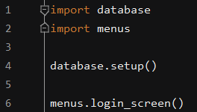This is the entire main file of the program, in order to keep it simple it only performs 2 functions. It imports the database and menus file as these are all that is needed. The database it then set up for use throughout the entire program. The login screen function is then called. This leads to the rest of the program as the main menu is the called if a successful login is detected. From the main menu the quiz is called, then the rocket game is called from the quiz. The main menu can then be called again when the rocket game is over. This means the whole program can be self-contained in this main file.

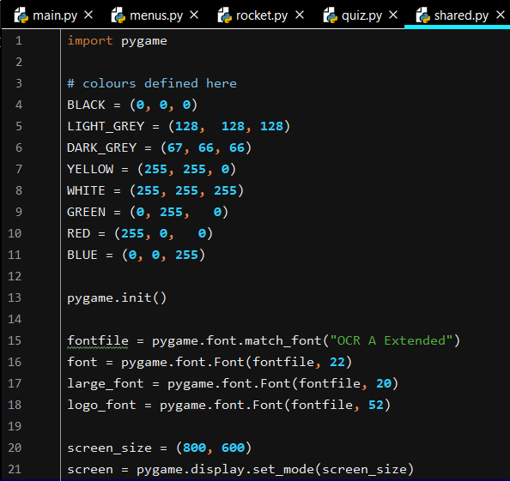This is the shared.py file which contains all of the data which is shared by the files. As you can see all of the colours used in the program are defined here. There is also some other data such as pygame.init() which is required for all parts of the program which use pygame. This is because the pygame module has to be initialised every time it is used so that it’s features become available. The font which I selected for use in the program is also here along with the different font sizes used throughout the program. The screen size is also defined here as this remains constant throughout the whole program. The screen is then also created here using the Pygame syntax display.set_mode. This takes the screen size variable so that the screens are always created the same size.

**Phase 10:** Testing

Test Table:

In order to evaluate parts of the code individually and test their functionality I will be referring back to the test tables form the design section. This means that I can perform each test on the newly developed code to ensure that it performs the functions that it is mean to. Each test will be shown with screenshots of the code working and some with past versions of the code which I used to test and to get me to where the code is now, this will show how the code has progressed and show it working in its final form. This also helps to inform evaluation and prove that certain success criteria have been satisfied. I have chosen a modular approach to testing whereby each module is tested individually and can work individually, when new features were added they were then tested again in order to ensure that they functioned as they should and didn’t disrupt previously developed modules. This enabled me to keep up to date with testing and reduce the amount of changes that needed to be made to the program at the end of the development. This also enabled me to ensure that all the cod in each module was as efficient as possible and that the techniques used were complex enough.

Quiz Testing

|  |  |  |
| --- | --- | --- |
| Test Number | Test Aims | Expected Result |
|  | When game begins the quiz shows questions from the selected subject. | Appropriate questions are displayed. |
|  | Confirm that quiz proceeds with the next question when an answer is pressed. | The next question is displayed regardless of correct/incorrect answer. |
|  | Scoring is counted correctly. | Score counter incremented when correct answer is clicked. |
|  | Questions are not repeated. | Question doesn’t appear more than once within the same quiz. |
|  | Questions are shown in a random order. | The questions appear in a different order each time the game is played. |
|  | Ensure that all items are displayed correctly on screen. | Text shouldn’t exceed the width of the pygame window or buttons that they are inside. |

**Test 1:**

Initially the quiz game did not have the ability to select questions from a file and the questions and answers were stored in a list. Although initially this was alright for just developing the question screen I thought in order to make it more complex I would need to add some kind of file read into the program. That is the reasoning behind using the Tab separated values file. Each subject has its own file which can be easily altered by the teacher which allows them to easily set the questions, when the topic is chosen in the main menu the respective file is opened as shown below.

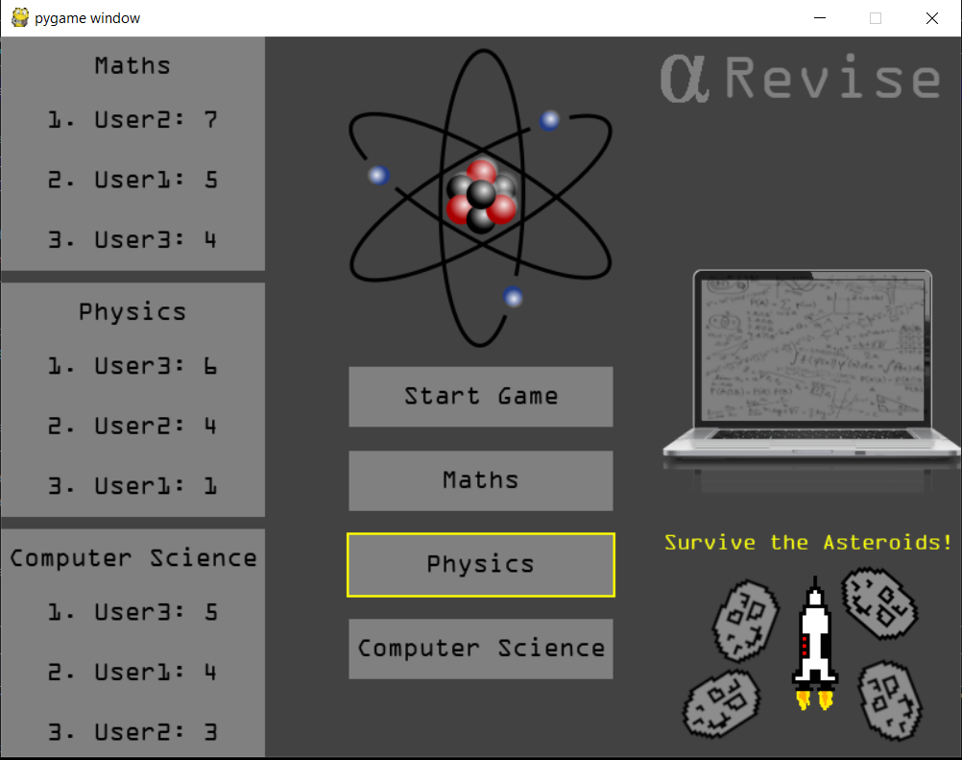

This is the main menu and as you can see the student clearly has the physics topic selected, they then click start game to play. The topic name is then passed into the quiz game function so the correct file is opened and appropriate questions and answers are displayed.

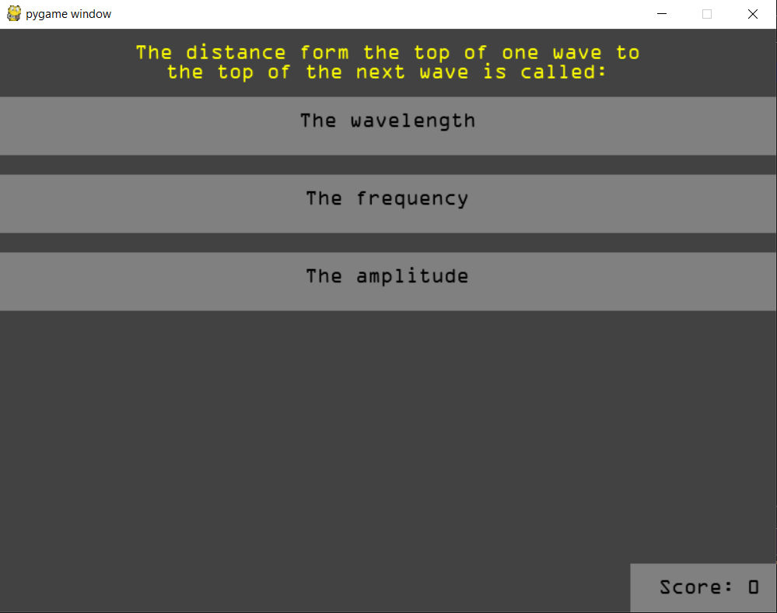

The first question to appear is a physics question based on the waves unit at GCSE, this shows that it has worked as I know that this question comes form the physics file and this is proven below:

As you can see at the top of the file is the file name, “Physics” and the question being shown above is the question from the 5th line.

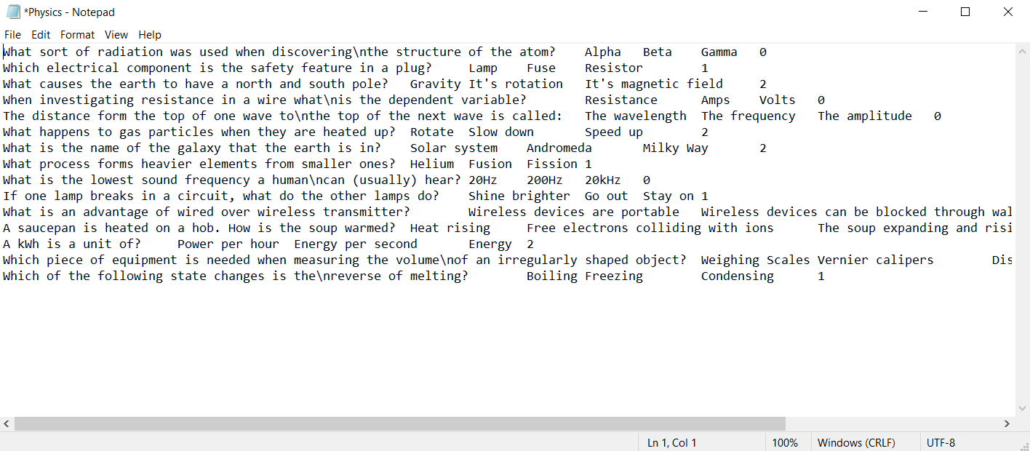

Then in order to double check I clicked through the rest of the questions and they were all from the same file as you would expect. I did this 5 times to ensure that each time the correct file was opened and that it wasn’t just a coincidence by chance or that there was a problem with recognising the file name. Therefore test 1 has been successful as the game begins with the selected subject which was the initial aim and expected result from the test. I had to test this as I switched from the system whereby the questions and answers were part of the program code to a system where they were stored in an external file.

**Test 2:**

When an answer is clicked the quiz proceeds whether it is correct or incorrect. This one life system helps to reduce the risk of trial and error when the students are doing the quiz part of the program meaning they cannot just guess the answer.

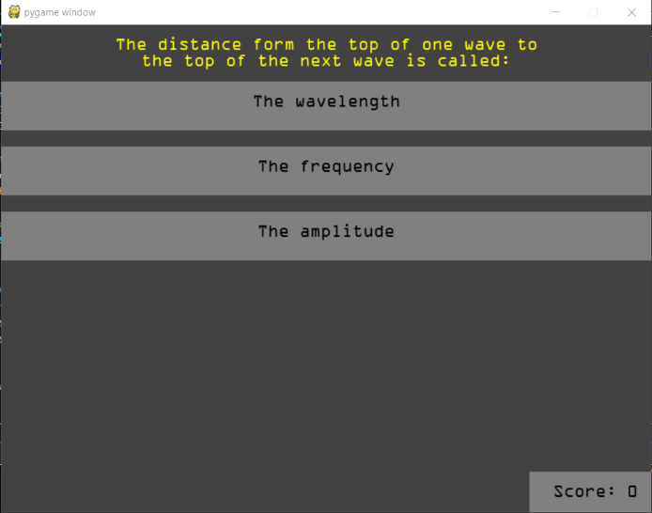An example of a run through:

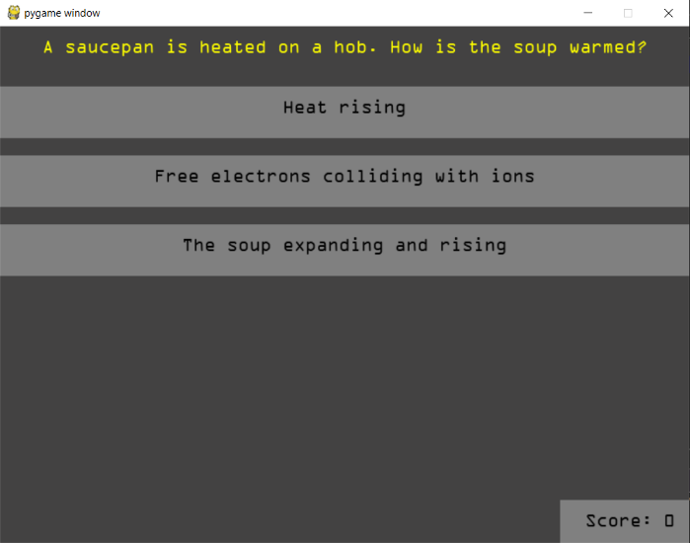Wrong answer purposefully pressed, question screen changes to show next question. I will not show all of the testing as there would be hundreds of screenshots to show this however it does work and this is just one example of this shown here.

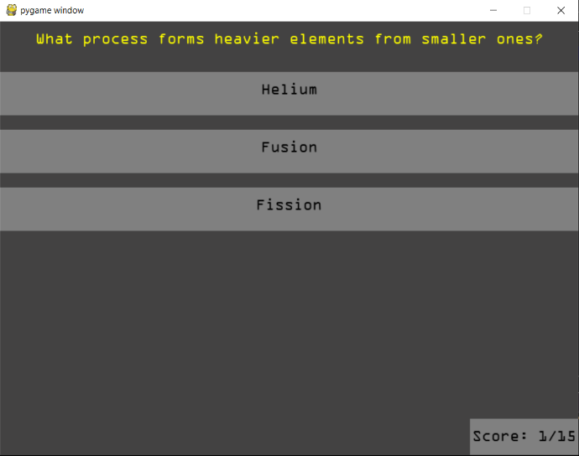Correct answer pressed, next screen shown. After this I ran through the entire quiz and every time an answer was pressed a new question and set of answers was shown. I repeated this three times for all topics to ensure that this function worked correctly.

Test 2 has been a success as the questions move on no matter what answer was selected. This ensures that students are carefully selecting the answers to their questions rather than clicking straight through. It prevents the program getting stuck in a process which the user can’t get out of. This is essential for the program flow as the user would become frustrated if the program was getting stuck on questions and was unable to continue with the quiz.

**Test 3:**

In order to demonstrate that the scoring is counted correctly I will be testing the scoring by playing the game multiple times with the question file open next to it. That means I can prove that when the correct answer is pressed the score is incremented properly.

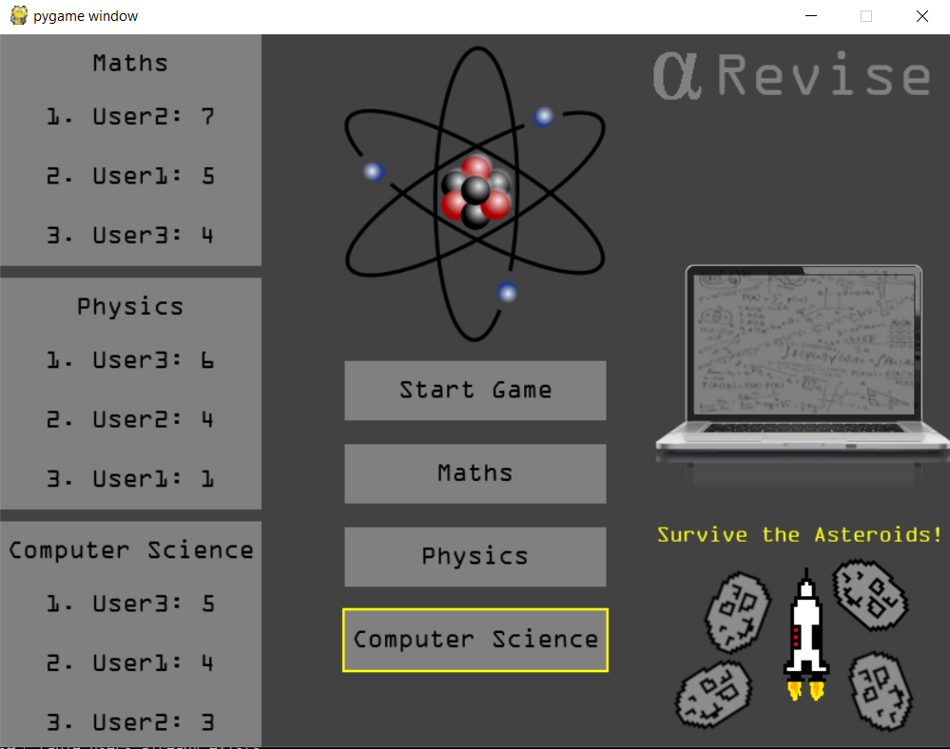

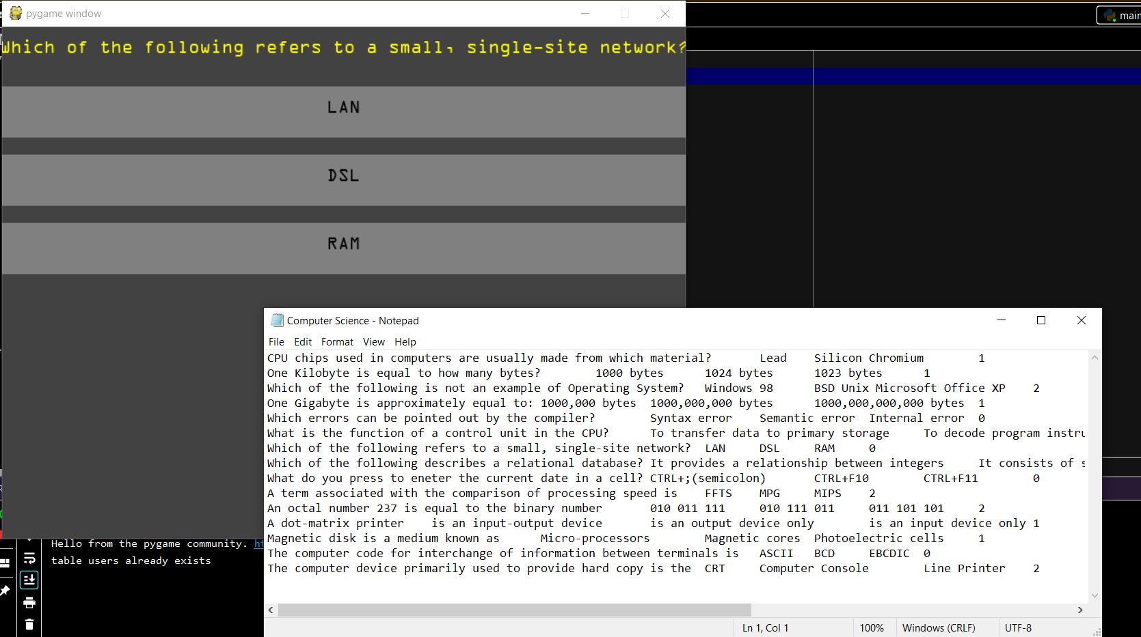

Here I have selected the computer science Topic and you can see I have the first question open alongside the question file, I will then select the correct answer from the question file and click it into the game. I expect that when the screen updates the with the next question that the score counter will be incremented. I know from the way I’ve coded the program that the score is stored as an integer and the score counter is created using this integer. Therefore the score is always the same as what is shown on the counter. As you can see the answer for the question above is shown to be index 0, therefore that is the option I will select (the top option).

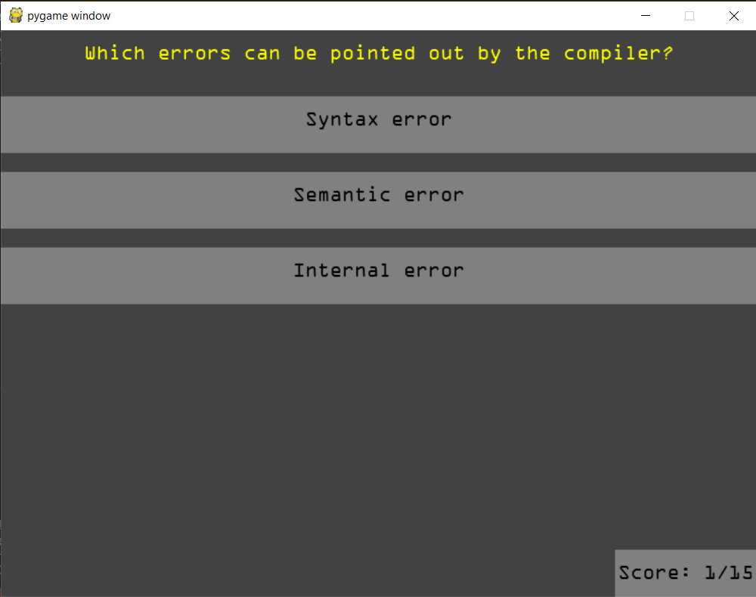

As you can see having pressed the answer which is set to be correct in the answer file the score has been incremented by 1.

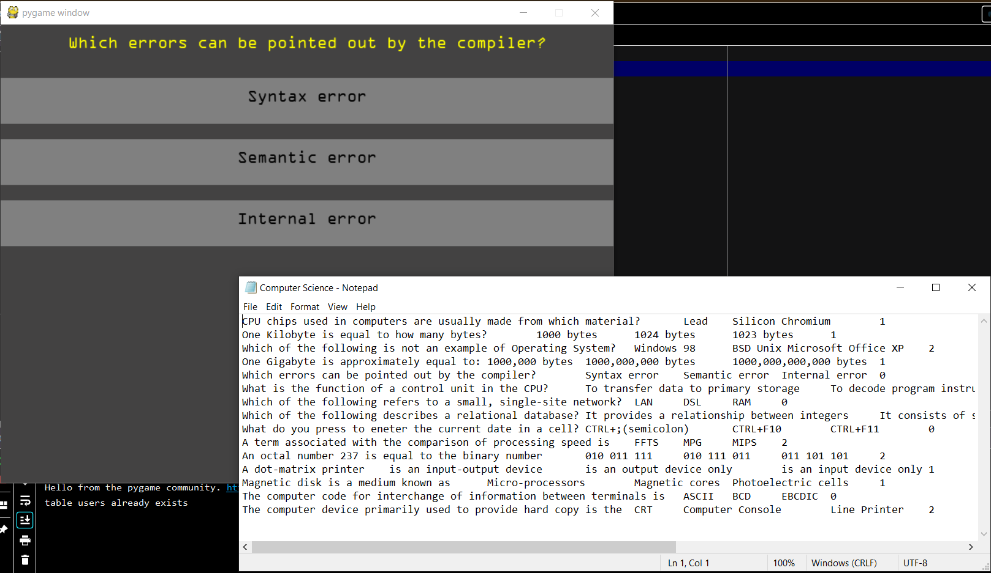

As you can see for the next question the correct answer is also index 0, I will press the first option in the program in order to check this.

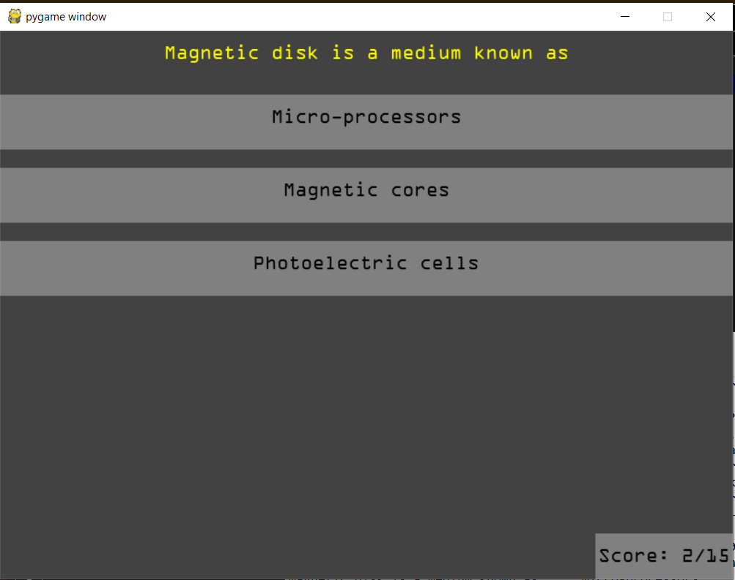

The score counter has been incremented by 1 again, doing this test twice is not sufficient so I completed it many times both getting the questions wrong and right in order to ensure that the score counter was/wasn’t incremented based on whether the user got the answer right/wrong. I will show an example of getting the question wrong below.

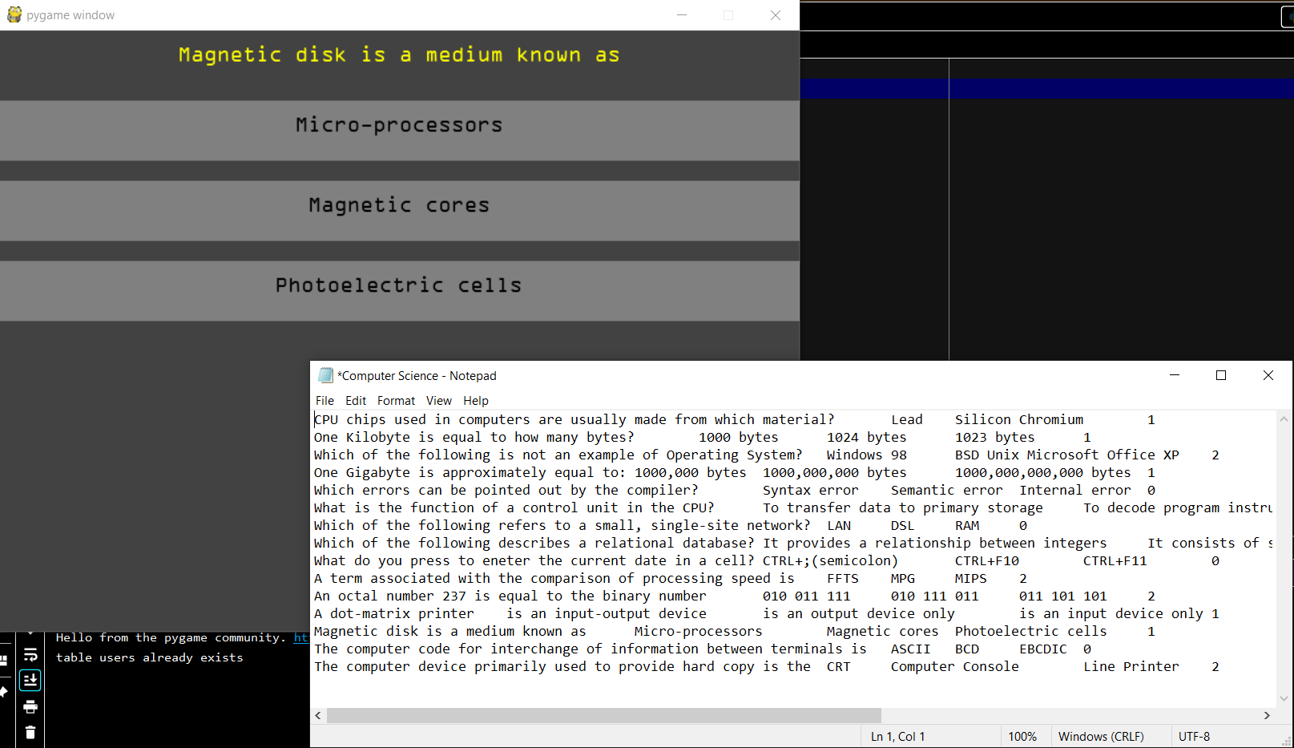

As you can see the index of the correct answer for this question is 1 (the second option) therefore I will choose the wrong answer on purpose to see if the score counter is incremented.

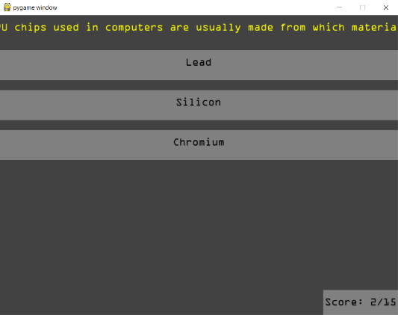I chose the third answer which was clearly wrong as we checked the index of the correct answer. As expected the score counter has not incremented. After multiple tests on all quiz files I concluded that the score is being stored and displayed correctly. Therefore test 3 has been a success as the code performs as expected.

**Test 4:**

The aim of test 4 is to ensure that the questions in the quiz are not repeated so that a student can gain easy points and increase their fuel level without actually doing any revision of the question. If questions were to be repeated this would cause problems as students could just boost their score using the repeated questions. I have included code which removes questions from a list of questions once the question has been answered. This means that the user cannot see the same question again in the same quiz. This is demonstrated below.

|  |
| --- |
|  |
|  |
|  |
|  |
|  |
|  |
|  |
|  |
|  |
|  |
|  |
|  |
|  |
|  |
|  |

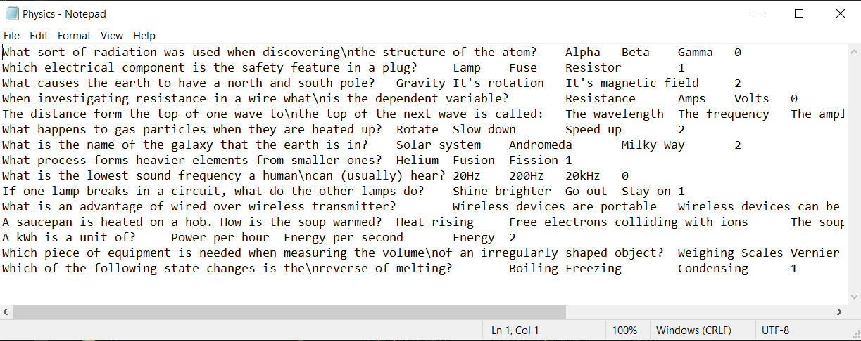

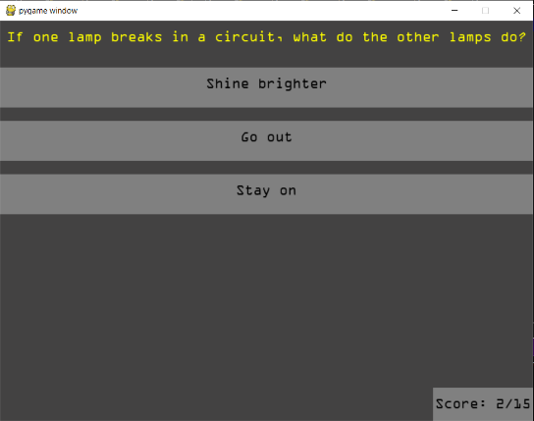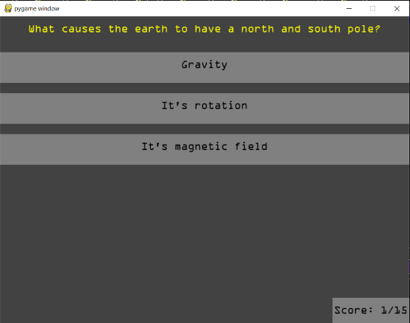The quiz is out of 15 and so in theory each of these questions should appear at least once, but not twice if the user plays the quiz. If I had not included the code that removes the question from the list the probability of a question appearing twice is high.

J.

C.

L.

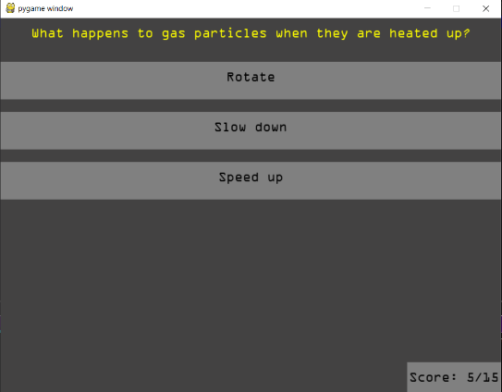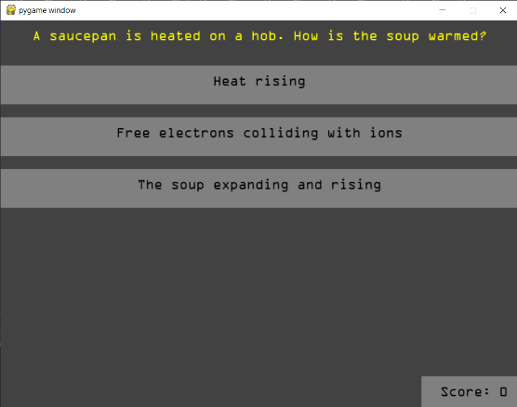

F.

O.

B.

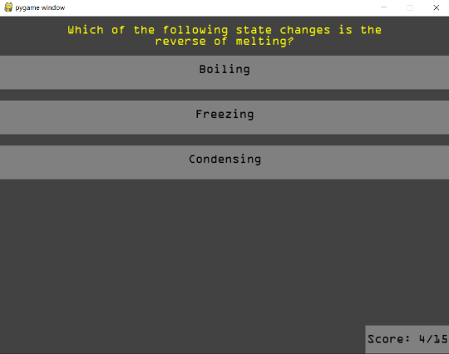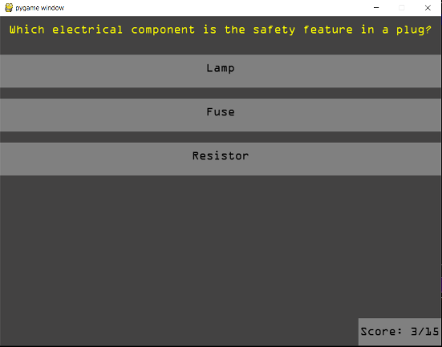

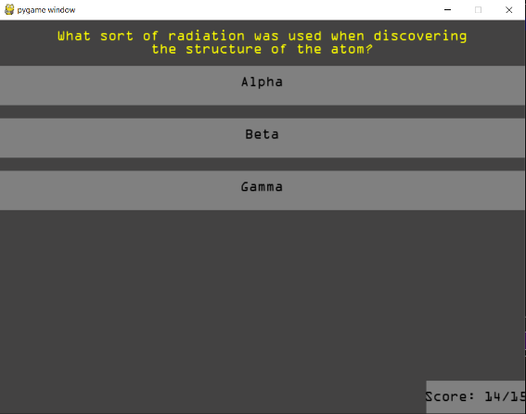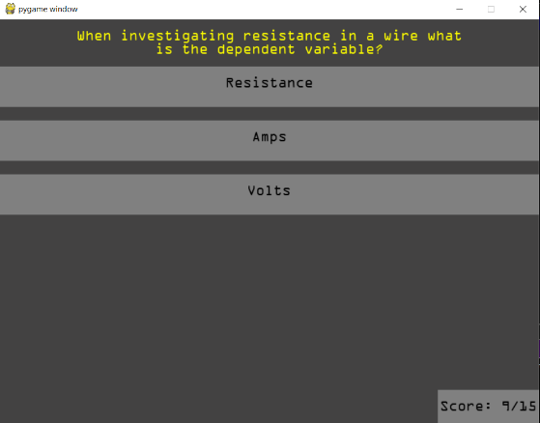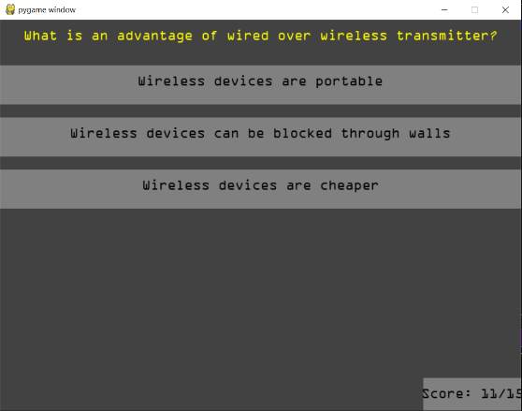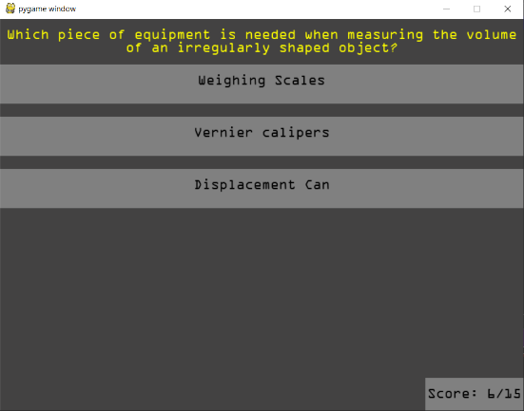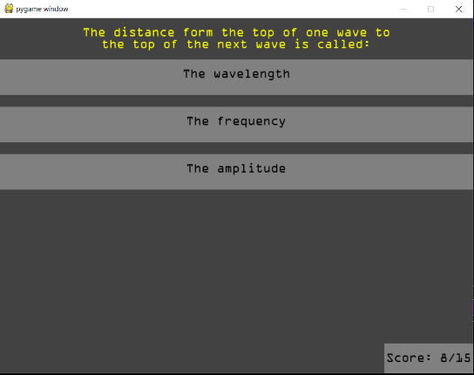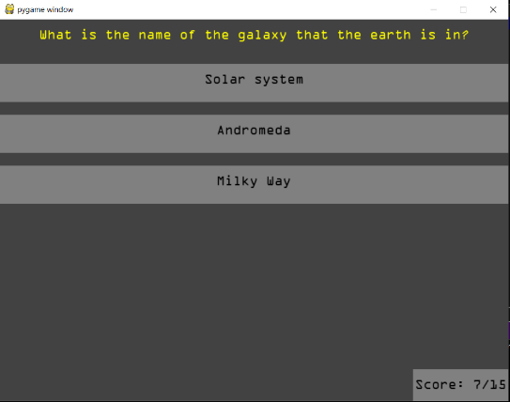

M.

D.

A.

H.

I.

K.

E.

G.

N.

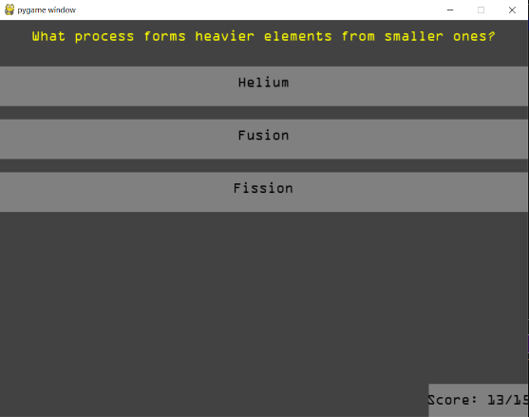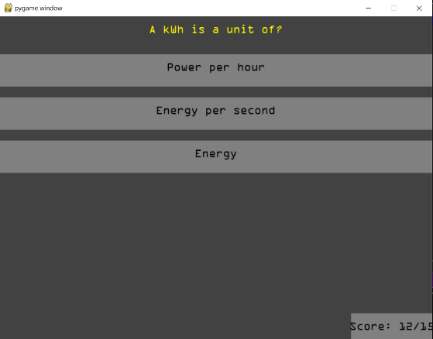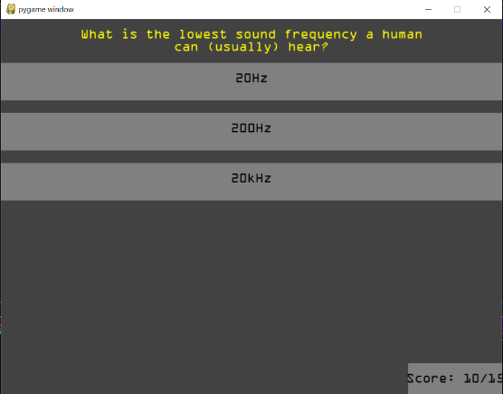

Shown above is a full run through of the quiz, the letters in the screenshots correspond to the letters of the questions in the question file. Question A is the first in the quiz file, I used this system to prove that all the questions appear and only appear once. Therefore they are not repeated. The same test was performed 4 times for each topic and involved a system the same as this for all run throughs. That means that this has been tested a total of 12 times. It proved that the code was effective in preventing any questions from appearing twice. Again it would take a lot of space to show this 12 times so this is an example of one of the tests I carried out. This way I could actively track as I went through the program which questions had appeared and log it to make sure that they didn’t appear twice. Test 4 was successful and the questions do not repeat twice in the same quiz, this means the code I implemented works as it should and the students are unable to gain an unfair advantage.

**Test 5:**

The purpose of this test was to show that the questions appear in a random order different to how they appear in the question file. This makes the questions less predictable and the answers cannot be memorised easily. If there were more questions then it would select randomly form the questions available up to the specified number of questions for that quiz.

|  |  |
| --- | --- |
|  | |
|  | |
|  | |
|  |
|  |
|  |
|  |
|  |
|  |
|  |
|  |
|  |
|  |
|  |
|  |



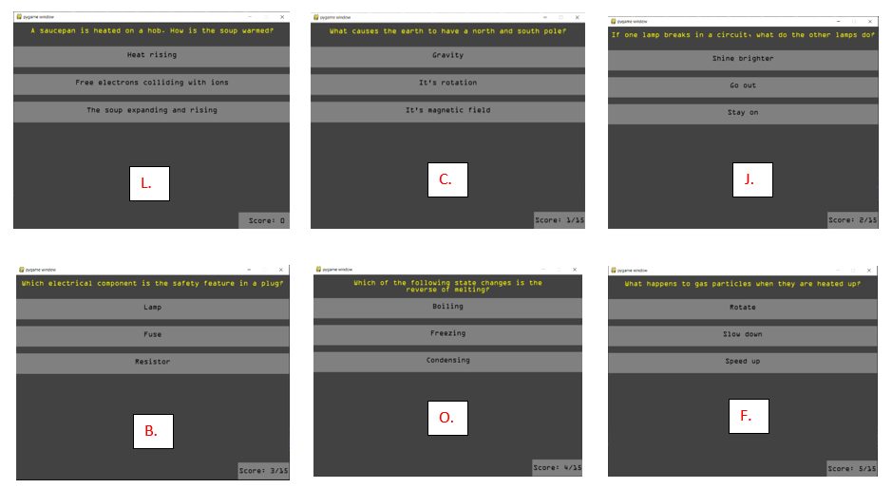

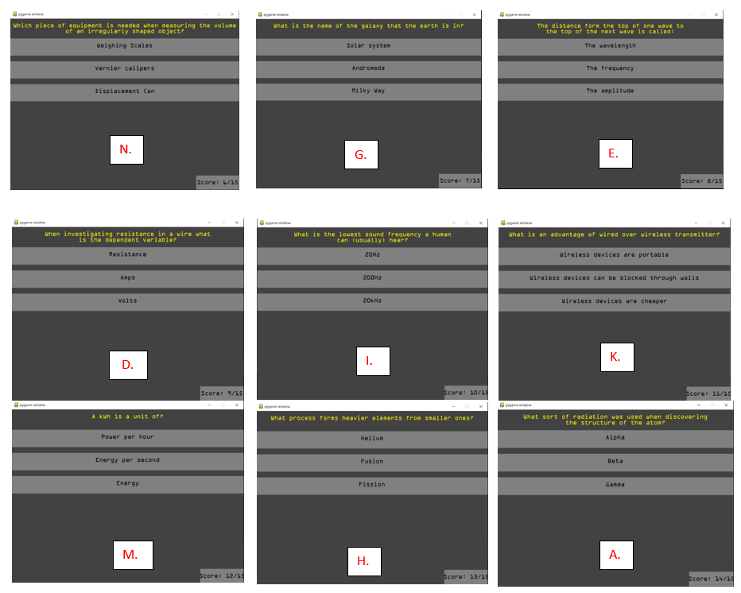

Shown above is a successful test of the quiz and the randomisation, the questions appear in a random order compared with how they appear in the question file. As you can see A which is the top question in the question file is the last question to appear in the quiz (by chance). I repeated this test multiple times for the quiz on each topic mode. Each time produced a different result and therefore I can conclude that the test was a success and that the question order is always randomised to ensure that the question order cannot be noted down. This means that cheat sheets won’t be of any use and the students can’t cheat.

**Test 6:**

Text 6 is about ensuring that the questions and answers are displayed correctly on the screen. In this test I was looking out for things such as the text not fitting inside the buttons, the text being distorted in any way or any display issues. I wrote the question files after developing the quiz as I originally just used the placeholder questions I talked about earlier. Therefore when I loaded thew question files I had an issue whereby the question text wasn’t fitting on the screen correctly, here is an example:

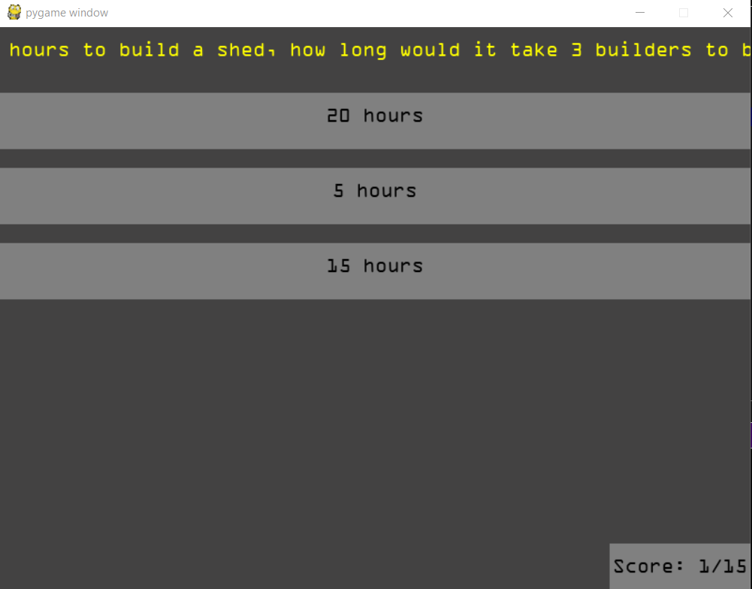

Here you can see the question is being opened and displayed correctly from the file and the answers are present. However as you can see not all of the question text fits on the screen. This is an issue as the student cannot actually read the question which would allow them to work out the answer.

The solution is shown below:

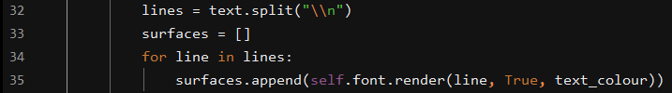

This is a method of adding new lines in the text by putting \n in the text. This is not an ideal way of doing it as the teacher will actually have to type \n in the questions in order to fit them on the screen.

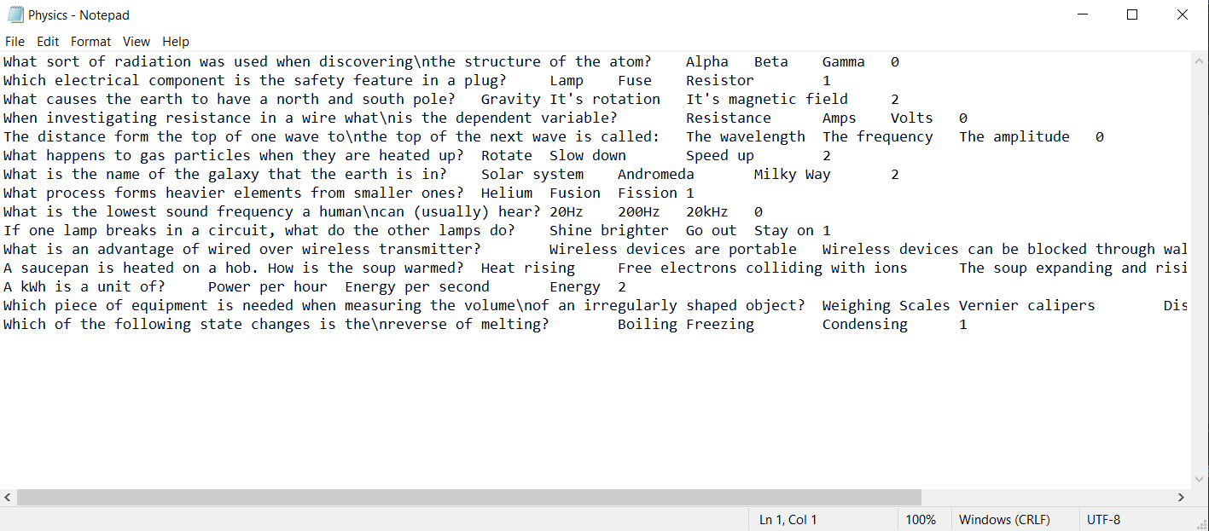

Here is the new text file for the physics topic, as you can see some of the question text has a \n in it. This is where the question doesn’t fit on the screen and a new line is created in order to make it fit.

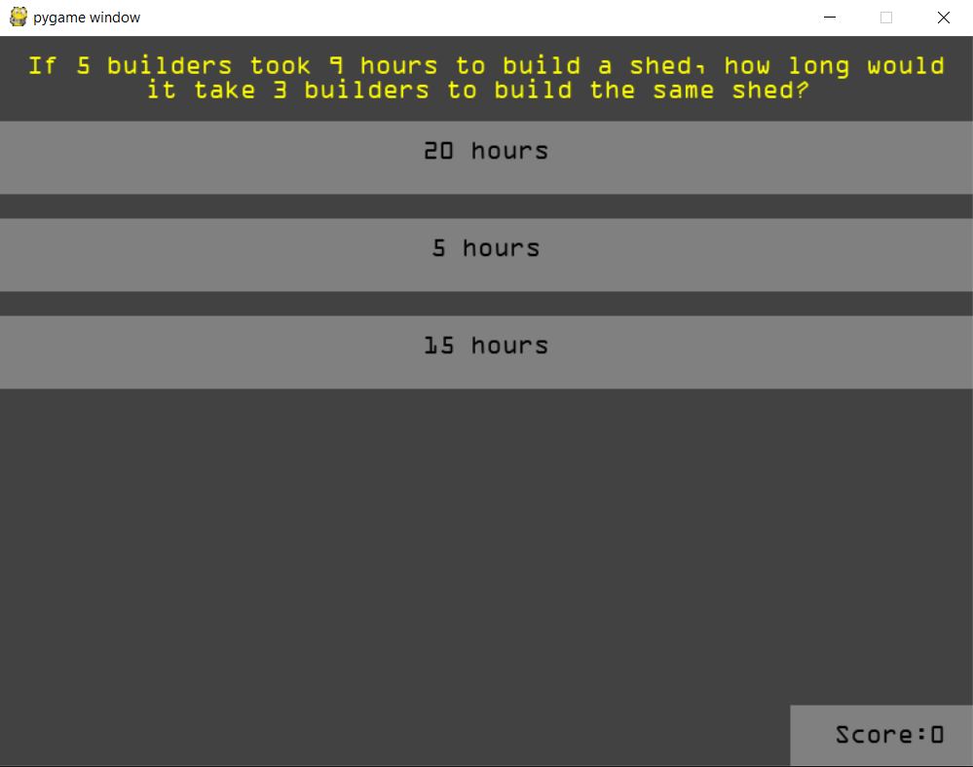

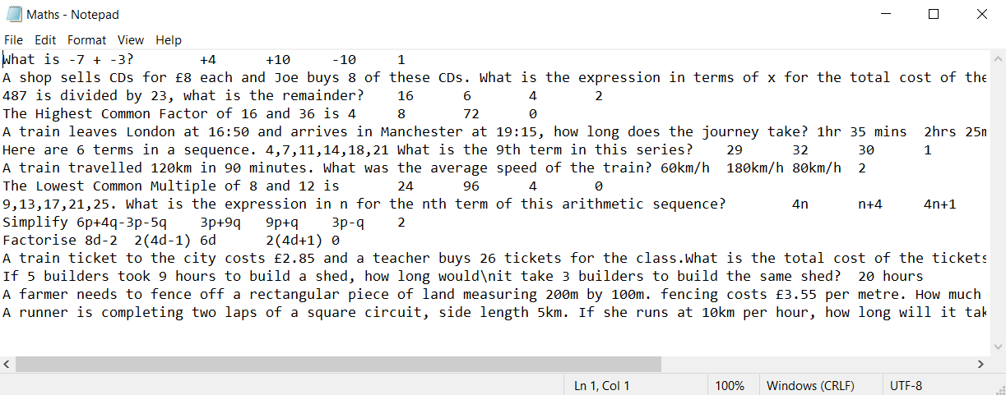

Shown above is the same maths question which was shown before with the issue where it wasn’t all displayed on the screen. This is the question after the amendment and the amendment shown in the text file. As you can see the question text in the file is actually required to have a \n in it. I used \n as it is a universal term for the beginning of a new line in programming. Ideally if I had more time there would be a text wrap function whereby if the length of the text exceeded the width of the screen the program would put the text on new lines automatically in order to make it fit. However for this prototype this solution will be appropriate and that feature can be added at a later date.

After this amendment the questions are now displayed correctly and test 6 is completed successfully. This means that this module is now fully complete and useable as a standalone feature which makes it independent from the rest of the program. I have made sure to use sensible variable names and functions in order to make the code as maintainable as possible. I have also used extensive commenting throughout the code for the quiz game in order to ensure that it can be understood by others who view the source code. The quiz module is now ready to be integrated and combined with the rest of the program.

Minigame Testing

|  |  |  |
| --- | --- | --- |
| Test number | Test Aims | Expected Result |
|  | Check that when left and right controls cause the rocket to rotate. | Rocket rotates by expected amount. |
|  | Thrust control affects rocket’s velocity. | Holding thrust causes rocket to begin to move in the direction it is pointing. |
|  | Determine that correct rocket sprite is shown when thrusting. | Thrust animation is shown when thrust control is pressed. |
|  | Collisions with the ground at high speed. | Hitting the ground above acceptable speed causes crash. |
|  | Collisions with the ground at an angle. | If the angle is past a certain point it causes a crash. |
|  | Collisions with Asteroids | Ensure that when an asteroid hits the rocket it causes a crash. |
|  | Crash effect is shown when rocket is in crashed state. | The crashed sprite is displayed. |
|  | Fuel gauge decreases when thrust is pressed. | The fuel gauge goes down at the correct rate. |
|  | Rocket cannot thrust when fuel is 0. | Check that rocket isn’t affected by thrust if the fuel level is 0. |
|  | Rocket fuel amount is correct based on quiz score. | Ensure that a 100% score is a full fuel bar and that 0% score is the default fuel amount. |
|  | Asteroid trajectories are randomised. | Check asteroids don’t all follow the same path. |

**Test 1:**

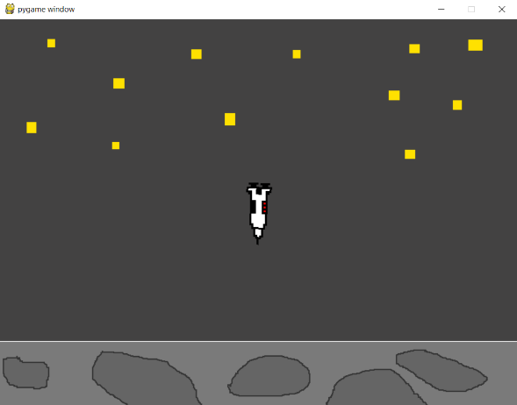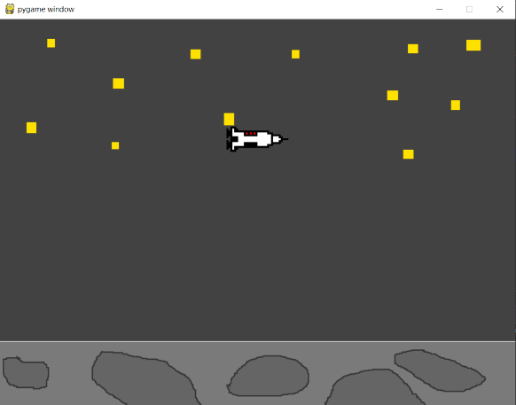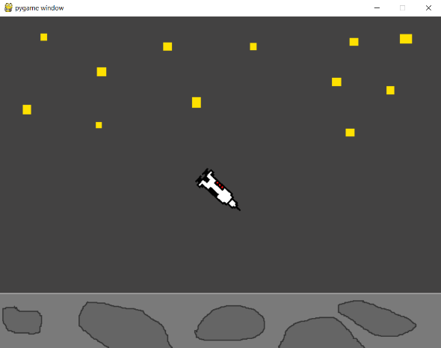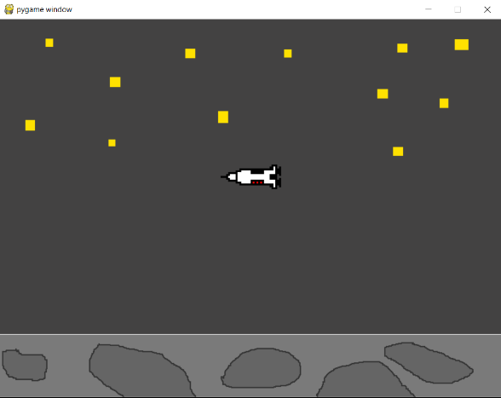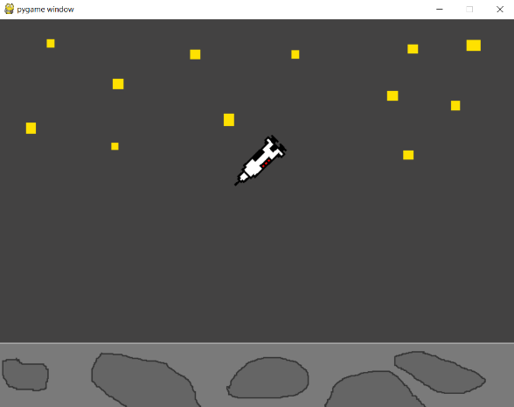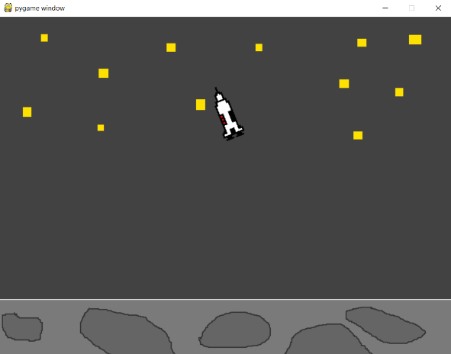The aim of test 1 is to check that when left and right controls cause the rocket to rotate, this means that when the user is pressing the left and right arrows on the keyboard they are able to rotate the rocket in order to control it’s direction. In order to test this fully I will be turning the asteroids off by commenting out the code which is used to create them.

Above I have tried to demonstrate how the rocket has 360 degree motion, Through the use of the left and right arrow the user is able to rotate through 360 degrees. It is hard to demonstrate however I’ve used a system whereby the rocket rotates by a specified amount each frame where the key is pressed down. This means the rocket smoothly rotates and responds to the users input. This allows them to control the rotation for things like landing and dodging asteroids. It also looks good graphically when the rocket smoothly rotates rather than it suddenly turning when a key is pressed. Test 1 has been a success as the user is able to use the ;eft and right arrows in order to rotate the rocket by the desired amount.

**Test 2:**

The purpose of test 2 is to ensure that when the up arrow is pressed the rocket is thrusting and that the button click is registering correctly and having an effect on the rocket’s velocity. This mechanic is important as it is what allows the user to control the rocket and move it around the screen. I will test this by allowing the rocket to be pulled down by the ‘gravity’ effect and then using the thrust to move it back up the screen. If the rocket begins to move when the up arrow is pressed I will know that it is functioning correctly. I will also rotate the rocket to see if it goes in the correct direction when rotated and thrusting.

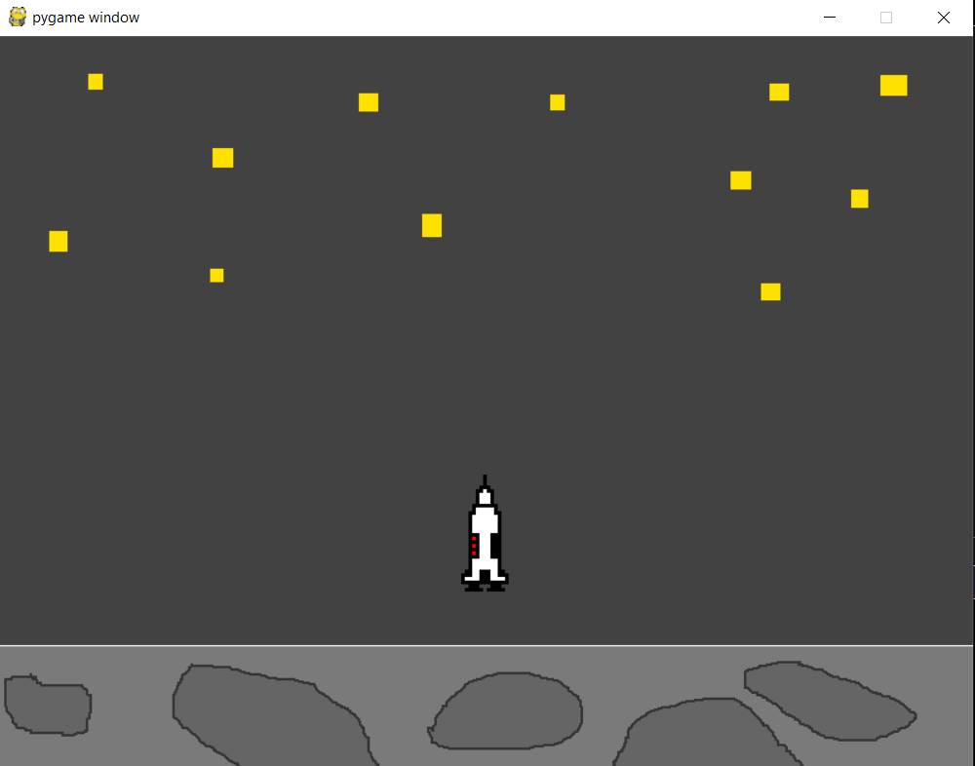 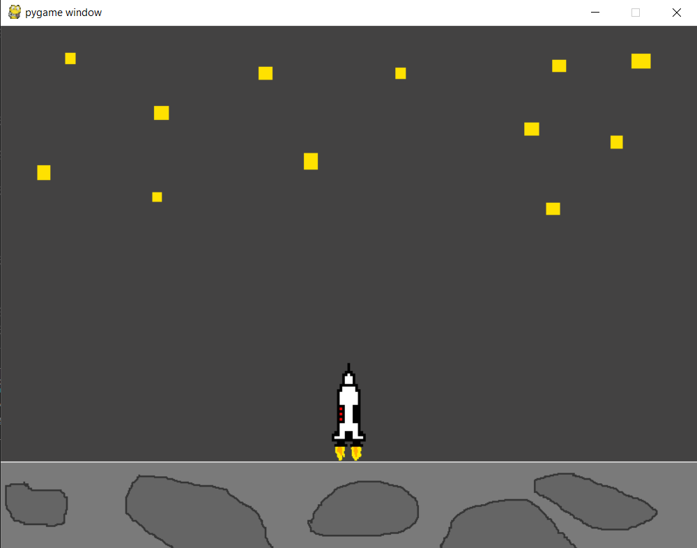

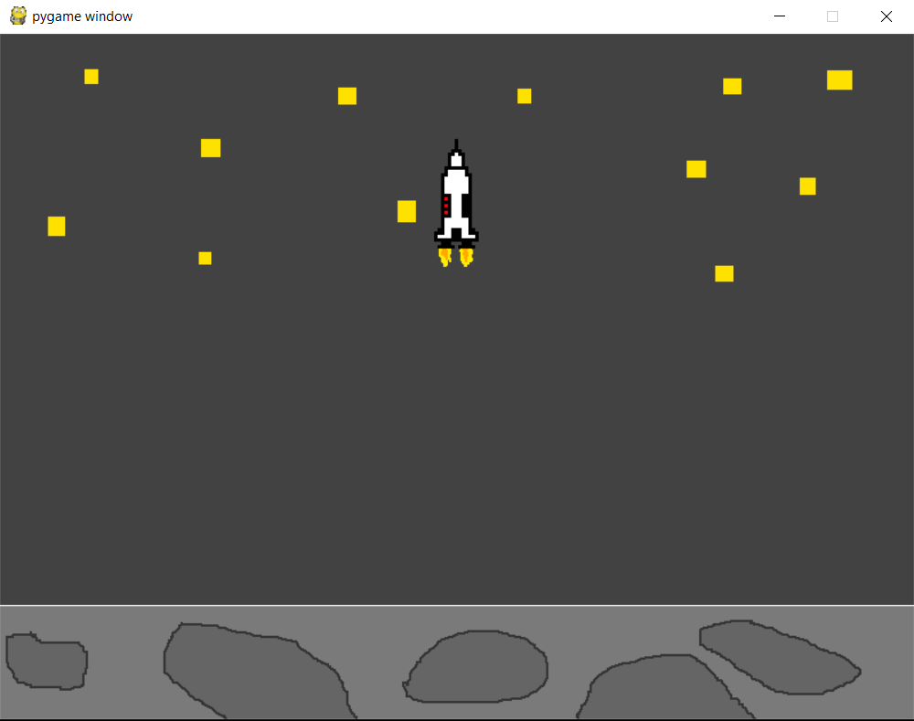 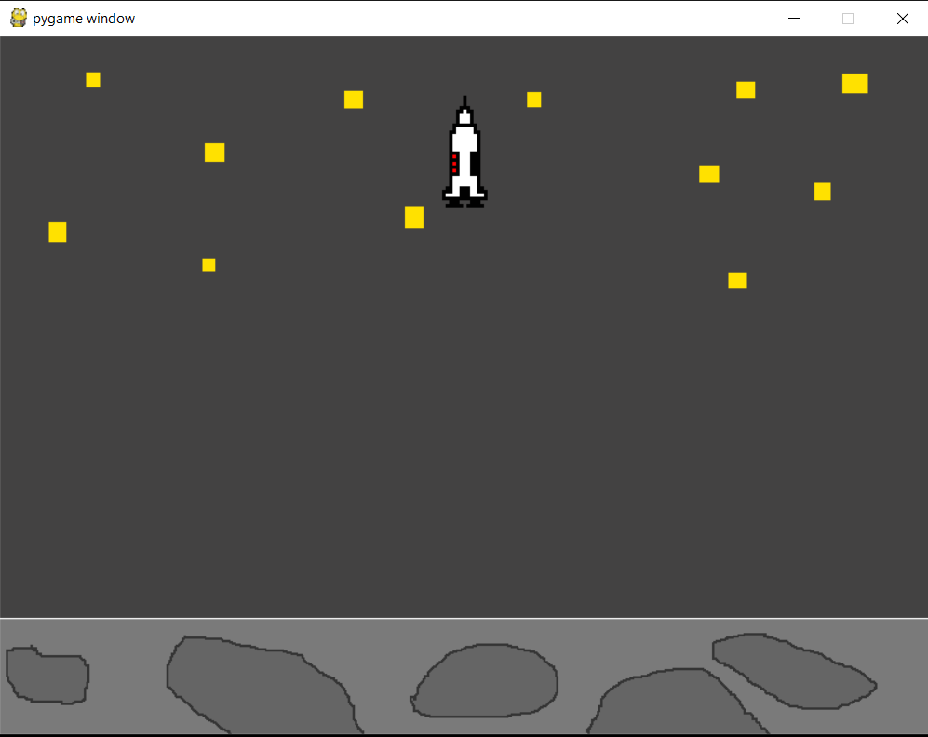

Here is a demonstration where I let the rocket drop down to the surface, I then caught it using the thrust feature and prevented it from touching the surface. I then thrusted upwards without rotating and the rocket was able to counteract the gravity and accelerate toward the top of the screen. I then let the thrust go and the rocket carried on as expected toward the top of the screen. This proves that the thrust is affecting the velocity along the Y axis and the rocket is able to go directly up and down.

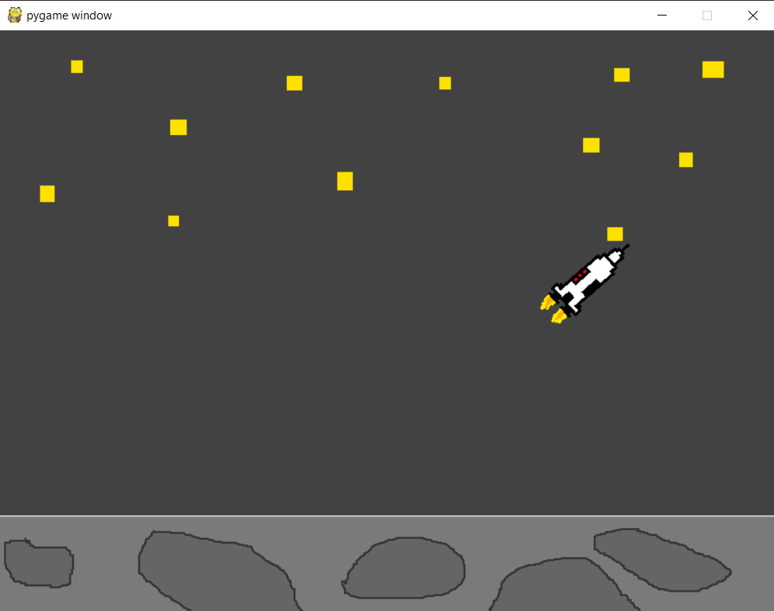 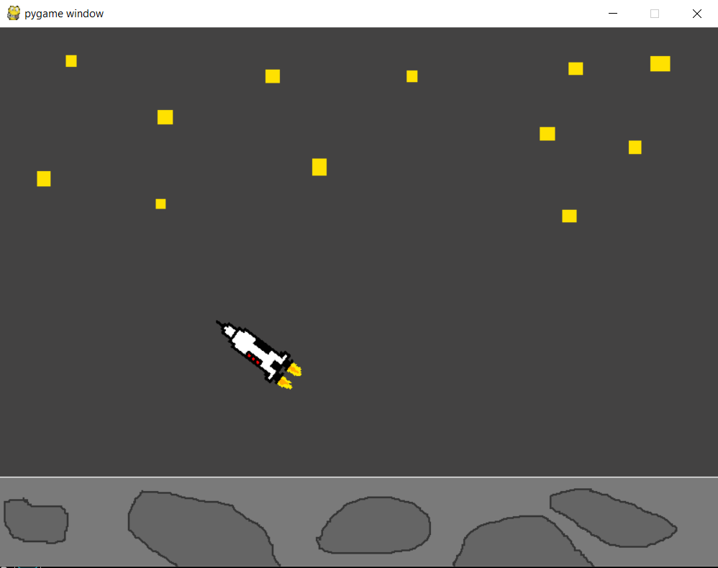

Here I have tested that the rocket is able to boost away from the moon’s surface at an angle, the motion works as expected. The gravity continues to pull the rocket downwards and therefore the thrust is required to keep the rocket moving in the expected direction. This is because when velocity is both in the x and y direction there is a resultant velocity which is the direction that the rocket should be travelling in, when playing the game it would be impossible to work out this resultant velocity as it changes every frame however you can make a judgement based on real life comparison to footage in space and the game mirrors this.

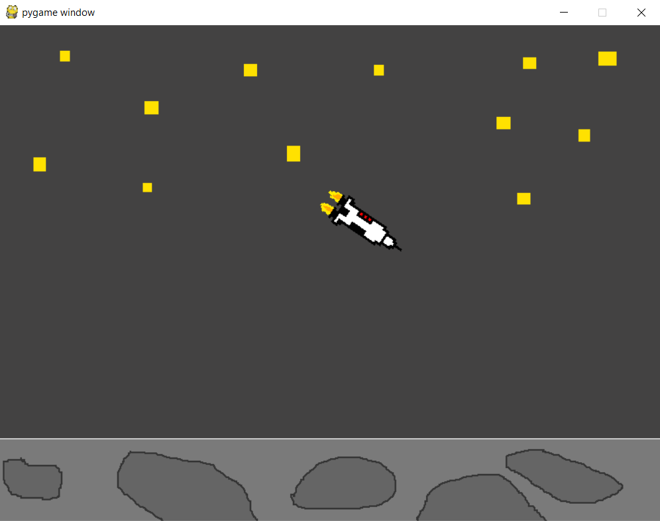 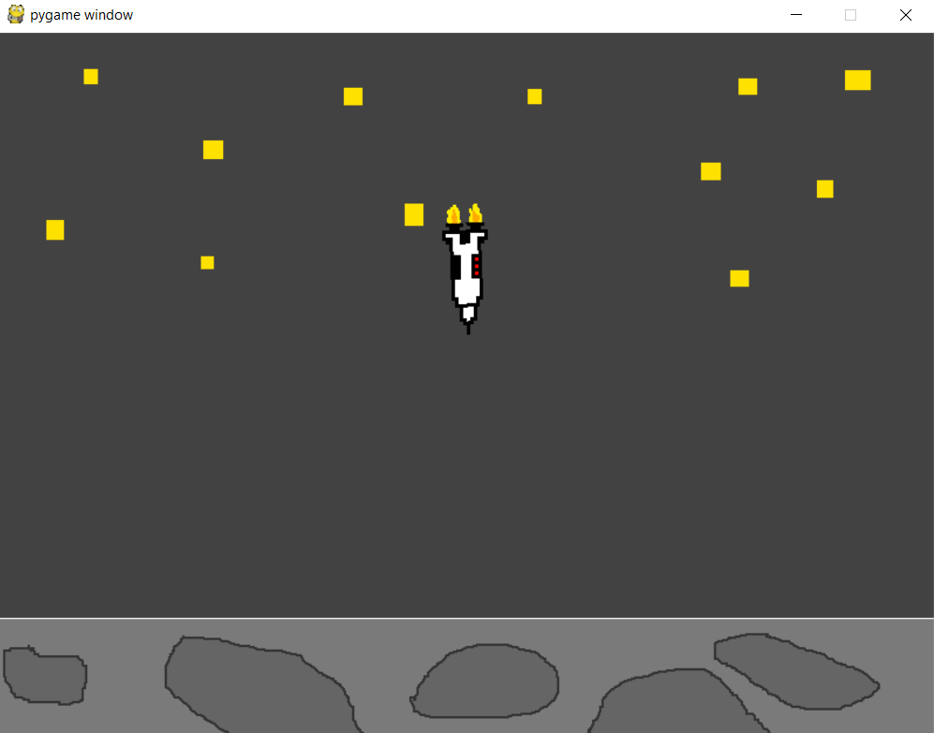

Of course the thrust should still work even if the rocket is pointing downwards, while unwise it is still possible that the player may want to do this. The problem with doing this is that the acceleration due to the thrust of the rocket is combined with the acceleration of the pull of the gravity effect. This means the rocket can begin to travel very quickly but this is realistic and what I would expect to see in a game like this.

In summary test 2 has been a success and I have created a realistic game mechanic which mimics a real life situation. It allows the user to accelerate and rotate in order to go in any direction. This combined with the gravity effect creates a realistic simulation while still maintaining the fun part of the game.

**Test 3:**

The third test is a graphical test whereby I am checking to see if the rocket sprite is displaying correctly when the rocket thrust is activated. This is a simple test to show that the graphic changes in order to show the user that the thrust is working and give a visual representation and prompt.

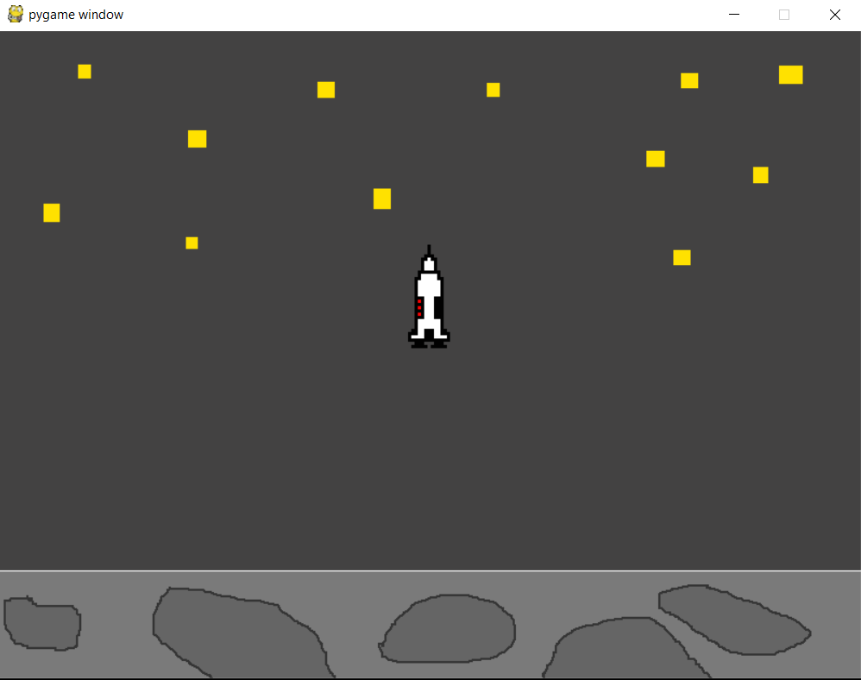 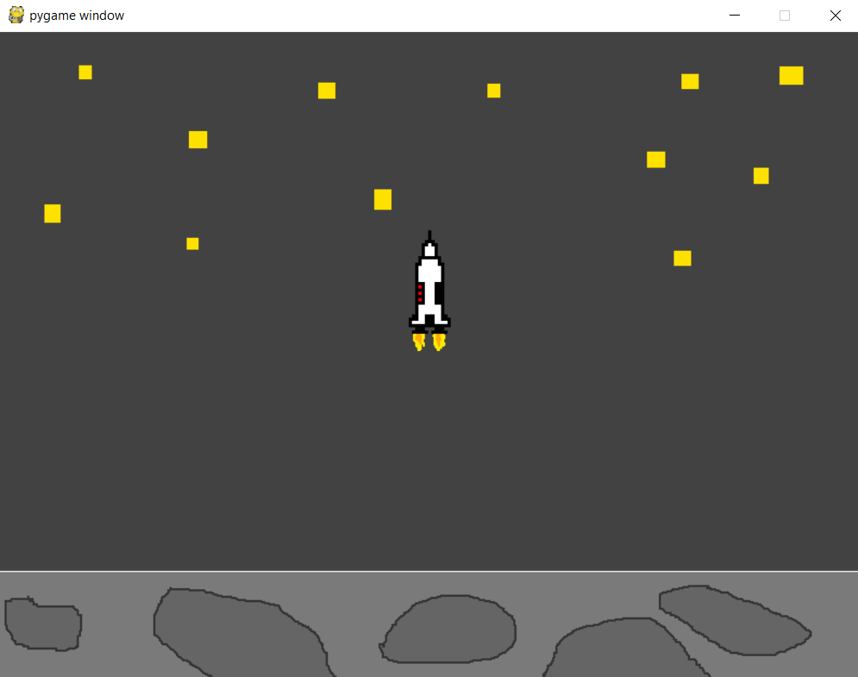

As you can see the sprite switches over to the thrust sprite when the button is pressed. I ensured that this happened every time by pressing the thrust button repeatedly in game. This meant that I could check it didn’t just change once, I also rotated the rocket and tried it at different angles to ensure that both sprites were displayed correctly even when rotated by any amount. The animation works at any angle and displays correctly, some examples of this are shown in test 2 where I was testing thrusting at different angles.

**Test 4:**

During the development of the game I decided to make it so that if the player hit the ground at a high speed their rocket would crash. This was done using the following line of code which allowed me to actively see how fast the rocket was going. The speed of the rocket would be outputted to the debugger each frame.

 This code allowed me to see how quickly the rocket was travelling at all times but more importantly at the time of the landing. In doing this I was able to see what io thought would be an acceptable speed for the landing and then set the landing speed based on this. The following screenshots attempt to demonstrate this:

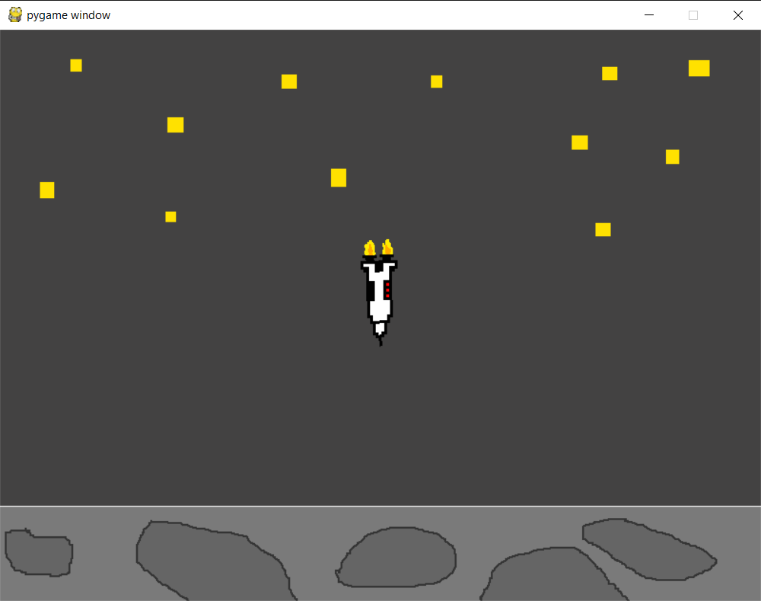 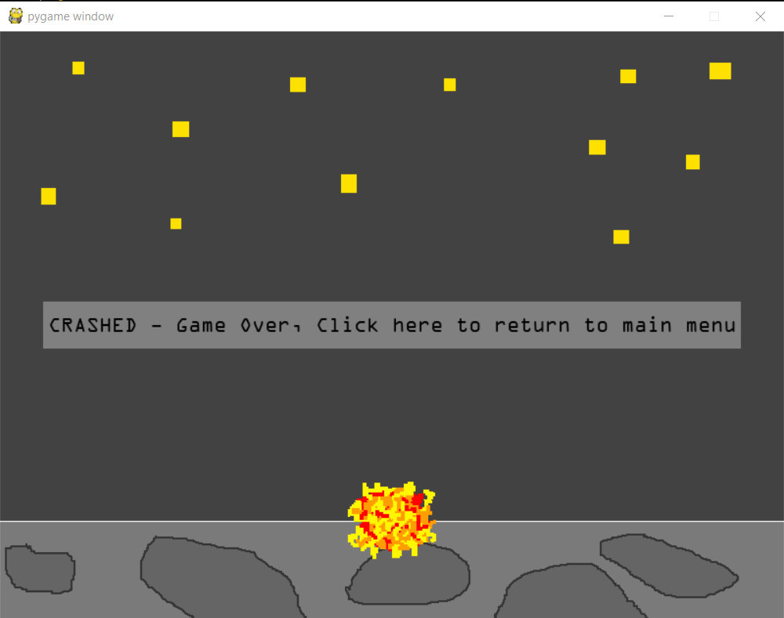

In order to ensure that I went at a high speed and crashed I rotate the rocket around so that it faced the moon and accelerated toward it. This meant that I was sure to have a velocity which was far higher than the accepted value I set. Sure enough the rocket crashed and the game was over and ended in the crashed messaged being displayed.

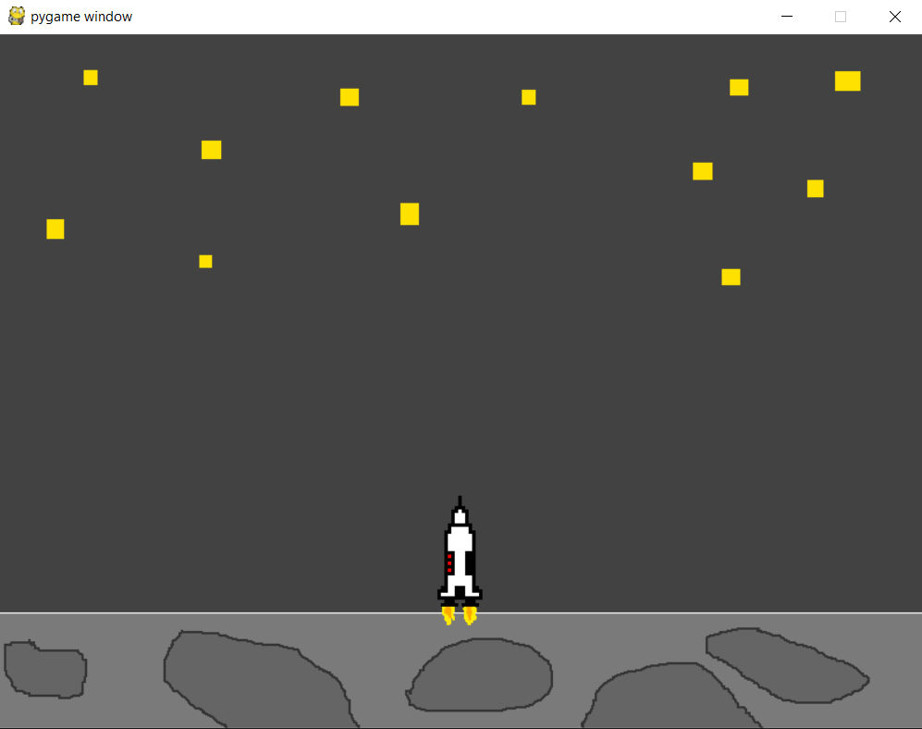 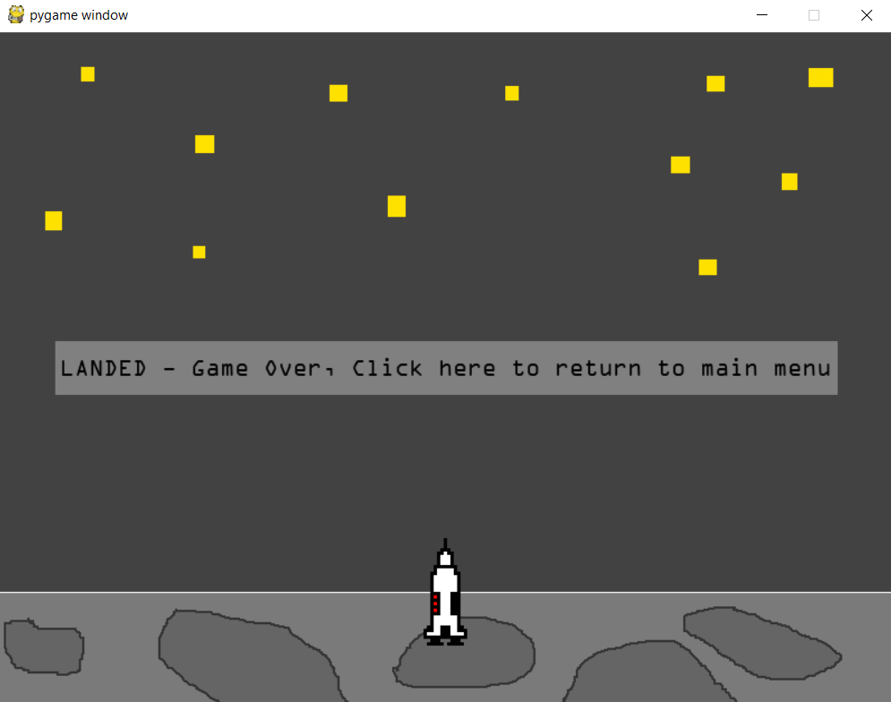

In order to test that the rocket could still land despite the velocity validation I used the thrust to drastically slow the rocket down before it touched the moon’s surface. The rocket was still able to complete a successful landing and the correct message was displayed.

Test 4 has been a success as the speed restriction for landing has worked as it should, it can still be altered to be a higher/lower value if the game is too hard or easy. This means that the game difficulty could potentially be altered by allowing for faster or slower landings.

**Test 5:**

The speed restriction for landing has been shown, I also included a restriction for the angle of the rocket when landing. Test 5 looks at ensuring this functions properly and the user cannot land at an angle which is deemed to be too steep.

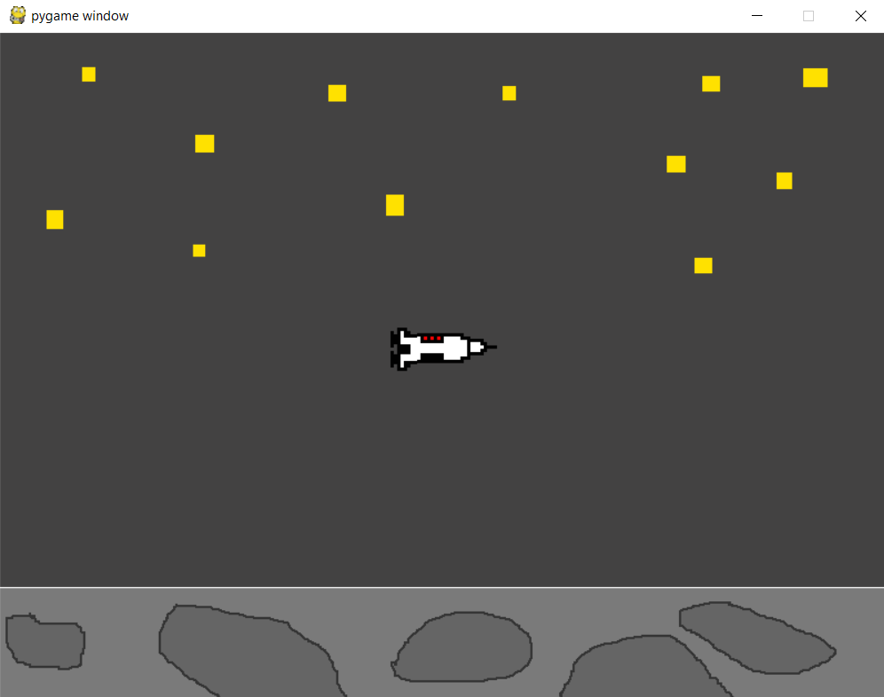 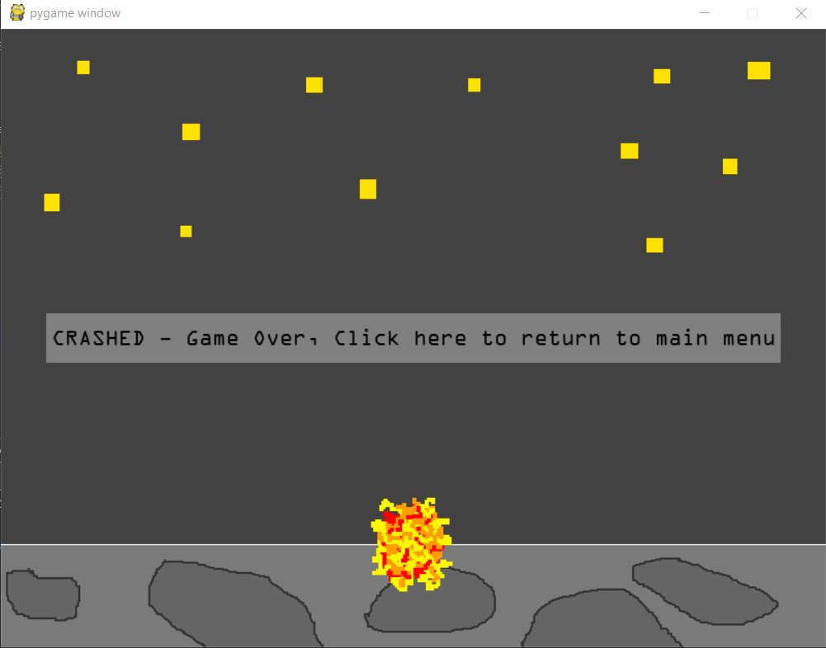

As you can see at an angle such as this the rocket would clearly crash and it does as expected. However this is an extreme situation and the user probably wouldn’t try and land like this.

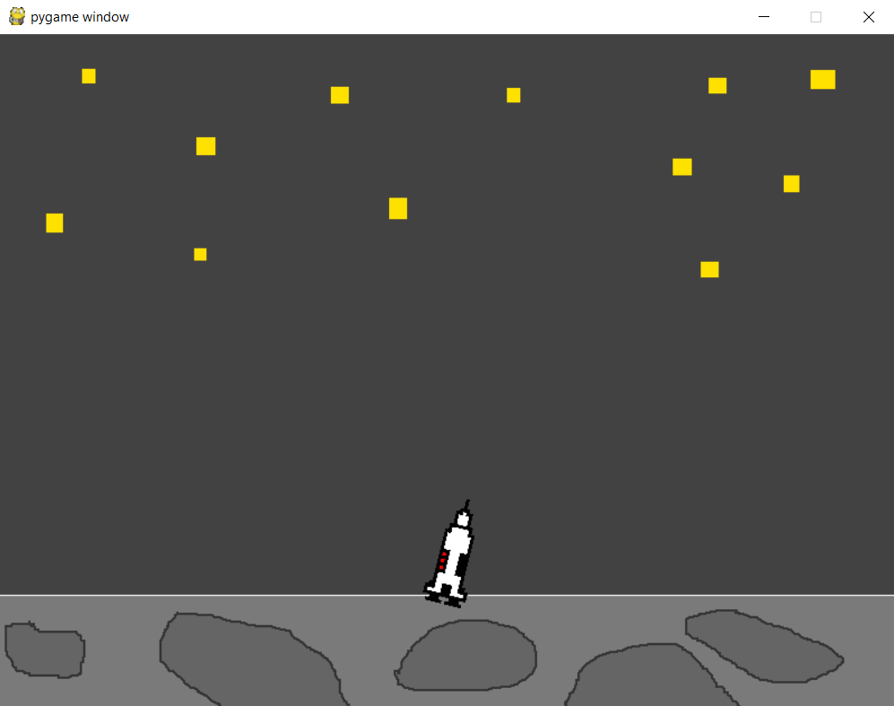 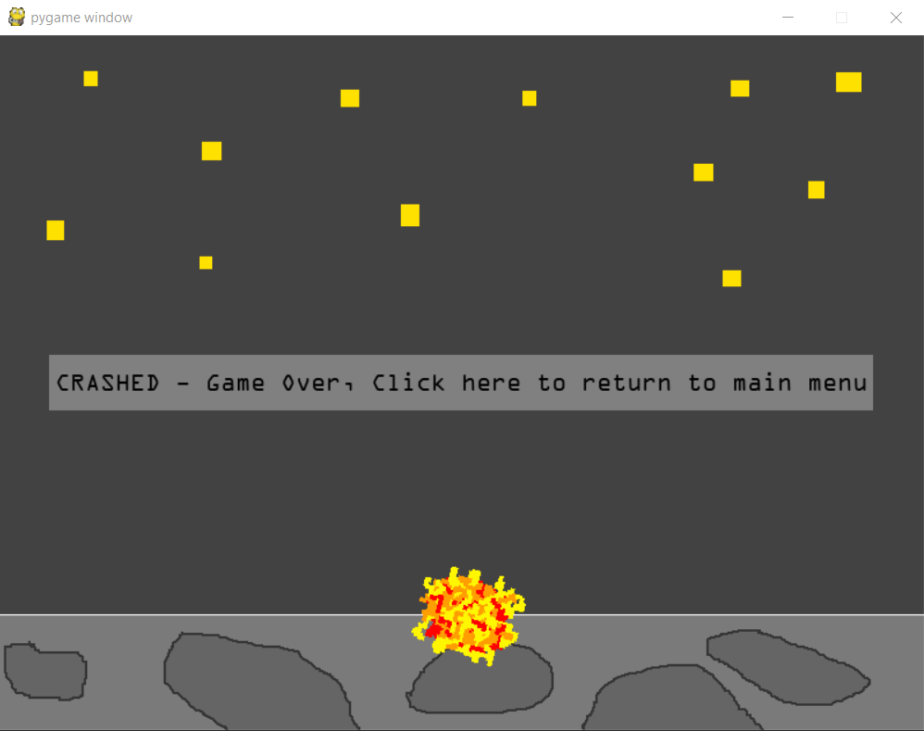

This is more realistic example of how someone may try to land, however I haven’t allowed an angle as steep as this to be a landing as I believe the rocket would tip over if it landed at this angle.

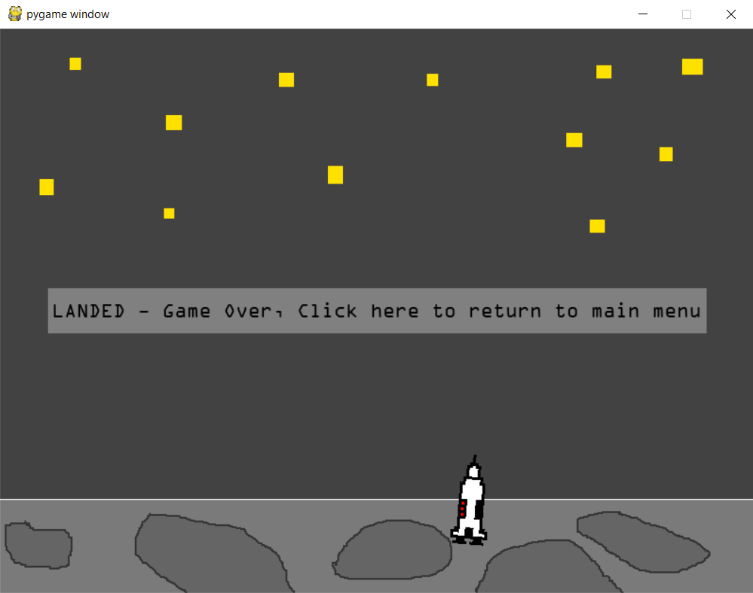

Here is an example which is less extreme and shows where the player hasn’t quire achieved the perfect angle but they have still succeeded in landing the rocket. It shows that there is some leeway in the angle and that users aren’t going to get frustrated thinking that they should have landed.

Test 5 has been a success as the angle validation works as expected. I have since altered the angle to allow for a more step angle(within reason) however this can be tested and altered at any time using the lines of code I implemented for checking the angle of the rocket. All you have to do is remove the # symbol and test what angle you think is acceptable for a landing.

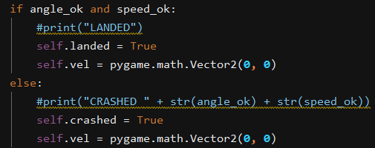

Using the code above you can also see when playing the game what went wrong if you didn’t land. This would help to evaluate how difficult the game is by playing it. If you wanted to query why you didn’t land you would uncomment the print statements and it would tell you which of the conditions you didn’t satisfy.

**Test 6:**

Test 6 is concerned with testing the collision between the player and asteroids to make sure that when the objects touch on screen the player I put into crashed mode and the correct sprite is displayed. For this test I will need to re-enable the asteroids so that they appear on screen as I have had them disabled for the rest of the tests on the minigame.

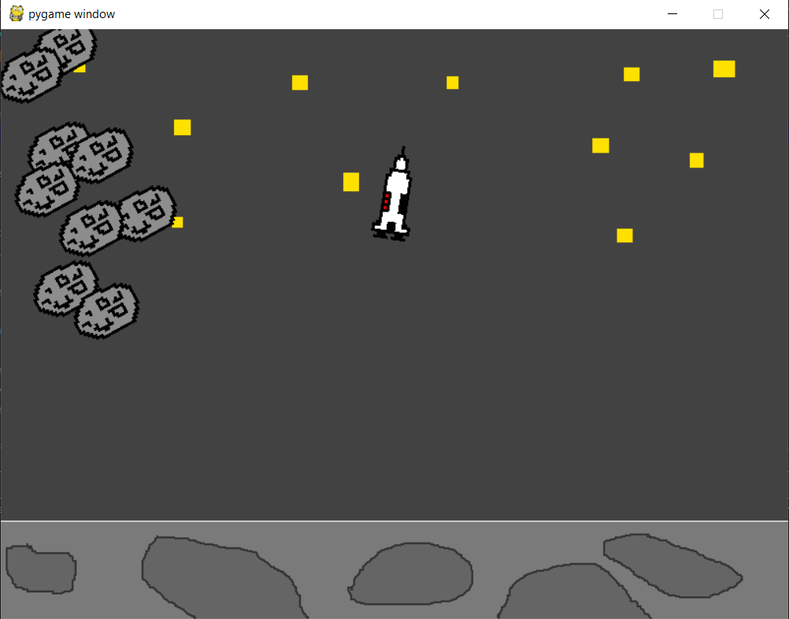 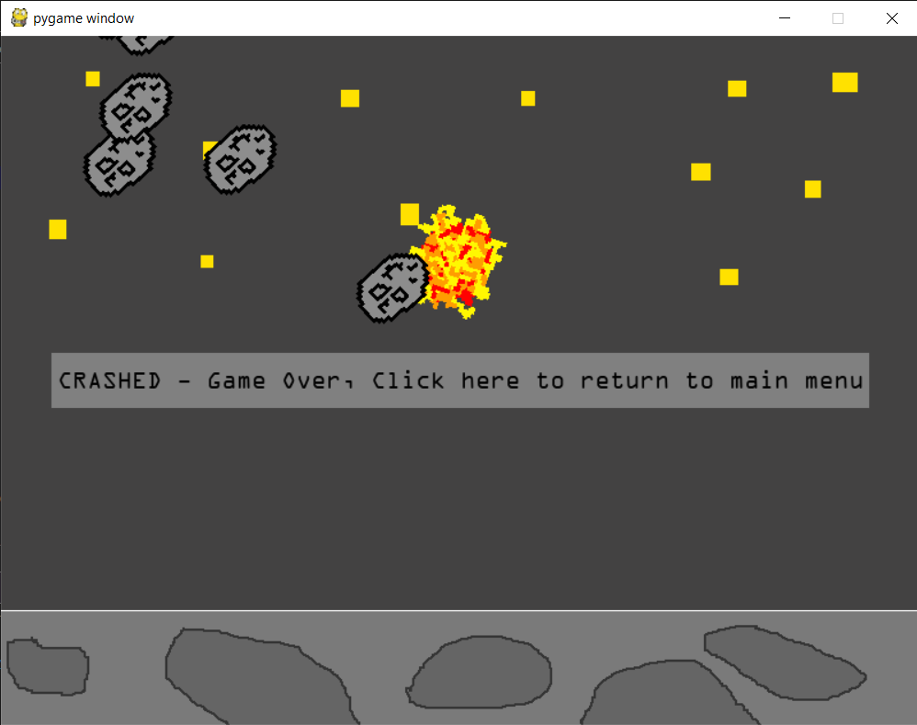

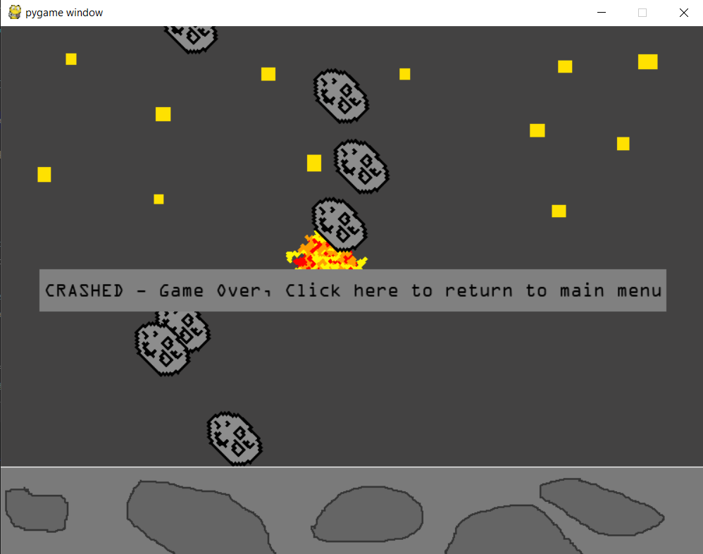 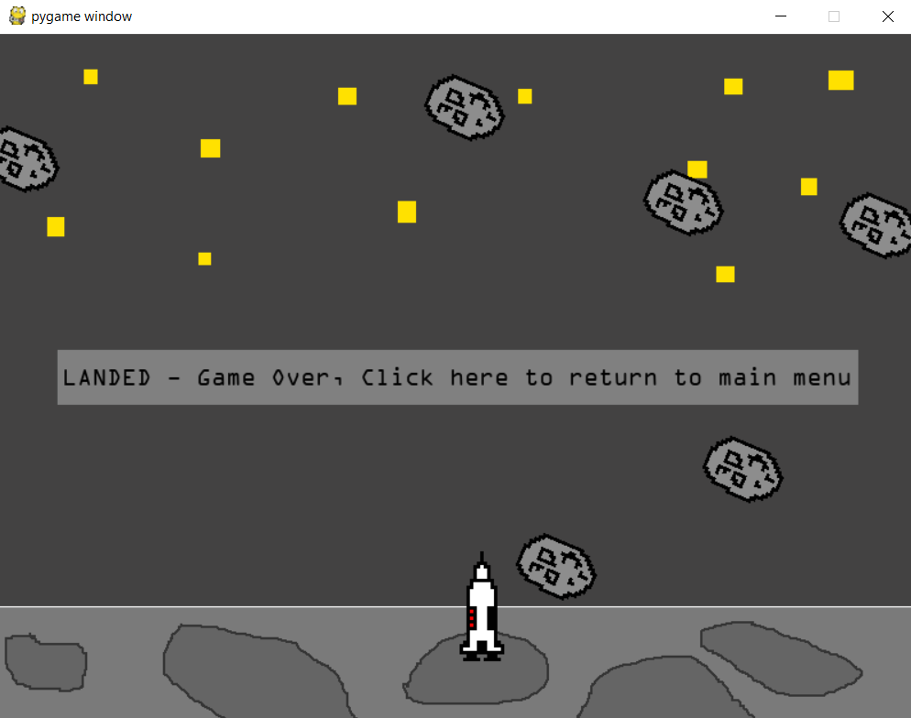

As you can see there is no way of proving this except for trying the game many times and hitting the asteroids at all the possible angles and speeds to ensure that it always registers the collision. I have tested this hundreds of times when running the game to ensure that it works correctly and it hasn’t failed once. Having the asteroids allows me to alter the difficulty of the game and see how hard it is to complete. The test is a success as no matter the angle, speed or direction if an asteroid touches the rocket it is put into a crashed state.

**Test 7:**

When developing the game I decided that when the user crashed there should be an animation to show the user that the rocket has crashed. In order to do this I created a crash sprite which should be shown if the user crashes into the moon or into an asteroid. In order to test this I will try multiple crash situations with the rocket and check that the animation happens when it crashes.

Moon Collisions:

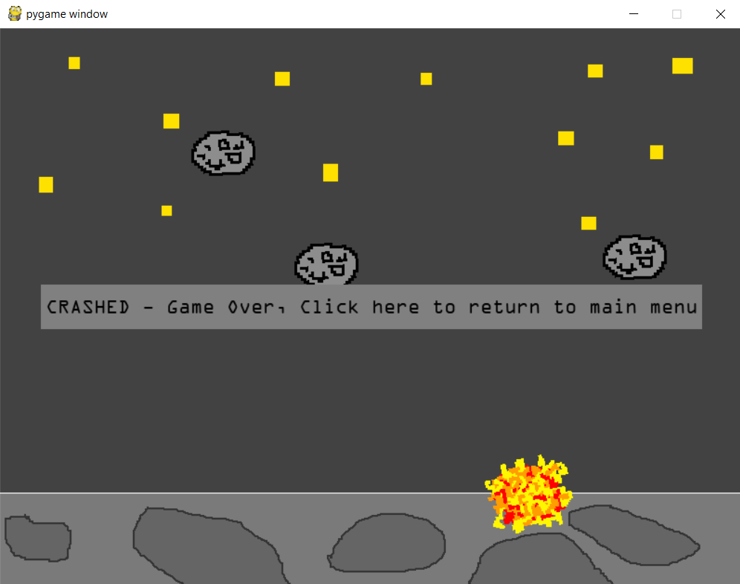 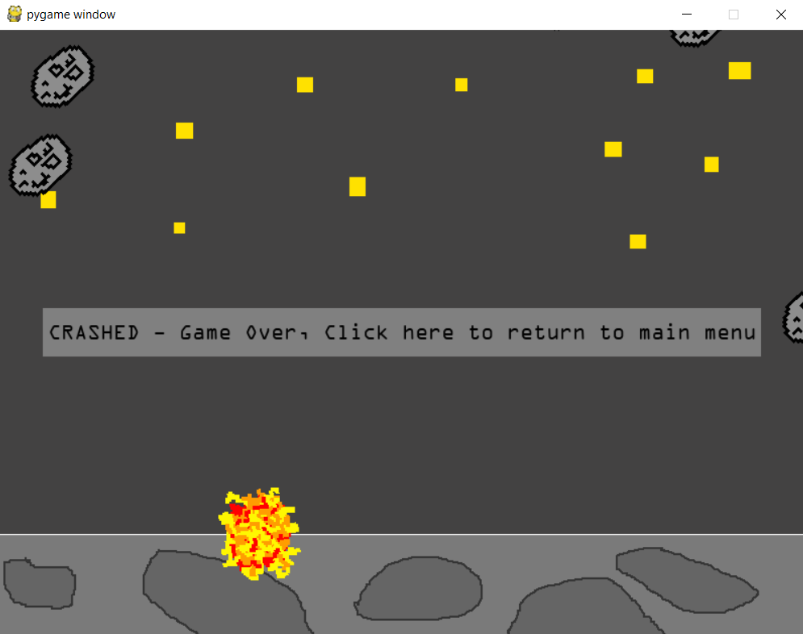 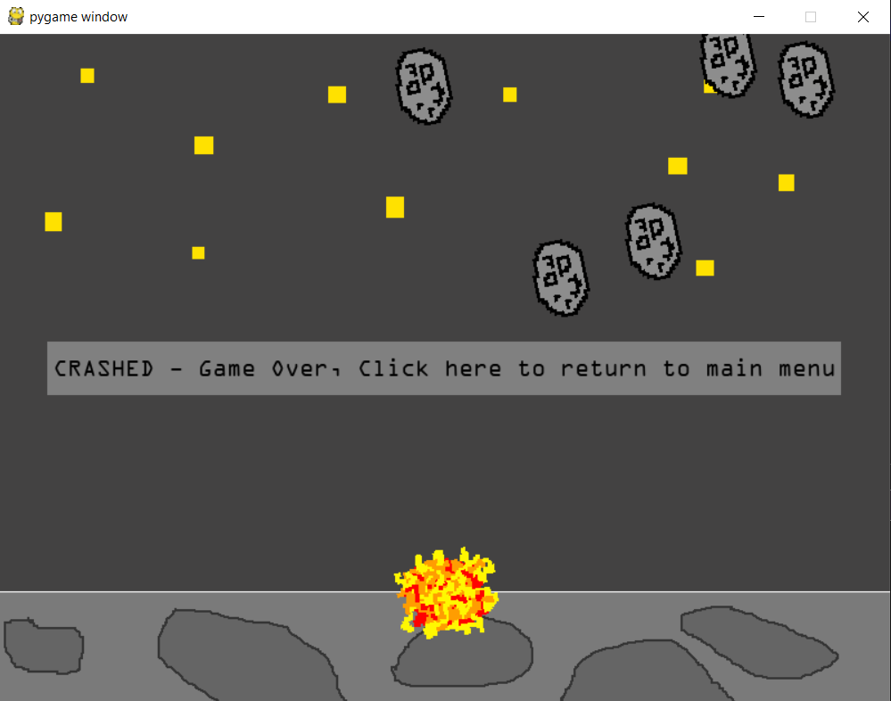

Here are three examples where I have purposefully crashed the rocket into the surface of the moon at high speeds and angles which exceed the allowed angles. I have done this many times throughout the testing process and this is just 3 examples of the landing crash animation in action. I am confident that it works in any situation that the user throws at it and the animation is displayed correctly.

Asteroid Collisions:

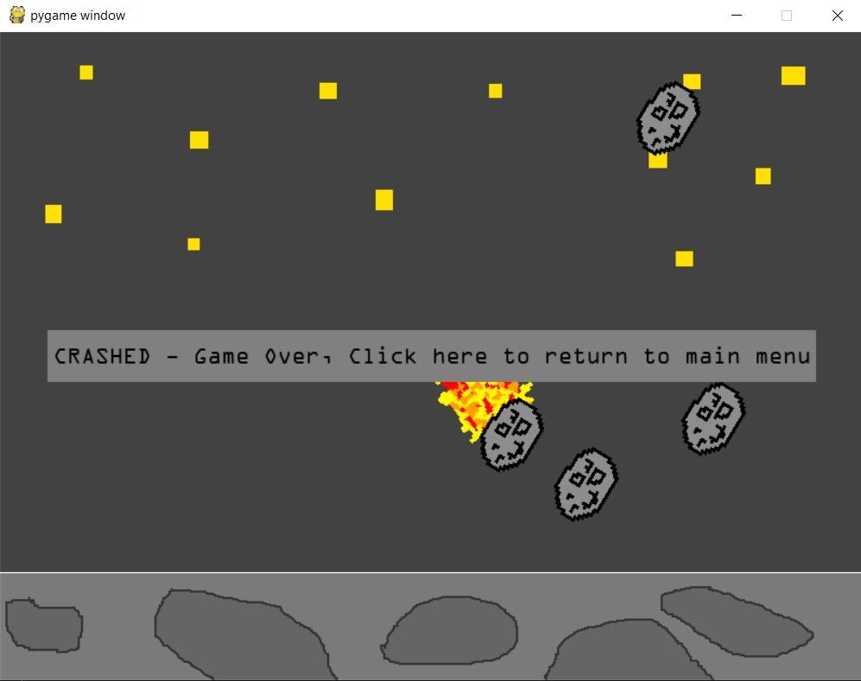 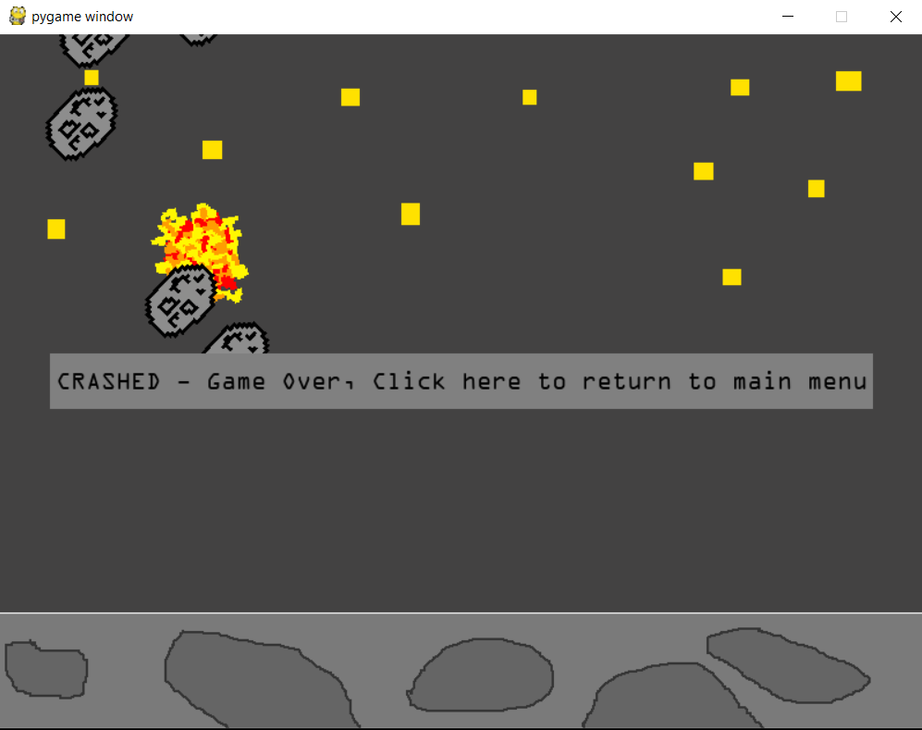 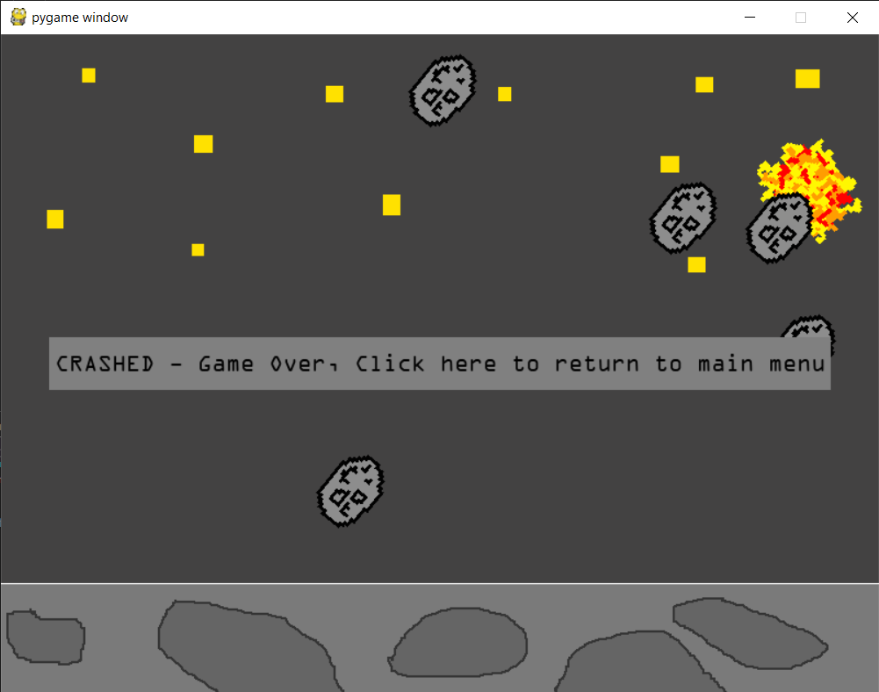

Similarly to above I have included 3 examples of the test, throughout development and other parts of the testing I have collided with the asteroids many times. Test 7 has been a success and I am confident that the animation is shown in whatever situation where the rocket crashes.

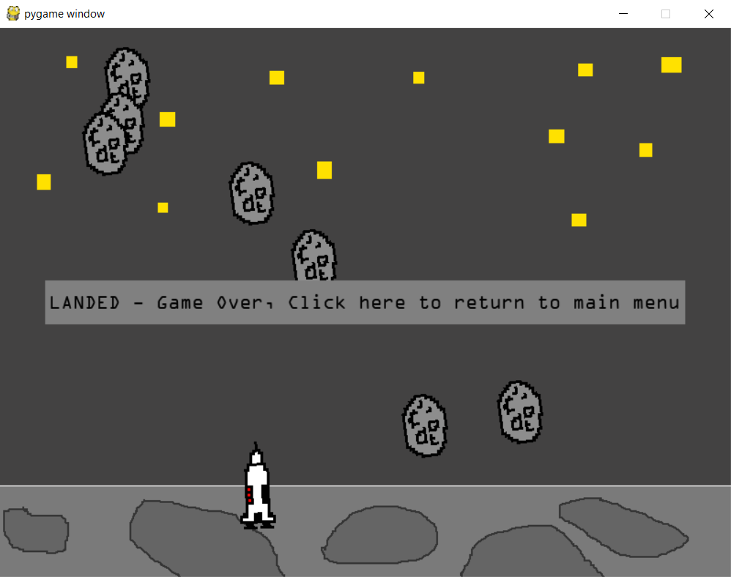 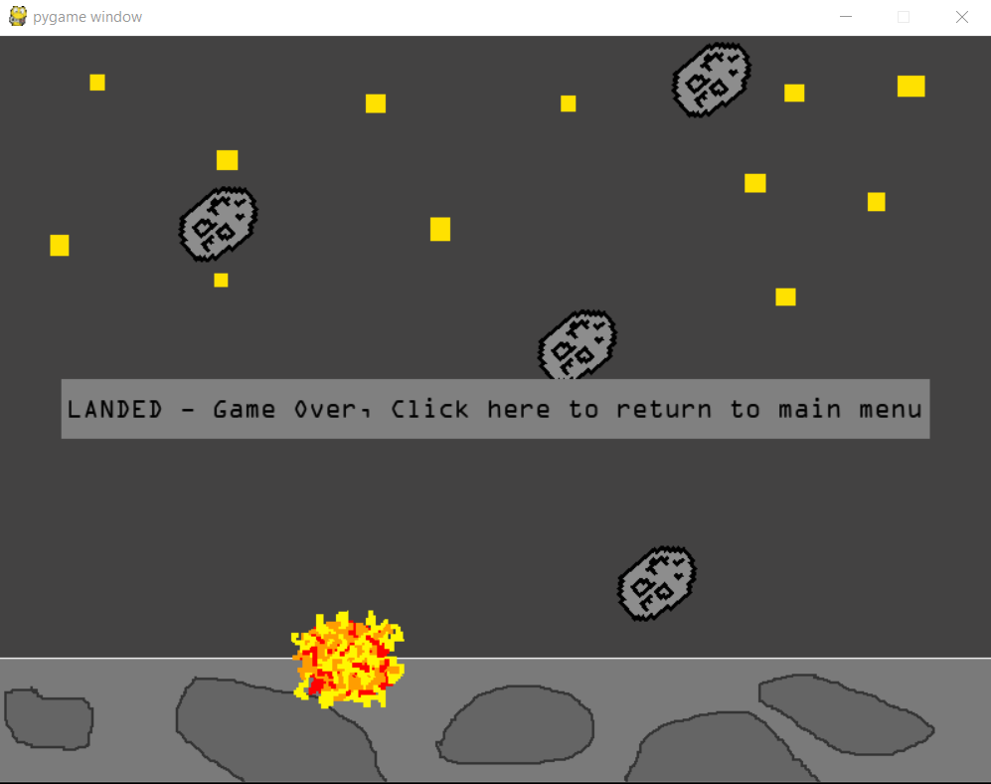

Shown above is a feature which I didn’t originally intend to be in the program, after the game has ended the asteroids continue to move in the background which I think looks good. However if they hit the rocket they are able to blow it up, I decided to keep this in the program as it would look wrong if the asteroids just bounced off the rocket. It also looks quite funny if the rocket is randomly blown up in the background by a stray asteroid. This kind of thing is also what used to happen in the video games of this style.

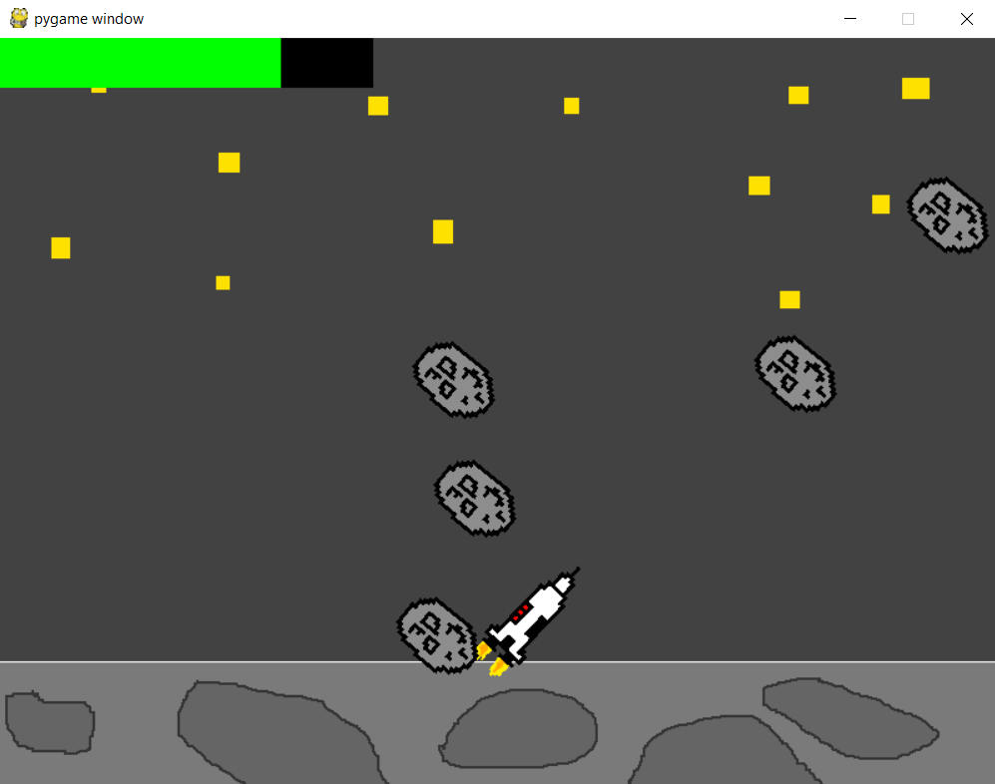

I also tested as part of the animation testing that the flames of the thrust couldn’t cause the rocket to be destroyed. I coded this specifically so that the rocket wasn’t destroyed if the flames hit an asteroid. This was because I thought that it would be unfair if suddenly the part of the rocket the user had to avoid touching the asteroids suddenly became bigger if they were thrusting. As you can see form the screenshot although very close the rocket hasn’t actually touched the asteroid and therefore it hasn’t been destroyed. This makes the game fairer and more realistic.

**Test 8:**

The aim of test 8 is to show how the fuel gauge for the rocket game decreases at an appropriate rate. The user starts off with an amount of fuel which should be shown correctly in the fuel gauge initially nut as they begin to play and use the thrust more the fuel should decrease at an appropriate rate. For this test I re-enabled the fuel gauge which I had disabled for the other tests.

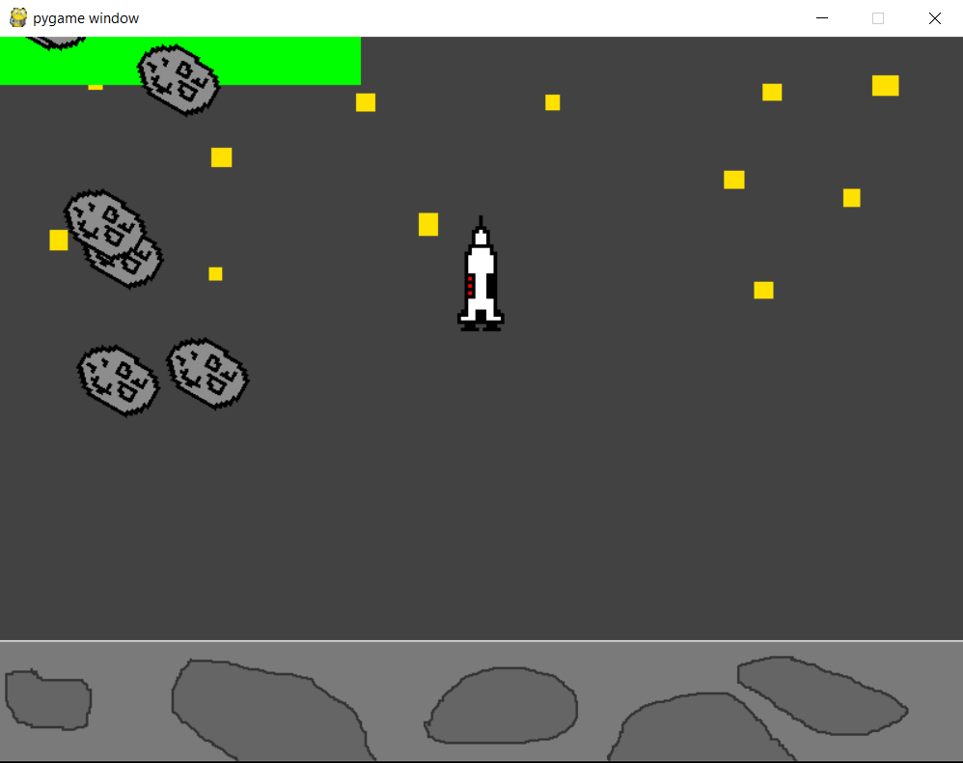 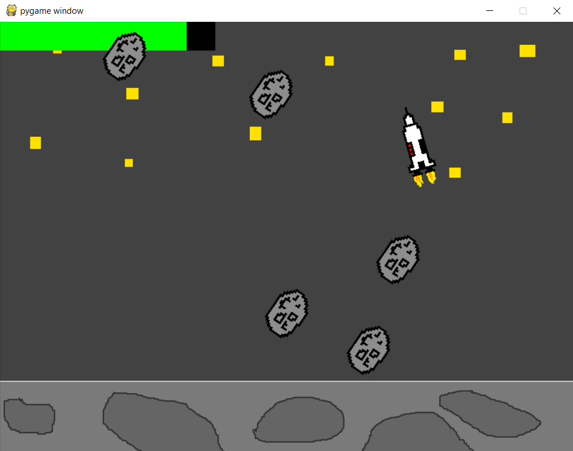 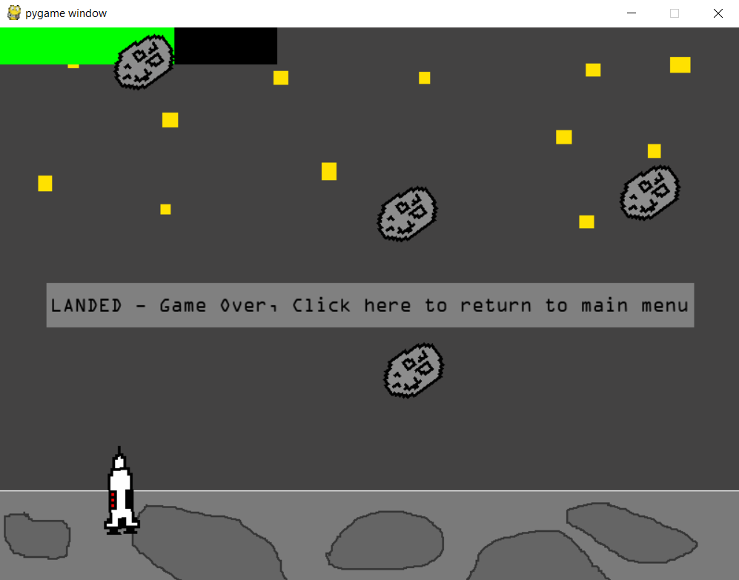

Shown above is a run through of the game where I gave the user 100% fuel and you can see 3 stages of the game and the fuel level at these stages. Although hard to demonstrate this shows that during the singular run through the fuel was decreased in some way. The only way for the fuel level to decrease is if the user is pressing the thrust button. I tested this multiple times along with everything else in order to adjust the rate of fuel depreciation so that the fuel went down at a fair rate. The example above is just one of many however as the game is real time it is difficult to represent the rate at which the fuel level goes down and the animation of the rectangle. The rectangle is animated and decreases by a certain amount per frame that the up arrow is pressed. This is because the measurements come from the fuel level which is constantly calculated when the up arrow is pressed, therefore if the arrow is pressed the length of the green rectangle decreases. This test has been successful as the fuel gauge is animated like I wanted it to be and provides a dynamic feature to show the user what their effort in the quiz equated to.

**Test 9:**

The purpose of test 9 is to ensure that if the fuel level is 0 the player cannot use the boost function. In order to do this I set the fuel level to the default amount by passing in a score of 0 to the game and used up all the thrust to get the fuel level to decrease to 0.

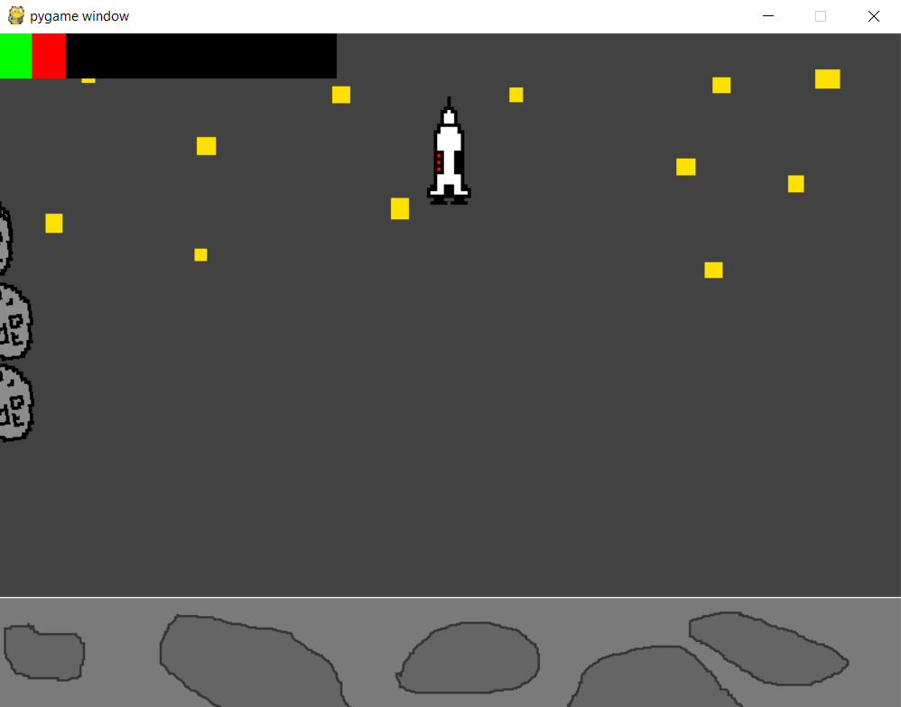 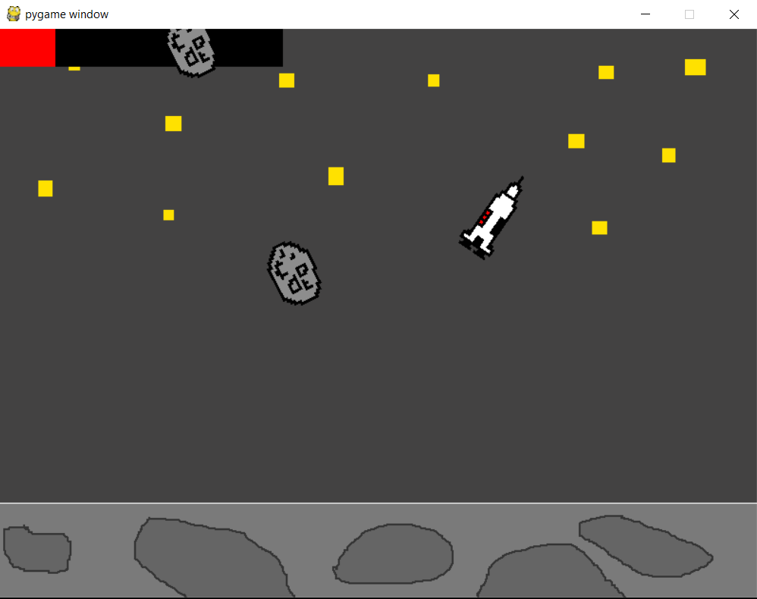 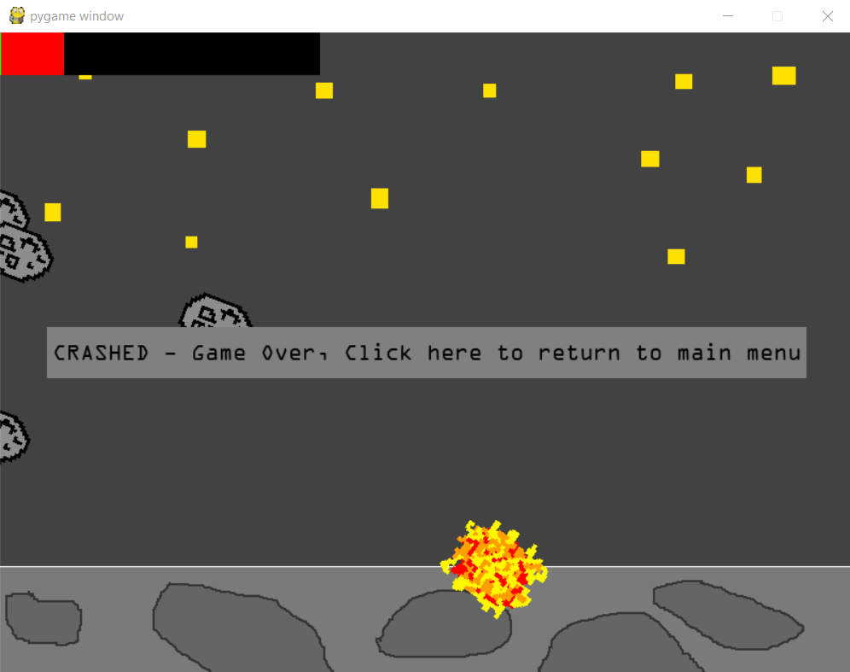

As you can see the fuel level quickly decreased to 0 and the rocket crashed. This is because when I pressed the up arow the rocket didn’t display the thrust animation and the velocity of the rocket was not affected at all. You are still able to alter the rockets angle to give you a chance at landing or dodge asteroids however if there is no fuel the up arrow has no effect on the rocket’s speed. This inevitably leads to a crash and the rocket being destroyed which is the whole point of the game.

**Test 10:**

The aim of this test is to check that the quiz score has an effect on the rocket’s initial starting fuel as this is the whole point of the rocket game to reward the user for their efforts in the quiz. I will go through each score and show the initial fuel level for each score from 0-15 to show how much fuel each point equates to. Remembering that there is a default amount of fuel given so that even if the user scores 0 they are still awarded with some fuel for their participation in the quiz. Below I have shown the in game fuel bar and the game intro screen which tells the user how much fuel they’ve earnt.

Score of 0/15 (default fuel): Score of 1/15:

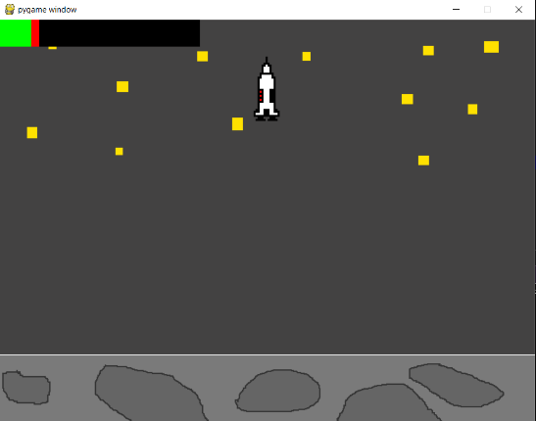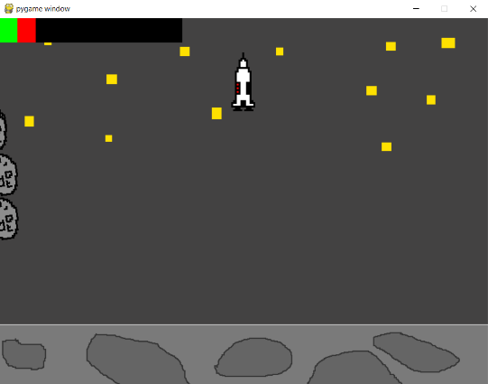

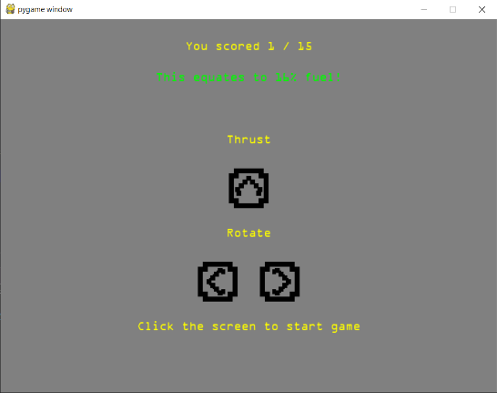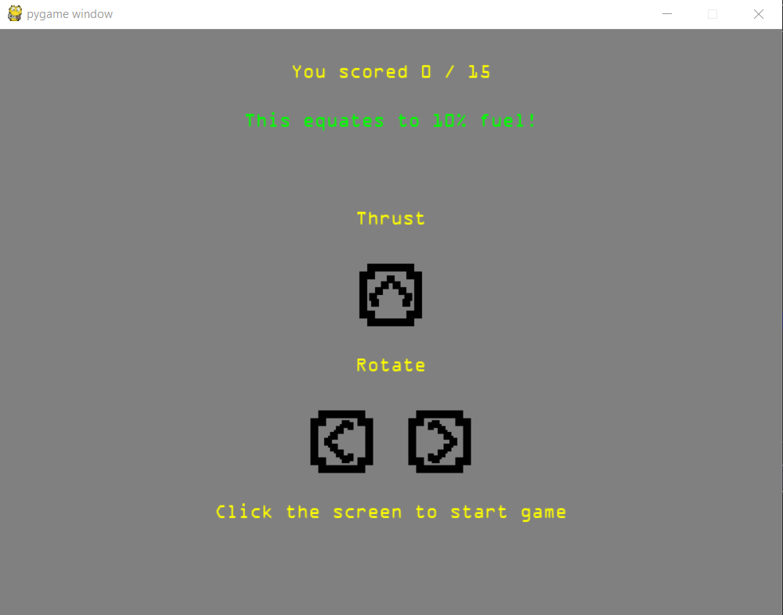

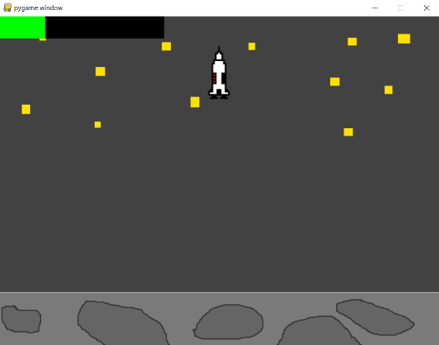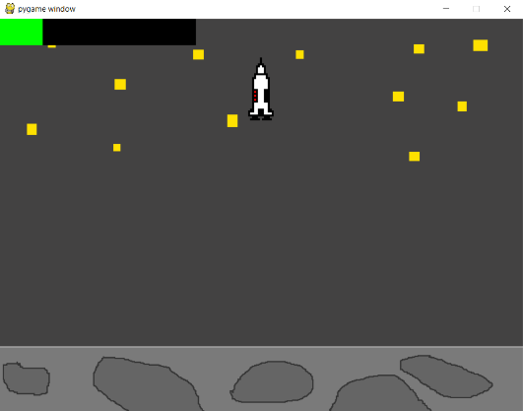Score of 2/15: Score of 3/15:

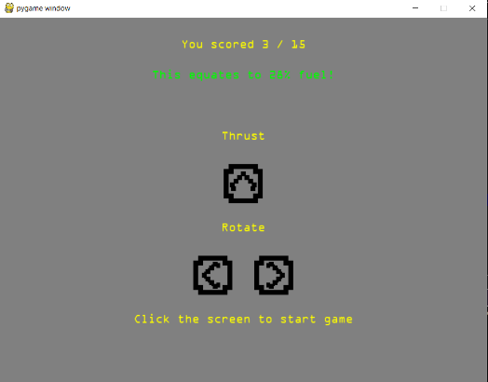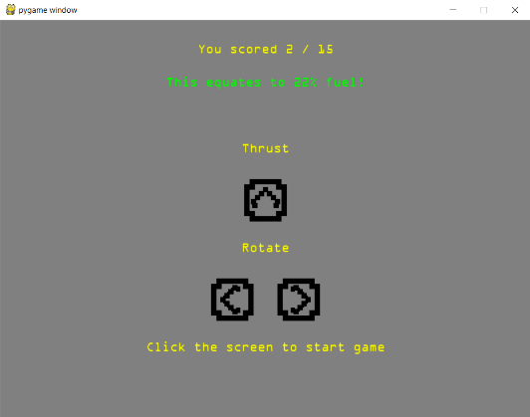

Score of 4/15: Score of 5/15:

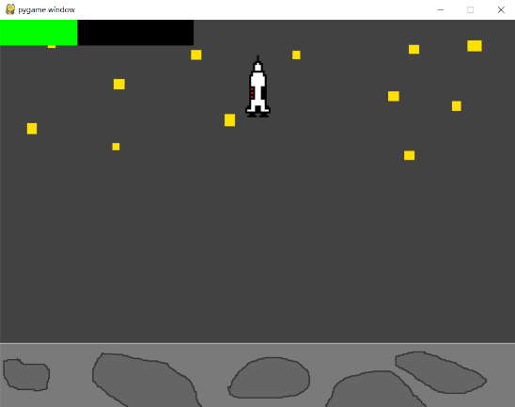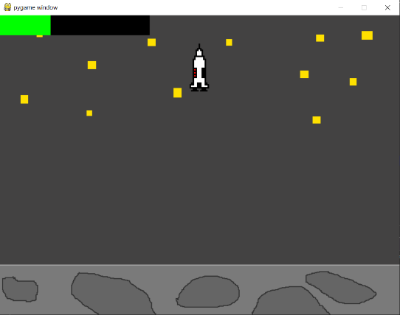

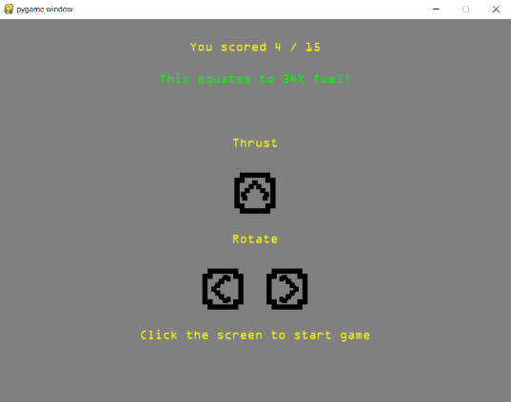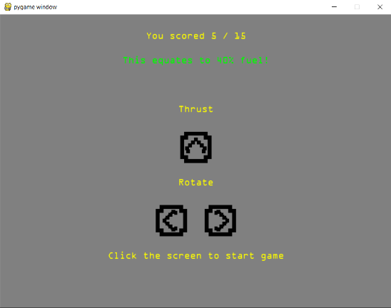

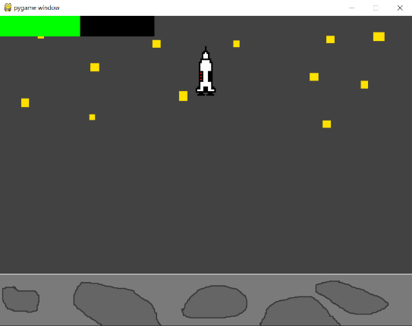Score of 6/15: Score of 7/15 (should be around half of the fuel bar):

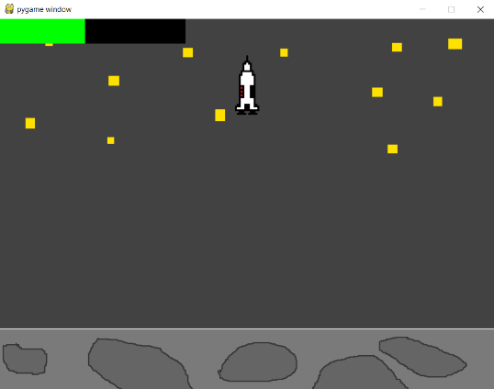

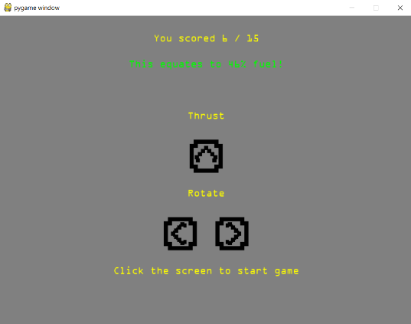 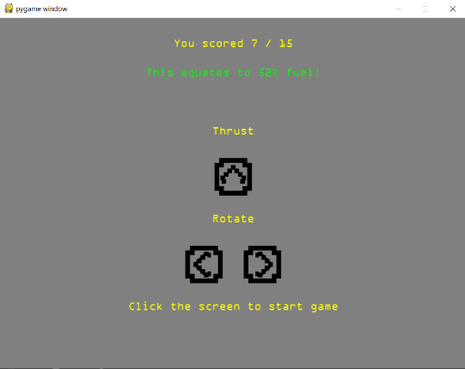

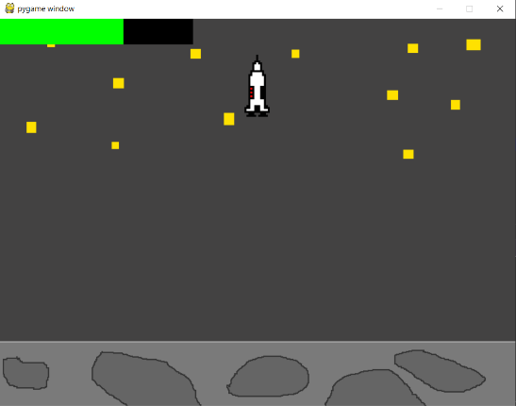Score of 8/15: Score of 9/15:

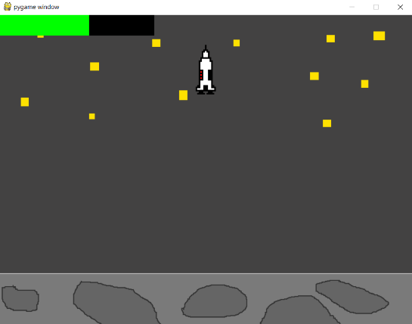

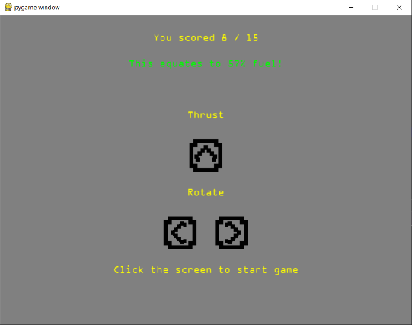 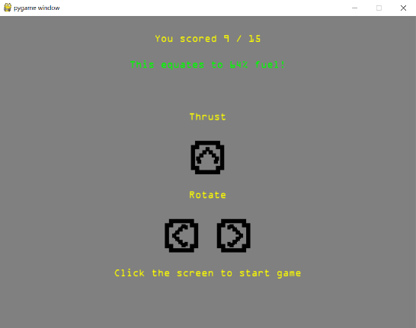

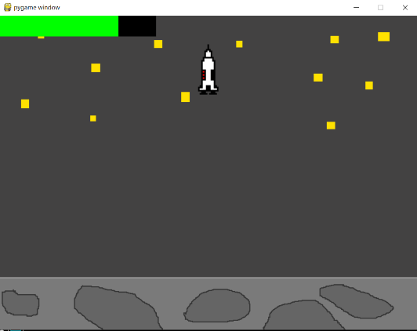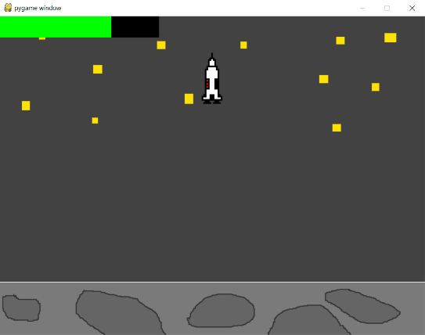Score of 10/15: Score of 11/15:

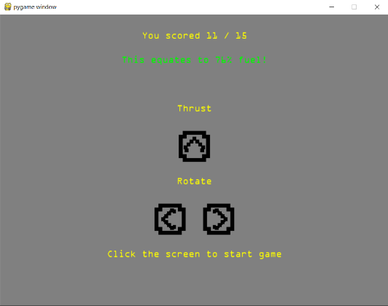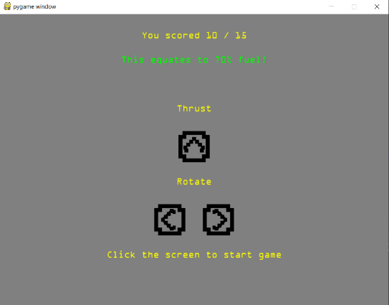

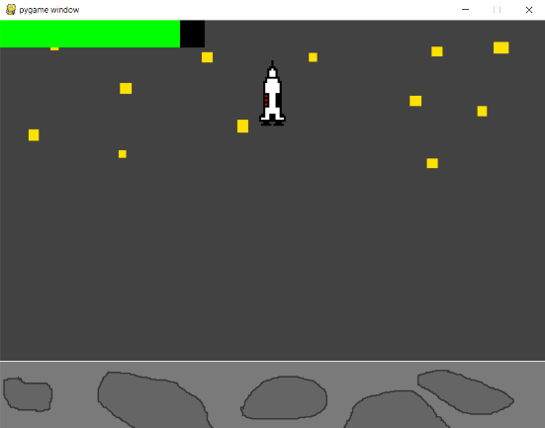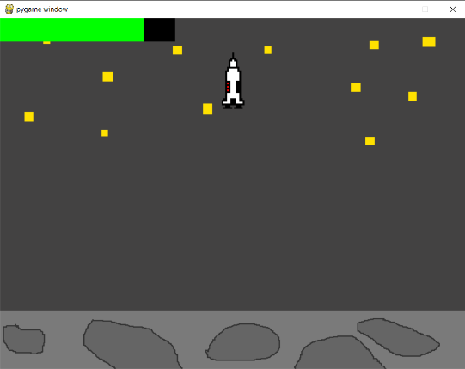Score of 12/15: Score of 13/15:

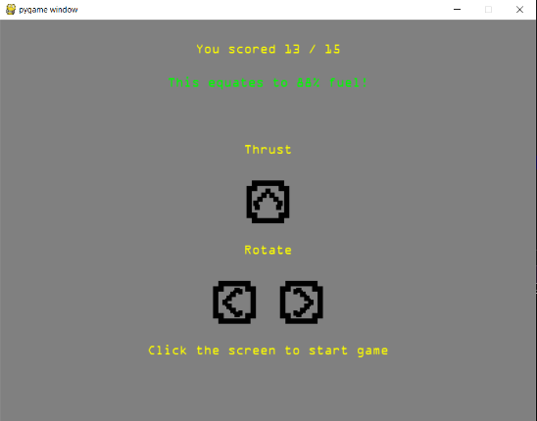

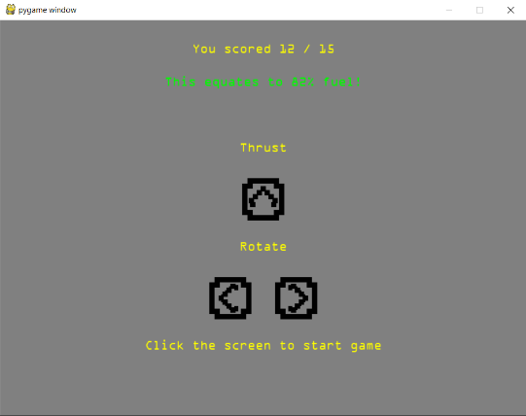

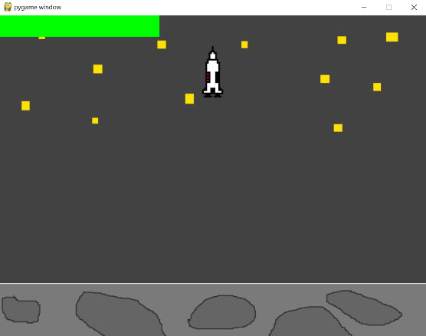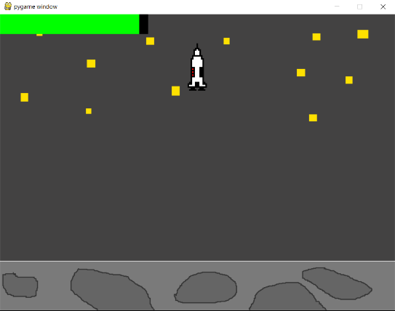Score of 14/15: Score of 15/15 (should be full bar):

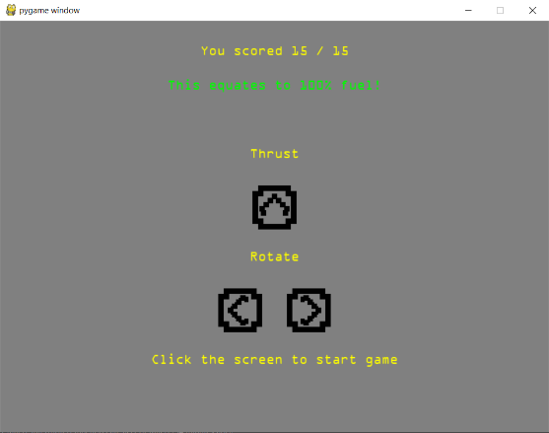

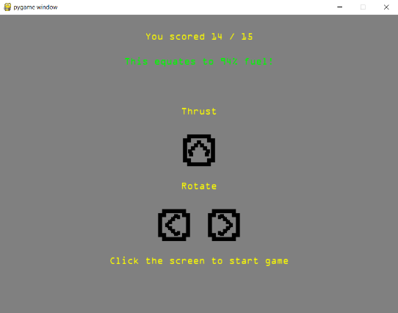

As you can see the test has been successful and the score goes up by 6% per question that is correct, this shows a correct increment for each question as the user starts with 10% of the fuel already so that means they have to work for the remaining 90% of the fuel. 90% / 15 (questions) = 6% per question. Therefore the test has been successful and the user is able to gain all the fuel from 15 questions. They also get the correct amount of fuel for each question they get right.

**Test 11:**

The aim of the final test is to ensure that the asteroids have a randomised trajectory like I planned in the development. In order to test this I will begin the game and wait 4 seconds and take a screenshot to see the trajectory of the asteroids. I will add arrows to the screenshots to show the direction the asteroids are travelling in.

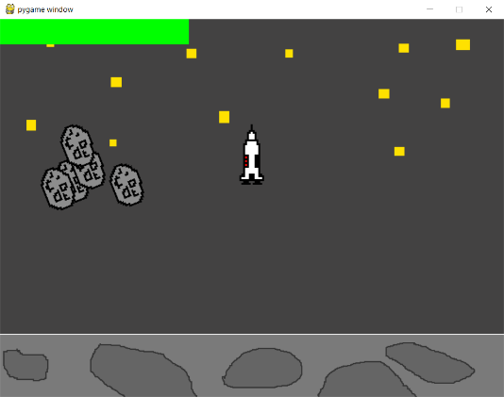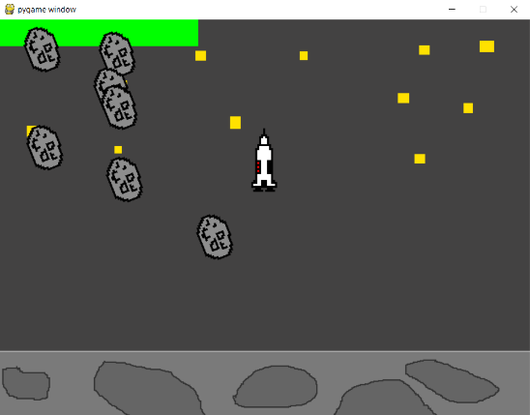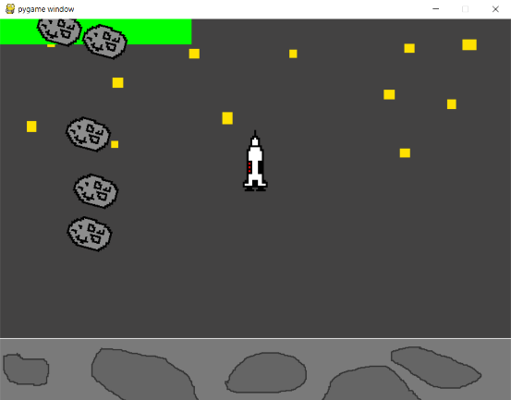Test 1: Test 2: Test 3:

As you can see the asteroid trajectories are completely random every time the game starts. I have tested this more than three times but this is just a demonstration of three random attempts. Due to the use of the uniform random values they can only appear from a range of selected values. This means, like in example 3, that sometimes some of the asteroids can have very similar trajectories although due to their different velocities and the effect of the gravity they often split up and travel independently. Therefore the test has been successful and I am confident the trajectories are random.

Login Screen Testing

|  |  |  |
| --- | --- | --- |
| Test Number | Test Aim | Expected Result |
|  | Ensure username is present when creating an account. | It doesn’t allow an account to be created if no username has been entered. |
|  | Ensure password is present when an account is created. | It doesn’t allow an account to be created if no password is entered. |
|  | Ensure username is of a suitable length. | Doesn’t allow a username to be created with a username of <3 or >10 characters. |
|  | Ensure password is of a suitable length. | Doesn’t allow a password of <5 characters to be created. |
|  | Account can be created if password and username are valid. | Account is created and user is notified. |
|  | Account details can be used to log in to the system. | The user is logged in and taken to the next screen. |
|  | Entering incorrect username or password doesn’t allow the user to log in. | Error message displayed telling user that the username or password is incorrect. |
|  | Focus of the buttons can be changed using tab key and mouse click. | Pressing Tab changes the focus of the button to the next button down or puts is back to the top if it is the last button. If the mouse click is in the username or password then the focus should be put on that button. |
|  | Account can be created or user can log in by pressing enter key. | Pressing enter while either of the text boxes or login is highlighted will attempt to log the user in. Pressing enter on ‘create account’ attempts to create an account. |
|  | Check users can’t make two accounts with the same username. | The program will now allow two accounts with the same username to exist. |

**Test 1:**

Test 1 aims to test that an account can only be created when there is a username in the text box. This prevents redundant and useless accounts being made in the database.

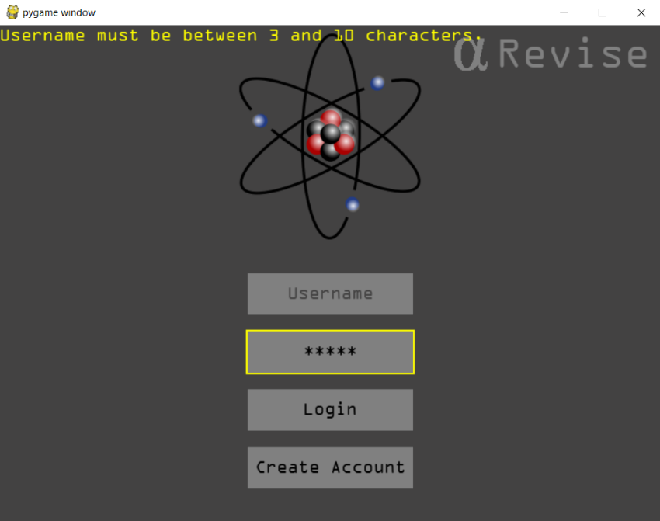

As you can see when you attempt to create an account with only a password the error message in the top left is shown telling the user their username must be at least 3 characters. This means that the account cannot be created with a blank username.

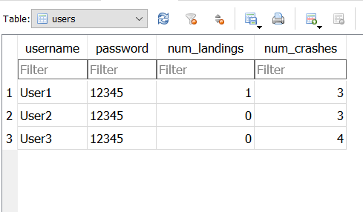

As you can see no data was added to the database, therefore a username must be present and this test has been a success.

**Test 2:**

Test 2 aims to prevent accounts being created that do not have a password. This would be ridiculous as anyone would be able to access any account. It also prevents the database being filed with redundant data.

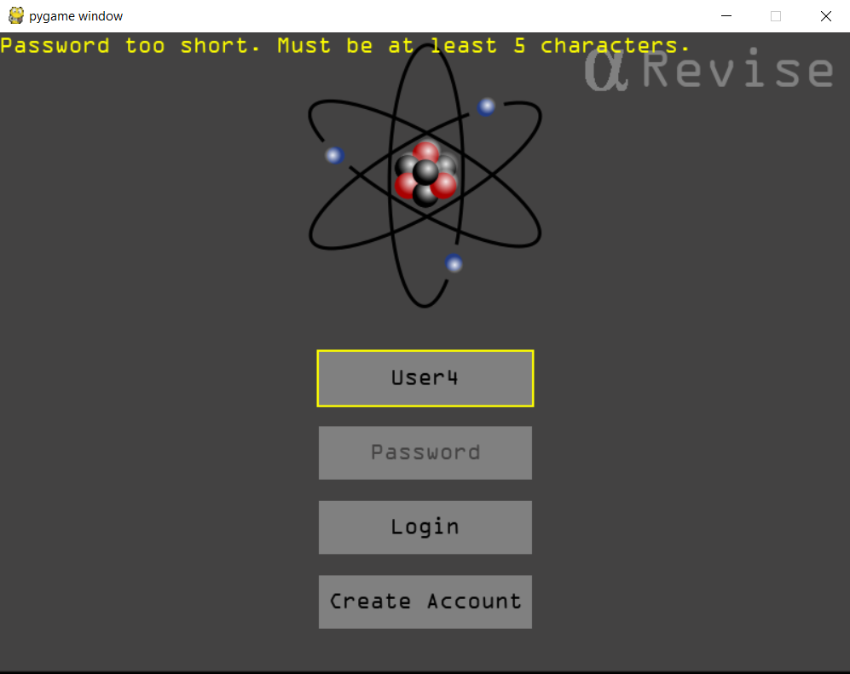

As you can see similarly to the username an appropriate error message is displayed telling the user that they must have a password which has more than 5 characters in it.



Again no data is added to the database meaning the test is a success as it has prevented the user from creating an account with a blank password.

**Test 3:**

We have already shown that the username cannot be created blank but I have also imposed restrictions on its length. For this test I will try and create an account with a username which has more than 10 characters in it. I will then try to create an account which has 2 characters in it. This will prove whether the restrictions work. For these tests I have used a password which would be considered valid to ensure that if it was possible an account would have been created.

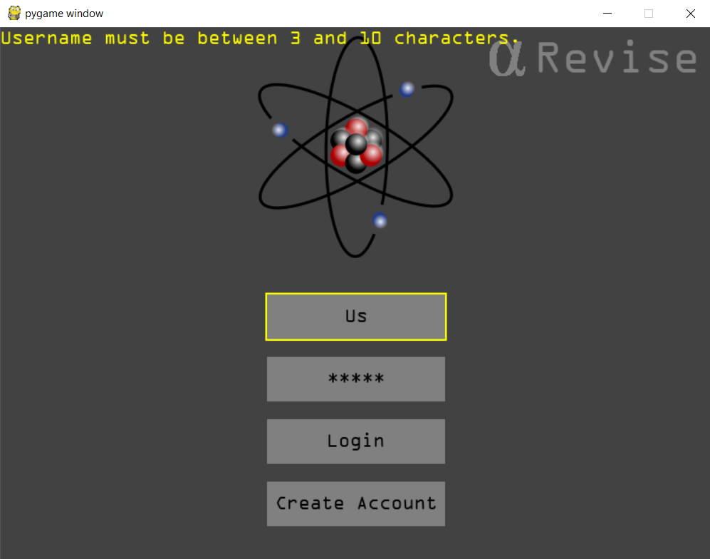

The correct error message is being displayed to tell the user the mistake that they’re making.

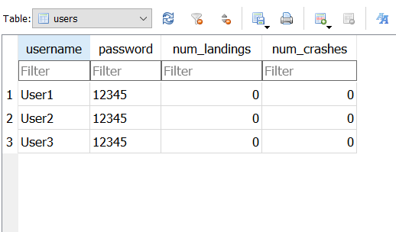

No data is saved to the database meaning the test is a success and accounts cannot be created with usernames that are too short.

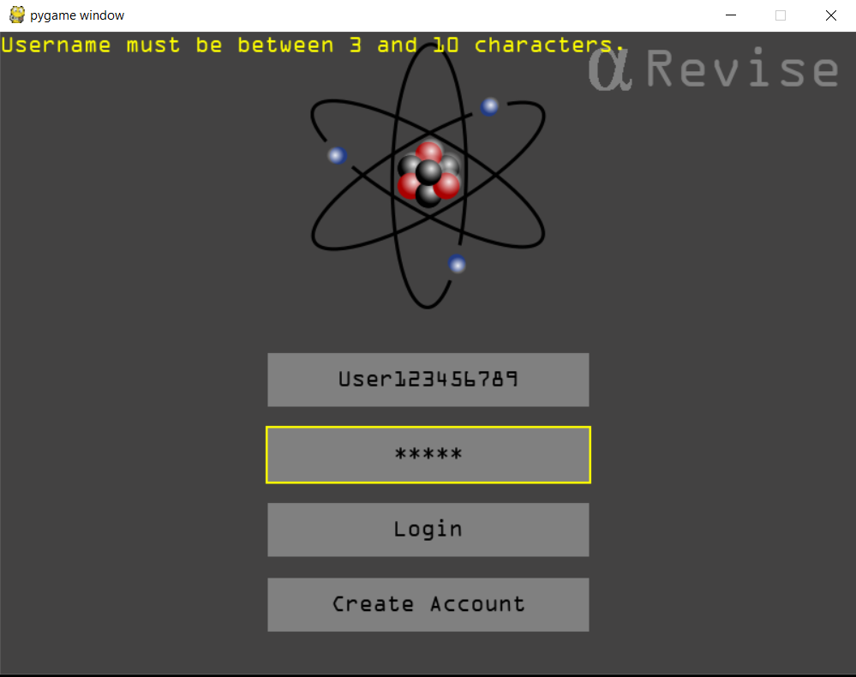

This username is 13 characters long and sop exceeds the 10 character limit. The correct error message is displayed showing the user that they cannot have a username that long.



Again as expected no data is saved to the database due to the length of the username.

These tests have been successful in proving the username validation system to be accurate and that it works correctly as users cannot create accounts with usernames that fall outside of the parameters even if their password is valid and no data is added to the database if the username is seen to be invalid. As you can see above when testing this I realised that you couldn’t see a username of 10 characters in the text box so I took the opportunity to extend the text boxes due to the problem which I spotted from testing.

**Test 4:**

In order for an account to be created the password must be five characters or more, this promotes secure password creation and there is no limit on how long the password can be. It also prevents the database from being spammed if students where to create accounts with one letter usernames and passwords.

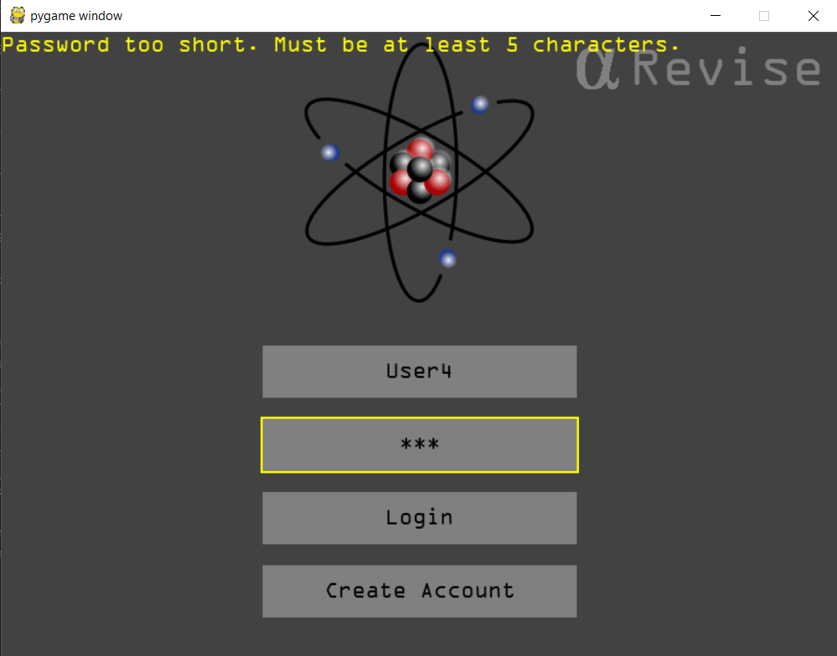

As you can see here I have entered a username which is completely valid but the password only has three letters in it therefore the program recognises it Is too short. There is no need to repeat this many times although when using the program I have anyway and it doesn’t allow for a password of under 5 characters to be created, therefore making this test a success.

**Test 5:**

Now that the validation for the username and password has been checked we now need to check that an account can actually be created. For this test the username will be: User4 (5 characters) and the password will be: 12345 (5 characters and it may not be secure but it is only for testing purposes.

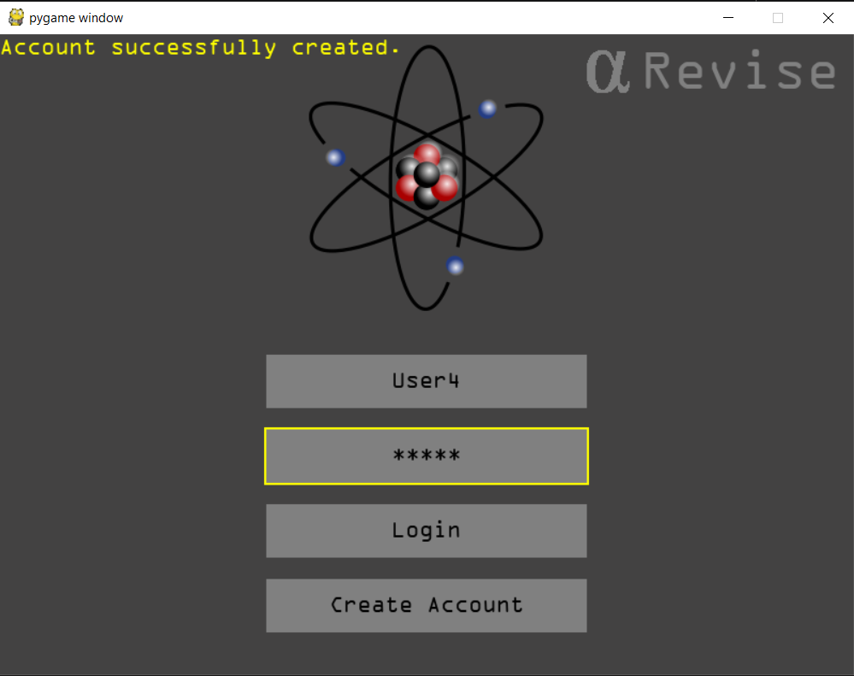

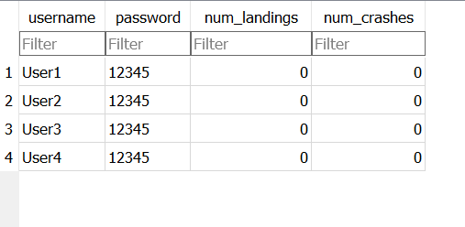

As you can see the new account has now been created in the database. This shows that the account creation and validation section of the login screen works perfectly and without fault. The only adjustment I’ve had to make is making the buttons wider in order to fit a username of over 10 characters on it. There is no way of spamming the system now with short text lengths and flooding the database with redundant data unless a student types all of the accounts out separately.

**Test 6:**

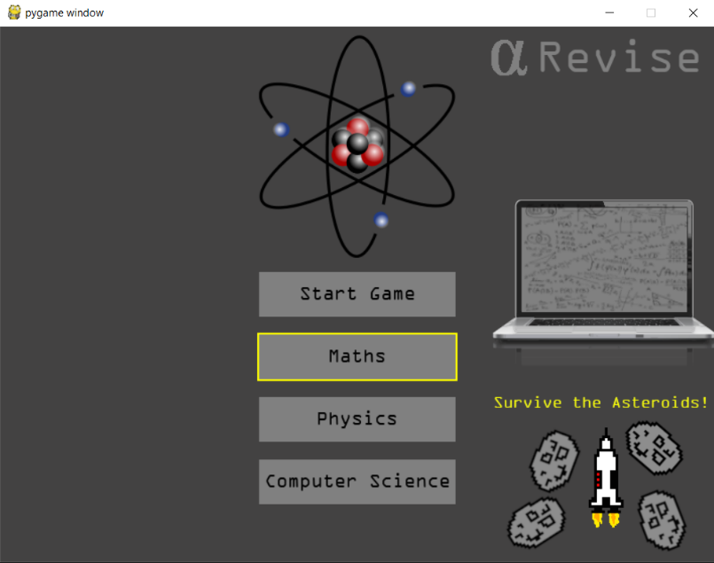This test aims to check that if the user enters valid details the program will actually allow them to be logged in. I will use the user 4 account that I just created to demonstrate this.

(12345)

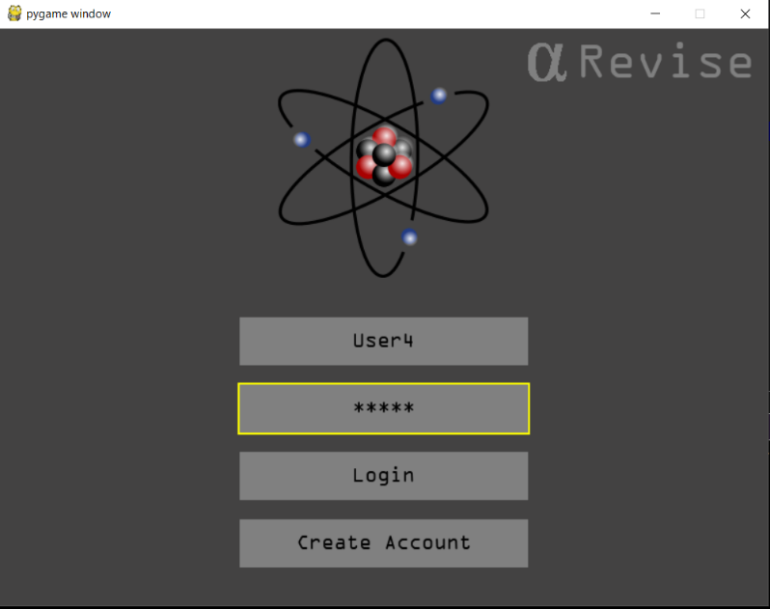

When ‘login’ or the enter key is pressed the program takes you to the main menu proving this test to be successful. It checks with the data in the database and takes you to the main menu, this is exactly what was expected from the program and proves that a user is now able to log in.

**Test 7:**

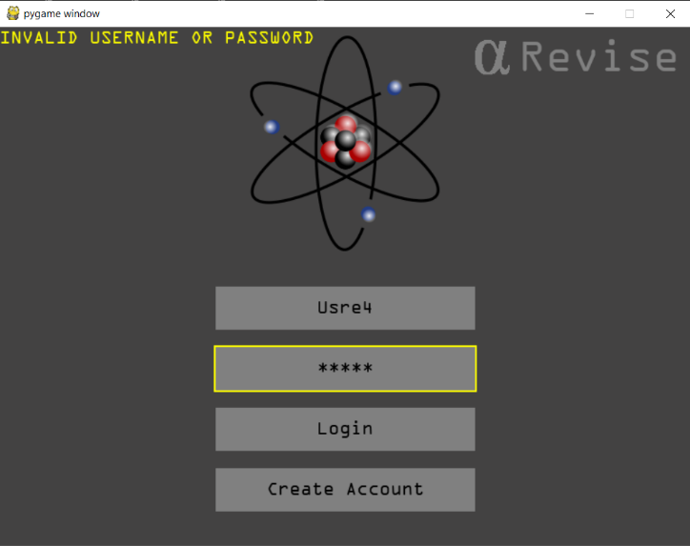Of course entering correct data should allow the user to log in, but they should be prevented form logging in if the incorrect username or password is entered. For the first test I will use the User4 username but the password will be “hellothere”. I will then attempt to use the username “usre4” but with 12345 as the password in order to mimic a spelling error.

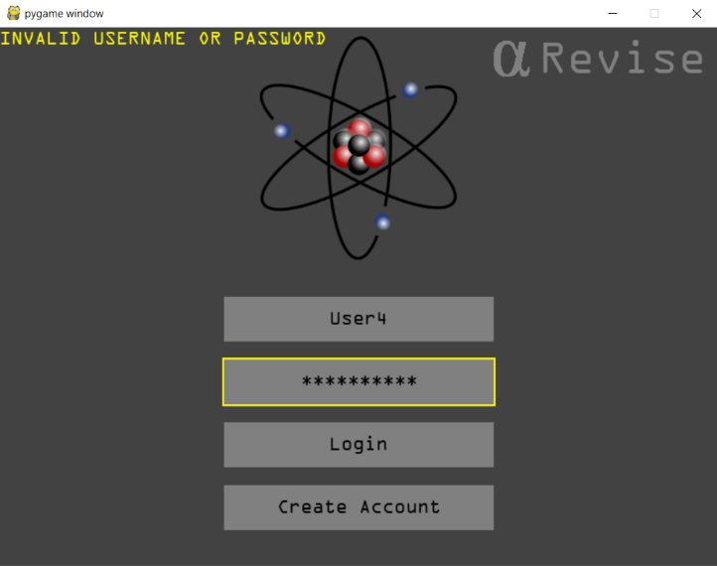

As you can see the program doesn’t allow you to proceed with an incorrect username or password, this is exactly what I wanted to happen. As you can also see it displayed the message invalid username or password. This phrase is used in the industry to stop hacking, if for example there was a password leak people may use the same password for different sites so a hacker may try to enter their username and password in several sites to see if they have an account. If the site just said wrong password it would be clear to the hacker that the victim has an account with that site.

**Test 8:**

Focus of the buttons can be changed using tab key, this is the focus feature that I built into the button class and I needed to test that the button changes focus when the tab button is pressed. I also needed to ensure that the focus goes to the next button and that if the last button is focused and tab is pressed again then the focus returns to the top. The focus should also be changeable via the mouse click, where the user can click on the username or password box and the button will be focused and the user will be able to type into the box.

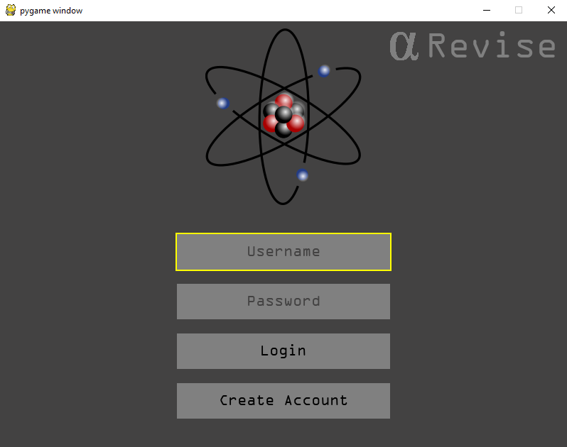

As you can see by default the top button is focused when the program is opened.

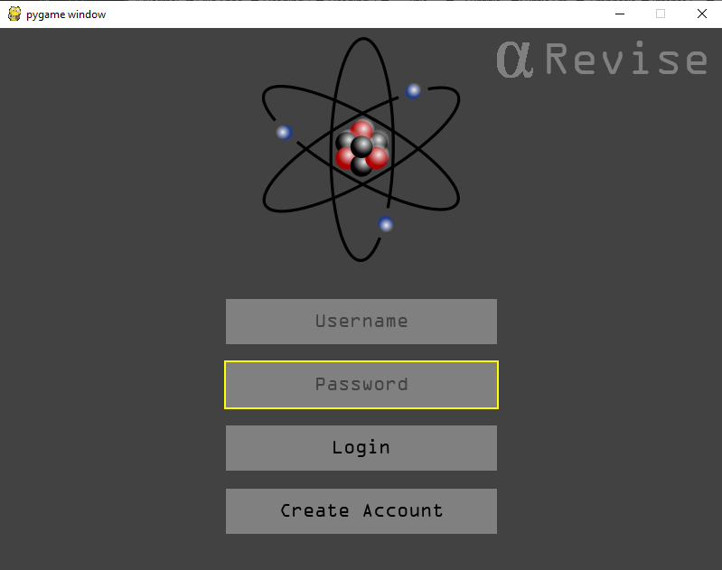

If the tab button is pressed then the next button down is focused.

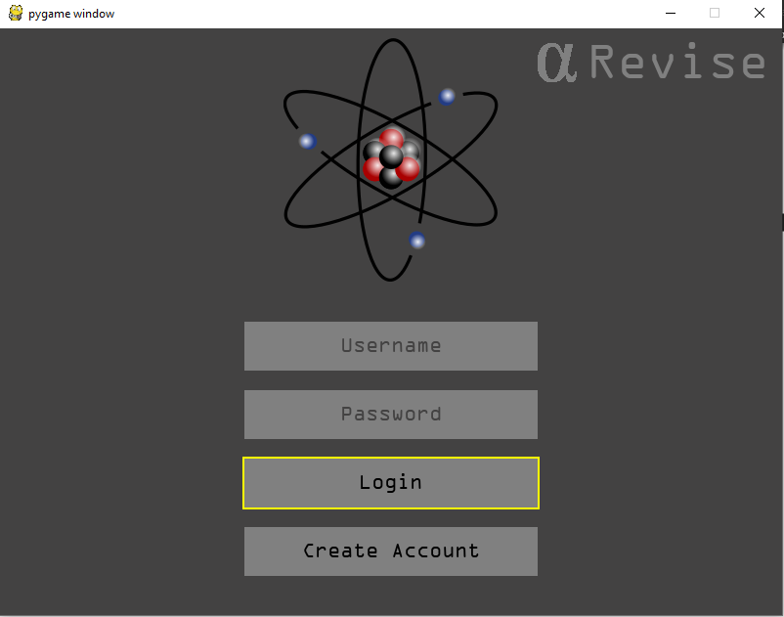

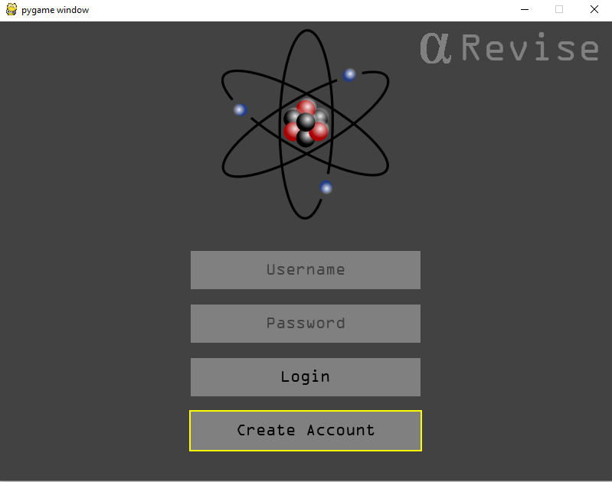

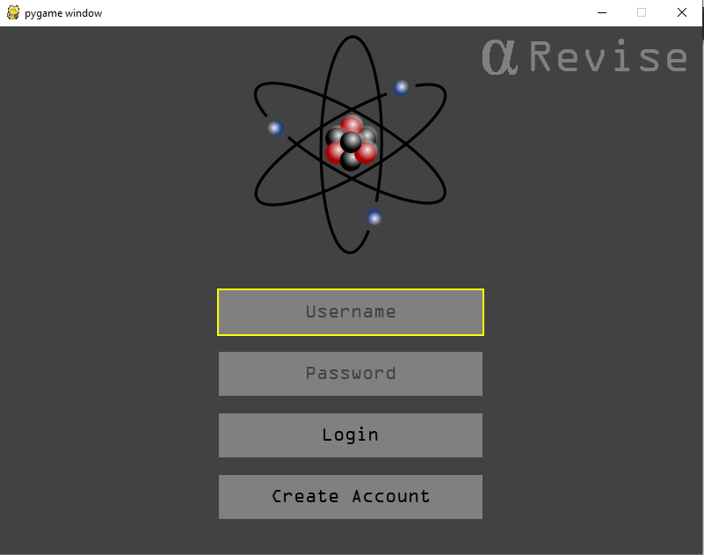

Each time the tab button is pressed the next button is focused and when it returns to the top. This test has been a success, this was an important part that I wanted to use in the GUI as it is used in the industry and in real applications. You can also focus either the username or password text box by clicking them with the mouse. This means that this has been a success as the focus of the buttons can be changed with the tab key or the click of the mouse as planned.

**Test 9:**

The aim of test 9 on the login screen is to show that the create account button works both with the enter key and by clicking it with the mouse, for this I will create anew account called “User5” and with the password 12345, I will then create “User6” with the same password to demonstrate both functionalities.

Pressing Enter:

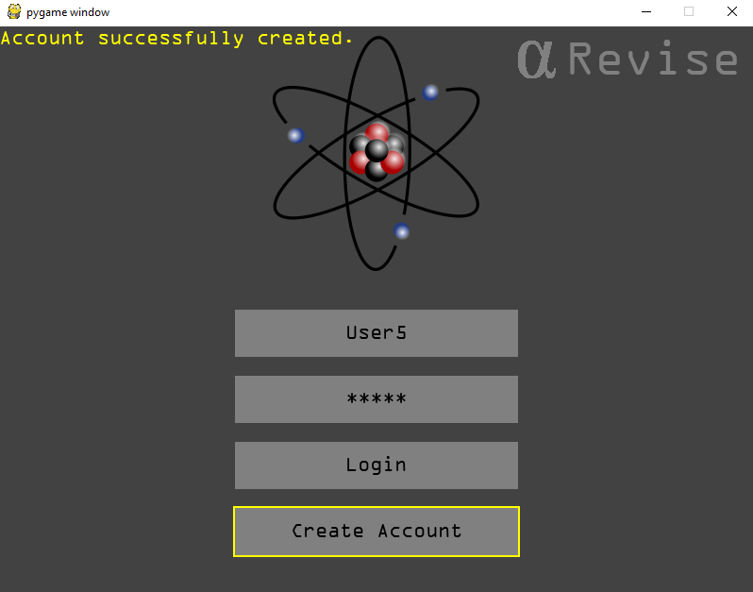

As you can see I have created the User5 account by focusing the create account button using Tab and then pressing enter to confirm the account creation.

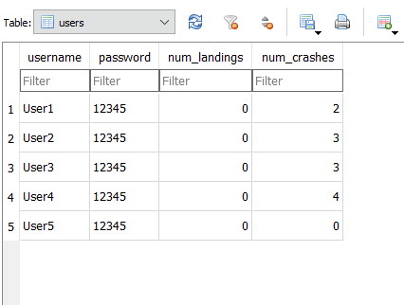

The account has been successfully created in the database proving that you are able to create an account using enter as long as the button is focused in the login screen.

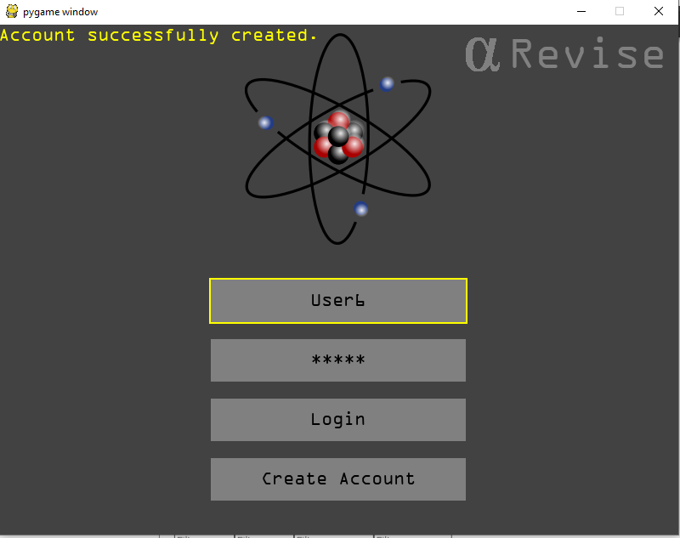

As you can see the create account button is not focused in this screenshot yet an account has been created, this is because I clicked it with the mouse. The correct message is being shown in the top left.

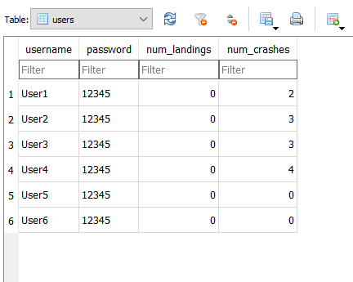

As you can see User6 is now in the database users table meaning that the click of the mouse is effective and that it works as expected. This test has been a success as the account creation works with both the enter key and the mouse click.

**Test 10:**

The final test for the login screen is to check users can’t make two accounts with the same username. This is essential as a database should never contain 2 records with the same primary key and if I allowed this to happen then the leader board system wouldn’t be able to work.



In order to test this I will try to create an account with the same username but a different password. I will user User1 to do this.

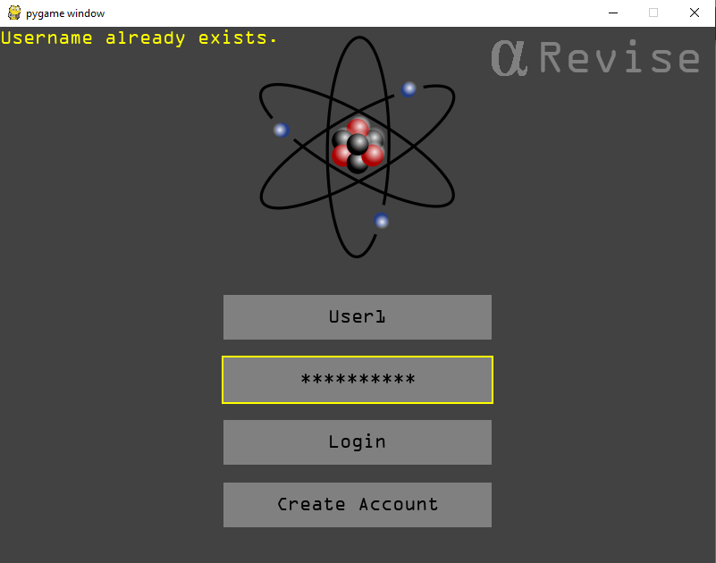

I attempted to create the account using the password “hellothere”, as you can see the correct error message is displayed telling the user that the username already exists.

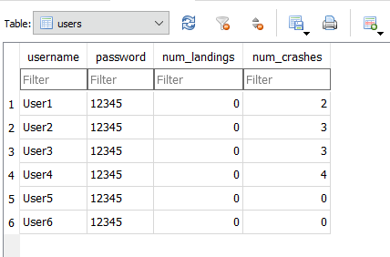

As you can see there is no new account with the username “User1”, this means that the test has been a success and that the usernames cannot be duplicated in the database. This ensures the integrity of the database and that other features of the program will be able to work.

Main Menu Testing

|  |  |  |
| --- | --- | --- |
| Test Number | Test Aims | Expected Result |
|  | The start game button performs the correct function. | When start game is pressed the quiz begins. |
|  | Topic selection allows for correct topic to be loaded into the quiz. | When quiz begins selected topic is the one which was focused in the main menu. |
|  | Leader board is not displayed if the game hasn’t yet been played. | The leader boards should not appear if the game has not yet been played as the data doesn’t exist. |
|  | Leader board displays correctly after the first game has been played. | The leader board displays the first user and their score. |
|  | After several games the leader board displays correctly. | The leader board displays each user in the correct place with their score and no more than three users. However there can be less than three entries on the leader board. |

**Test 1:**

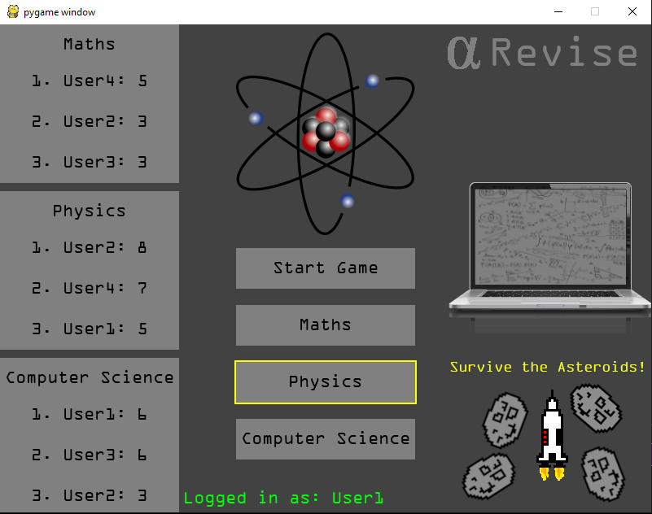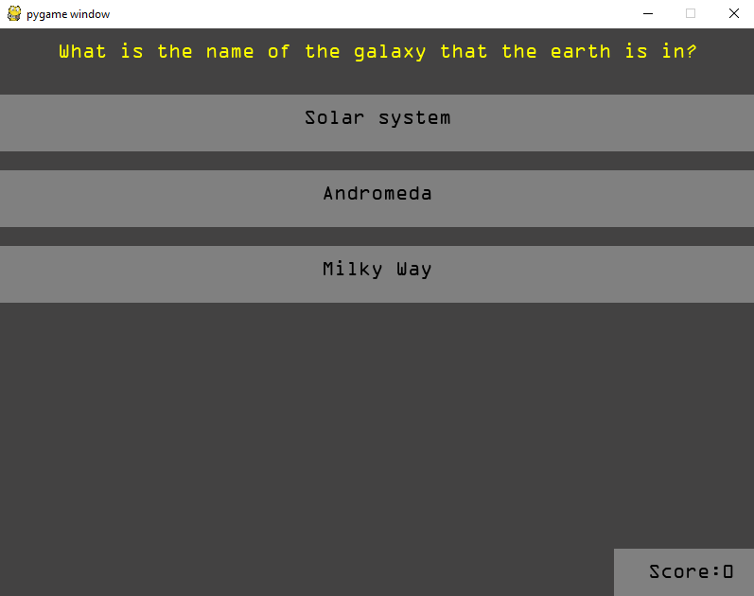In order to perform this test I have logged in as User1 and selected the physics topic, I will then click start game using the mouse.

The test has been successful as when the start game button is pressed the quiz is opened and the questions and answers are displayed. This is the expected result so the first test is a success.

**Test 2:**

When the topic is selected in the main menu the correct quiz is loaded. For this I will test for all 3 topics. The first topic is maths:

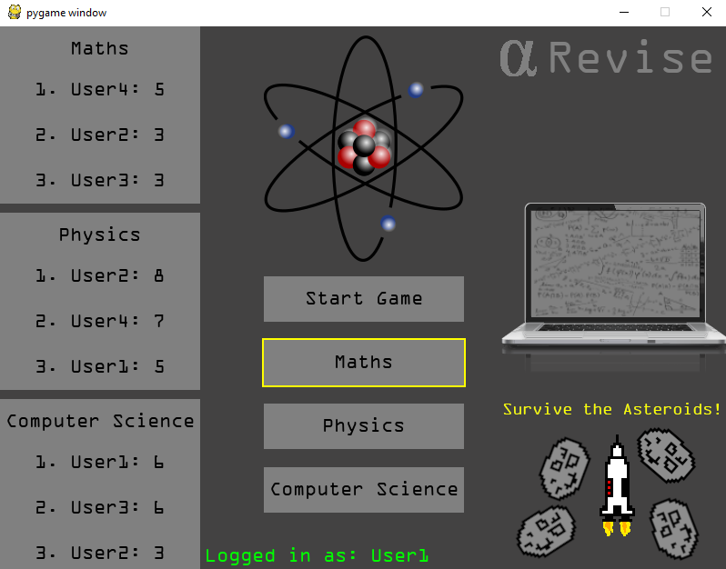

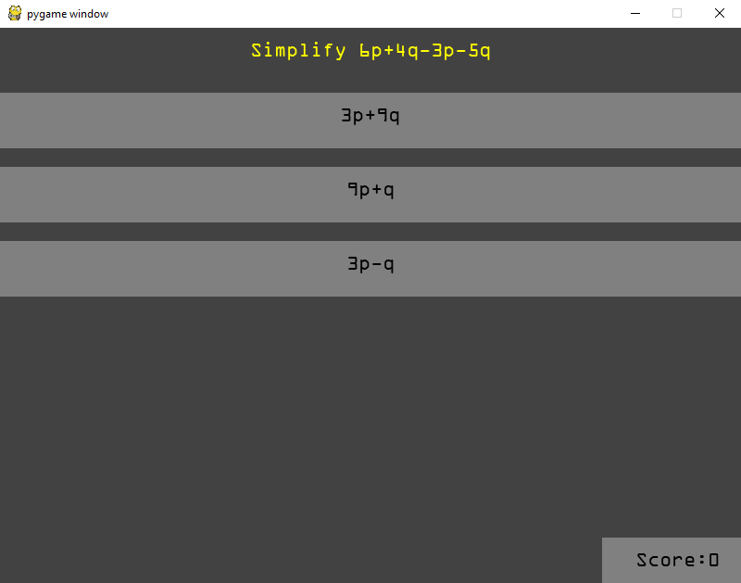

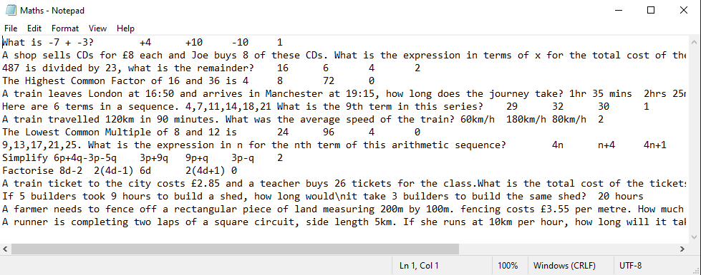

As you can see I had maths selected and I pressed the start game button, as you can see the quiz is started as expected. When compared with the question file for maths you can see that the question came from the maths file which means it successfully opened the correct file.

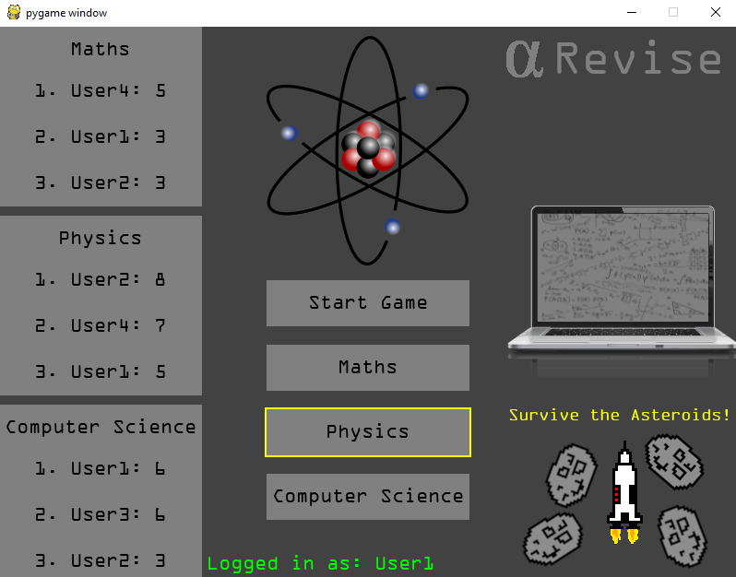

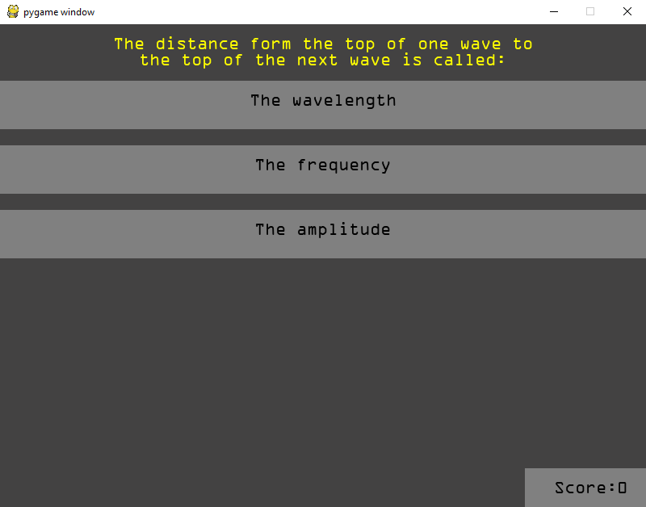

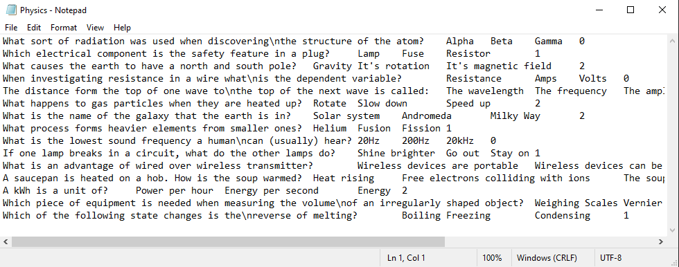

As you can see the correct quiz file has been loaded when start game is pressed meaning that the test has been successful and the quiz opens the correct file when the topic is elected using the buttons in the main menu.

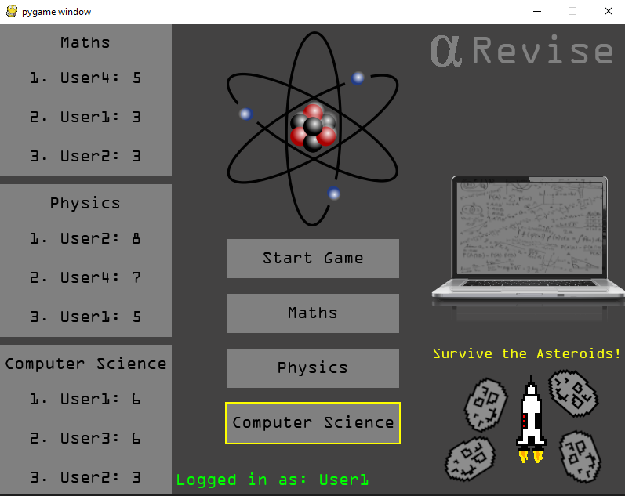

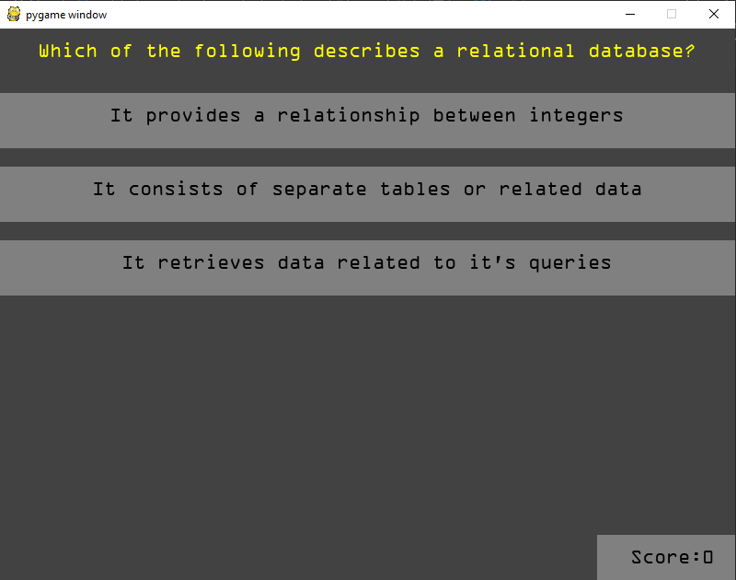

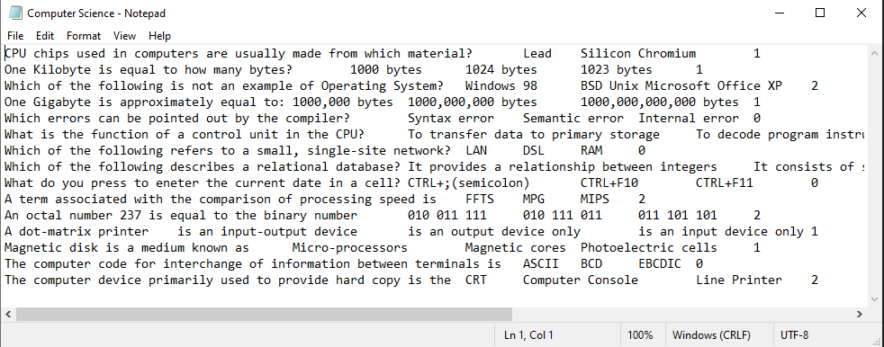

Here is the final example on the last quiz option, again showing the correct quiz to be opened when the user selects the computer science option. This again proves that the system of topic selection in the main menu works.

**Test 3:**

The way that I have designed the leader board is so that if there is no data in the table (the quiz hasn’t been played yet) then the leader board will not appear even if users are registered. In order to test this I deleted the leader board and ran the game to create a new one, I then created 3 accounts in the database.

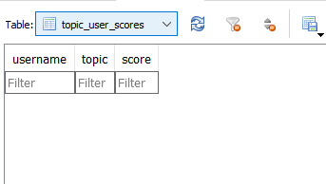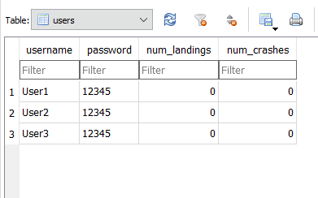

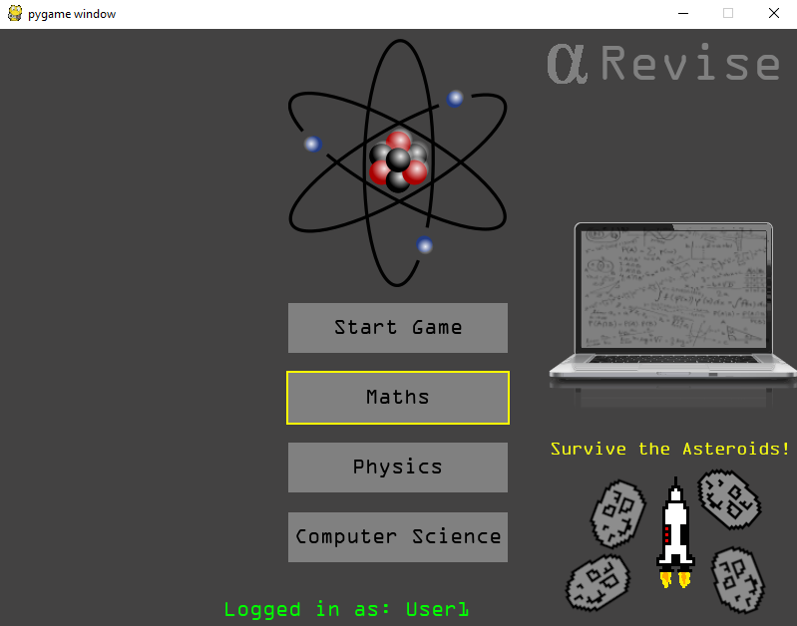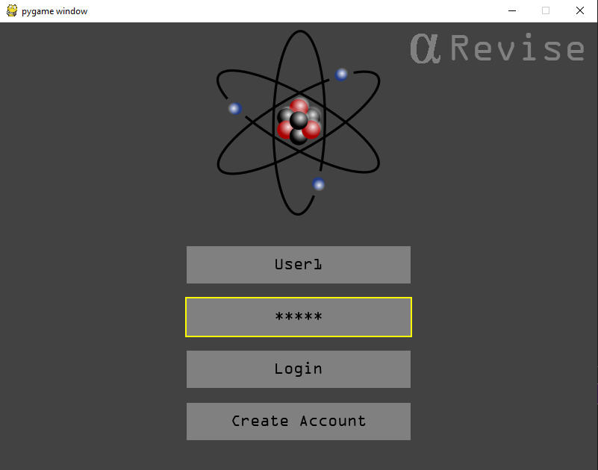As you can see the database has been created with both tables in it, The topic user scores table is empty because the quiz has not been played. I will now log in as “User1” and the main menu should display no leader board.

As you can see at the bottom of the main menu the user is logged in as User1 and the leader board is nowhere to be seen. This is what I expected to happen as there is no data to display. This demonstrates that the test is a success and that the leader board will only appear if there is data to put in it.

**Test 4:**

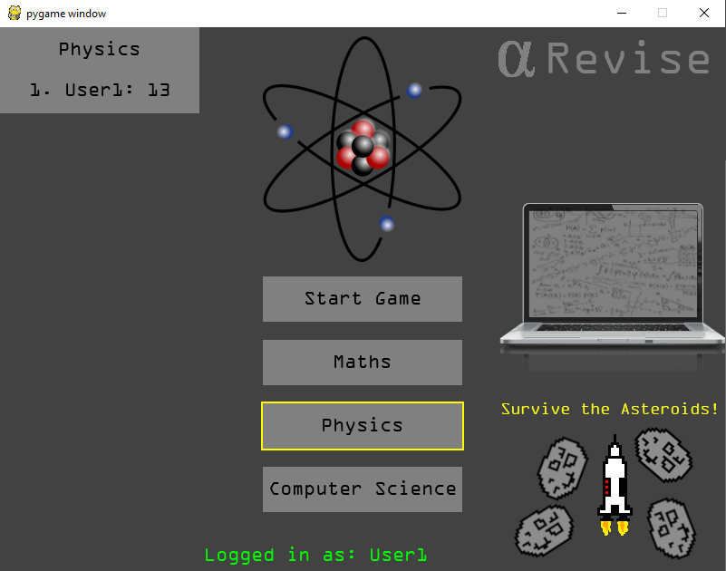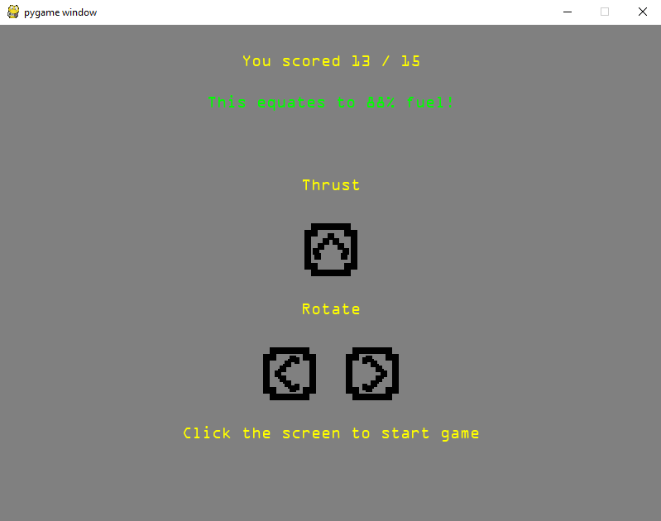When a user has played a game they are able to return to the main menu by clicking the game over button. It is essential that the leader board is updated when they return to the menu so that the user is not left confused and believes their score hasn’t registered if they have scored highly. I will log in as User1 with the current database and play the first game, after returning to the menu the leader board should appear.

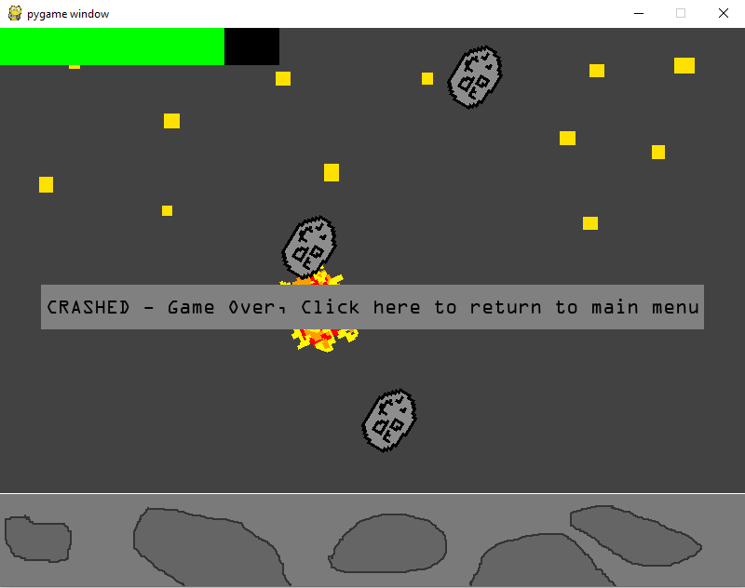

As you can see I played the game and scored 13/15, unfortunately I crashed in the rocket game but I returned to the main menu and the leader board had been created for the physics topic which I played. This proves the test was successful as the physics leader board was displayed an the correct username and score was presented. Only 1 quiz has been displayed so the leader board only shows the result for that score and obviously because they are they only one they are in 1st place so the placement is also displayed correctly.

**Test 5:**

The next test is the one to show that after several games the leader board shows the correct usernames, scores and positions on the leader board. This ensures that the leader board is being displayed correctly. For this test I will log in as User 1 and play all the quizzes 3 times on each user. This will give a wide range of data for the leader board.

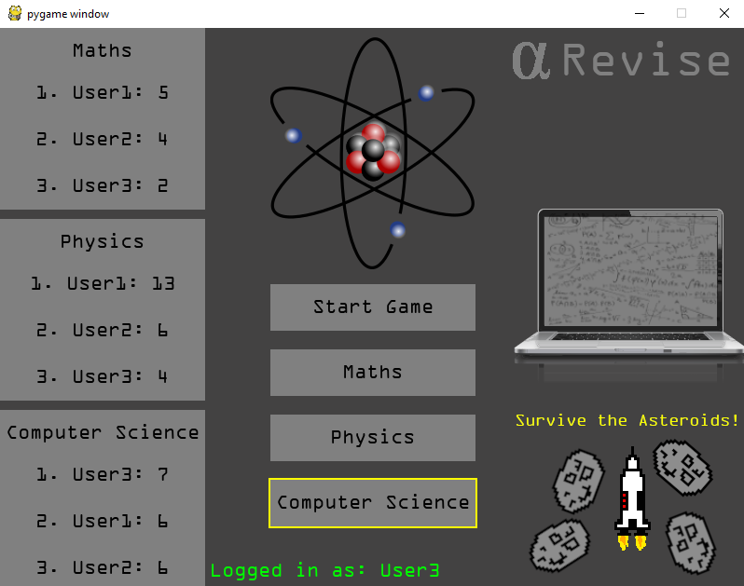

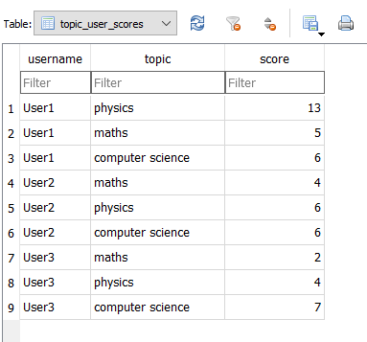

As you can see the leader boards are displayed correctly when the data in them Is compared with the data in the database. The users are displayed in the correct order, with the correct scores and position number next to them. This is what I expected to happen as the data comes directly from the database and therefore the test is a success and the main menu Is complete.

Database Testing

|  |  |  |
| --- | --- | --- |
| Test Number | Test Aims | Expected Result |
|  | Ensure that when create account is clicked an account is created in the database. | When create account is clicked an account with the correct username and password appears in the database. |
|  | Ensure that when log in is pressed the user is logged in with the correct account. | When the user logs in the main menu will display something to tell the user what account they are logged in with. |
|  | When a user has logged in with an account any data is saved to that account. | Any subsequent data such as high scores will be saved to that account and can be seen in the database. |
|  | Check that data in the leader board matches the data in the database. | When compared the results in the leader board should be the same as those in the database. |
|  | Check that when a crash happens the number of crashed should be updated in the database. | When a crash happens the number of crashes should be incremented by 1. |
|  | Check that when the rocket lands the number of landings is updated in the database. | When a landing occurs the number of landings should be incremented by 1. |

**Test 1:**

When the user clicks create account in the login screen I need to ensure that the data is added to the database so that they are able to log in using the account. For this test I will create a new account called “User4”. When I click the create account button I will refresh the database to see if it’s been added to the database.

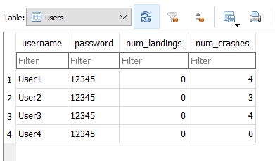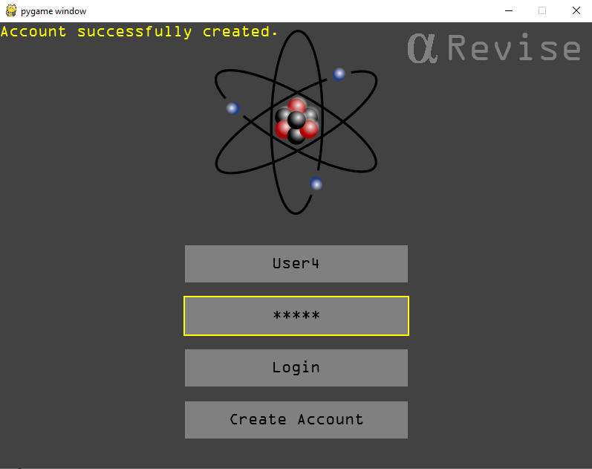The database previously:

As you can see after the user has clicked create account and the database is refreshed the new user is added to the table. This shows that when the user clicks create account the account is then added to the database and the database now contains the new data. This shows the test is successful and that users can now register accounts on the database.

**Test 2:**

The second test is to ensure that when a user clicks log in they are logged in with the correct account.

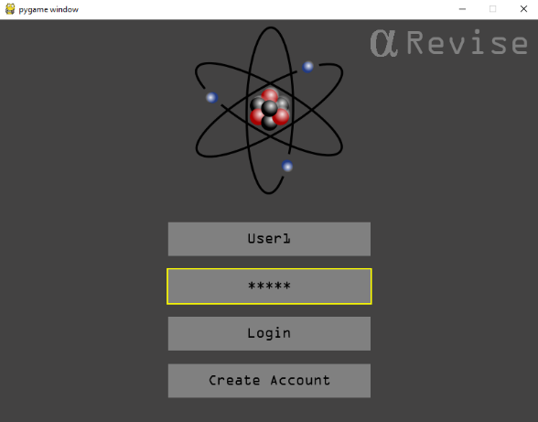

This is where the user logs in using their details. Currently the only way of the user knowing whether they have logged in with the correct account is when they gain a new high score, I will demonstrate this below. I have logged in with user 1’s account and I will now achieve a new high score for the maths section in order to show that the leader board updates for the correct user after User1 plays.

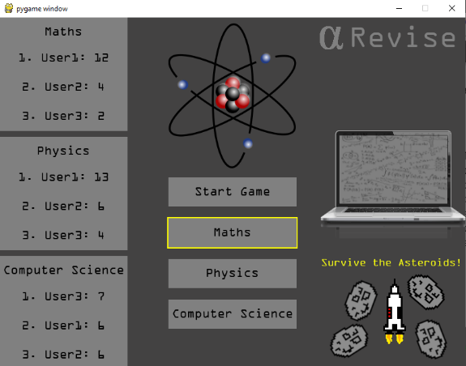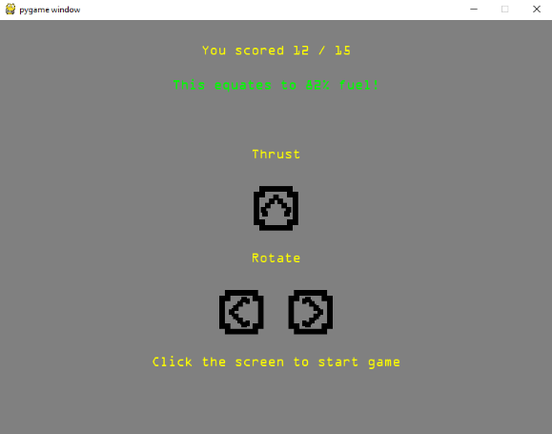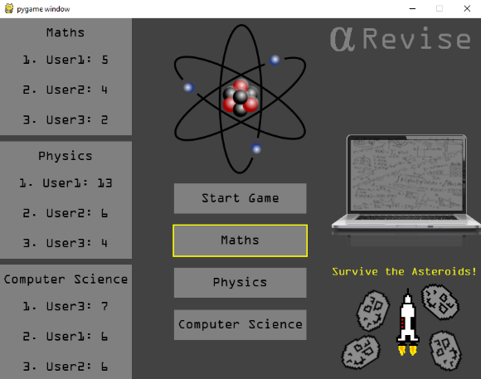

Here is the main menu and leader board before and after User1 gets a new high score, this way the user knows that they are logged in with the correct account as their score has been updated in the database. However in the main menu there is no way for the user to know if they are logged in with the correct account unless they get a new high score.

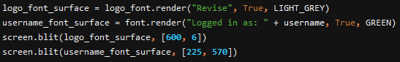

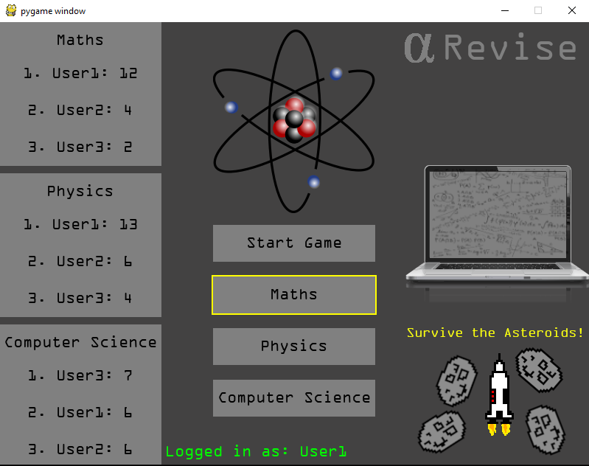I decided to add a font surface to the main menu in order to tell the user what account they are logged in with in real time after they’ve logged in and any time they are in the main menu. Using the code above I was able to implement this feature using the username parameter. You cans see this displayed at the bottom of the main menu in bright green text. This tells the current user which account they are using. It works both after the user logs in and after the game has ended and the user returns to the main menu. This way whenever not in the quiz or in the game the user knows they are using the correct account.

**Test 3:**

When a user has logged in with an account any data is saved to that account, this is imperative for saving high scores and ensuring the leader board works. Using the setter methods in the database file the data should be able to be changed and updated if the criteria are met.

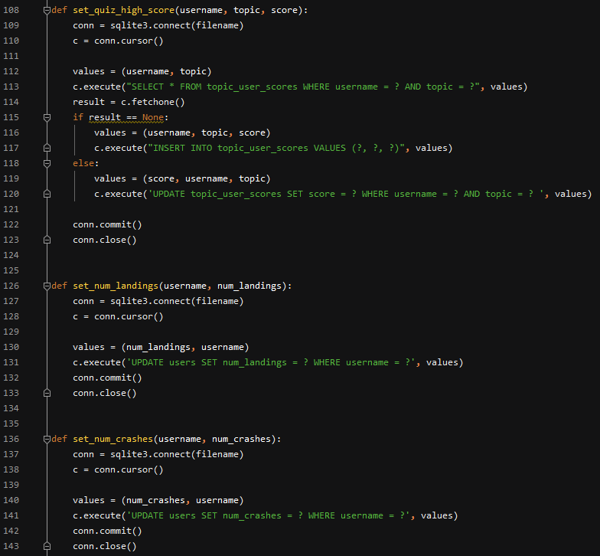Here is the code which updates the database when the function is called. The way to test this would be to get a new high score as a user and then refresh the database when the game is over to check the new score has been saved. I will use the “User2” account and gain a new physics high score for this test.



The above data is shown from the database currently for the User2 physics score, I will now log into the system and get a new high score.

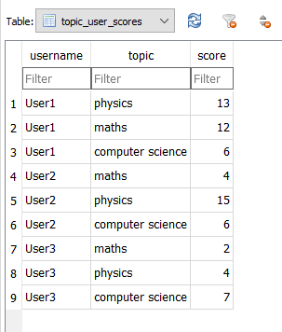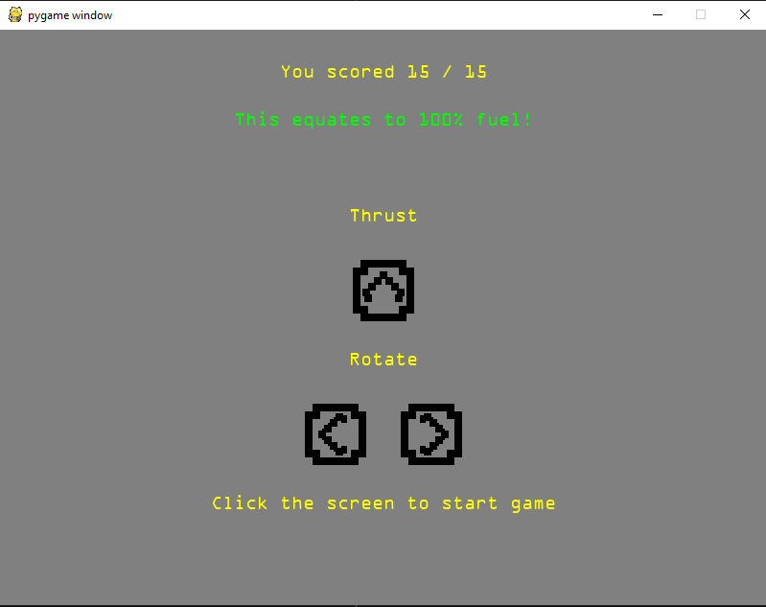

After doing the quiz I went into the database and refreshed it to see the new high score. This shows how the data has been saved correctly to the correct account. This means the test has been a success as the data is saved to the users account.

**Test 4:**

When the data is created the leader board should be correct and match the data in the database. This should be updated no matter how many changes are made. The data should also match the data in the database.

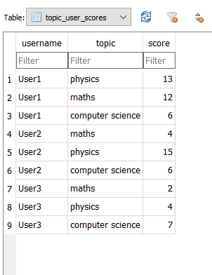

This is the database in it’s current state, I will log in using User3 to check the leader board.

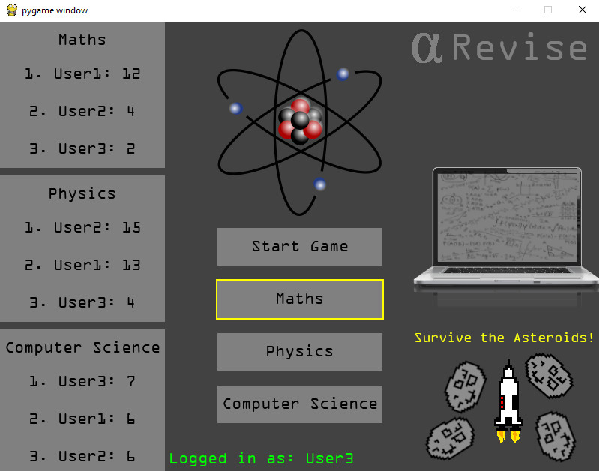

***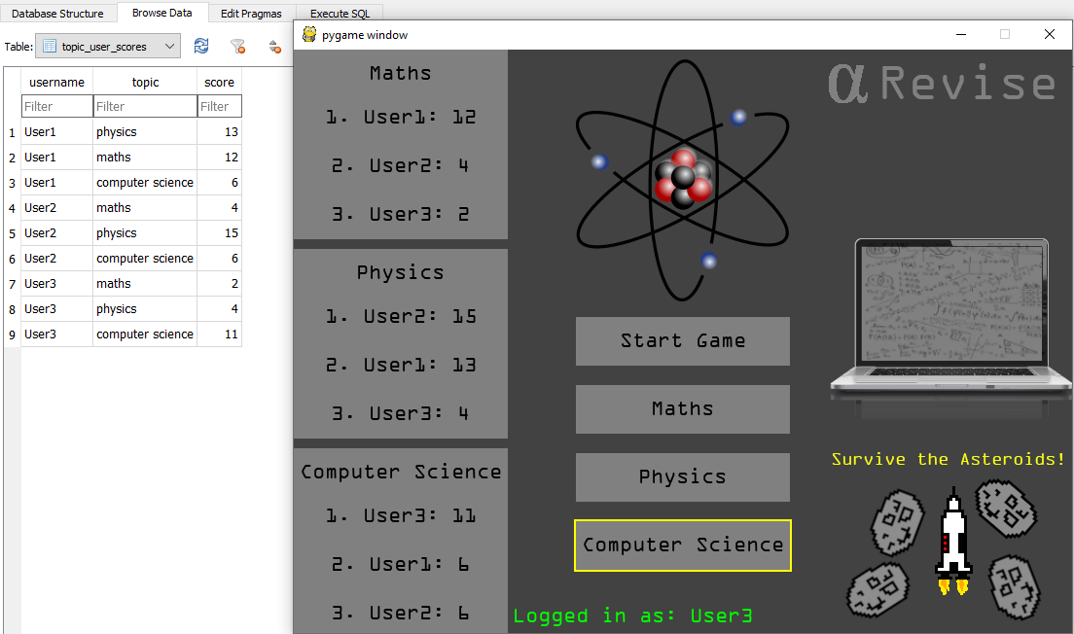*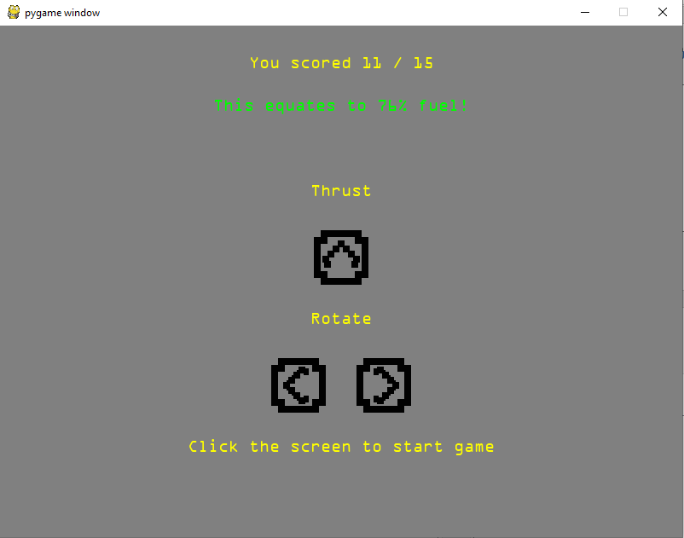**When compared side by side you can see that the data is correct and matches, I will now gain a new computer science high score and ensure the leader board and database still match.

Here is the proof of the new high score and the side by side comparison of the leader board and the updated database. This proves that the test is successful and the data in the leader board matches the data in the database.

**Test 5:**

For the 5th test I am checking to see if the crash counter is updated when the rocket crashes. Although it Is not currently being used in the program I still need to check that it is being updated in case I did want to use it. I will log in as user 1 and check how many crashes the user already has.

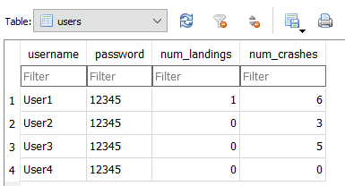

Here you can see User1 already has 6 crashes, in order to test this I will purposefully crash the rocket another 3 times and check that the leader board contains 9 crashes afterwards.

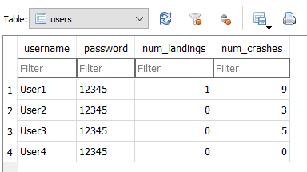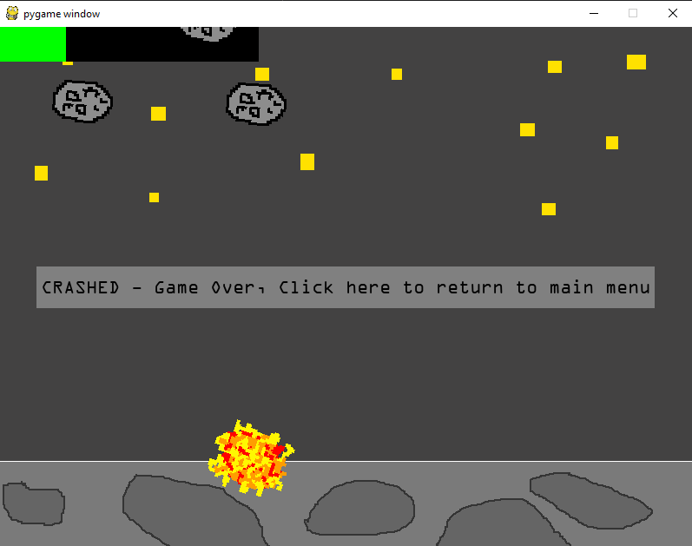

Here is the users table ion the database after the three tests. As you can see the number of crashes now shows as 9 which is what I expected to happen and the test has been a success.

**Test 6:**

The final test of the database is to test that if the player lands the number of landings is updated, this is also not being used in the program but I still need it to work in case I wanted to add it as a feature in a future version.

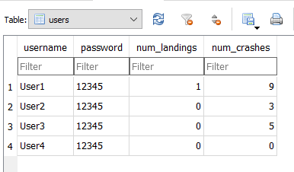As you can see User2 doesn’t have any landings yet, I will land the rocket 3 times on User2’s account to show the change in the database.

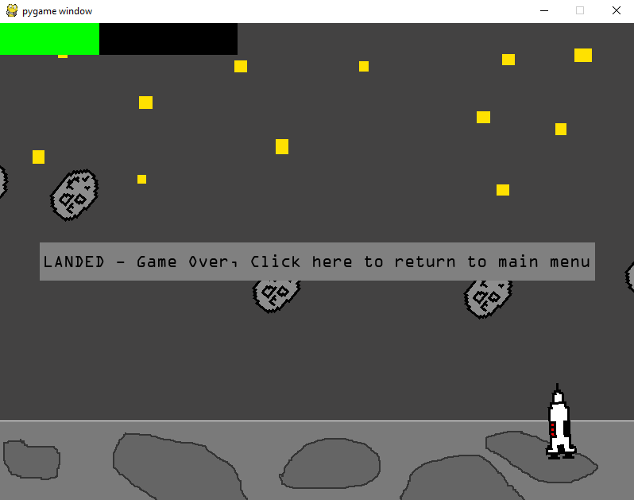

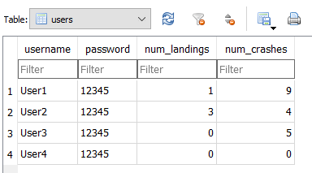As you can see after 3 successful landings the user landings score has been updated to 3. This shows that the test has been a success and that the landings score updates correctly in the database.

Evaluation

Satisfaction of Success Criteria:

Success Criteria:

1. The program will require the user to first create an account or log in if they already have one. After this the program will register any required data to the username of that account. This allows them to log their data to their own accounts. This is necessary as the learning process should be ongoing and should show continuous improvement. The student should be able to see what they have achieved and then work to improve their score.
2. The main menu will allow the student to select what subject they would like to revise. By including multiple topics in the program it is not limited to just one topic in a subject or even just one subject. The program can be easily adapted and used for any topic or subject.
3. The user can begin the game with the topic they have chosen selected, the game will be clear and provide instruction as to what the student needs to do. When it comes to answering questions the options will be clearly shown. The student should be able to easily interpret what is going on in the program and what is required of them. The topic selection should also be clear enough so they know what they have selected.
4. The questions in the quiz will randomise each time so that that out of the topics selected no two questions are the same, questions will also be removed from the list in order to prevent repeats. This prevents a trial and error approach to the questions, it also means that per quiz each question can only be attempted once.
5. An indication of the correct or wrong answer will be shown when the student chooses an answer. A correct answer will increment score counter in real time. The student should be able to see how they’re doing in real time meaning their score updates each question, this Is necessary to show the student how well they are doing at any point.
6. The score from the quiz should feed into an interesting real time minigame which provides motivation to do well. Younger students often are motivated by reward, by initiating a minigame after they’ve completed the quiz they will have a type of reward for their efforts.
7. The data is fed into a database which is used to display a leader board for high scores for that month, this allows students to compete in order to improve their knowledge and get better scores than their friends. This builds on the reward system whereby the students can be rewarded for their efforts. This could encourage them to always improve and practise to get better.

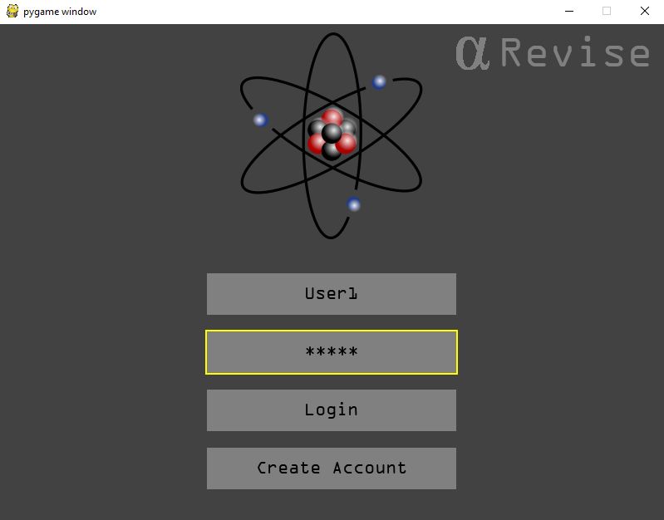

1.

Here is the login interface showing that success criteria 1 has been met. This is demonstrated in the testing section.

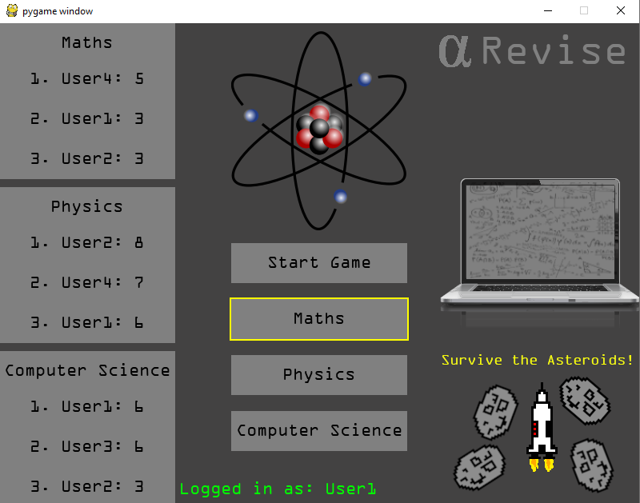

7.

2.

The topic selection and leader boards are shown here which satisfy success criteria 2 and 7.

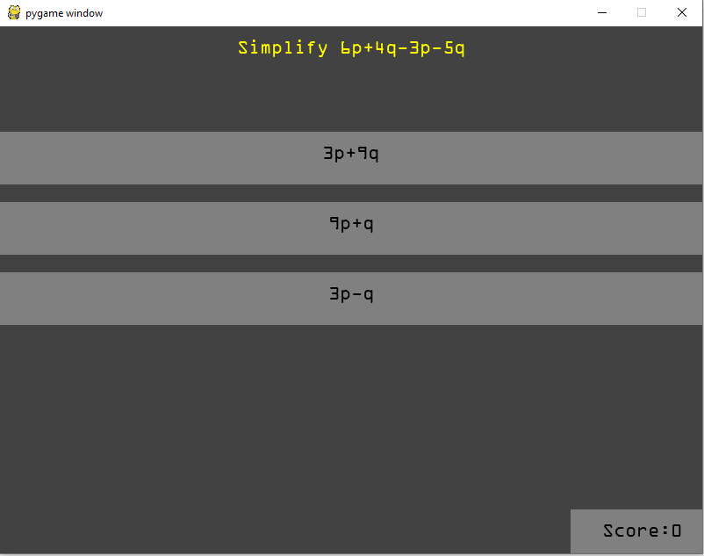

5.

4.

3.

The question shown at the top is one from the chosen topic, satisfying success criteria 3.

The questions are randomised, this is demonstrated in the testing section, satisfying success criteria 4.

The real time score counter is shown in the test also, satisfying success criteria 5.

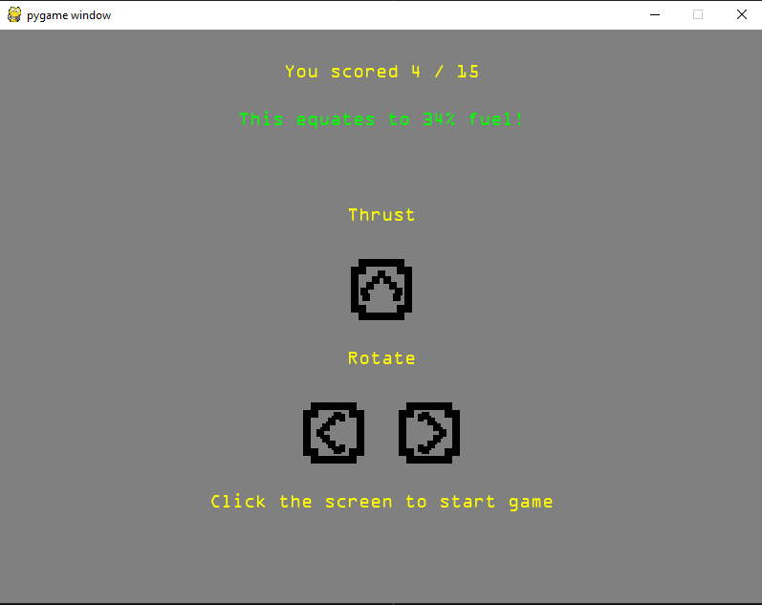

3.

The instructions for the minigame are clearly shown here, satisfying the second part of success criteria 3.

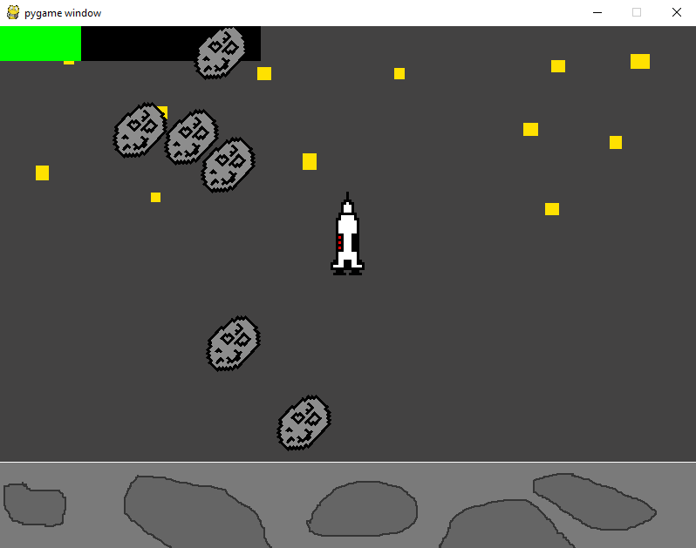

6.

The minigame takes the score and converts it into the in game fuel. The game is also interesting and real time, this satisfies success criteria 6.

**Limitations of the Program:**

Although for a final product it would be preferable to use a shared database, for reasons of time and resources I used SQLite as the database system. This means that the database is saved as a local file on the computer, rather than on a server. This would be sufficient if all the users were using the program on the same computer, however if users were running on separate computers they would each have their own version of the database, making it difficult to compare results. With the current version of the program the user would have to send their results to the teachers in order for them to see how well they’re doing. Another limitation of the program is that the questions are in a format which could seem repetitive and mundane as they are purely text based with little images or visual stimulation in the quiz.

**Future Improvements:**

* If I had more time, resources or funding I could possibly have set up a web server or server so that the game could be hosted online, this would make it accessible anywhere in the world where a student had internet connection, the database would also be hosted online so that it could be accessed anywhere in the world and be up to date. The teacher would also be able to see the leader boards whenever required.
* In order to improve the quiz experience in a future version I could add picture based questions and answers that the user may find more useful and interesting. It would also allow for a much larger range of questions to be added with a huge amount of variety possible.
* I could also add sound into the game for things such as rocket thrust, crashes and something such as a theme tune or background music, this would add an audio element to the game which could potentially improve user experience.
* In order to improve the security of the account system a hashing algorithm could be used as this is how passwords are normally stored in a database. Storing them as I do at the moment in plain text is not ideal for security, although I don’t think that the data in the database in its current form is any use of anyone other than the users and teacher. Despite this if I was to add the online database system I would need to use a hashing algorithm to keep user password secure.
* I could also make use of the crashes and landings section of the database to show who is the best pilot for the month, this could have its own leader board which is fed from the users table of the database.
* Where the questions and text is too big to fit on the screen my current system is not ideal for putting text onto new lines. I could improve this by using a text wrap algorithm feature which would allow the text to be automatically put onto new lines so that it fits onto the screen.
* I would also consider adding a variable difficulty setting for the rocket game in order to alter the game, if the user is finding it too easy to land then more asteroids could be added, if it’s too easy some could be taken away in the next game. This would allow the game to adapt to the users skill.

**Video Demonstration of the Game:**

<https://youtu.be/83PbEMutcO8>

(Unlisted YouTube video, only available to those with the link.)

**Stakeholder Student Review:**

In order to get an opinion on the finished product I asked my sister who is a year 11 GCSE student to have a go at using the program. I allowed her to create her own account on the system and play the quizzes in order to assess how good the program was. The actual score on the quiz was irrelevant for this test.

**Her response: “**I think that the program is interesting and engaging, if it were to be used by teachers it would make our learning experiences much better as the game provides something to work toward. Personally I think the game looks good and plays well although the styling is a bit drab and the colours are a bit dark, although I can see the theme and why those colours have been chosen. I think the login and account creation system could be improved as at first I was a bit confused that they were on the same screen. Otherwise the buttons and windows were very clear and self-explanatory, The leader boards could potentially be labelled better in order to show that they are leader boards but this is a minor detail and I was still able to deduce the purpose of the text boxes. The topic selection is very clear with the use of the yellow borders around the topic that is selected which makes it instantly clear which topic you have chosen to attempt. The rocket game provides clear instruction and explains how it is linked to the quiz that you just did and what the controls are. Overall I think the program has the potential to be very useful to GCSE students and younger students.”

**Stakeholder Teacher Review:**

In order to get another opinion I asked a supply teacher to review the software, they have previously taught a number of subjects in primary and secondary schools, I explained that although there are three subjects shown, that the program could be adapted and any there can be quizzes, leader boards and games for any subject. I also allowed them to create their own account and try the different quizzes and the minigame.

**Their response:** “I think this program would be excellent for GCSE students wanting a quick revision session to consolidate their learning, the questions can be altered and set by the teacher meaning that they can be set to cover any topic in the syllabus at any time. My criticism would be that when the minigame began I was initially confused as I didn’t know I had to hold the buttons to rotate and make the rocket move forward, this caused me to crash within seconds and the reward part of the game was gone. This game and would also be enjoyed by both KS1 and KS2 children. The multiple choice questions would work particularly well for Maths, Spelling and Grammar questions. It would be fantastic for KS1 children for applying phonics but in order for this to work they would need to be able to hear the sounds before selecting the answer. The children would find this game engaging and they learn well from interactive games. The concept of earning fuel is great for KS2, I think that a different reward might be more appealing for KS1 as they may not understand the value of fuel. Maybe they could earn coins and with the coins they could upgrade their rocket. They would not be motivated to play if the game was too short but the questions need to be challenging so they should be given a set time to play regardless of questions answered and just get to choose extra bits to add to their rockets with the coins that they earn. They will be able to see progress over time and won’t get fed up of repetitive or difficult play.

**Final Comments by the Developer:**

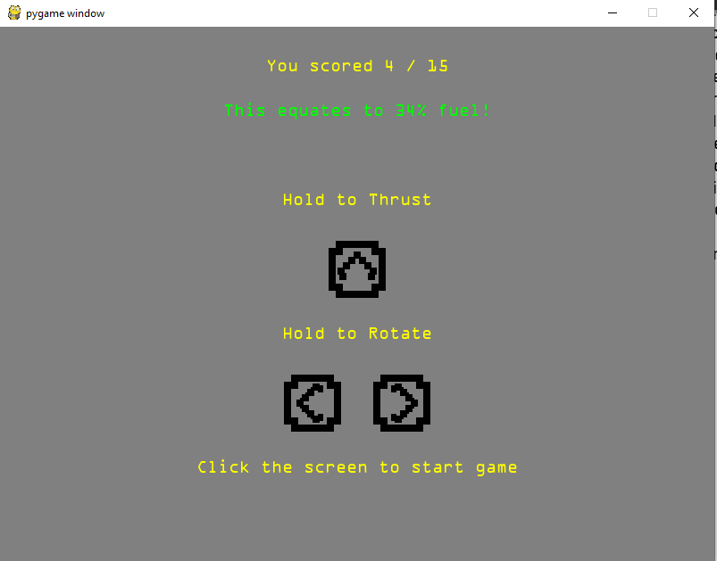I believe I have been successful in designing, developing and refining a program which satisfies all success criteria which I set out to for fill. Of course there is always room for improvement which I have highlighted earlier in my evaluation but given the time and resources available to me the solution I have come up with does exactly what it needs to do. Through thorough bottom up testing and having had two stakeholders test the program I have been able to make adjustments and improvements on details that I wouldn’t have previously picked up on myself. After stakeholder testing I changed the intro screen to tell the user to hold the keys in order to move the rocket, this makes it much clearer what they are meant to do so they don’t waste their minigame attempt. After making this change I believe the program is finished to the best of my ability.

The Code:

main.py

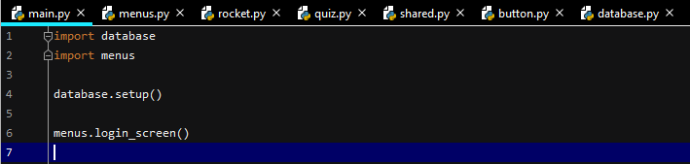

menus.py

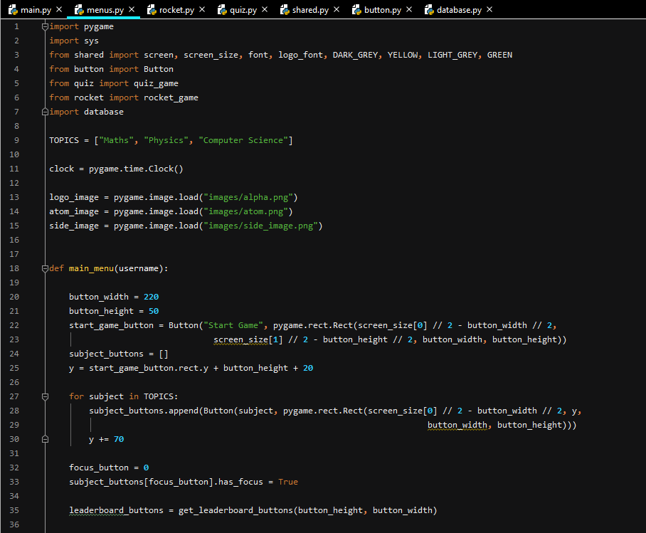

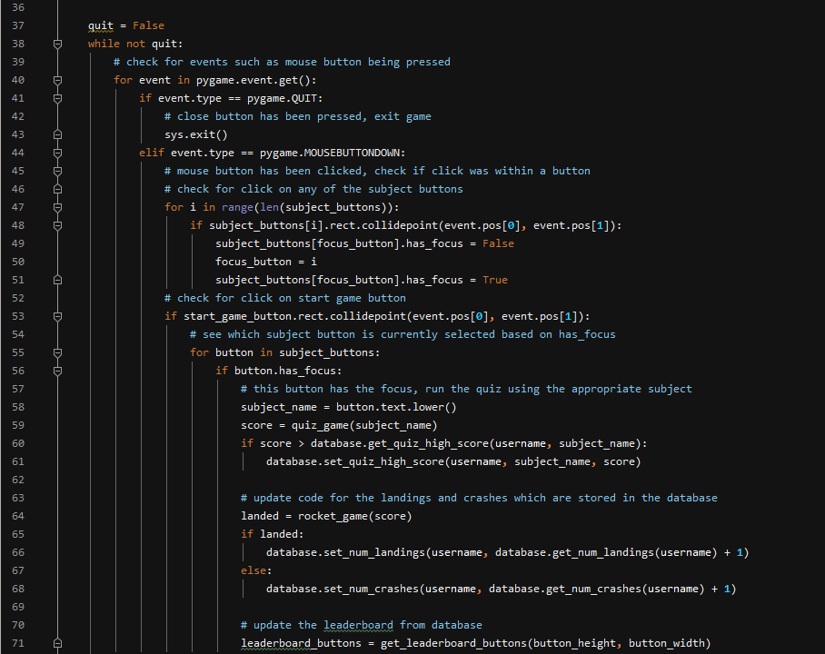

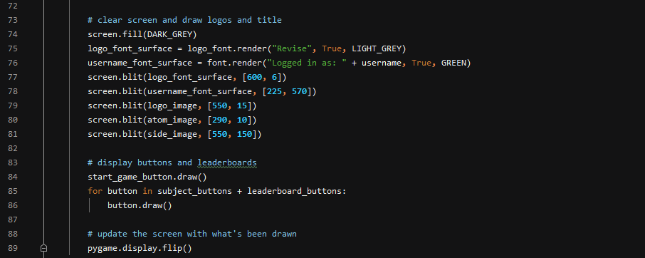

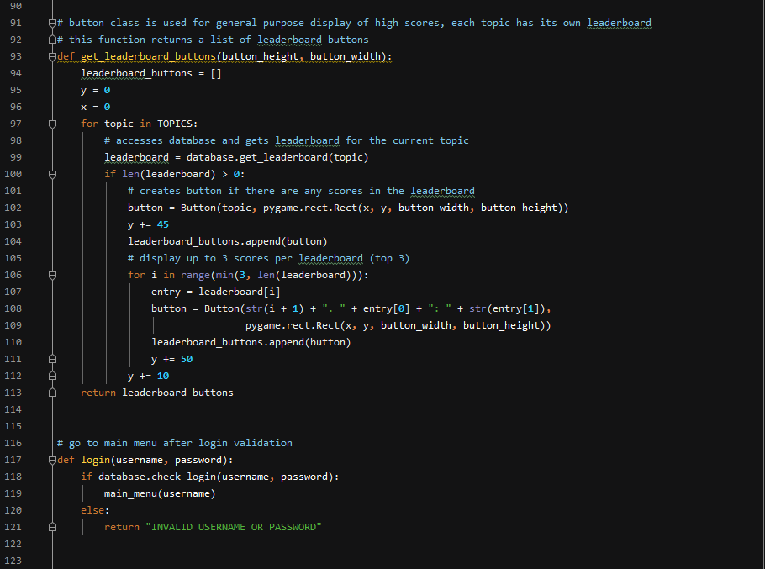

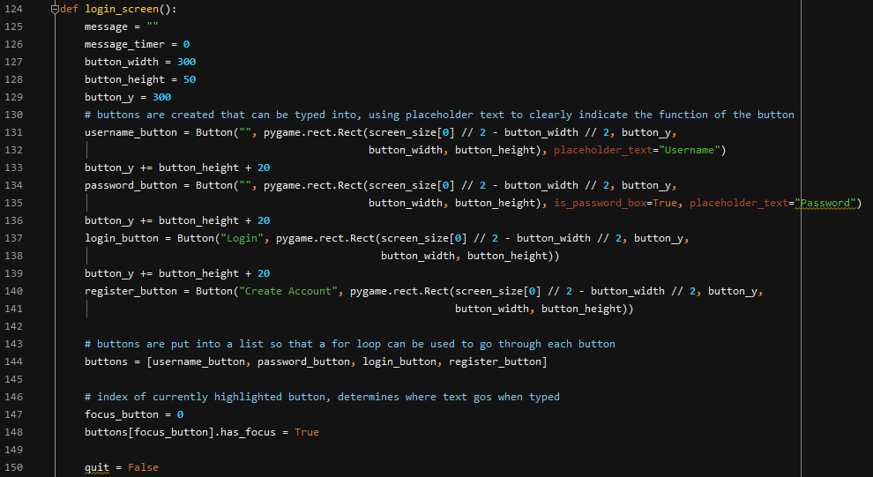

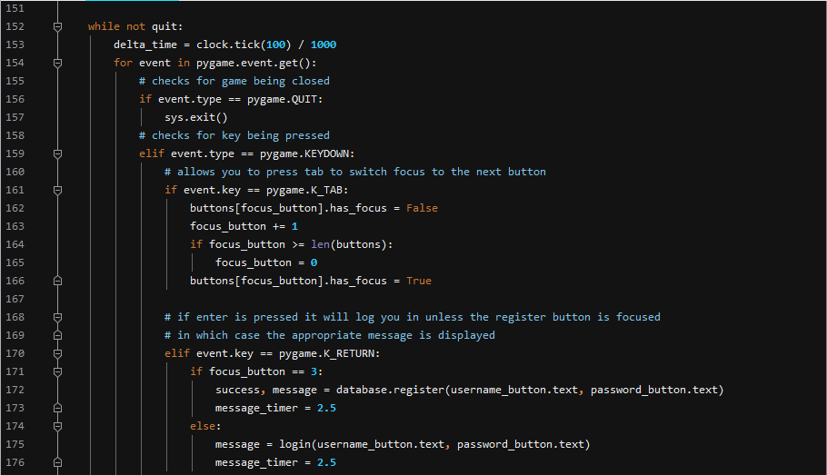

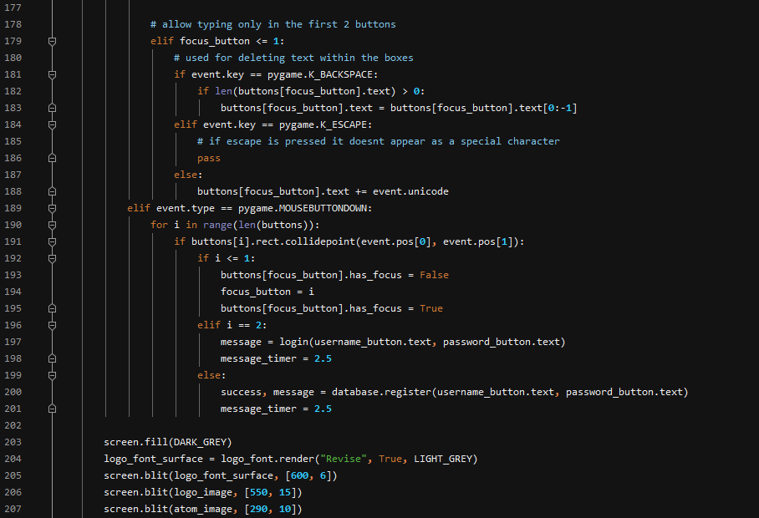

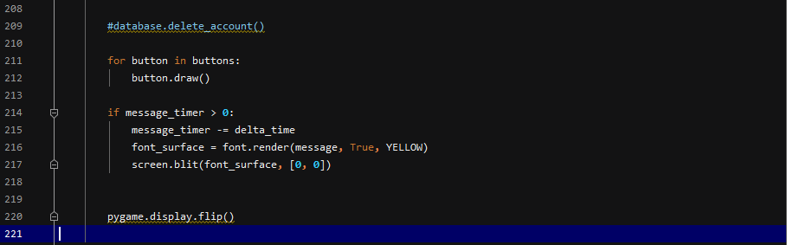

rocket.py

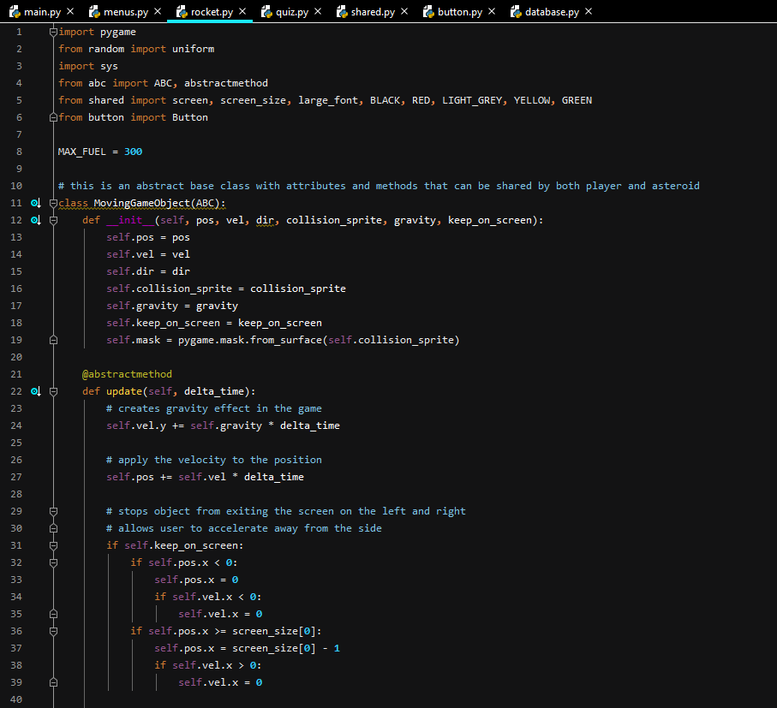

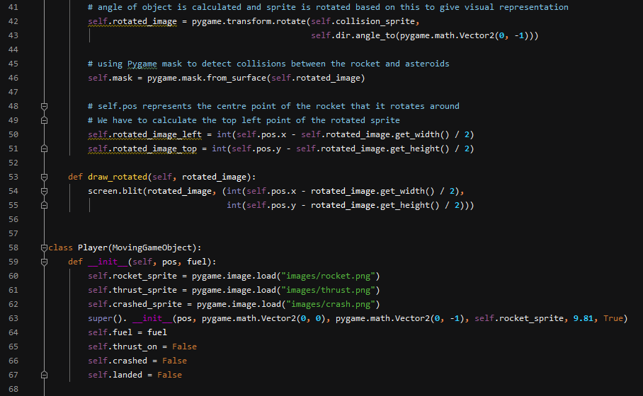

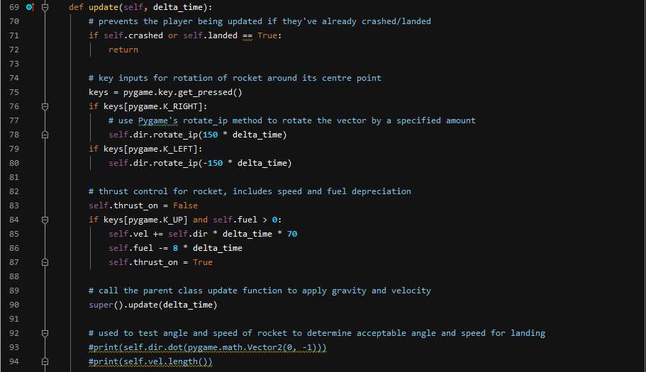

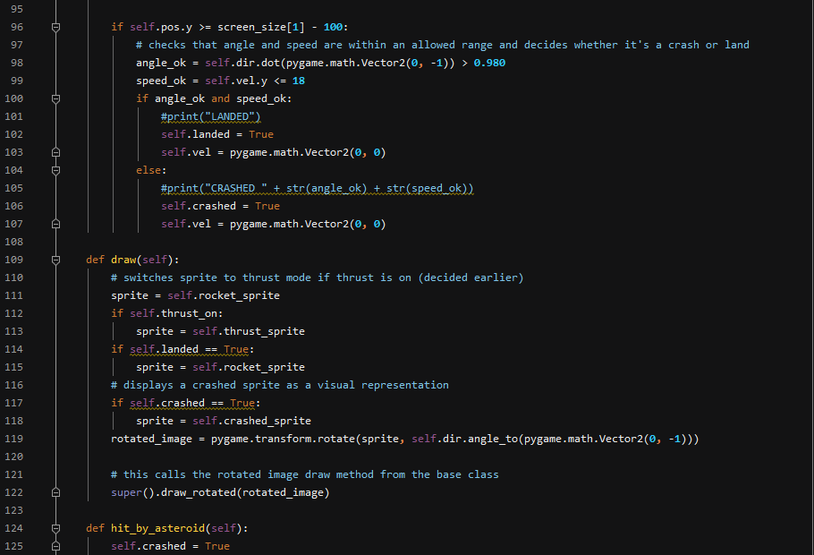

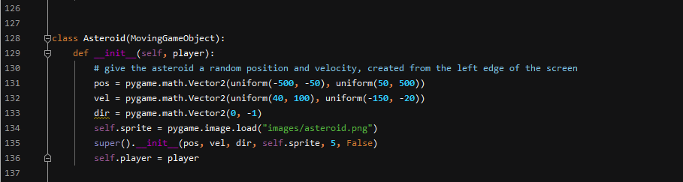

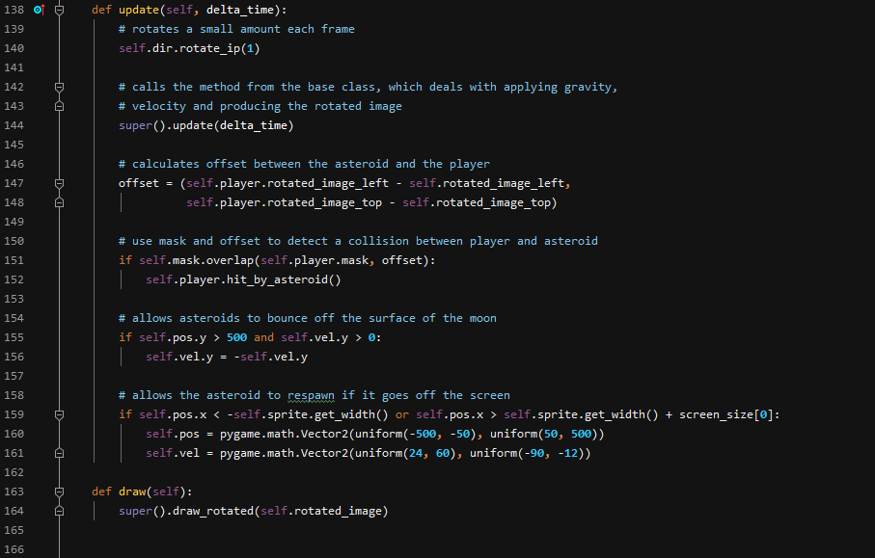

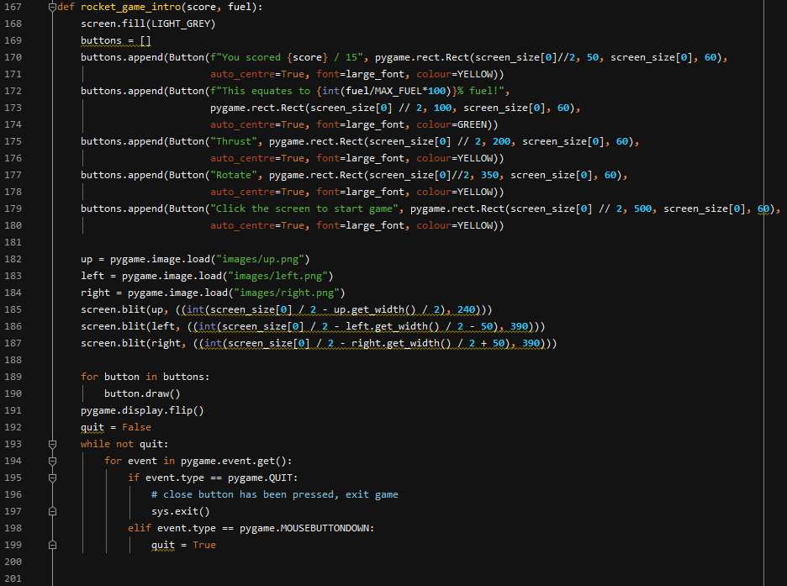

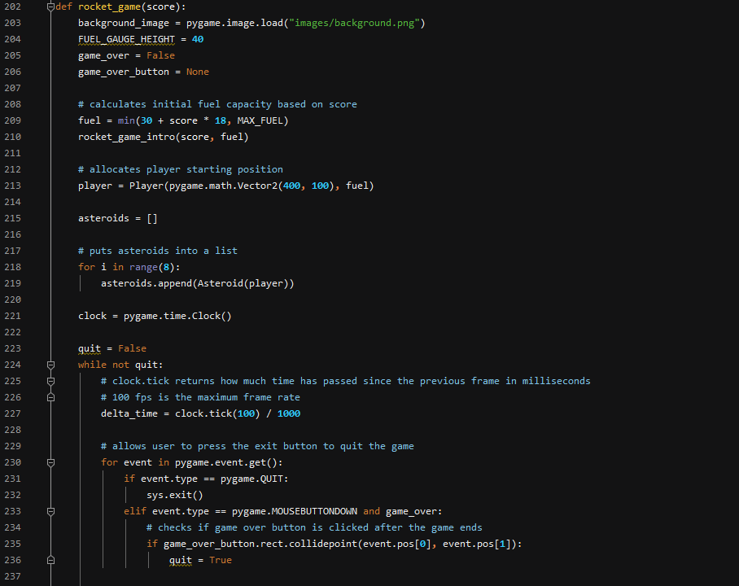

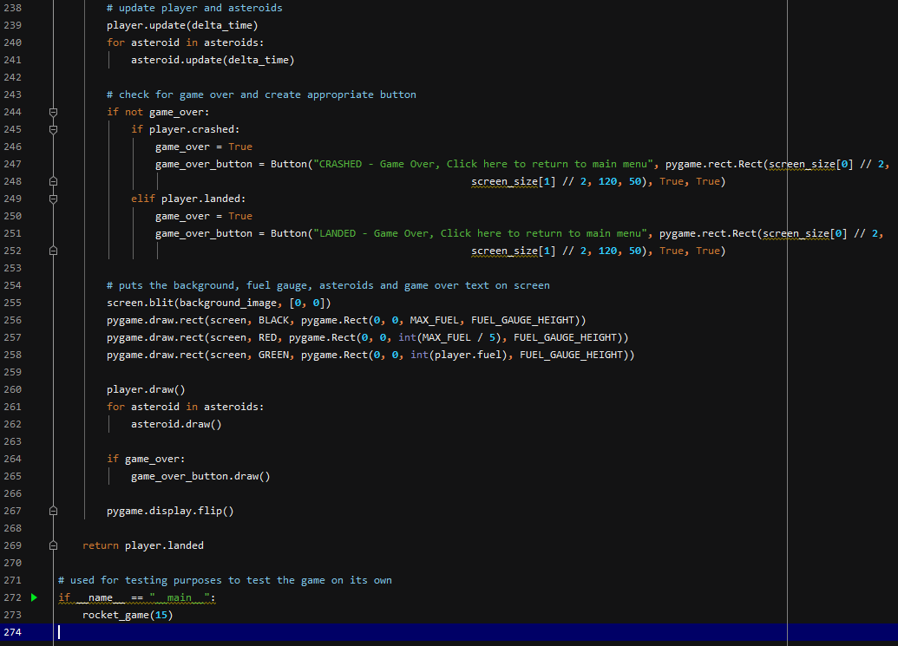

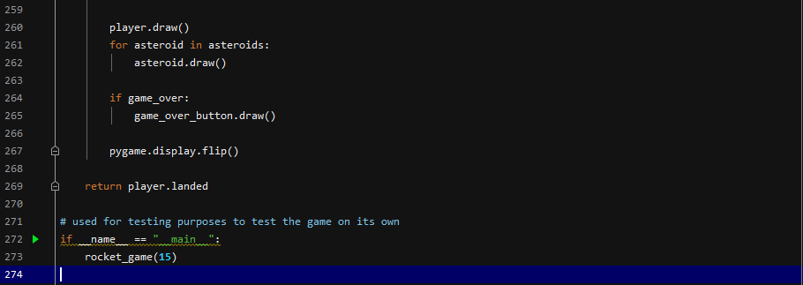

quiz.py

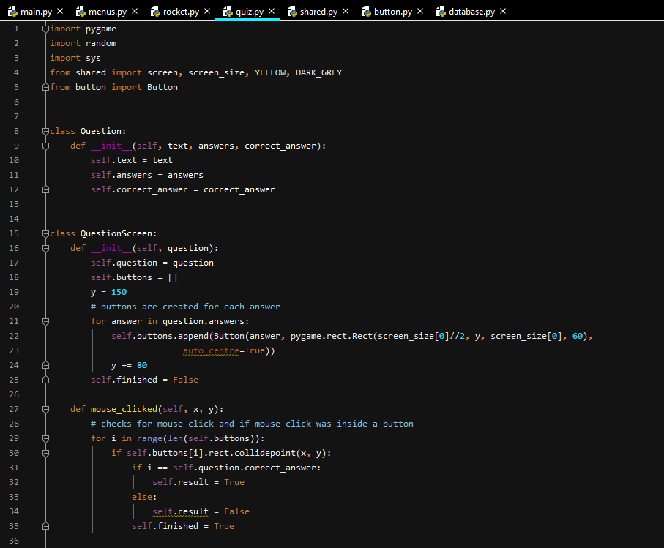

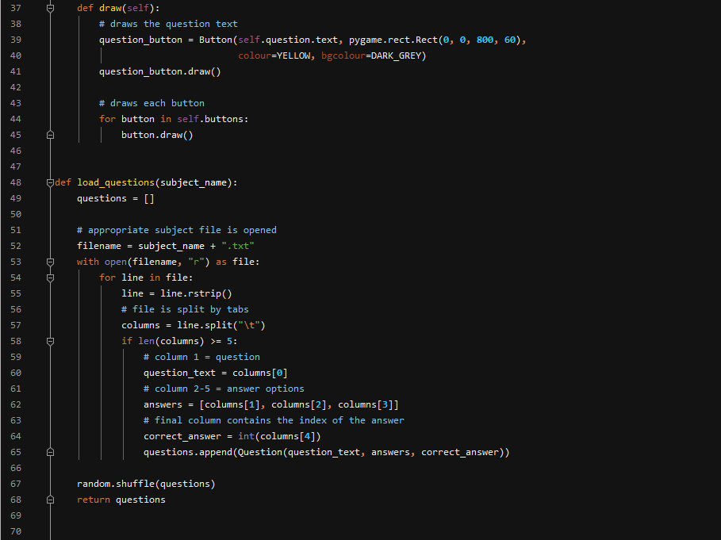

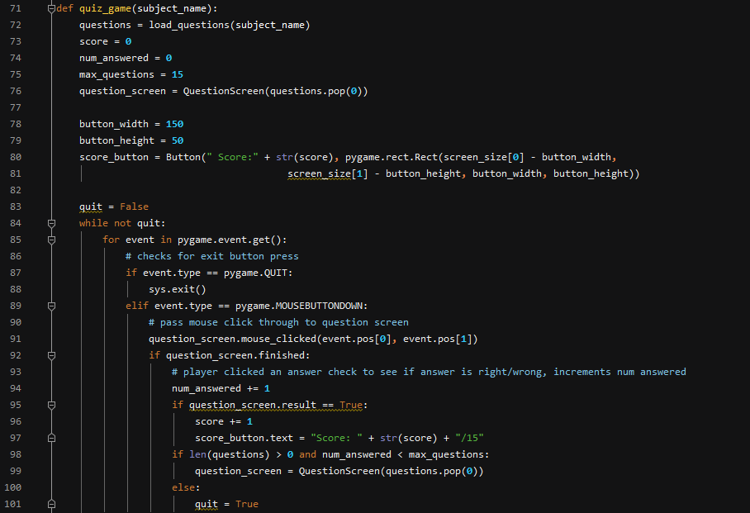

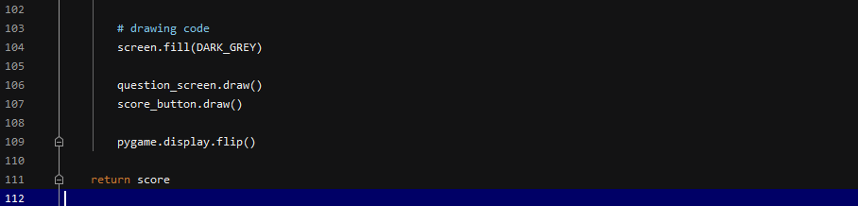

shared.py

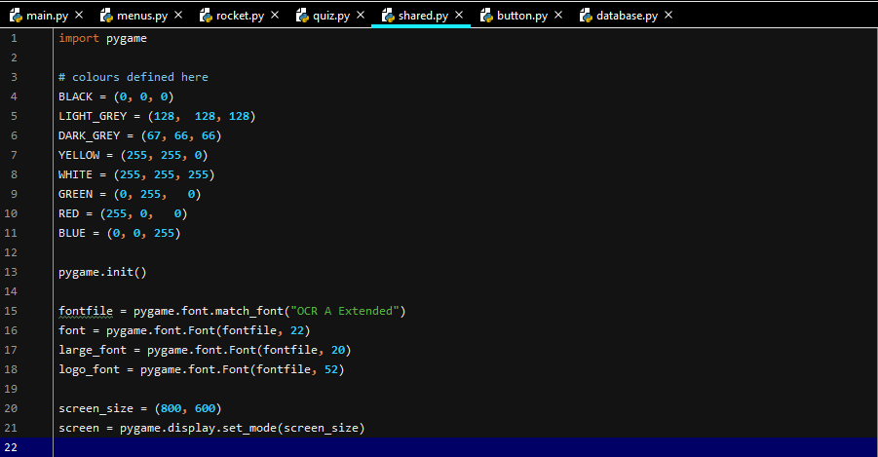

button.py

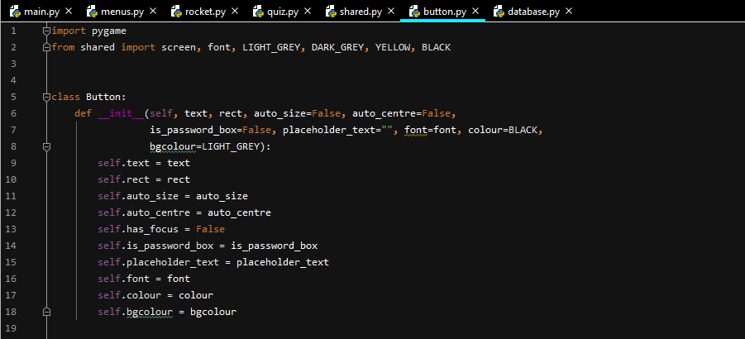

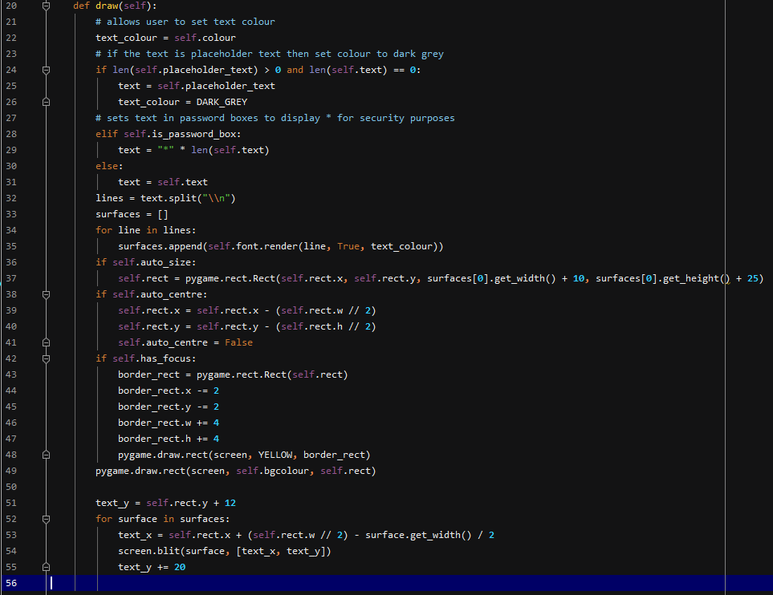

database.py

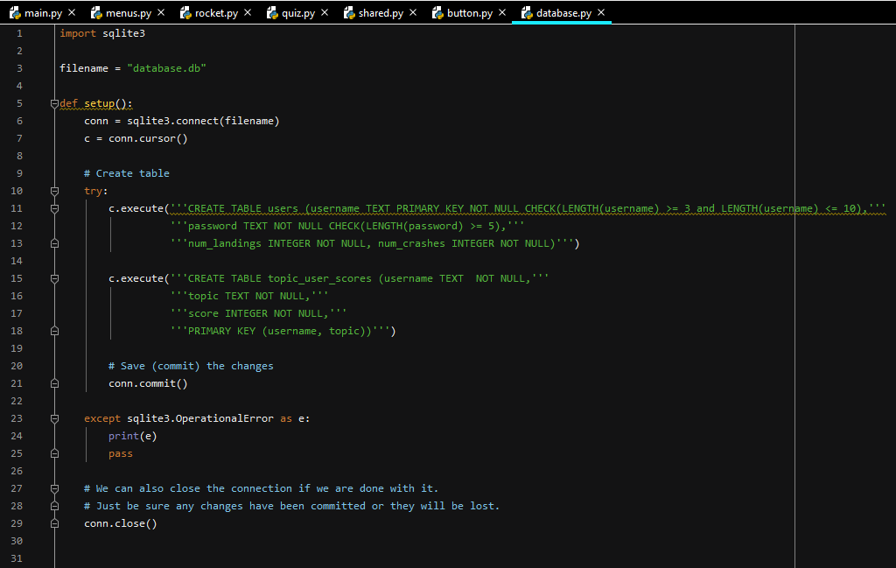

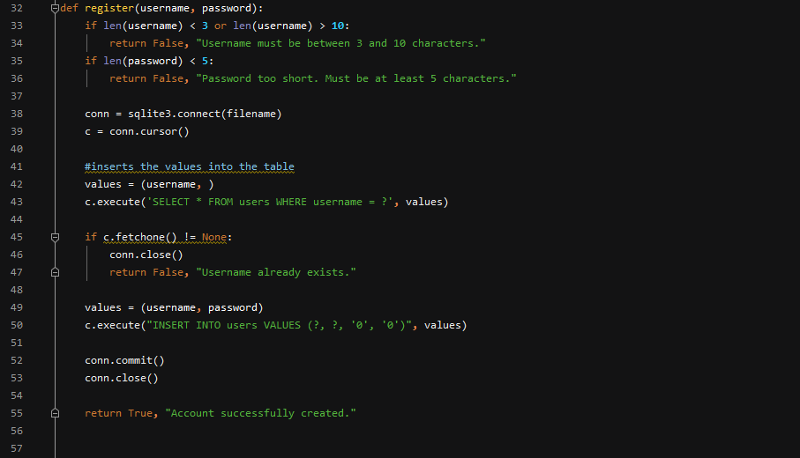

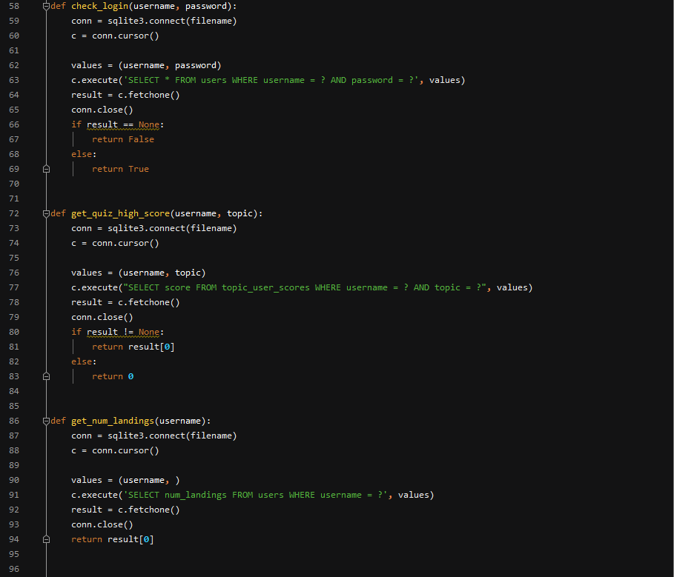

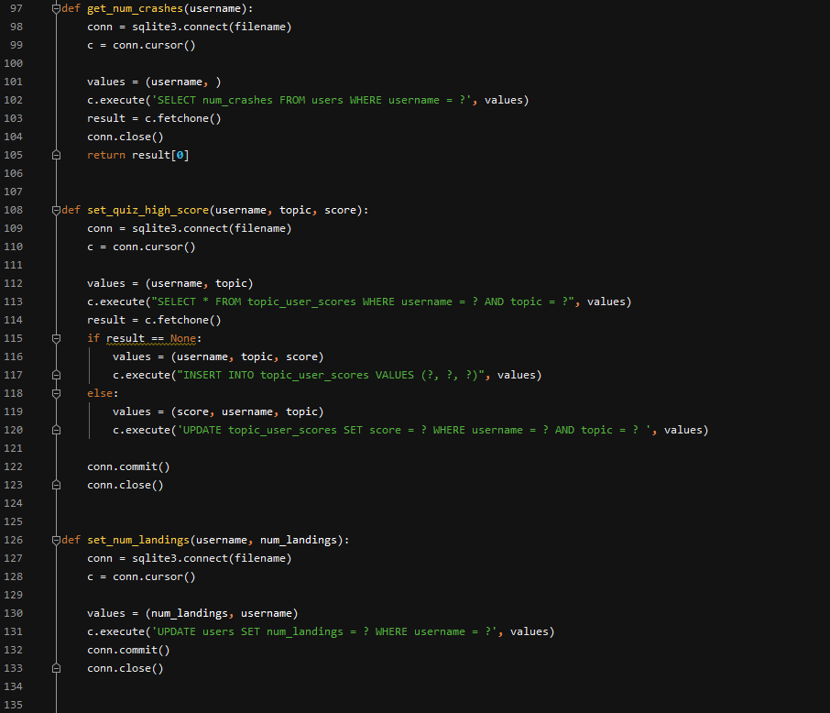

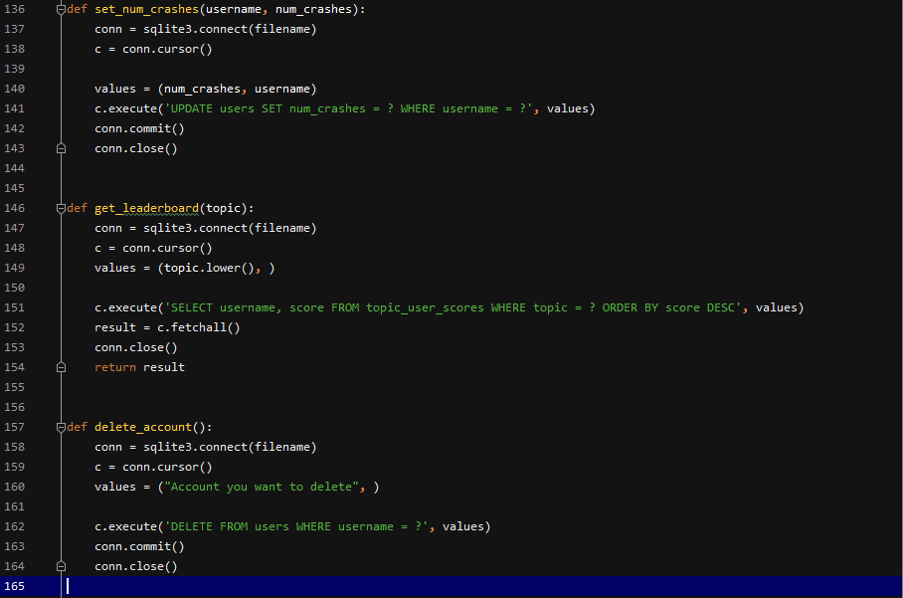

Bibliography:

<https://www.edrawsoft.com/algorithm-flowchart-examples.html> - Flowchart algorithm example

<https://www.khanacademy.org/computing/computer-science/algorithms/merge-sort/a/divide-and-conquer-algorithms> - Flowchart showing divide and conquer system

<https://senecalearning.com/en-GB/> - Seneca website

<https://www.mymaths.co.uk/> - MyMaths Website

<https://www.echalk.co.uk/amusements/Games/asteroidsClassic/ateroids.html> - Asteroids game website

<https://upload.wikimedia.org/wikipedia/commons/thumb/6/6f/Stylised_atom_with_three_Bohr_model_orbits_and_stylised_nucleus.svg/220px-Stylised_atom_with_three_Bohr_model_orbits_and_stylised_nucleus.svg.png> - Atom image in program

<http://clipart-library.com/clip-art/laptop-png-transparent-1.htm> - laptop image in program

<https://login.live.com/> – Microsoft login